Mobile Arena ™

Stage 4: Final Project

May 04, 2015

Management of Technological Organizations

Professor Hughes

Team 2:

Omar Ahmadi

Taha Khan

Branden Klemens

Alex Gleizer

**Executive Summary**

Sports have been undying form of entertainment and activity that attracts attention among all. Mobility is on the rise with various age groups and is in an upward trend with more and more people owning smart phones each day. Team 2 decided to create an application titled “Mobile Arena” which is aimed to benefit the many sports fans. The project was undertaken by undergraduate students from the School of Communication and Information at Rutgers University- The State University of New Jersey.

The project began in January 2015 and was completed using the agile process. Client meetings were taken place via web conferences and email. As conferences progressed, the scope of the project was determined as the Client’s requirements were discovered. Upon analyzing the requirements, the group communicated and collaborated throughout the weeks to achieve goals and to fulfill the requirements. The client provided feedback on the completed work and gave an overview of the topics to be discussed on the agenda each week.

The Mobile Arena mobile and web application will have live feed, news and statistics delivered to teams, coaches, recreation centers and individual users by direct updates via website and mobile applications. This application is intended to keep users up to date with their teams while having a new standard for quick delivery and a new standard for easy access.

Mobile Arena will be an application for everyone. It is projected that the number of clients will increase for this application after the first year of release.

The work of this project was divided among each member and all were responsible for completing tasks based on their designated roles. Independent research was done and project planning was perfected and completed as time progressed. The research of information was compiled and shared via Google Docs and the client’s input gave a better idea to focus on particular areas of research. The team conducted an interview with four individuals after the project was completed.

**Table of Contents**

Introduction …………………………………………………………….. Pg. 4

Team ……………………………………………………………………. Pg. 4

Requirements ………………………………………………………….... Pg. 5

System Overview - Concept & Scope, Non Functional Requirements, Software Requirements

Project Plan …………………………………………………………….. Pg. 8

Cost-Benefit Analysis ………………………………………………….. Pg.8

Costs, Revenue, Return on Investments

Process …………………………………………………………………. Pg.12

Design Methodologies, Communication & Collaboration

Design ………………………………………………………………….. Pg.14

System Architecture, Documentation, User Interface Design, Back-End Design / Database Design

Development …………………………………………………………… Pg.16

Development Process

Results …………………………………………………………………. Pg.24

User Testing

Summary and Conclusions …………………………………………….. Pg.26

**Introduction**

The Mobile Arena app is an easy and convenient way to keep informed of the score of the game of your kid’s under 18 sports team when you just can’t watch the game. The app allows you to set your favorite teams. When one of your favorite teams is playing a game and there is a change in score, the app notifies the user by making a sound or a vibration. The user then knows to check the score. The app can also be used to check the scores of games of teams other than your favorite teams, check sports news, team schedules, team standings, and team and player stats. If you see a score, stat or other information that you want to send to someone, the app can connect to e-mail, text messaging apps, Twitter and Facebook.

**Team**

The Group Two team is a group of seniors with diverse backgrounds in the Information Technology field, along with vast experiences in development. The team members are:

**Alex Gleizer** (Project Manager) - Alex is responsible for managing the team and setting goals to meet the requirements regarding the project. He notifies members of upcoming dates for deliverables and manages the weekly status reports In addition, he creates the presentation and manages weekly activities.

**Omar Ahmadi (**Technical Manager, Application Design, Programmer, Project Manager) – Omar is an IT student and a developer with prior experience in Computer Science. He has experience in creating mobile applications for Android and IOS. Omar has good experience and Java and has implemented it with the application design. He created the mobile application, diagrams and mockups for this project. Omar leads implementation on the front and back end of the application and communicates to the team requirements needed to oversee development.

**Taha Khan** (Documentation Manager, website design) – Taha is responsible for keeping everything up to date and document everything that is done within the scope of the project. He writes the reports and updates the website for Mobile Arena. In addition he organizes the notes of tasks to be completed for each stage, creates a weekly agenda for the client/professor and records ideas and concerns during weekly status updates and meetings.

**Brendan Klemens** (Research manager, cost benefits analysis) – Brendan is responsible in researching projected business costs and creating the cost benefits analysis for Mobile Arena. In addition, he analyzes the business expenses to ensure that costs are going accordingly.

**Requirements**

**System Overview - Concept & Scope**

Coaches, parents, and children alike can all use our sports tracker app to create game schedules, update the scores, and follow their favorite local teams. Coaches will have administrative ability to create the schedule and send them out to parents. Parents attending their kid’s games can manually update scores, while those stuck at home or at work are able to view their team's progress.

The project requires us to implement an application in which push notifications are sent to the user’s mobile for updated scores and breaking news. In addition, the website will display statistics based on the player’s gameplay and the overall team. There are no hardware or networking requirements for this project.

The application will be programmed in-house to cut overall costs. The system will consist of the following parts:

Front-end - Users are able to track sports games; this is the user interface with full functionality.

Back-end - Employ a server to record statistics on sports games. Values will be added to the database after each game.

**Back End Design**

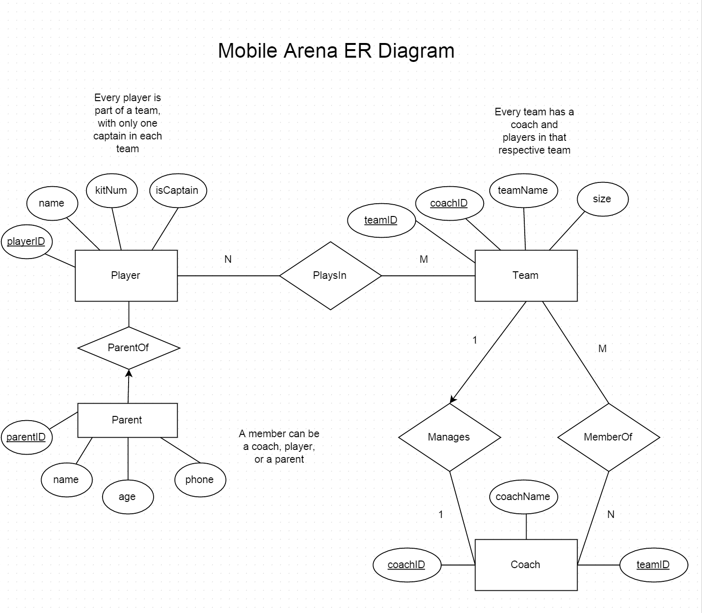

The project will application be displayed as a working prototype made through App Inventor. The programming for the application will be done by utilizing the Java language.

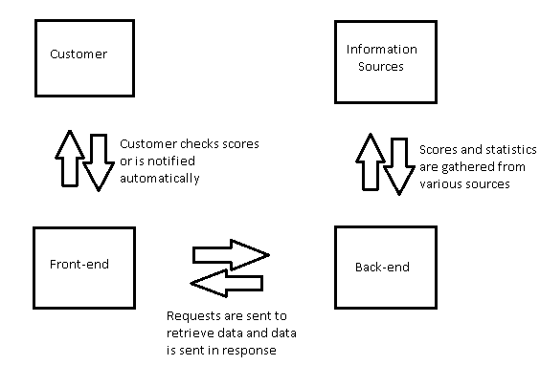

**Non Functional Requirements**

The quality goals for this sports tracker application will apply constraints and service requirements that will determine the quality of our system. The application must be able to provide accessibility, efficiency, effectiveness, fault tolerance, stability, and usability.

**Software Requirements**

· Language : Java, XHTML

· Database: MYSQL

· Web application framework: App inventor

· OS: IOS/Android

Software requirement for the development environment:

· IDE (Integrated Development Environment): Eclipse

**Project Plan**

The Project Plan includes several key tasks and milestones included within in the Gantt Chart. Responsibilities are assigned in the schedule in order to meet due dates for deliverables. Resources are allocated to each individual task in accordance with each team members’ set of skills. The project is divided into smaller stages to record progress made on the application.

Each of the stages in the assignment instructions were also implemented into the Gantt chart as follows:

**Stage 1**: Development Project Launch, Concept and Scope

* Finalize Teams and Roles
* Develop project concept and scope proposal

**Stage 2**: Project Planning and Status Report

* Research costs
* Construct cost benefit analysis
* Project management plan
* Detail database requirements
* Communications and collaborations plan
* Compile project status report

**Stage 3**: Design and Development of Application and Status Report

* User Interface Design: Lo-fi, Med-fi, Hi-fi Mockups
* Database design & ER Diagram
* Compile project status report

**Stage 4**: Project Report and Presentation

* Testing and debugging of the application
* User Testing
* Usability requirements
* Complete final report
* Project presentation

**Cost-Benefit Analysis**

**Costs**

Costs are associated with the following areas:

1. Development
   1. Costs included in developing the project. $15/h per team member.
2. Implementation
   1. Costs include implementing the system, hosting the application on a server and marketing. Marketing assumes an average of 4 hours each day at $15/hr
   2. Typical app store fee of $99 is included.
3. Upkeep
   1. Costs include maintenance and updates of the service; $15/hr per team member working on maintenance and/or updates at an average of 1 hour per day.
   2. Marketing at an average of 4 hours each day at $15/hr (this is combined with the marketing of implementation for Year 0 for a total of 8 hours a day to create initial customers).
   3. Server fees and app store fees. Approximately $30 a month for server and $99 a year for app store.

|  |  |  |  |  |  |  |  |
| --- | --- | --- | --- | --- | --- | --- | --- |
| **Total Cost** | | | | | | | |
|  |  | Year 0 | Year 1 | Year 2 | Year 3 | Total | Present Value |
|  | Project Development | $6,000.00* | $0.00 | $0.00 | $0.00 | $6,000.00 | $6,000.00 |
|  | Project Implementation | $21,999.00 | $0.00 | $0.00 | $0.00 | $21,999.00 | $21,999.00 |
|  | Upkeep/Ongoing Cost | $27,735.00** | $27,834.00 | $27,834.00 | $27,834.00 | $111,237.00 | $91,286.29 |
|  |  |  |  |  |  |  |  |
|  | **Total Cost** | $55,734.00 | $27,834.00 | $27,834.00 | $27,834.00 | $139,236.00 | $63,551.29 |

*Figure calculated from $15/h for 4 team members working 100 hours each.** value assumes server cost for full year, therefore cost will be lower in actuality; it is kept in but redundant app store fee was removed.

**Revenue**

Revenue is generated from in-app advertisements, as well as purchases of the application at $1 per download. Year 1 assumes 100,000 downloads and the following years are extrapolated from this value and include advertising revenue. Numbers increase as popularity grows and are based on an estimate of the number of *total* downloads doubling each year due to expansion and marketing; therefore, Year 2 has the same revenue as Year 1 because the count of *new* downloads is the same as Year 1 (200,000 - 100,000 = 100,000), while Year 3 is higher due to the doubling of the last year’s count (400,000 - 200,000; therefore, a total of 400,000 total downloads reflected overall with 200,000 new downloads for Year 3). Advertising revenue is calculated by numerous variables. Average daily user sessions is set to a value of 5,000 (as is the average value according to PlacePlay); because these figures cannot be calculated appropriately before implementation, to keep the revenue reasonable, a value of 5000 will be used *each* year rather than starting lower and increasing the amount. Average minute per session is approximately 2 minutes and advertising impressions per minute is a value of 2 as well. Advertisement network fill rate is 80% and eCPM is $2 (all values are also averages from PlacePlay).

|  |  |  |  |  |  |  |  |
| --- | --- | --- | --- | --- | --- | --- | --- |
| **Benefits** | | | | | | | |
|  |  | Year 0 | Year 1 | Year 2 | Year 3 | Total | Present Value |
|  | Application Purchase Revenue | $0.00 | $100,000.00 | $100,000.00 | $200,000.00 | $400,000.00 | $294,074.13 |
|  | Advertisement Revenue | $0.00 | $11,680.00 | $11,680.00 | $11,680.00 | $35,040.00 | $26,668.07 |
|  |  |  |  |  |  |  |  |
|  | **Total Revenue** | $0.00 | $111,680.00 | $111,680.00 | $211,680.00 | $435,040.00 | $320,742.20 |

**Return on Investment**

As the previous table shows, the revenue steadily increases over the years, while the cost table shows a steady cost of upkeep *alone* (with the exception of Year 0). The non-risk-adjusted return on investment is 169.40%, while the risk-adjusted return on investment is 124.08%. Net present values and risk adjustments include a project discount rate of 15%.

|  |  |  |  |  |  |  |  |
| --- | --- | --- | --- | --- | --- | --- | --- |
| **Non-Risk-Adjusted** | | | | | | | |
|  | **Item** | **Year 0** | **Year 1** | **Year 2** | **Year 3** | **Total** | **NPV** |
|  | Application-Purchase Benefit | $0.00 | $100,000.00 | $100,000.00 | $200,000.00 | $400,000.00 | $294,074.13 |
|  | Advertisement Benefit | $0.00 | $11,680.00 | $11,680.00 | $11,680.00 | $35,040.00 | $26,668.07 |
|  | Project Development Cost | -$6,000 | $0.00 | $0.00 | $0.00 | -$6,000 | -$6,000.00 |
|  | Project Implementation Cost | -$21,999 | $0.00 | $0.00 | $0.00 | -$21,999 | -$21,999 |
|  | Upkeep/Ongoing Cost | -$27,735.00 | -$27,735.00 | -$27,735.00 | -$27,735.00 | -$110,940.00 | -$91,060.25 |
|  | **Totals** | -$55,734.00 | $83,945.00 | $83,945.00 | $183,945.00 | $296,101.00 | $201,682.96 |
|  |  |  |  |  |  |  |  |
|  | **ROI** | 169.40% |  |  |  |  |  |
|  | **Payback Period** | 8 months |  |  |  |  |  |
|  | **IRR** | 158.36% |  |  |  |  |  |

|  |  |  |  |  |  |  |  |
| --- | --- | --- | --- | --- | --- | --- | --- |
| **Risk-Adjusted** | | | | | | | |
|  | **Item** | **Year 0** | **Year 1** | **Year 2** | **Year 3** | **Total** | **NPV** |
|  | Application-Purchase Benefit | $0.00 | $95,000.00 | $95,000.00 | $190,000.00 | $380,000.00 | $279,370.43 |
|  | Advertisement Benefit | $0.00 | $11,096.00 | $11,096.00 | $11,096.00 | $33,288.00 | $25,334.67 |
|  | Project Development Cost | -$8,000.00 | $0.00 | $0.00 | $0.00 | -$8,000.00 | -$8,000.00 |
|  | Project Implementation Cost | -$29,332.00 | $0.00 | $0.00 | $0.00 | -$29,332.00 | -$29,332.00 |
|  | Upkeep/Ongoing Cost | -$30,046.25 | -$30,046.25 | -$30,046.25 | -$30,046.25 | -$120,185.00 | -$98,648.60 |
|  | **Totals** | -$67,378.25 | $76,049.75 | $76,049.75 | $171,049.75 | $255,771.00 | $168,724.49 |
|  |  |  |  |  |  |  |  |
|  | **ROI** | 124.08% |  |  |  |  |  |
|  | **Payback Period** | 11 months |  |  |  |  |  |
|  | **IRR** | 118.04% |  |  |  |  |  |

**Process**

**Design Methodologies**

use of cba to assess viability and justify doing the project, used gantt chart in order to schedule tasks, system development life cycle

**Communication and Collaboration**

**Face-To-Face Meeting Times**:

* General Team Meetings
  + Purpose of the general meeting is for team members to discuss and ask questions concerning the deliverables for the assignments due that week
  + Meetings are scheduled every Monday after class
  + The team will focus on the following topics:
    - Assigning responsibilities of each teammate
    - Finding the best approach to complete deliverables on time
    - Addressing issues with tasks

**Group Electronic Communication**:

* Email facilitates non-urgent communication and file sharing
* GroupMe
  + allows for real-time communication between team members via text messaging
  + Each member sends a weekly status report to the project manager to ensure everyone is completing the tasks at hand
* Google Docs
  + Enables the group to work in a collaborative manner on tasks
  + Collectively review and finalize the work of each team member
* Google Hangouts
  + allows for real-time communication between team members and/or professor/client

**Collaboration Plan**:

* Collaboration via Google Documents
  + Every member has access to documents at every stage and is able to makes edits after reviewing drafts
* Project Manager
  + Notifies members of upcoming dates for deliverables
  + Manages the weekly status reports and updates completed tasks on the Gantt chart
  + Gathers up project information each week into a Powerpoint Presentation
* Technology Manager
  + Leads implementation on the front and back end of the application
  + Communicates to the team requirements needed to oversee development
* Document Manager
  + Organizes notes of tasks to be completed for each stage
  + Creates a weekly agenda for the client/professor
  + Records ideas and concerns during weekly status updates and meetings

**Design**

**System Architecture**

The project will application be displayed as a working prototype made through App Inventor. The programming for the application will be done by utilizing the Java language.

**Documentation**

Code documentation will be generated constantly as developers will be asked to do so by the project manager, business analysts and other roles that play a part with communicating with the developers throughout the project. Databases will continue to be updated as well.

System Architecture Documentation User Interface Design

**User Interface Design**

The user interface for the application will be developed using XHTML The user interface developed by our team will be basic as we will also display a working prototype via App Inventor. The interface will be further enhanced by the technology manager and his team after the project is handed off to the client.

**Personas Mobile Arena is Designer for:**

*"Dennis"*

Dennis is a 42 year old accountant. He is married with two children. Sports were a passion of his while growing up, both the competition of playing sports as well as watching them. He played high school and some college football. From an early age, Dennis and his father would watch Giants games on Sundays in the fall. His father was an avid Giants’ fan and he became an avid Giants’ fan as a result. He also played fantasy football with his college buddies. Now, however, his job and family duties don’t leave him much time to indulge in his passion for sports.

*"George"*

George loves soccer. He plays just about every Sunday with his three brothers, with a lot of teasing based on who did poorly that week. Since he himself is playing Sunday mornings, he cannot be at other games and watch the tournaments his brothers participate in as they happen. Fortunately, one of his brother’s told him about Mobile Arena!

Our two personas are based on a superfan of one team and a fan of a sport without teams, two very different types of sports fans. A third possible Persona would be someone who just wants to track ALL teams within a specific sport. This kind of user seemed most likely to have already chosen other very powerful tools to gain the information they wanted.

**User Interface Design (cont’d)**

**User-Task Matrix for the Mobile Arena App**

|  |  |  |  |  |
| --- | --- | --- | --- | --- |
| Users | Task 1 | Task 2 | Task 3 | Task 4 |
| Sports Fans & Families | Set favorite team preferences | Check scores of games | Check additional information about teams and players | Send information about scores, teams, schedule & stats to friends |

**Task Matrix for the Mobile Arena App**

|  |  |  |  |
| --- | --- | --- | --- |
| Tasks | Frequency | Priority | Task Details |
| Set favorite team preferences | Rarely | Low | User sets team preferences so favorite team scores are displayed on the main page. |
| Check scores of games | Very Often | High | User checks scores of games of favorite teams and other teams. |
| Check additional information about teams and players | Occasionally | Medium | User checks for news, schedule, standings and stats of teams and players. |
| Send information about scores, teams, schedule & stats to friends | Occasionally | Low | User e-mails, texts, or uses social media such as Twitter or Facebook to send information to friends. |

**Development**

**Development Process**

The development team is utilizing the agile development strategy as many activities are occurring simultaneously within the timeframe. Taking time to develop a mobile application, as well as a website for users is vital to the success of the service. The team is heavily taking time to develop a mobile application, as well as a website for users. The application is mainly designed for families and coaches in which they track the teams of local children under approximately eighteen teams. In addition, this sports team tracker application is an easy and convenient way to keep informed of the score of the game and the user’s selected sports teams. The application can connect to social media and text messaging applications to share scores. The requirements below are emphasized on Phase 1 of the project. There will be constant changes as the project progresses.

**Low-Fidelity MockUp:**

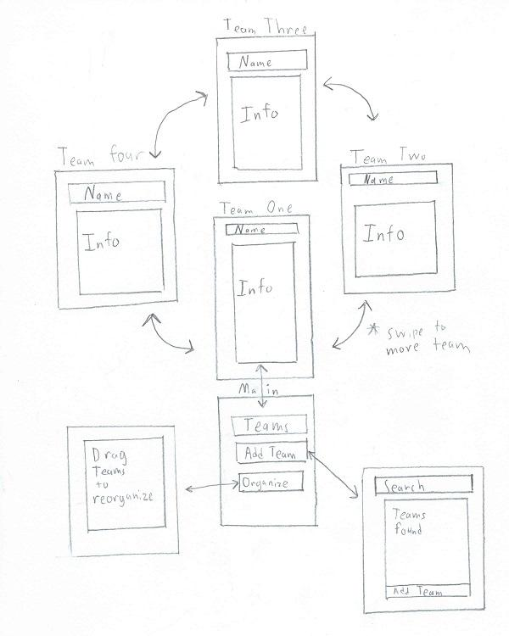

After the initial installation, the user is placed onto the "Add Teams" screen where they add all the teams they are interested in following. When loading the app with teams added, it will go to the "Main" screen. The main screen has three paths available, adding new teams, going to the teams you have followed, and reorganizing the team order. Adding a new team is done by searching for a team and then selecting the one you are interested in and clicking the "Add Team" button. By hitting the "Teams" button you immediately get information of your first team. You can get information on other teams by swiping left and right. Finally, you can hit "Organize" button which allows you to reorganize the teams because the teams that are in the middle of the list are more challenging to get to.

Targeted user requests

"The most common feature request was a desire to make easy to get more details quickly"

Pros:

1.Users would get more information right away

2.Teams can be reordered to get to favorite teams faster

Cons:

1. Longer to get to the teams in the middle of the list.

**Medium Fidelity Mockup:**

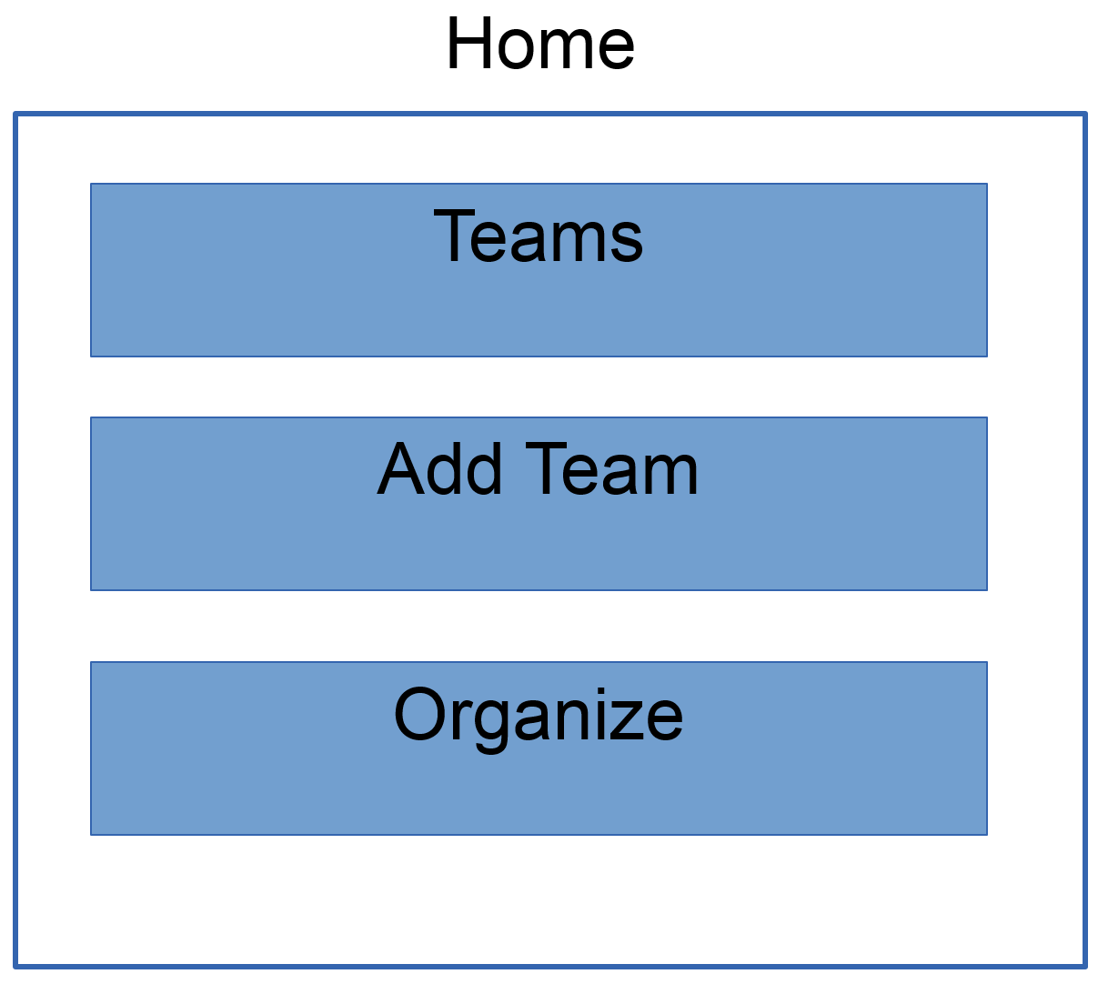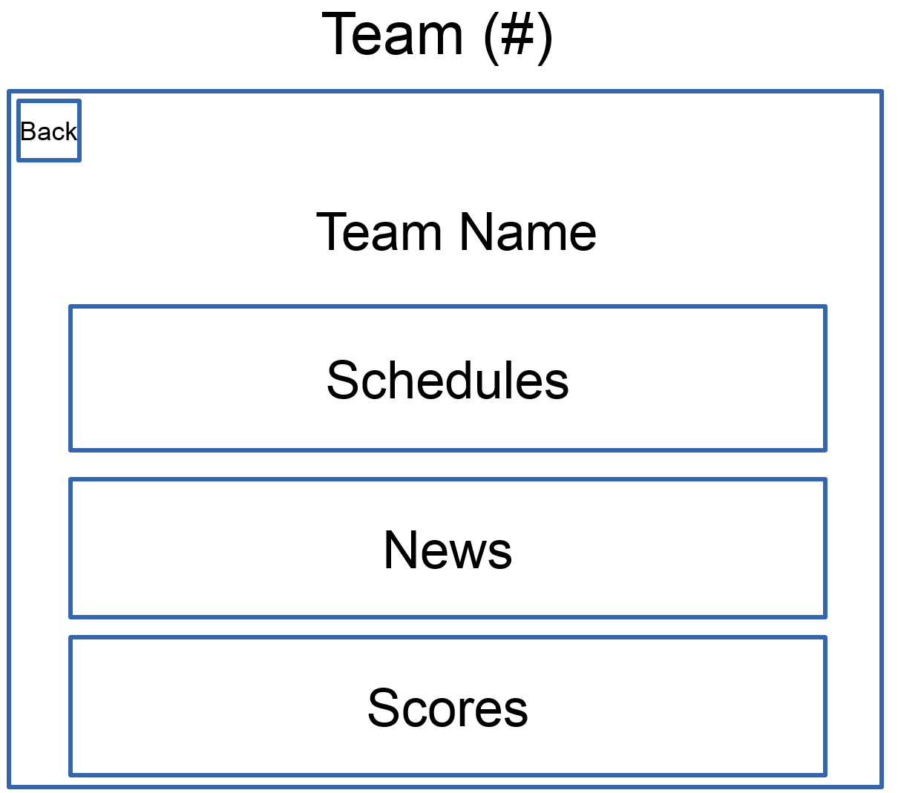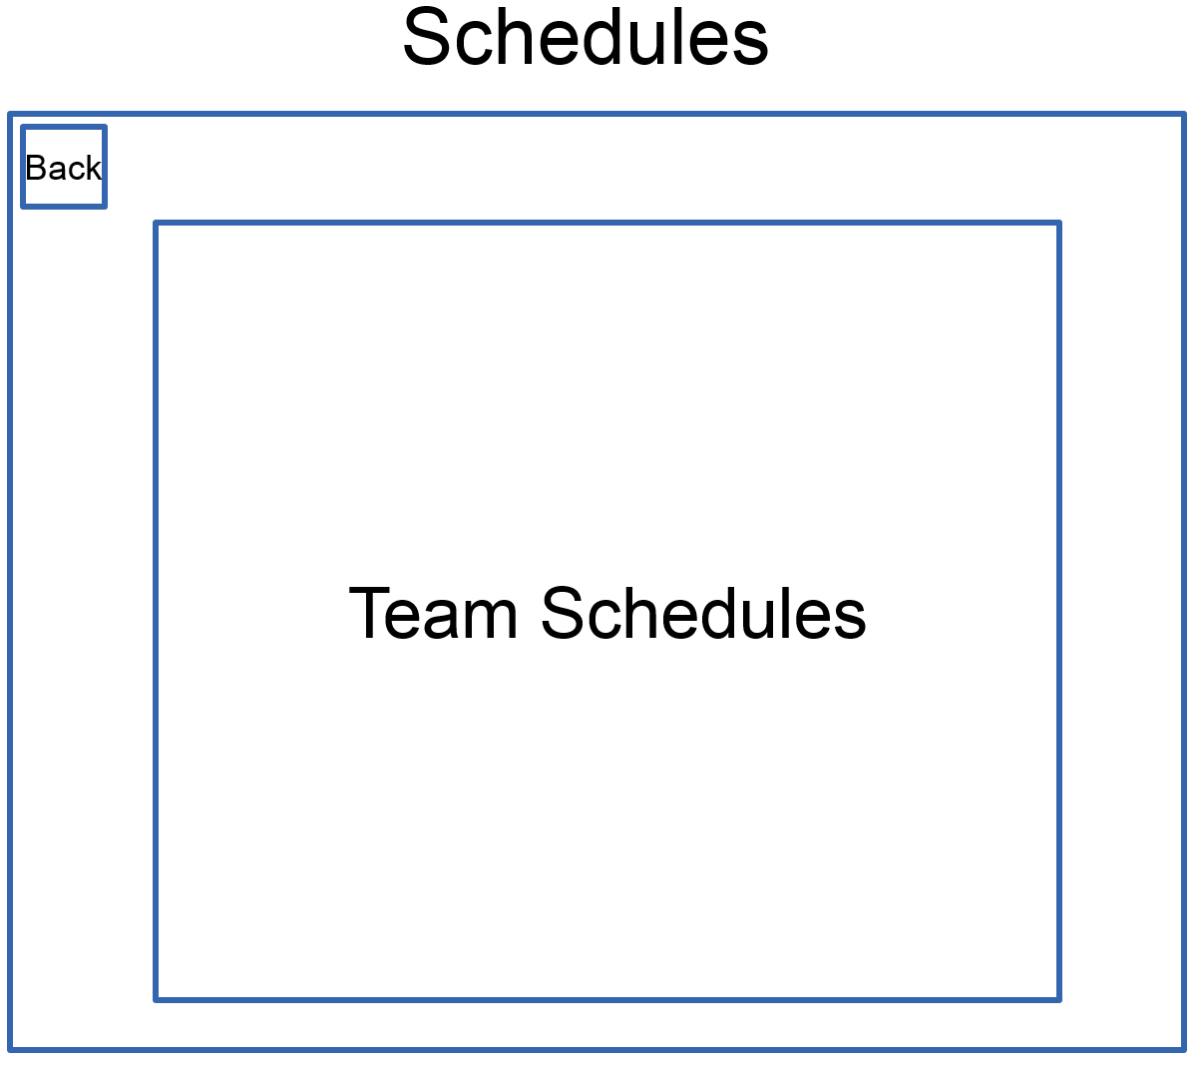

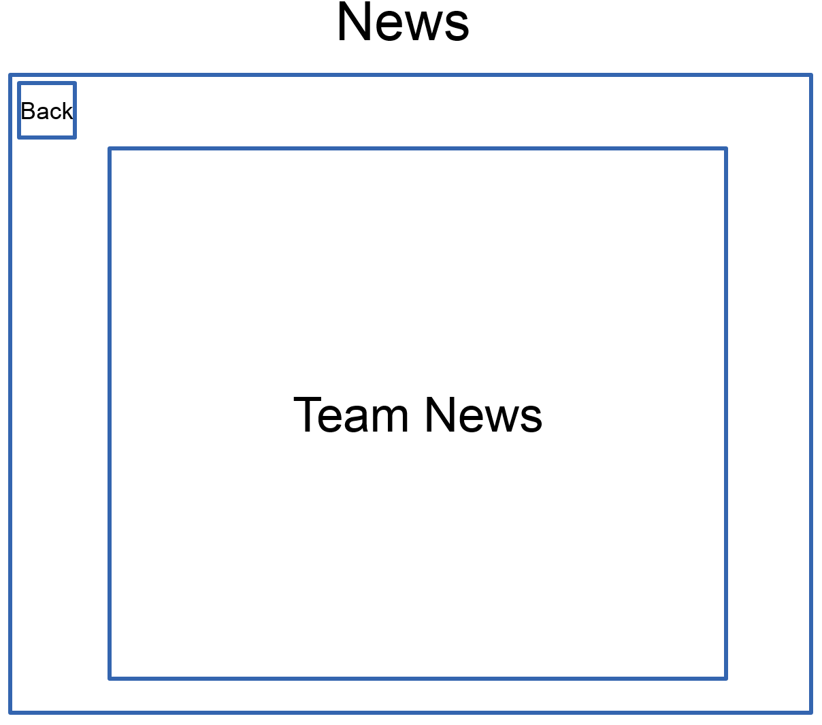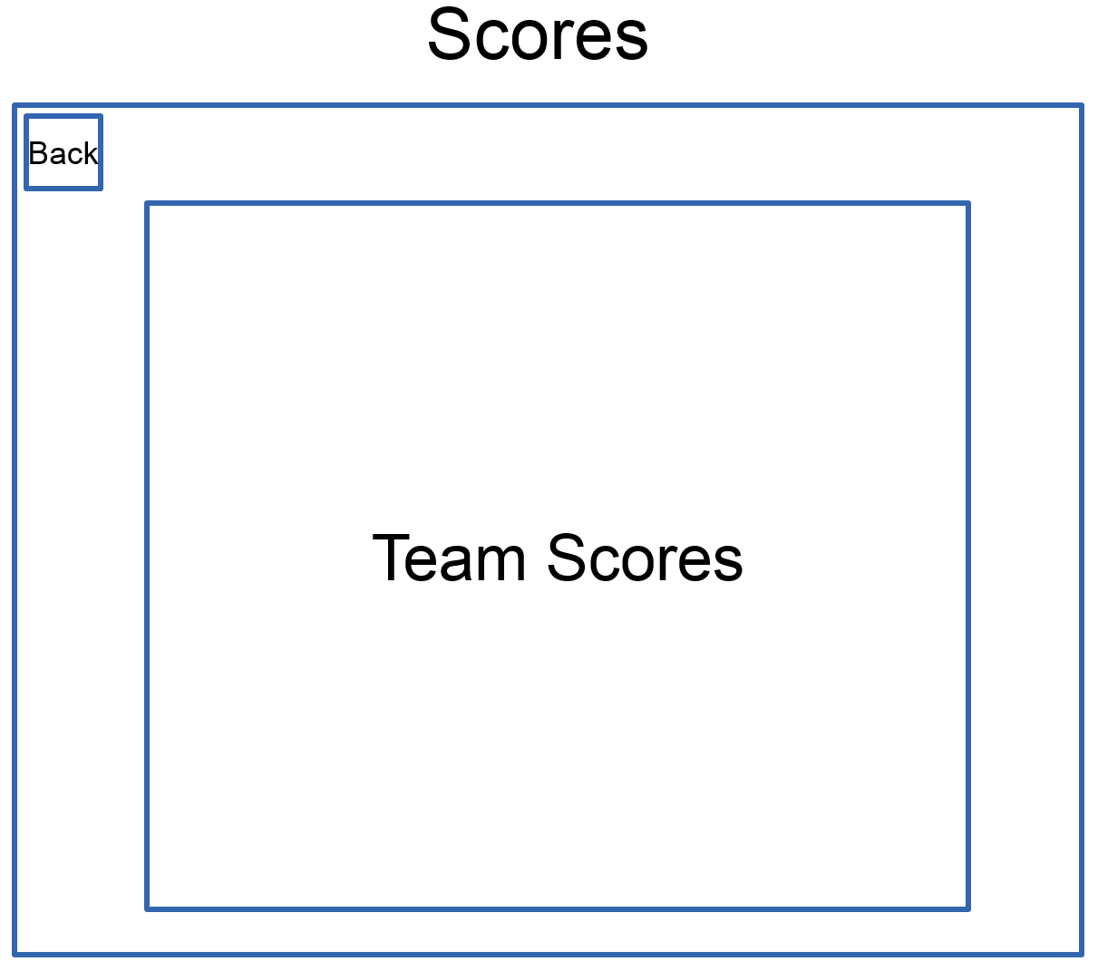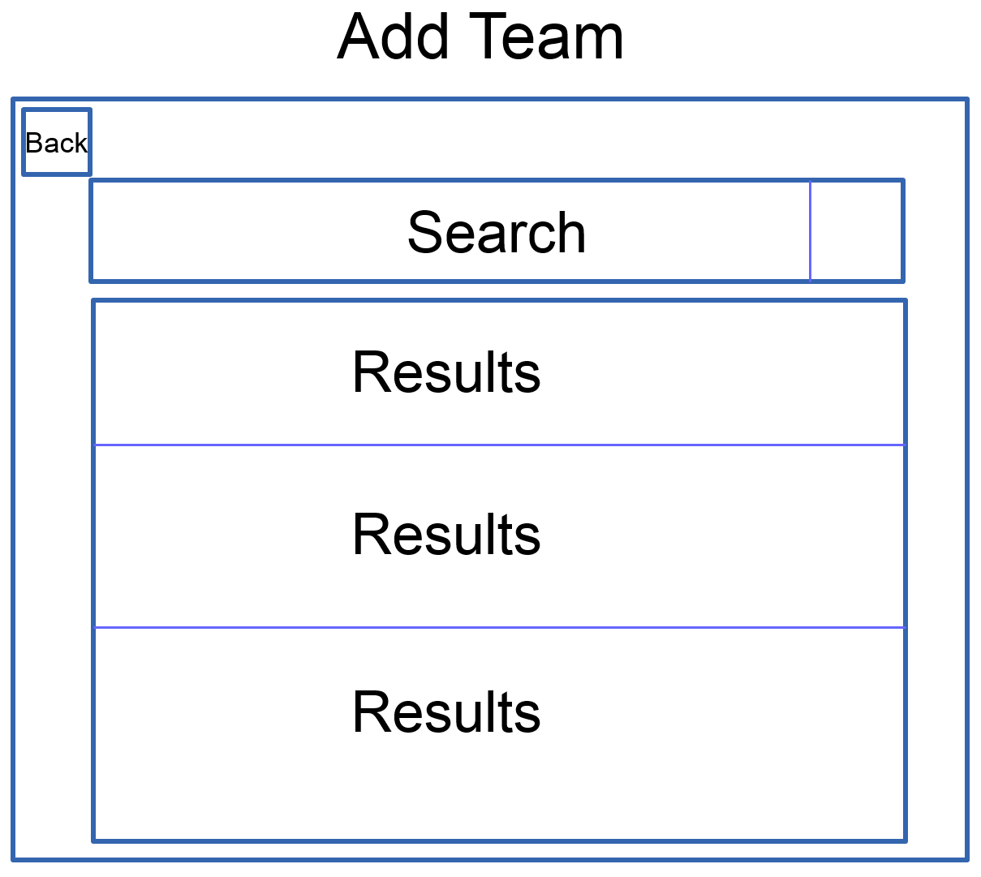

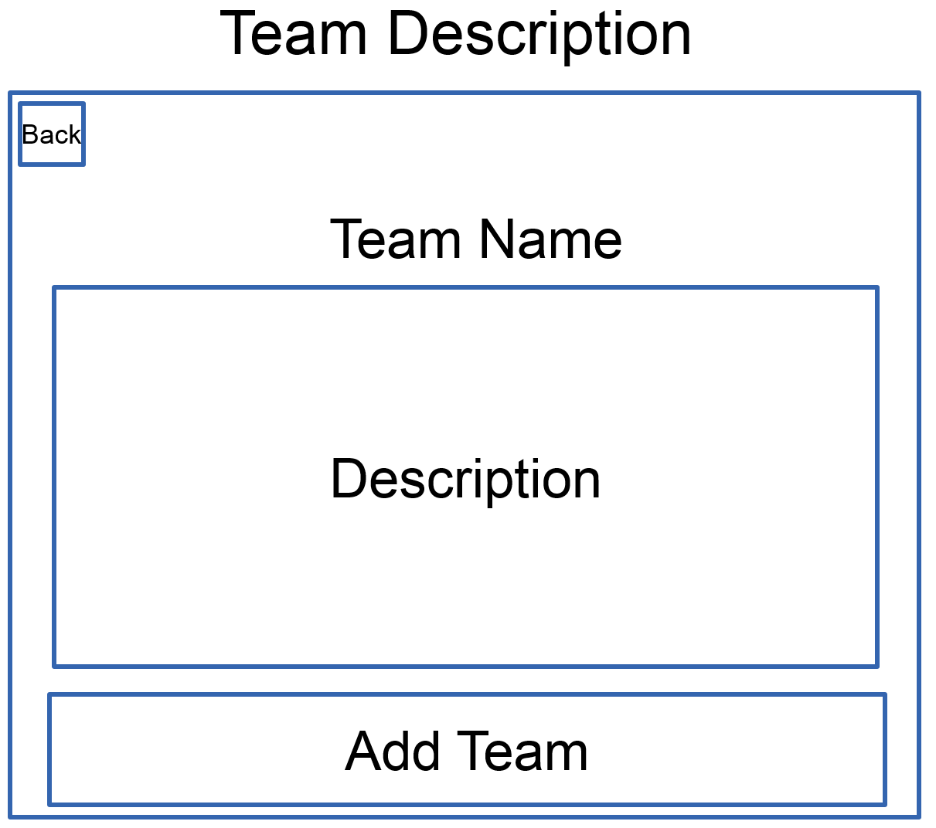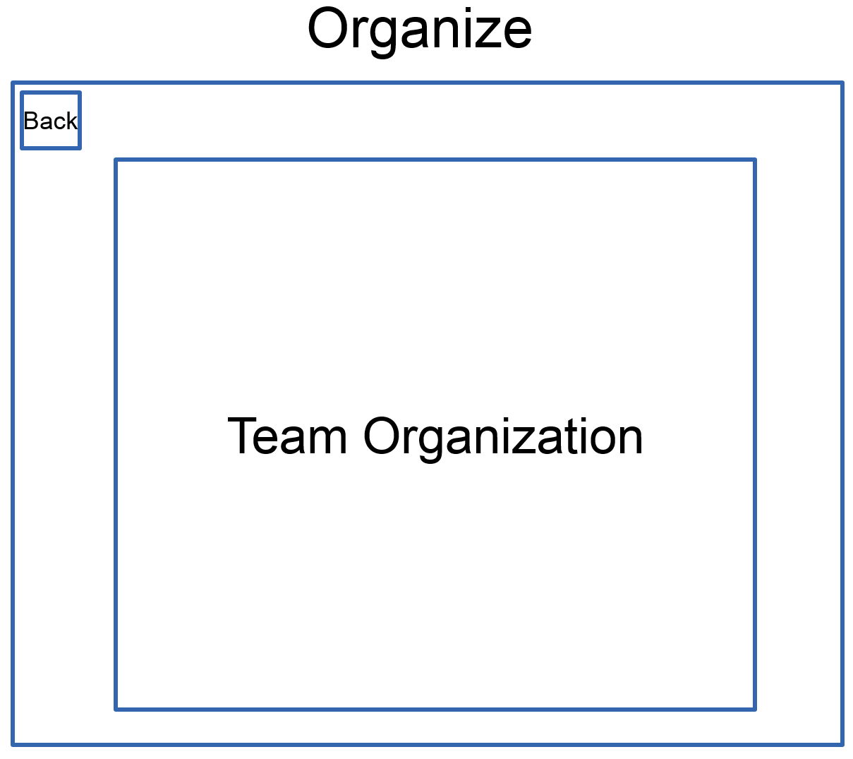

When the application is loaded, the user is met with the 'Main' screen; three options are available: 'Teams', 'Add Team' and 'Organize'. When the 'Teams' button is pressed, the user is brought to the screen in which information on their followed team is viewable and additional teams can be viewed by swiping the screen. This 'Teams' screen contains three options as well: 'Schedules', 'News' and 'Scores'; the buttons bring the user to their respective screens with information on schedules, news or scores. Returning to the 'Main' screen, the user has the option of adding new teams. When the 'Add Team' button is pressed, the user is brought to the 'Add Team' screen in which they can search for teams and are given results based on their query. When a result is selected, the user is brought to the 'Team Description' screen which displays the team name, description and option for adding the team. Lastly, returning to the 'Main' screen, the user may select 'Organize'; the user is then taken to the 'Organize' screen in which they can reorganize the order of the teams they are following. The changes made will be reflected in the ‘Teams’ section of the application, allowing the user to place their favorite teams earlier in the list to reduce the amount of swiping and searching.

**High Fidelity Mockup:**

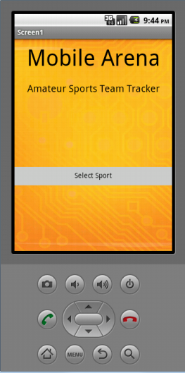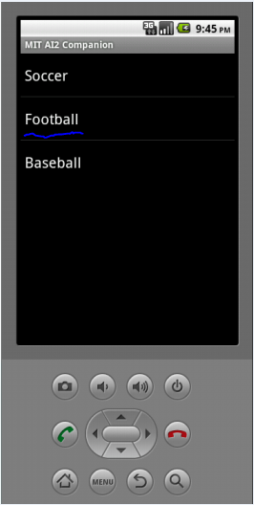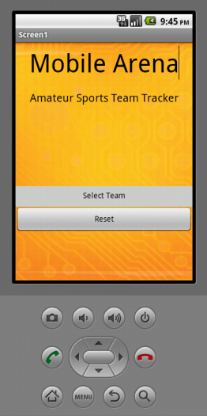

**Lo-Fi to Hi-Fi Changes:**

We built the Hi-Fi Prototype from the "Quick Look up" Lo-fi Prototype. The largest change was the removal of the initial setup page, replacing it with the sport/team selection page. We also fixed a design flaw by placing a button in the sports hub that directs users to select a different team. These added features give users more navigational tools and power to access the content they desire.

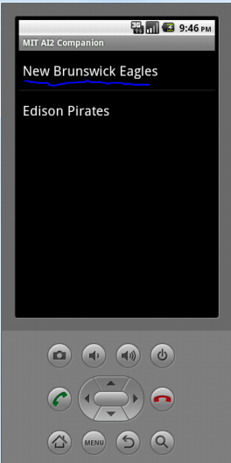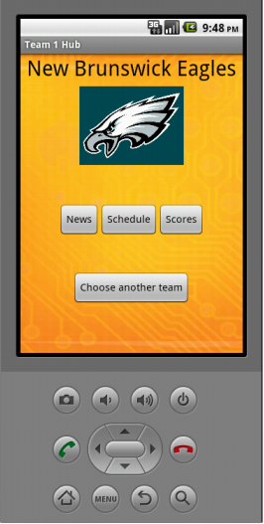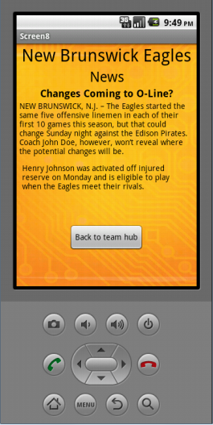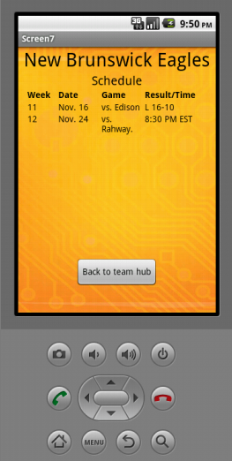

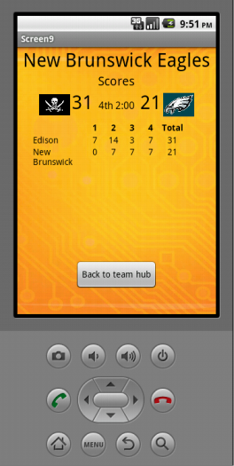

**Overview:**

This Hi-Fi prototype demonstrates our mobile interface and interactive flow of the Mobile Arena application.

In this scenario the user starts by going through the initial setup/main screen choosing a sport and team. For demonstration purposes, we have limited the selection to the New Brunswick Eagles football team in the demo.

After selecting the combination of a sport and team, the app loads up a team hub with three buttons:

* News - displays the newest article about the team
* Schedule - displays the upcoming games along with dates
* Scores - displays the latest scores

The user can also go back another team by returning to the main screen from any team hub page.

**Database Design**



Entities:

Player: playerID (PK int), Name (string), kitnum (int), isCaptain (bool)

Parent: parentID (PK, int), Name (string), age (int), phone (int)

Team: teamID (PK, int), coachID (FK, string), teamName (string), size (int)

Coach: coachID (PK, int), teamID (FK, string), coachName (string)

**User Interface:** The user interface for the application will be developed using XHTML The user interface developed by our team will be basic as we will also display a working prototype via App Inventor. The interface will be further enhanced by the technology manager and his team after the project is handed off to the client.

**Results**

**User Testing**

***Interview Questions:***

To gauge the opinions of our potential users, we devised a questionnaire that looked to find out what people thought about using their smartphone for sports applications. We asked various questions to get a better understanding of how our users use their cell phone.Our questions assumed a certain type of sports fan with a desire to get easier, or more, access to sport scores.

1. How do you currently get your favorite team's score (Select all that apply: Website, App, Television, Other)?
2. If you have a favorite place to get your team's scores, what is it?
3. What do you like about the app?
4. What do you dislike about the app?
5. On a scale of 1-10, how would you rate the app?
6. Are there any missing features you wish it had?
7. Would you like an app that automatically notifies you of your team's scores as they occur?
8. How would you rate that feature (of no use -> very useful)
9. How many teams do you follow?
10. How often do you check their scores?

***Interview Results:***

Each group member interviewed one person. The summary of results to each question are collated in the table below.

|  |  |
| --- | --- |
|  | **Summary** |
| Question 1 | Most people trust Google, ESPN, Goal, and Yahoo when it comes to retrieving their team's scores. |
| Question 2 | A majority feel ESPN is the most credible source for sports news. They have a website, application, and television channel |
| Question 3 | Positives: These applications are convenient with readily available news and their favorite teams are accessible |
| Question 4 | Negatives: No details besides scores, not enough highlights, cover sports the user aren't interested in |
| Question 5 | Ratings of these sources are consistently 7 or 8 out of 10 |
| Question 6 | Include more highlights and details about the games as they happen |
| Question 7 | A majority would appreciate receiving push notifications of their team's scores as they occur |
| Question 8 | Usefulness of this feature is rated average 4 out of 5 |
| Question 9 | The average number of teams being followed is between 4 to 6 |
| Question 10 | Some constantly check scores throughout the duration of the game (every 10 minutes) while others wait until after the game is over to check scores |

* The Internet was the most common source for scores, with most just using Google to search for scores. ESPN was the most common non-Google site mentioned. Television was also a common answer, though one of our interviewees told us he prefers to watch (American) football games with no knowledge of the score, and therefore actively avoids discovering the score.
* Google’s convenience was listed as the most common “favorite” place to get a score. One interviewee told us that the “Google Now” function on his Android phone already delivers the scores to him, updating in real time.
* Television was also listed as convenient, since these potential users were already watching the games/sport.
* One interviewee had a small complaint about irrelevant information (information about sports/sport teams he was not interested) popping up on his ESPN web visits.
* The ratings ranged from 7-8 (out of a maximum of 10) for the existing sources.
* The most common feature request was a desire to make it easy to get more details quickly.
* Several interviewees had no desire for our application (an application that automatically notified them of scoring updates as they happened).
* Those that did, rated the auto-updating feature as a 4 (out of a maximum of 5).
* Most follow 4-6 teams, but one interviewee only followed Professional Golf and the Redskins.
* How often interviewees checked scores varied greatly, from “every 5 to 10 minutes during games” to “never” (he preferred to watch the games with no fore-knowledge) to “once a month.”

There was a surprising lack of (expressed) desire for this application, although some said that if it allowed for an easy/quick way to get additional details, they would like that feature even more.

This likely means we will need to change our project to focus on the feature most requested, which is a way to quickly get to additional news about the teams.

**Summary and Conclusions**

Owning a smartphone means never having to wonder who is winning the game, how fantasy teams are doing or how many touchdown passes a favorite player threw while the user wasn’t available to watch the game. With ever-increasing competition in application and web development, sports applications are competing with their competitors to provide a different and valuable product to their customers. Mobile Arena is able to do that as its purpose is to be able to manage under 18 teams nationwide. The project team has collaborated and helped the client, with allowing Mobile Arena available to their customers, offering them the ability to keep up to date with their teams, manage their teams and view statistics for under 18 teams. This ability will allow customers to be able to keep track of their sports news and be overall satisfied.

Mobile Arena is unique and different from other sports applications because of its customization function as presented via the medium fidelity mockup. The feature can be implemented regionally nationwide with having diverse options to customize in managing under 18 teams. The mobile application and website is updated constantly with the availability to view the many rosters that will be registered with Mobile Arena. These functions will benefit any customer as there will be flexibility to customize Mobile Arena, manage teams and view statistics.

The creation of Mobile Arena and learning experience of developing this application was extremely valuable to the project team. The team had the opportunity to work with a client and was given until the end the semester to complete this project. This vision has become a reality as completing this project has become a success, with being able to obtain skills that will be beneficial in the future.