**Requirements**

The application will be programmed in-house to cut overall costs. The system will consist of the following parts:

Front-end - Users are able to track sports games; this is the user interface with full functionality.

Back-end - Employ a server to record statistics on sports games. Values will be added to the database after each game.

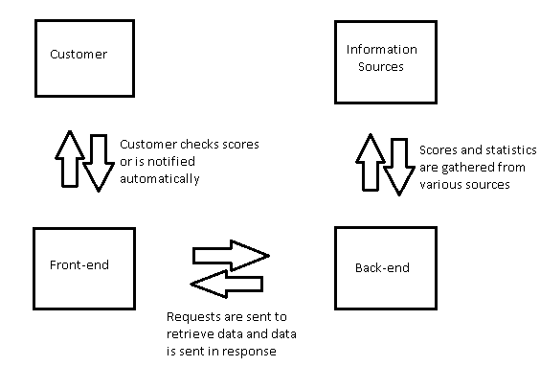

**Development Process**

Our development team is utilizing the agile development strategy as many activities are occurring simultaneously within the timeframe. We are heavily taking time to develop a mobile application, as well as a website for users. The application is mainly designed for families and coaches in which they track the teams of local children under approximately eighteen teams. In addition, this sports team tracker application is an easy and convenient way to keep informed of the score of the game and the user’s selected sports teams. The application can connect to social media and text messaging applications to share scores. The requirements below are emphasized on Phase 1 of the project. There will be constant changes as we progress with the project.

**System Overview**

Coaches, parents, and children alike can all use our sports tracker app to create game schedules, update the scores, and follow their favorite local teams. Coaches will have administrative ability to create the schedule and send them out to parents. Parents attending their kid’s games can manually update scores, while those stuck at home or at work are able to view their team's progress.

The project requires us to implement an application in which push notifications are sent to the user’s mobile for updated scores and breaking news. In addition, the website will display statistics based on the player’s gameplay and the overall team. There are no hardware or networking requirements for this project.

**Non Functional Requirements**

The quality goals for this sports tracker application will apply constraints and service requirements that will determine the quality of our system. The application must be able to provide accessibility, efficiency, effectiveness, fault tolerance, stability, and usability.

**System Architecture**

The project will application be displayed as a working prototype made through App Inventor. The programming for the application will be done by utilizing the Java language.

**Software**

Software requirements

· Language : Java, XHTML

· Database: MYSQL

· Web application framework: App inventor

· OS: IOS/Android

Software requirement for the development environment:

· IDE (Integrated Development Environment): Eclipse

**User Interface**

The user interface for the application will be developed using XHTML The user interface developed by our team will be basic as we will also display a working prototype via App Inventor. The interface will be further enhanced by the technology manager and his team after the project is handed off to the client.

**Documentation**

Code documentation will be generated constantly as developers will be asked to do so by the project manager, business analysts and other roles that play a part with communicating with the developers throughout the project. Databases will continue to be updated as well.