ITE4005 Data Science course

Assignment 1

2016026080 한다진

* **Experiment environments**

OS Windows 10

Language python3

Tools Jupyter notebook

Pure python script

* **Apriori algorithm**

“*sets*” is the name of list has the data about item_set_object. Item_set_object format is like this {‘*items’*:{1,2,3}, ‘*nums’*:5, ‘*idxs’*:[4,5,6,7,8]}. For this case, it means, the item_set {1,2,3} is appeared 5 times and is appeard in 4th, 5th, 6th, 7th, 8th transaction.

Every step, item_set_objects are newly added to *sets.* And start_point is the index of first item_set_objects among newly added item_set_objects to *sets*.

Get initial *sets* with function init_sets().

Set initial start_point and initial end_point to 0 and len(sets)

while start point is less than end_point(=len(sets)).

1. Get the item_set_object_A(obj_A) = sets[i] (start_point <= i <end_point)
2. Get the item_set_object_B(obj_B) = sets[j] (0 <= j < i)
3. 1. Check if obj_A[‘items’] and obj_B[‘items’] are mutually exclusive. if yes, go 3-2  
   2. Check times the item_set(=obj_A[‘items’]|obj_B[‘items’]) appeard in transactions. If times are bigger than minimum_support, go 3-3  
   3. Add the new item_set_object with item_set (obj_A[‘items’]|obj_B[‘items’]) and make new rules.
4. Execute with every (i,j) cases
5. Update start_point to end_point, and end_point to len(sets). and run one more while loop

* **Code explanation**
  + Import Libraries

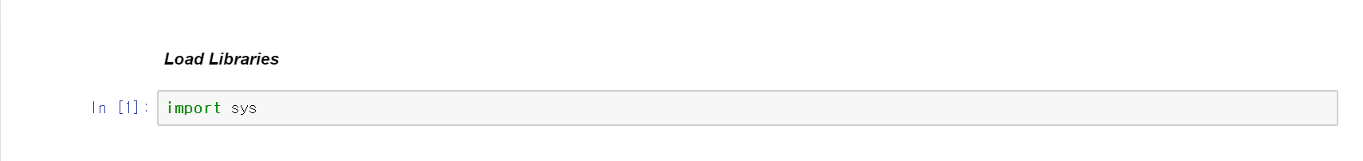

Import sys libraries to get the arguments

* + **Apriori Class**

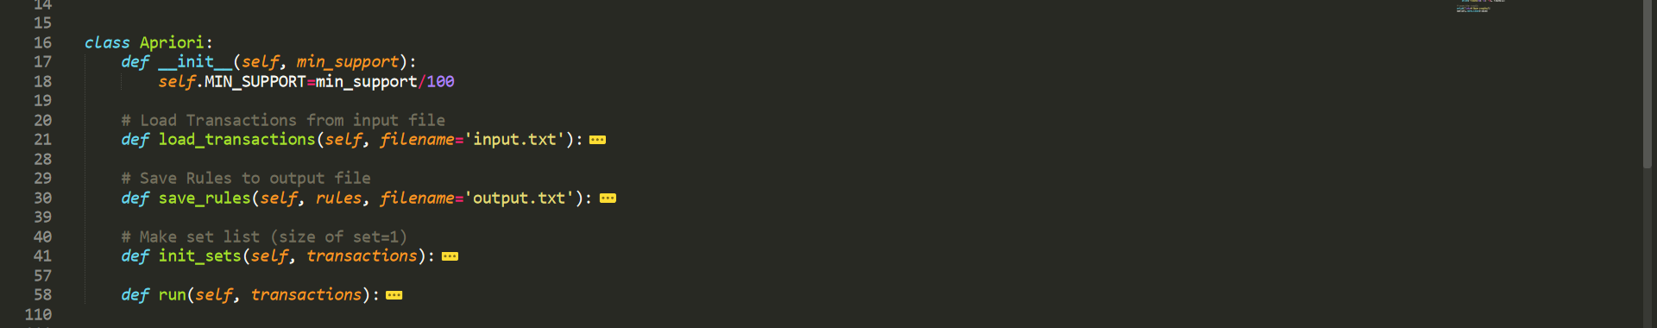

Make apriori class and use the internal function in apriori class. Detail of each function is below.

* + Load input file

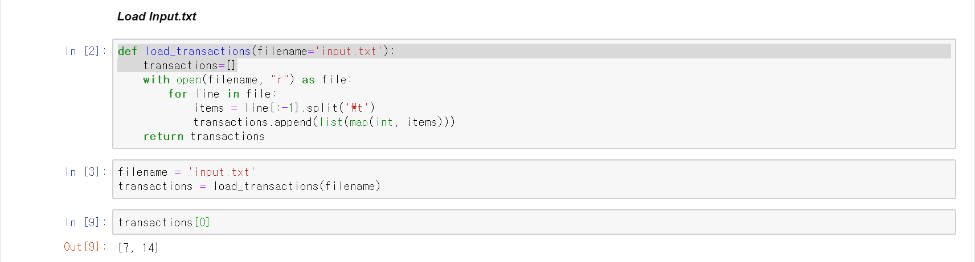

Load input file and store it to *transactions*.

Every items in each transactions are managed with int type.

* + Save rules to output.txt

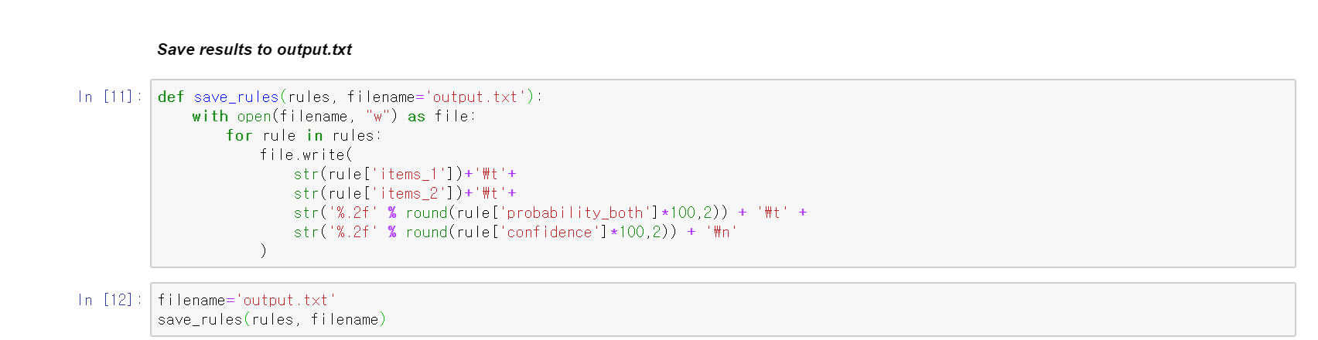

Save *rules* to output.txt.

* + Make initial sets with transaction file

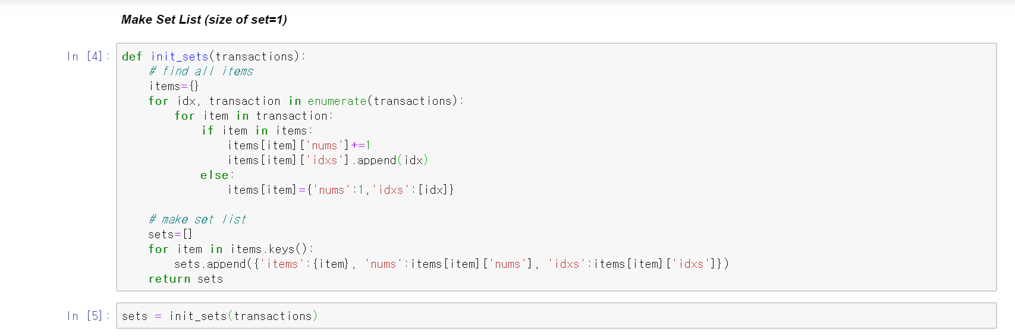

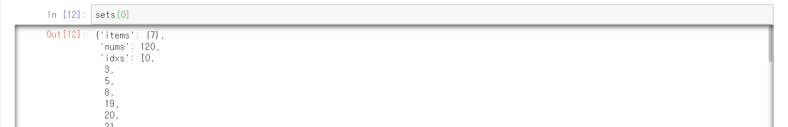

First, find every item in *transactions* and store it to *items*. *Items* is a dictionary. Its key is an item and its value is consist of ‘*nums’* and ‘*idxs’*. ‘*nums’* means the number of times an item has appeared. ‘*idxs’* is the list of indexs which current item is appeard in *transactions*.

Then make list of dictionary with data in *items*. Each dictionary is consist of ‘items’, ‘nums’ and ‘idxs’. ‘nums’ and ‘idxs’ are same with those of *items*. ‘items’ means the set of item.

* + Run apriori algorithm

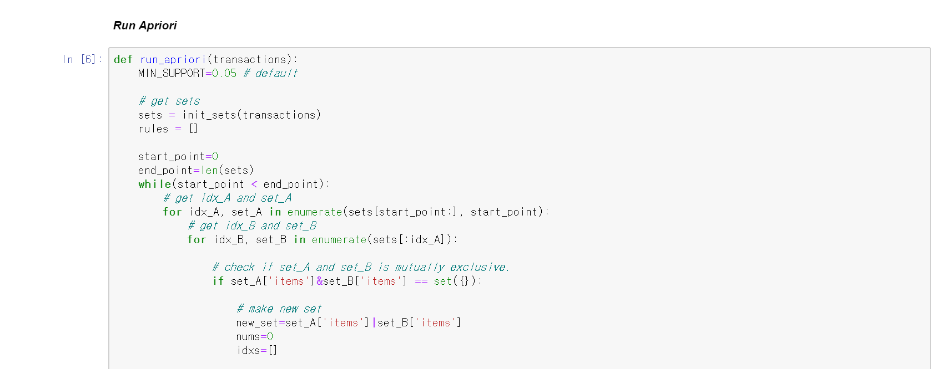

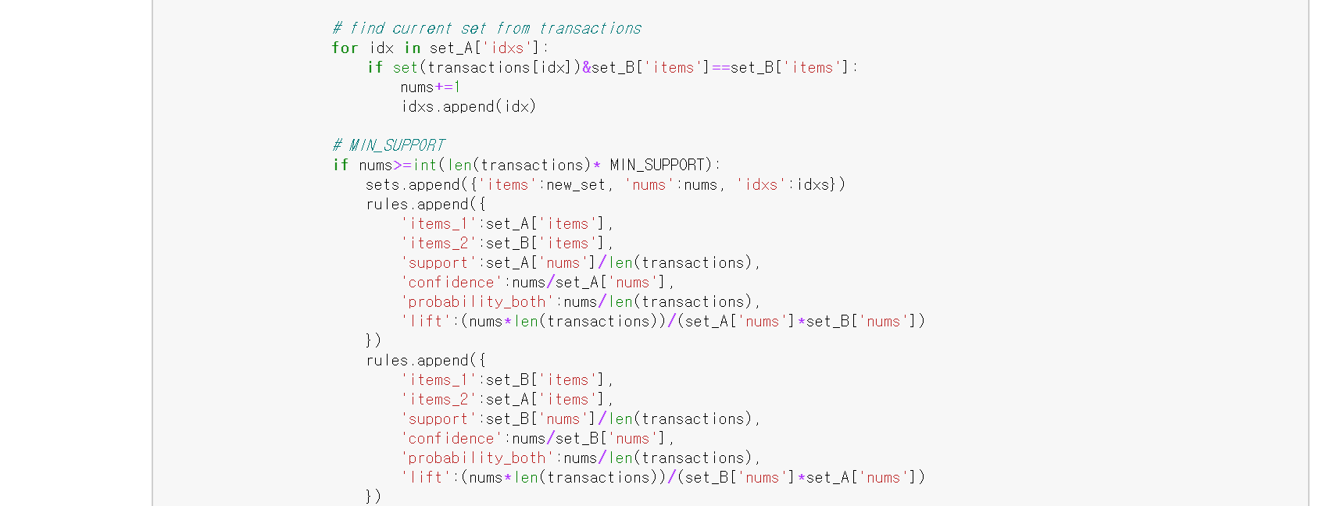





Details are explained in ***Apriori Algorithm***

‘**support’** means the probability of an transaction ‘items_1’ occurring.

‘**confidence’** means the probability of an transaction ‘items_2’ occurring where transaction ‘items_1’ occuered

**‘probability_both’** means the probability of an transaction ’items_1’&items_2’ occuring

* **Experiment**

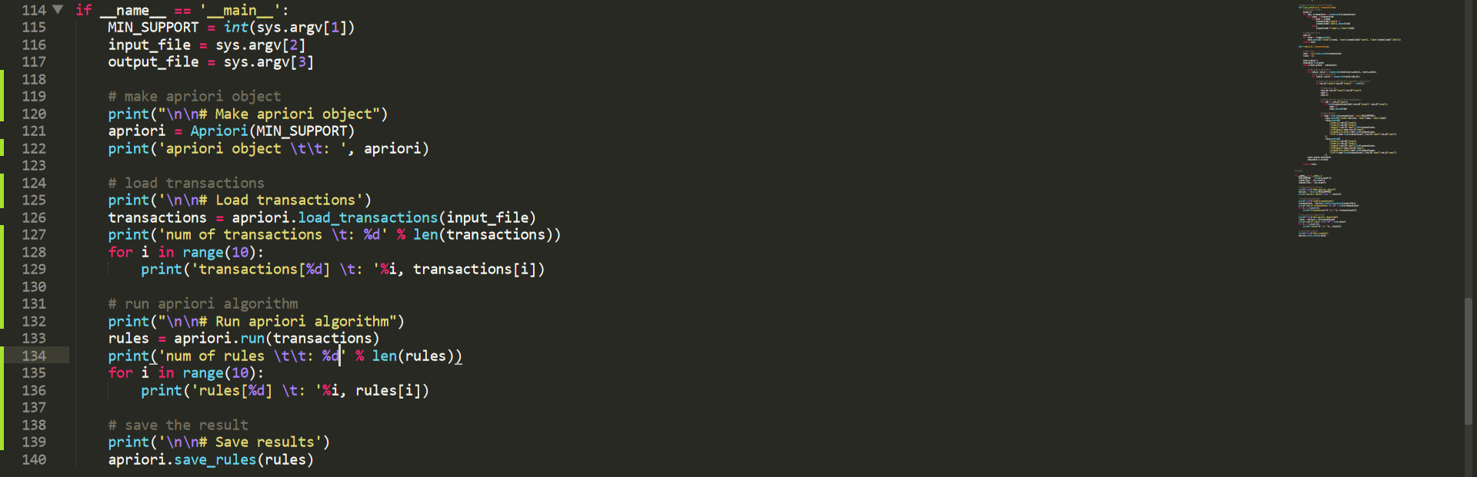

This is the python code in apriori.py to check the result in console screen.

Show up to 10th transaction and 10rules.

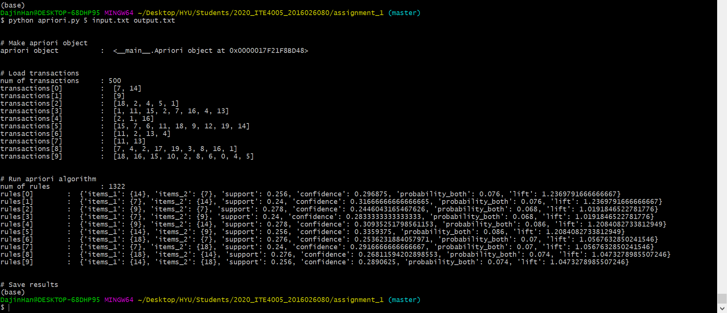

This is the result screen when excuting the command “python apriori.py 5 input.txt output.txt”