Introduction to the electricity theory with the moving potentials of the charges
in the classical frame (Zorb theory)
S.A. Tsikra , tsikraserg@gmail.com
Some reasons are to provide a new alternative theory of electrodynamics in attempt to exploit the classical frame of space and time, because the known Maxwell-Lorenz theory has some problems in classical frame, especially in the tasks of motion of the charged bodies, and it is fully available only in relativistic frame. The corporation with Weber’s theory is providing also.
1. Main hypotheses about moving scalar potential of charge and its force fields
Some main alternative hypotheses are presented:
- Any charged body q has their own field of scalar potential φ which moving with body as its shells and has a form of Coulomb potential if the motion is with constant velocity v in the rest frame (uniform inertial motion)*:
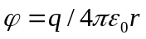. (1)
The distance r is the real instant distance from the point of field to charge in the case of inertial motion, but the form of field of scalar potential is deforms if the motion of charge q is accelerated (as rubber medium or shell of zorb, so I named it Zorb-theory), and the dependence φ from r is more complicate (in retarding manner, it need to additional research).
- If the charge is moving in the rest frame, it has the additional scalar potential ψ (kinetic or convective potential) as the kinetic energy of moving field:
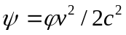; (2)
Thus entire scalar potential is:
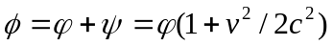. (3)
- Moving field of scalar potential φ is also the causal source of vector potential A as momentum of electricity movement :
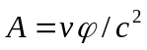. (4)
Therefore, the differential dependence is obtained with the rule of vector analysis:
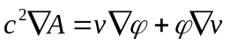. (5)
As follows from the full Lagrange derivative of the “liquid volume” of the unchanged moving potential field φ:
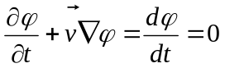; (6)
the first term in (5) look like the known Lorenz gauge if charge uniform moving, but consist only Coulomb potential φ:
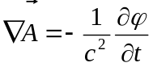; (7)
The other term may be useful in the case of accelerated movement.
- The field of scalar potential with the vector potential A are forming the electricity field E and the magnetic field B like in the ordinary electrodynamics theory [1], but in E presented kinetic potential ψ, which absent in A (4) and then in B:
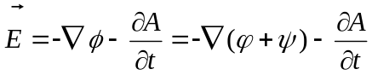; (8)
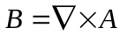. (9)
Note, that scalar potential field moving as real substance only, but the vector potential A and forces fields E and B do not moving, they changed. “Gauge freedom” unable in proposed theory, firstly because A consist only primary potential φ, not entire potential ϕ=φ+ψ. It is a shortcoming at the ordinary point of view, but it may be an advantage for the alternative theory.
The first Maxwell’s differential equation is traditional in proposed theory congratulating with (8) and (9):
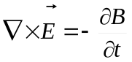. (10)
The other equation obtained from (9) is evident as consequences of the rule of vector analysis:
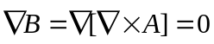. (11)
But the other two differential equations have problems, will considered after retarded potential consideration.

* Apply the international system of units SI.

2. The retarded potential of Lienard and Wiechert vs new Zorb potantial
E
gradφ
E
-dA/dt
P_{obs}
P_{pr}
b)
P_{ret}
P_{pr}
P_{obs}
a)
R_{pr}
R_{ret}
r_{LW}
Vτ
r
R
R_{obs}
O
P_{t}
Path R_{q}(t)
Fig.1
a) the retarded potential of Lienard and Wiechert ;
b) the field E obtained from retarded LW potential.

Let the charge q is traveling along path of any kind R_{q}(t) in the frame with point O at its bigining, as on fig.1 a).
The retarded point P_{ret} is found by Lienard and Wiechert for this charge congratulating with the retarded distant condition [2],[3]:
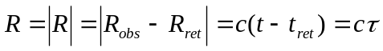; (13)
where 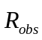is the vector from O to point with observer P_{obs} at the time of t,
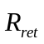 is the vector from O to retarded position of charge P_{ret} :
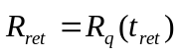.
Thus 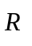is the vector from retarded position of charge P_{ret} to observer at P_{obs} , and r is retarded distance between both,
τ=t-t_{ret} is the interval of time in which any stress gone the retarded distance r with the speed of light c.
Then, this retarded distance r multiply on the term 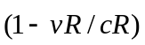 in the equation LW retarded potential of the moving charge:
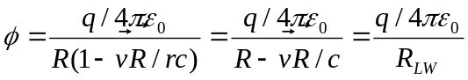; (14)
This mean, in a formalism of the vector geometry and mathematic, that a “projected” position P_{pr} calculated, in which the charge might been placed at the time t, if it prolonged the uniform inertial motion from the retarded position P_{ret} along vector v on the distance vR/c, then calculated the subtraction of the retarded distance r and the projection P_{pr} to retarded vector 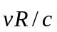. The subtraction result r_{LW} is the leg of triangle with its hypotenuse from P_{pr} to P_{obs} . Thus in result the fraction denominator r_{LW} in the LW retarded potential equation is not the retarded distance r, but not the real or “projected” distance P_{pr} also, although nearby of the last, and r_{LW} magnitude less then distance from P_{pr} to P_{obs} , excepts of the case when observer is on the line of charge’s speed v, consequently in this direction the LW potential is the same as Coulomb one, but in any other direction the LW potential is grater then Coulomb one at the same distance, us well known.
But, it is not any clear physical sense in this transformations, they seemed curiously in original works of Lienard and Wiechert. They explained the additional term as the retarded volume transformation of the undoted charge with distributed density ρ, and they has not a doubt about magnitude ρ which is not changed, it the same as it was for unmoving charge with his own volume, thus integration of ρ for transformed retarded volume lad to violate of conversation of charge. Feynman repeated theirs in his lectures [4]. Other explanation was done later by Jackson [5] exploited Dirak’s delta function for doted charge, but it seemed speculative in physical sense also. I have not objections to relativistic explanation of LW potentials [1], apart from it is reveries in historical time and not apply in classical frame.
Let return to fig.1 after reflections above. Surfaces of equal potential are ellipsoidal with the center in “projected” position P_{pr} , as in fig.1 b). Gradient of scalar potential’s field ϕ(r) is normal (transverse) to this ellipsoidal surface and do not pointed in the center, except of its small axis along direct of movement v and its transverse section . But the second part 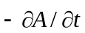 in equation (8) make the entire force E pointing to the “projected” position of charge P_{pr} , thus the field E appear as central force field, at least in the case of uniform motion of the charge. So, when the flux of intensity E integrated cross the spherical shell around of “projected” position of charge P_{pr} (it’s real position in uniform motion), it counted the all magnitude of E because it is the central force, see fig.2.

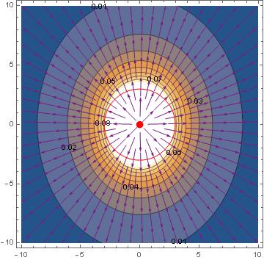
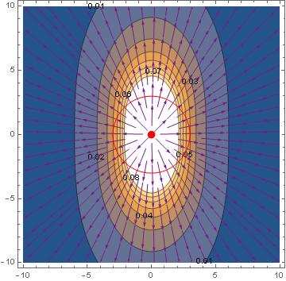
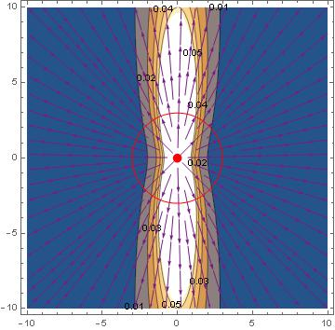
Fig.2
Fields E graphics for the horizontal moving charge with speed 0.5, 0.8 and 0.98 of c
calculated in Maxwell’s theory with LW potentials.

The equation for electric field E of moving charge (with speed v and accelerating a) is known [1]:
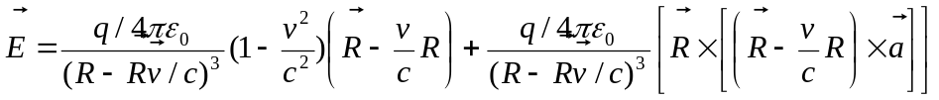; (15)
or in other equivalence form:
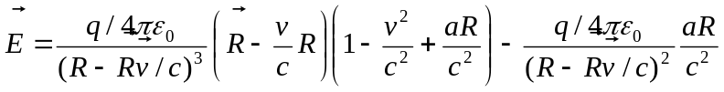. (16)
Note that all parameters are in retarded position of charge on the retarded distance r, not a distance to the center of picture with charge at this “projected” position, from were the radial force lines E beginning.
At the contrary, the force E is not the central force from moving charge in proposed theory, see fig.3. Surfaces of equal potential ϕ are spherical, and line of grad ϕ are radial, central. The term rotate the line of grad ϕ and the entire field E is not central force field. Thus, when flux E integrated on spherical surfaces around the charge, calculated only normal (radial) part of E .
Fig.3. Scalar potential and force E from inertial charge in Zorb-theory
R_{qp}
P
-grad φ
ϕ
φ
q
E
-dA/dt
v
P_{pr}
In fig.4 fields E graphics are for the charge moving with speed 0.5, 0.8 and 0.98 of light speed c calculated in proposed theory by the formula:
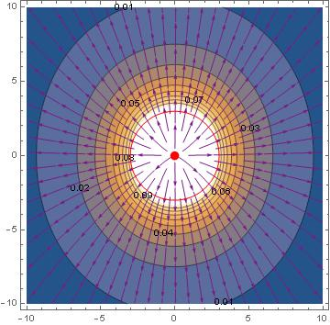
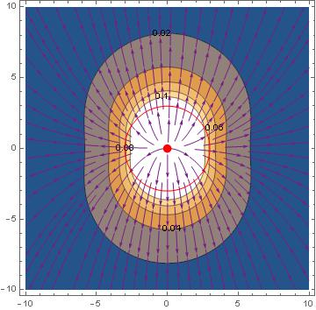
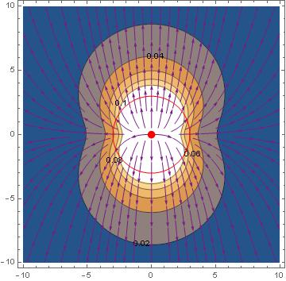
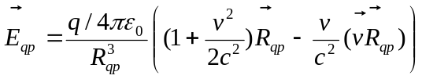. (17)
Fig 4.
Fields E graphics for the moving charge with speed 0.5, 0.8 and 0.98 of c, calculated in Zorb-theory
Vector E is not radial from charge point. Distribution of magnitude E differ from Maxwell’s theory also, especially at the speed more then 0.7 c .

Forces fields E and B of charge moving very quickly (near the light speed) look like thing flat “pancake” transverse movement in Maxwell’s theory. Contrary, in Zorb theory forces fields E and B has no big changes in very quickly motion of charge. It may be has a good sense in some tasks with high energy particles [6].
Integral of flux E thru spherical surface around the charge (red circle) was calculated. It is by 4% more then quantity of charge at the speed 0.5 c, 10% at 0.8 c, and 16% at the 0.98 c. More over, the integral of E flux is not zero if control surface is beyond the charge but along its movement. Therefore the Gauss theorem is right in Zorb theory for primary potential φ only, but not for entire potential ϕ=φ+ψ :
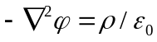. (18)
This divergent problem considered later in part 5.

3. The retarded electric force field E in Zorb-theory

The grate problem in new theory is to take into account the acceleration of charge, because point P_{pr} is the real position of charge only in it uniform motion along some time t_{v} for all observers inside the “causal sphere” R= t_{v}c. In the case of accelerated motion the potential must be counted from retarded position, where the acceleration stress was appeared from charge. But in contrary to Maxwell’s theory with LW potentials, stress spread from charge in the “medium” of scalar potential field moving with charge and deformed by acceleration. This task more difficult then stresses in air infront the piston moving in the tube or infront bullet in a gun barrel. I solve this problem by simplification. Fortunately, the Lienard and Wiechert retarding method is flexible to varies of light speed. Let the charge start movement with speed v from observer O in time t=0. At the time t in observer’s clock the retarded time is t_{r}= t/(1+v/c) and retarded distance r_{r}=vt_{r}=vt/(1+v/c)<vt=r, if counted for well-known c. “Projected” distance for LW potential is r_{r}(1+v/c)=vt=r, and LW potential is q/r.
In Zorb-theory the retarded time must been t_{z}= t/[1+v/(c-v)]=t(1-v/c)<t_{r} , retarded distance r_{z}=vt_{z}=vt(1-v/c)<r_{r} , “projected” distance r_{z}+v r_{z}/(c-v)=vt=r, and Zorb-potential is q/r, if charge move uniformly, same as the LW potential too. But, if charge accelerated in time t_{z} , the LW potential should become another in O in time t, differ from Zorb potential at the same time. This difference has magnitude proportional to (v/c)².
So, I propose the simplify algorithm of calculation of force field E by eq.(8):
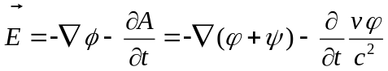.
Algorithm consists of two parts, counting E_{v} without acceleration and E_{a} with acceleration respectively.
The first part is E_{v} without acceleration, depend from entire potential ϕ with constant speed v (by eq. (2),(3)):
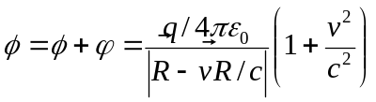; (19)
were R - is retarded distance fined as usually by condition (13);
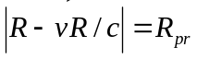 - is “projected” distance, which is the same for all observers in the one fixed time t;
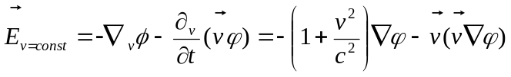; (20)
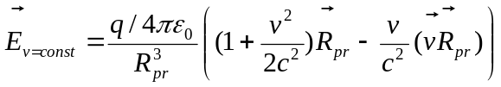. (21)
The second part of algorithm is for acceleration, which appears at the retarded distance R. The differential of R for acceleration is:
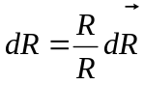, were 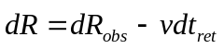; (22)
were t_{ret} is the retarded time by Lienard and Wiechert condition (13) in simplified Zorb-theory with constant c, thus
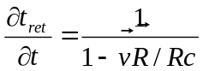 and 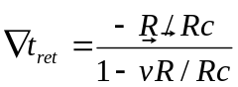 in this application too [1].
Differential of potential ϕ for acceleration part is:
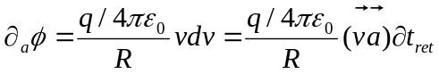. (23)
The gradient of entire potential ϕ for acceleration part depends of differential (1+v²/2c²) :
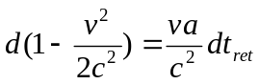;
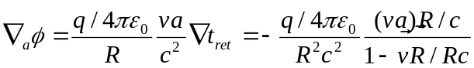. (24)
Times derivative of A for accelerated part is:
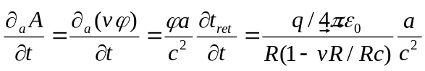; (25)
Therefore the acceleration part of electric field E is:
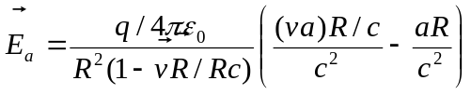. (26)

Entire force field E is by eq. (21) and (26):
. (27)
In a quality sense the first unaccelerated part E_{v} consist of term directed along projected R_{pr} and speed directions and decrease at 1/r² rate , the second accelerating part E_{a} consist of term directed along retarded R and acceleration directions and decrease at 1/r rate (radiation part).
Graphics of the charge are in fig.5 and fig.6 started from point 0 with accelerating 0.2c/s to speed 0.5, 0.8 and 0.98 of c, calculated in Maxwell’s theory and in simplification Zorb theory for compare.
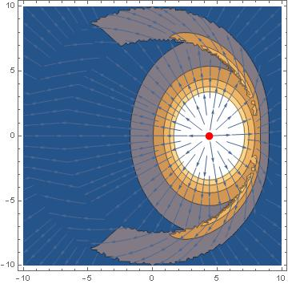
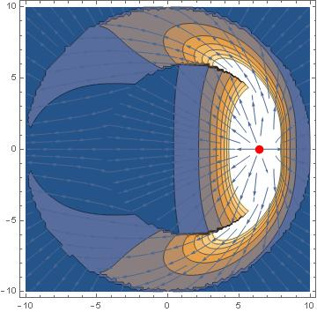
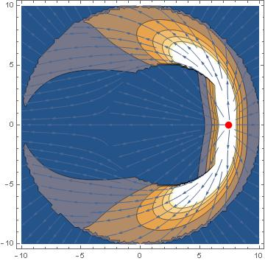
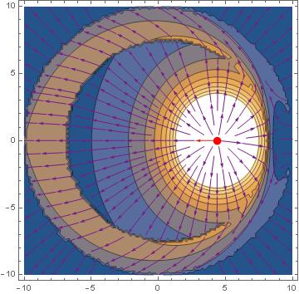
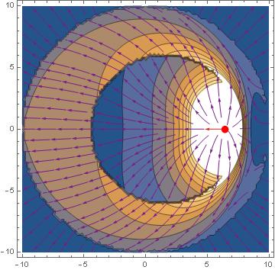
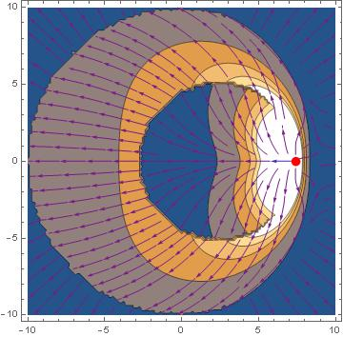
Note the reverse direction of E infront of charge in zone of its acceleration. Its explained by negative term 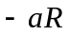 large then positive term 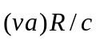in eq.(27) when the speed v is low after starting (or v transverse to a in any other case). But there is no such reverse in Maxwell’s theory. Thus it is may be control point to compare this theories.
Fig.5. The charge started from point 0 with accelerating 0.2c/s to speed 0.5, 0.8 and 0.98 of c.
Calculated in Maxwell and LW theory.
Fig.6. The charge started from point 0 with accelerating 0.2c/s to speed 0.5, 0.8 and 0.98 of c.
Calculated in simplification Zorb theory.

4. The magnetic field B and displacement current dE/dt .

Now let compare the magnetic field B in Maxwell’s theory fig.7 and in Zorb-theory fig.8. The equation available:
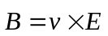. (28)
The form of the magnetic field of the charge move uniformly is independent of speed in Zorb-theory, only it magnitude changed, contrary to Maxwell’s theory, where changes are well seen depended from speed, its became as “pancake” transverse to motion with large speed.

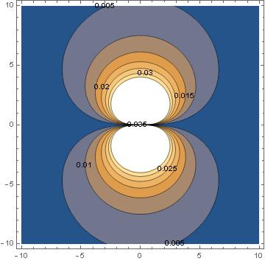
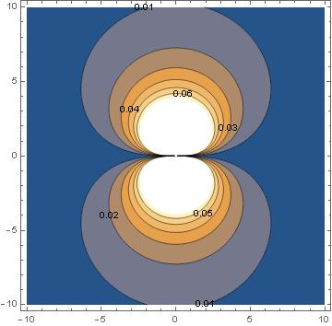
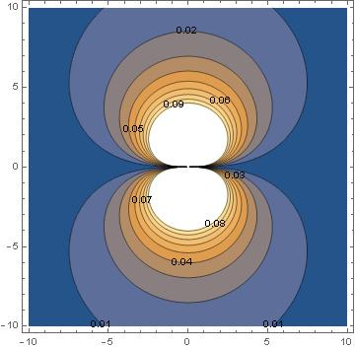
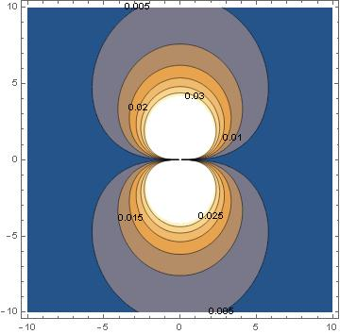
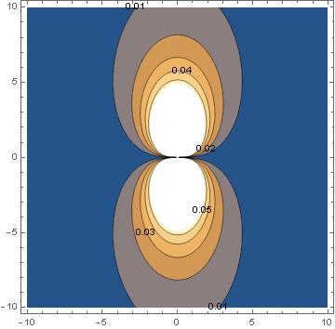
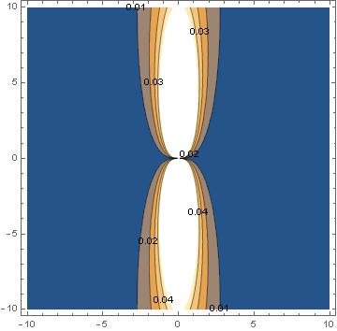
Fig.8
Cross section of magnetic field B of charge moving with the speed 0.5, 0.8 and 0.95 of c calculated in Zorb-theory.

Fig.7
Cross section of magnetic field B of charge moving with the speed 0.5, 0.8 and 0.95 of c calculated in Maxwell’s theory.

The next equation is obtained from determinations B (9) and vector potential A (4):
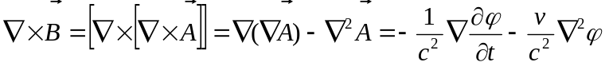. (29)
Note that the last consist primary scalar potential φ only, not an entire potential ϕ=φ+ψ. Therefore the Gauss theorem is right in differential form in Zorb theory as in Maxwell’s too, and the last term in (29) equal to density of current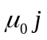, or zero if there are no charges and current in this place. The next step is divergent operation of rotB with the rule available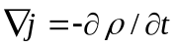:
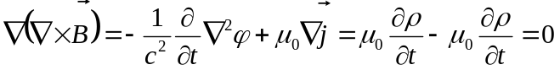. (30)
From the other side the equation of current or magnetic induction B is known as second Maxwell’s equation now:
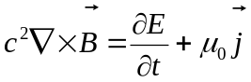; (31)
But divergence of right part in (29) is not zero if divergence of E not zero in space free of charge, as in Zorb theory.
Hence in Zorb theory the equations (29) and (30) are available, bat the equation (31) do not available, because E consist entire potential ϕ=φ+ψ, not primary potential φ only, as the vector potential A and then B=rot A. Note that it is has not influence on the fist Maxwell’s equation (10) presents in Zorb theory :
,
because rotor of any gradient part of E is zero and there is impotent part –dA/dt only with primary potential φ there.
From the other side, the equation (29) is not popular in Maxwell’s theory in general because of ”gauge freedom” of potentials, which is not present in Zorb theory.
It is shown at bottom in part 7 that magnetic field B has no the same importance in Zorb theory as in now known Maxwell’s, although Zorb theory has many similarities to ideas written by Maxwell in his “Treaty”.

- The divergence problem solve.

Thus the displacement current dE/dt has not zero divergence in Zorb-theory, the equation (31) not applicable , at least in its known form. I change it to dD/dt, were electric displacement D depended of primary potential φ only, thus it is true two equations:
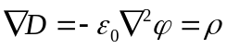; (32)
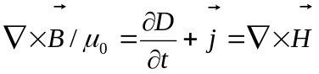. (33)
The equation (32) represents the Gauss theorem in Zorb theory and thus the conservation of charge law involve.
The equation (33) is in Zorb theory as analog of equation (31) in Maxwell’s, in addition to equation (29) in both.
The first Maxwell’s equation (10) with E generally equivalence to equation with D:
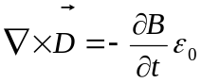; (34)
and applicable in Zorb theory in this form.
So, equations (32), (33), (34) represent the system which is analog to system in Maxwell’s theory. Remarkable that Maxwell wrote in “Treaty” these equations with displacement D firstly too [7]. Maxwell did not has mentioned the equation (11) 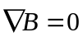 because it is evident consequence of equation (9) . But Maxwell assumes condition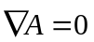instead. More over, the additional equation is in his theory :
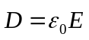. (35)
It is mean that E and D are mutual linearly depended in medium with electric permittivity ε, and in vacuum D= ε₀ E.
Therefore, it is easy to change D to E, and Maxwell did it. Contrary, the condition (7) is stated in Zorb theory for A:
;
the dependence E and D is more difficult with term (1+v²/2c²) , and equation (35) is not applicable generally.
At the end of this problem consideration, write the general equation for D available:
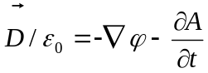. (36)
It differ from equation (8) for E by absence of kinetic potential ψ (2), thus it is not the equation of electric force as (8).
Note, that Maxwell has mentioned the kinetic potential ψ in “Treaty”, part VIII p.600, 601, but neglected it because its influence disappeared if the current circuit closed, as he thought. However it must be involve if the motion of some charged particles consider.
Three questions are stay open, must the conservation of charge law be involved in its strong meaning as Gauss theorem for electric field E ore for displacement D namely, may the Gauss theorem be extended to field E with kinetic divergence beside of moving charges , and therefore mast the equation be carried out undoubtedly in vacuum ?

- Main peculiarities of Zorb theory .

Unmoving charges interacts by Coulomb force between themselves in Zorb theory, as in Maxwell’s. The Ampere force is ordinary between closed current circuits in Zorb theory too, as a force act to current in the magnetic field of other current . But a small electric force appears from current circuit proportional to v²/c² magnitude of moving charges speed there. This force negligible for currents in ordinary conductors with Ohm resistance because low speed of charges there. But this force may be detected in the superconductive coil. This kind of electrostatic induction from superconductive coil was find in experiments of Edvards and Lemon [8], [9], repeated by Shishkin [10] and Mende [11]. This may be a reason of LHC accident in 2008 also, when the superconductive coil was damaged.
The Faraday’s electromagnet induction is obtained in Zorb theory too, according to equation (10):
.
At the other way, beside of known theory formalism, in Zorb theory electromotive force of induction appear as a direct action of changed moving potential field momentum A=vφ/c², may existed even where field B absent (rotA=0). For example, the magnetic field B concentrated inside the transformer core and not exist beside it (in ideal case at least). But the electromotive force inducted in second coil by the current in primary coil, even if they placed independent one from other, despite of field B absent there, concentrated inside the core. Thus B=rotA=0 continuously in the second coil region, hence rotE=-dB/dt =0 also in this volume, but E=-dA/dt not zero there. This is proof the direct action of moving potential field momentum A even without field B necessary. This has place in known Aharonov and Bom quantum effect also.

Known electromagnetic waves (radiation) are in Zorb theory too, although they counting by the known Lienard retarding at this work, see the last term in eq. (27). This is acceptable in far waves zone when the source of waves is unmoving in the observers frame. More proper retarding waves in the moving and deformated field of scalar potential will be investigate in the next works. But even in this work is a reason to admit that known transverse EM waves with energy flux expressed by Pointing vector P=[ExB] may bin expressed as transverse waves of changing scalar potential field momentum –dA/dt=aφ/c² . Retarded acceleration of source charges a has the constant magnitude at the distant, potential φ reduced as 1/r, thus the waves has magnitude reduced as 1/r also. In this way the EM waves explained as the transverse “elastic” waves of the scalar potential field medium, which rotor not a zero and thus made a field B. Even more exotic explanation of radiated waves may be done as longitudinal waves of kinetic potential ψ=φv²/2c², as the waves of energy flux in the scalar potential field medium. But it is important that waves of changing scalar potential field momentum –dA/dt=aφ/c² are longitudinal also in direction of movement and acceleration of source charges, and compensate waves of kinetic potential ψ in this direct. Therefore the potential waves are effective only in transverse direction of acceleration movement of source charges, as ordinary.

Other peculiarities of Zorb theory are seen in cases of moving charged particles interactions, as in the Trouton and Noble experiment. It is known problem in this experiment explored, that if two charges rigid connected (two charges on the rod ends, or charges in condenser) are in motion, a force torque proportional to (v/c)²Sin2α must appear, α is the angle between the velocity and the rod or the normal of the condenser plate, as the charge moving in the magnetic field of its neighbor. But it is not detected. The SRT explain this fact as "hidden" forces torque action from the stick or condenser body (by tensor of energy and momentum). The Zorb theory explain this fact, at the one way, by eccentric electric forces E, see equations (17) and (27) above, term
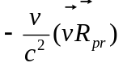.
From the other way, the fields of scalar potential move with charges according Zorb theory, therefore one charge is no moving relative to other and there are no additional forces in this system apart of central Coulomb forces, thus torque is absent. In this way Zorb theory is similar to Weber theory of direct action, although differ at the better way by accounting of retarding and eccentric electric forces achieved by vector potential A, thus EM transverse waves radiation are obtained in proper direction. Therefore it is interesting to compare Webers and Zorb theories more completely.

7. Compare Zorb theory with W. Weber’s.

The potential assumed between two charges e₁ and e₂ in Weber theory [7], [12], [13]:
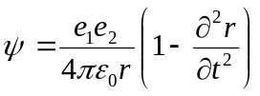; (37)
were 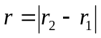 is the instant distance between two charges, thus the force is obtained :
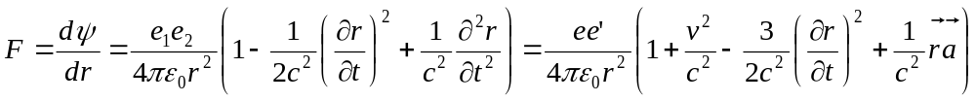; (38)
were 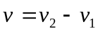is the relative speed; thus 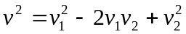 ;
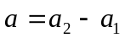is the relative acceleration.
Note that 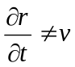 but 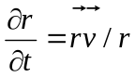;
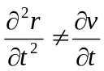 but 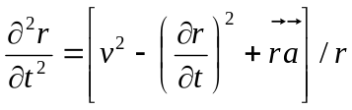.
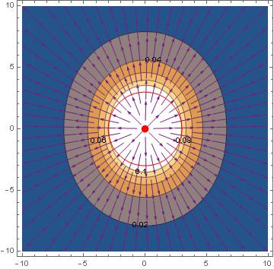
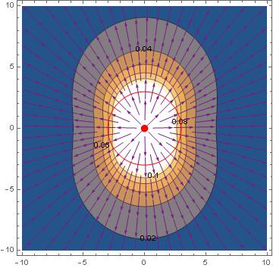
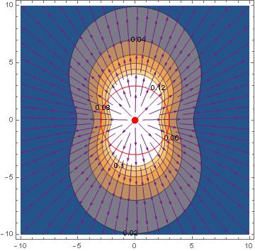
Assume that e₂ is stationary probe charge in any point (x,y) for easily comparison, thus Eq.(38) is the equation of “field” E of the moving charge e₁ in this case. On fig.9 are graphics of Weber’s “field” of charge moving uniformly with speed 0.5, 0.8 and 0.98 of light speed c. We see that magnitude of “field” is the same us field in Zorb theory on fig.4 at the same speed. But directions of streamlines are differ in both cases, because Weber’s force is centric, as the Maxwell’s. Therefore this divergence violate of Gauss theorem (conservation of charge law) more significant in Weber’s then in Zorb theory , it is 12% at the speed 0.5 c, 32% at 0.8 c, and 50% at 0.98 c (compare with 4% at 0.5 c, 10% at 0.8 c, and 16% at the 0.98 c in Zorb theory). From the other side, the divergence of the Weber’s “field” E is zero in volume beside charges if it is in uniformly motion , contrary in Zorb theory it is not zero, force field E of moving scalar potential seems as “selfcharged”.
Fig.9. Fields E graphics for the moving charge with speed 0.5, 0.8 and 0.98 of c, calculated in Weber’s theory

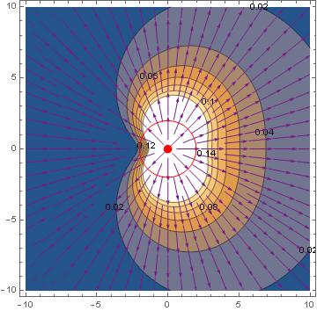
If the charge accelerated, the Weber’s force field is not symmetric, the force increase backward to acceleration, see fig.10 (note that term 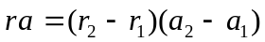in Eq.(38)), and divergence beside of charge not a zero (positive forward and negative backward) . Thus the Weber’s theory explains the Faradays induction thanks to this asymmetric property only, without retarding (but by violate conservation of charge law in it Gauss theorem form). Note the region backward of charge were force streamline direct inverse (contrary to brake acceleration). The similar region of inverse force is in Zorb theory in accelerated case (fig.6). EM waves radiation are not obtained generally without retarding, and this is main flaw the Weber’s origin theory in his idea of instant action on distance at least.
Fig.10. Field E of charge with brake accelerating 0.2 c/s from speed 0.98 c calculated in Weber’s theory.
Riemann attempted to involve retarding in the potential theory by propose of wave equation:
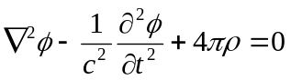. (39)
This equation well known with its analog to vector potential A in modern Maxwell’s theory and they both allow to involve processes with acceleration. But a problem to compose the acceleration of charge with its steady uniform motion.
Some authors [14] have attempts to change moving charge singularity in the Weber’s theory to distributed density of charge and current in volume, and then to involve retardation at the same way as Lienard and Wiechert in Maxwell’s. It is objection at this way the same as written above: the retarded distance R dos not achieve valid results, and proper modified value 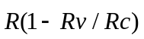 has no clear physical sense in this theories, apart of mathematic abstraction.
Nevertheless, let continue to compare Zorb theory with Weber’s (and Maxwell’s) in example of two charges the same sign move uniformly transverse one to other, fig 11. Feynman illustrate by this example namely the violation of third Newton’s law in Maxwell’s theory ([4], part 26, § 2) because the electric field E₂ only act on the first charge from the second (B₂=0 there), but the second charge move in magnetic field of the first charge, thus the addition Lorenz force F_{L}=V₂ x B₁ act on it. Therefore the uncompensated forces F₁₂ and F₂₁ and uncompensated angular momentum of forces appear in this case, fig.11 a). In Weber’s theory forces W₂₁ and W₂₁ are compensated between the charges, and uncompensated angular momentum of forces not appears generally because forces are central, fig 11.b).
In Zorb theory this charges act one to other by potentials forces Q₁₂ and Q₂₁ firstly (gradients of the spherical potential fields ϕ=φ+ψ (3)) , and by changing relative momentum of electricity movement –dA₁₂/dt and –dA₂₁/dt secondary . It is important that relative momentum of electricity movement A₁₂ and A₂₁ are not same as A₁ = v₁φ₁ and A₂ = v₂φ₂ (that momentum in coordinates frame choused take place), but relative one charge to other mutually:
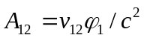; 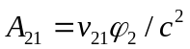. (40)
As charges move uniformly, fields of scalar potentials are spherical “shells” moving with charges (dashed curves in fig.11 c)), and the time derivatives of A is gradient φ in direction of relative speed 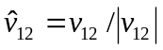:
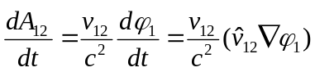; and reversely: 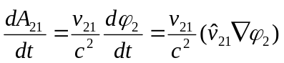. (41)
V₂₁
v₂₁
V₂
V₁
q₂
q₁
W₂₁
v₁₂
V₁₂
W₁₂
R
b) Weber
F_{L}
a) Maxwell
V₂
V₁
q₂
q₁
F₂₁
F₁₂
R
Q₁₂
Q₂₁
V₂₁
-dA₁₂/dt
V₂
V₁
q₂
q₁
F₂₁
-dA₂₁/dt
F₁₂
R
V₁₂
Q₁₂
Q₂₁
c) Zorb
Fig.11. Forces between two charges moving transverse
Therefore forces F₁₂ and F₂₁ are equal and contrary one to other, but they not gone on one line, they gone two parallel lines, create angular momentum of forces. This angular momentum of forces is similar to Maxwell’s theory, but forces end momentum are compensated in Zorb theory, contrary to Maxwell’s. Such angular momentum is absent in Weber’s theory, and it investigators approve that as its advantage. Hence it is a question, is this angular momentum the drawback of theories or advantage really ? As I know, the angular momentum of electricity confirmed by experiments, in particular by experiment of G.M. Graham, D.G. Lahoz [16].
There is no involve the action of magnetic field B in this example in Zorb theory. But this is not mean that magnetic field B not involve generally. I think that must be combined involve of “microforce” –dA_{ij}/dt between separate particles as was above, and “macroforce” [vxB] of movement in the magnetic field B from closed current circuits and permanent magnets as macrosources. Note that Maxwell assumed the same combined equation in his “Treaty” for “electromotive force” in §599:
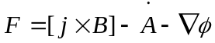; were 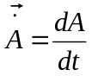.

8. The Gravity.

If the answer to questions about kinetic divergence above will be decided at favor of effective charge grows of half quadric velocity (1+v²/2c²) it may assume the next considerations. Light negative charged particles move faster then heavy slow positive, thus neutral bodies (with equal quantity of positive and negative charges) must interact mutually with forces below:
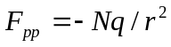 is the repulsion between positive charges if they unmoving ;
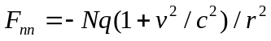 is the repulsion between negative charges ;
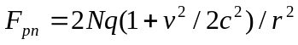 is the attraction negative charges to positive ;
v² is the average quadric velocity of negative charge; thus generally:
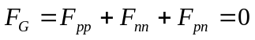.
If the movement of positive charged particles to involve (as thermal movement) thus the first force grows:
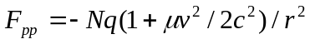; 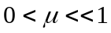;
and general balance become negative. But if the negative charged particles participate in common motion (synchronization at least at any small rate) the repulsion between negative charges must to reduce:
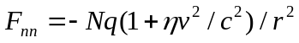; 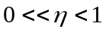;
and general force may be positive to attraction if η+μ<1:
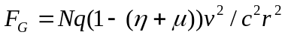.
The property to common motion of negative charged particles (synchronization) may be provided by cosmic anisotropy microwave background for instance. But this synchronization violate at grate distance and attraction reverse to repulsion.
9. Conclusion

Some questions were considered in this work vary important for alternative theories:
- about meaning electromagnet field as number of primary fields of scalar potential of charged particles;
- about wide meaning of charge conservation law and Gauss theorem;
- about changes of known Maxwell’s equations and the theory generally;
- about wide meaning of conservation momentum and angular momentum.
The question not considered properly is about new (or very old ?) meaning of electricity momentum as and therefore change meaning of energy flux as Pointing vector only.
All this questions deal with any alternative theory, as Weber’s and others, not with proposed Zorb theory only.
As my mind, the Zorb theory most similar to theory of Carl Neumann [7], [15] with potentials “shells” moving linked with its source (charges carried its own potential fields). It’s just easy calculate field and force when charge move uniformly, it appears as absence of retarding. The acceleration must deform the initial spherical field of scalar potential at retarding manner evidently, but it is not known as namely and how to calculate the movement of such field properly, spatially with varieties of propagation speed c. Unfortunately, there are not any known important investigations of this idea at last 150 years. My attempt is not well enough here also, but may be other investigators make it better in future.

References

1. L.D. Landau, E.M. Lifshits, The Field Theory. Moscow (1973).
2. Liénard, A. (1898). "Champ électrique et magnétique produit par une charge concentrée en un point et animée d'un mouvement quelconque". L'Éclairage Électrique. 16 (27, 28, 29): 5–14, 53–59, 106–112.
3. Wiechert, E. (1901). "Elektrodynamische Elementargesetze". Annalen der Physik. 309 (4): 667–689.
4. R. Feynman, R. Leighton, and M. Sands, The Feynman lectures on physics, Volume 6.
5. J. D. Jackson, Classical electrodynamics (John Wiley & Sons, Minneola, New York, 1999)
6. E. Stefanovich. Propagation speed of Coulomb force. What do experiments say? https://www.researchgate.net/publication/355442704
7. J C Maxwell, A treatise on electricity and magnetism (Dover, New York, 1954).
8. W.F. Edwards, C.S. Kenyon, D.K. Lemon, Continuing investigation into possible electric arising from steady conduction current, Phys. Rev. D 14, 922 (1976)
9. D.K. Lemon, W.F. Edwards and C.S. Kenyon, Electric potentials associated with steady conduction currents in superconducting coils, Physics Letters A 162 (1992) 105—114
10. G.G. Shishkin, A.G. Shishkin, A.G. Smirnov, A.V. Dudarev, A.V. Barkov, P.P. Zagnetov and Yu. M. Rybin. Investigation of possible electric potential arising from a constant current through a superconductor coil. J. Phys. D: Appl. Phys. 35 (2002) 497–502.
11. Mende F. F. On refinement of certain laws of classical electrodynamics. arXiv, physics/0402084.
12. A.K.T. Assis, Weber’s Electrodynamics; Kluwer Academic Publishers: Dordrecht, The Netherlands, 1994
13. A.K.T. Assis and H. T. Silva, Comparison between Weber’s electrodynamics and classical electrodynamics,
Pramana 55, 393 (2000).
14. J.P. Wesley , Weber Electrodynamics, Part I, Plenum Publishing Corporation, 1990.
15. A. O’Rahilly, Electromagnetic theory — A critical examination of fundamentals (Dover, New York, 1965).
16. G.M. Graham, D.G. Lahoz. Observation of Static Electromagnetic Angular Momentum in Vacuo. - Nature, v. 285 (1980), p. 154-155.

