Estudio del patrón de suelos PSI

## CALCULOS ESTADÍSTICOS

Se realizan los cálculos siguiendo el manual “Guidelines for quality management in soil and plant laboratories” (FAO, soils bulletin 74 pag:132 ISBN: 92-5-104065-6, 1998) adaptado de Massart et tal. 1988.Se eliminan automaticamente los outliers.

## [1] "Humedad"  
## [1] "Como n1 o n2 son < 30 se calcula el F-test, n inicial= 21 n de datos = 65"  
## [1] "El test F demuestra que las desviaciones estandar son DIFERENTES pues 5.55872854300653 > 1.90816580063981"  
## [1] "Se utiliza el t-test de Cochran"  
## [1] "media datos matriz= 1.88446153846154"  
## [1] "desviación estandar datos matriz= 0.0644697305240696"  
## [1] "tcal= 4.26556185352454"  
## [1] "grados de libertad matriz(df)= 84"  
## [1] "ttab= 2.081116924799"  
## [1] "las medias son estadisticamente DIFERENTES pues 4.26556185352454 > 2.081116924799"  
## [1] "------------------------------------------------------------"  
## [1] "pH"  
## [1] "Como n1 y n2 son >=30 se utiliza un t-test normal, n inicial= 59 n de datos= 47"  
## [1] "media datos matriz= 5.46808510638298"  
## [1] "desviación estandar datos matriz= 0.0677475588481219"  
## [1] "tcal= 4.52294673130096"  
## [1] "grados de libertad matriz(df)= 104"  
## [1] "ttab= 1.98303752648373"  
## [1] "las medias son estadisticamente DIFERENTES pues 4.52294673130096 > 1.98303752648373"  
## [1] "------------------------------------------------------------"  
## [1] "CE"  
## [1] "Como n1 y n2 son >=30 se utiliza un t-test normal, n inicial= 55 n de datos= 47"  
## [1] "media datos matriz= 0.0996170212765957"  
## [1] "desviación estandar datos matriz= 0.000677373170845247"  
## [1] "tcal= 0.891638015418177"  
## [1] "grados de libertad matriz(df)= 100"  
## [1] "ttab= 1.98397151852355"  
## [1] "las medias son estadisticamente IGUALES pues 0.891638015418177 <= 1.98397151852355"  
## [1] "------------------------------------------------------------"  
## [1] "MO"  
## [1] "Como n1 y n2 son >=30 se utiliza un t-test normal, n inicial= 65 n de datos= 63"  
## [1] "media datos matriz= 52.5992968253968"  
## [1] "desviación estandar datos matriz= 1.05022632998002"  
## [1] "tcal= 0.00427842585873794"  
## [1] "grados de libertad matriz(df)= 126"  
## [1] "ttab= 1.97897060199061"  
## [1] "las medias son estadisticamente IGUALES pues 0.00427842585873794 <= 1.97897060199061"  
## [1] "------------------------------------------------------------"  
## [1] "CTOTAL"  
## [1] "Como n1 o n2 son < 30 se calcula el F-test, n inicial= 24 n de datos = 10"  
## [1] "El test F demuestra que las desviaciones estandar son IGUALES pues 1.93867574257426 <= 3.36536871436384"  
## [1] "Se utiliza el t-test de Student modificado con agrupación de las desviaciones estandar"  
## [1] "media datos matriz= 21.18"  
## [1] "desviación estandar datos matriz= 0.423739962188552"  
## [1] "tcal= 3.5853654134984"  
## [1] "grados de libertad matriz(df)= 32"  
## [1] "ttab= 2.0369333434601"  
## [1] "las medias son estadisticamente DIFERENTES pues 3.5853654134984 > 2.0369333434601"  
## [1] "------------------------------------------------------------"  
## [1] "NTOTAL"  
## [1] "Como n1 o n2 son < 30 se calcula el F-test, n inicial= 23 n de datos = 10"  
## [1] "El test F demuestra que las desviaciones estandar son IGUALES pues 1.03997437913064 <= 2.66824405118467"  
## [1] "Se utiliza el t-test de Student modificado con agrupación de las desviaciones estandar"  
## [1] "media datos matriz= 2.272"  
## [1] "desviación estandar datos matriz= 0.109117673484485"  
## [1] "tcal= 2.25686413146894"  
## [1] "grados de libertad matriz(df)= 31"  
## [1] "ttab= 2.03951344639641"  
## [1] "las medias son estadisticamente DIFERENTES pues 2.25686413146894 > 2.03951344639641"  
## [1] "------------------------------------------------------------"  
## [1] "POLSEN"  
## [1] "Como n1 o n2 son < 30 se calcula el F-test, n inicial= 21 n de datos = 6"  
## [1] "El test F demuestra que las desviaciones estandar son IGUALES pues 1.53562595693992 <= 3.08950899936072"  
## [1] "Se utiliza el t-test de Student modificado con agrupación de las desviaciones estandar"  
## [1] "media datos matriz= 59.5"  
## [1] "desviación estandar datos matriz= 4.03732584763727"  
## [1] "tcal= 0.315082257516056"  
## [1] "grados de libertad matriz(df)= 25"  
## [1] "ttab= 2.0595385527533"  
## [1] "las medias son estadisticamente IGUALES pues 0.315082257516056 <= 2.0595385527533"  
## [1] "------------------------------------------------------------"  
## [1] "Na"  
## [1] "Como n1 o n2 son < 30 se calcula el F-test, n inicial= 21 n de datos = 48"  
## [1] "El test F demuestra que las desviaciones estandar son IGUALES pues 1.37134308510639 <= 2.21459056275687"  
## [1] "Se utiliza el t-test de Student modificado con agrupación de las desviaciones estandar"  
## [1] "media datos matriz= 0.063125"  
## [1] "desviación estandar datos matriz= 0.00468417435218867"  
## [1] "tcal= 2.65965490768432"  
## [1] "grados de libertad matriz(df)= 67"  
## [1] "ttab= 1.9960083540253"  
## [1] "las medias son estadisticamente DIFERENTES pues 2.65965490768432 > 1.9960083540253"  
## [1] "------------------------------------------------------------"  
## [1] "K"  
## [1] "Como n1 o n2 son < 30 se calcula el F-test, n inicial= 21 n de datos = 49"  
## [1] "El test F demuestra que las desviaciones estandar son IGUALES pues 1.02443344201586 <= 2.2112951604745"  
## [1] "Se utiliza el t-test de Student modificado con agrupación de las desviaciones estandar"  
## [1] "media datos matriz= 0.716530612244898"  
## [1] "desviación estandar datos matriz= 0.0131578589329982"  
## [1] "tcal= 1.90965966651075"  
## [1] "grados de libertad matriz(df)= 68"  
## [1] "ttab= 1.99546893142984"  
## [1] "las medias son estadisticamente IGUALES pues 1.90965966651075 <= 1.99546893142984"  
## [1] "------------------------------------------------------------"  
## [1] "Ca"  
## [1] "Como n1 o n2 son < 30 se calcula el F-test, n inicial= 21 n de datos = 48"  
## [1] "El test F demuestra que las desviaciones estandar son IGUALES pues 1.25861591312057 <= 2.21459056275687"  
## [1] "Se utiliza el t-test de Student modificado con agrupación de las desviaciones estandar"  
## [1] "media datos matriz= 3.58291666666667"  
## [1] "desviación estandar datos matriz= 0.0897504420266086"  
## [1] "tcal= 1.44687146252862"  
## [1] "grados de libertad matriz(df)= 67"  
## [1] "ttab= 1.9960083540253"  
## [1] "las medias son estadisticamente IGUALES pues 1.44687146252862 <= 1.9960083540253"  
## [1] "------------------------------------------------------------"  
## [1] "Mg"  
## [1] "Como n1 o n2 son < 30 se calcula el F-test, n inicial= 21 n de datos = 49"  
## [1] "El test F demuestra que las desviaciones estandar son IGUALES pues 1.13942583732057 <= 1.98195469902513"  
## [1] "Se utiliza el t-test de Student modificado con agrupación de las desviaciones estandar"  
## [1] "media datos matriz= 0.305510204081633"  
## [1] "desviación estandar datos matriz= 0.00843139581410752"  
## [1] "tcal= 2.45583918006694"  
## [1] "grados de libertad matriz(df)= 68"  
## [1] "ttab= 1.99546893142984"  
## [1] "las medias son estadisticamente DIFERENTES pues 2.45583918006694 > 1.99546893142984"  
## [1] "------------------------------------------------------------"  
## [1] "Acidez"  
## [1] "Como n1 o n2 son < 30 se calcula el F-test, n inicial= 18 n de datos = 51"  
## [1] "El test F demuestra que las desviaciones estandar son IGUALES pues 1.23153409090909 <= 2.02724489535656"  
## [1] "Se utiliza el t-test de Student modificado con agrupación de las desviaciones estandar"  
## [1] "media datos matriz= 1.13333333333333"  
## [1] "desviación estandar datos matriz= 0.076594168620507"  
## [1] "tcal= 3.5482276846387"  
## [1] "grados de libertad matriz(df)= 67"  
## [1] "ttab= 1.9960083540253"  
## [1] "las medias son estadisticamente DIFERENTES pues 3.5482276846387 > 1.9960083540253"  
## [1] "------------------------------------------------------------"

## GRÁFICOS

Gráficos Boxplot e Histograma para cada método:

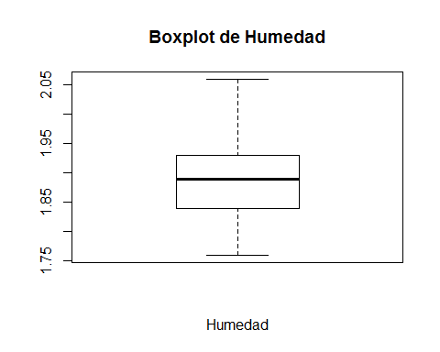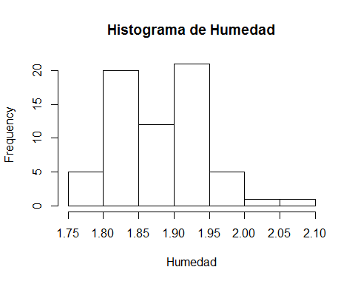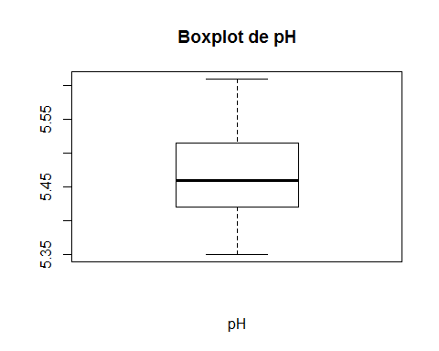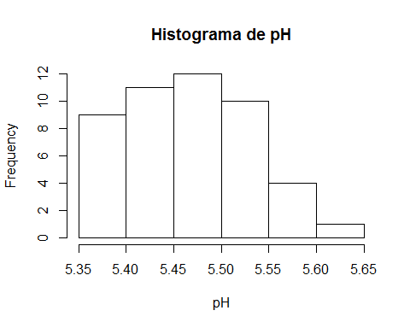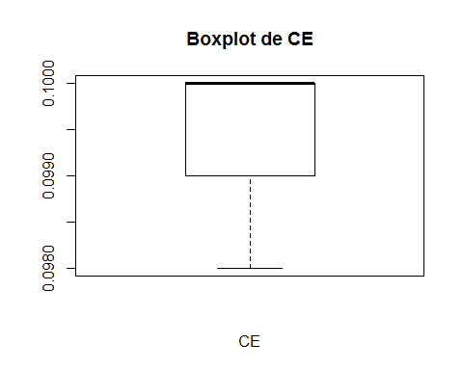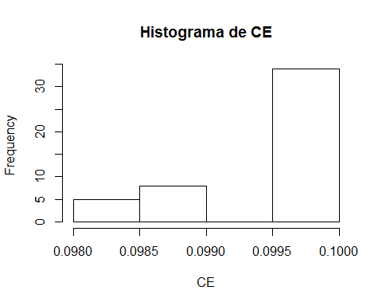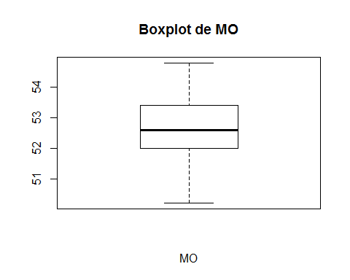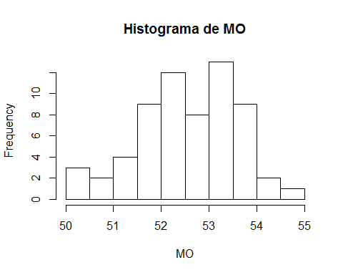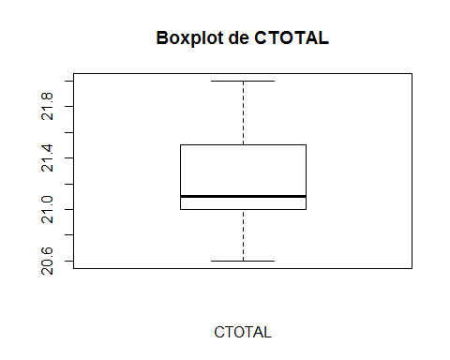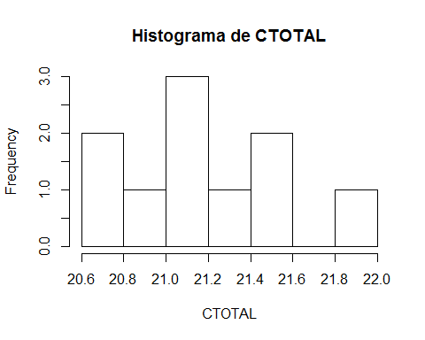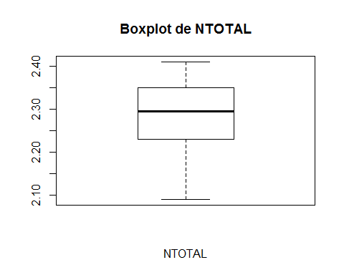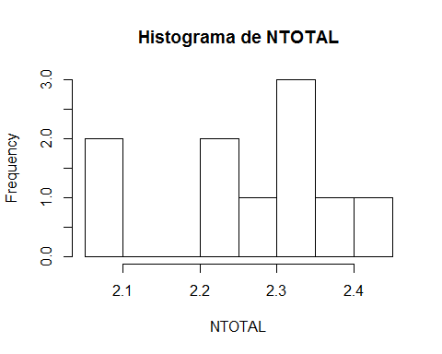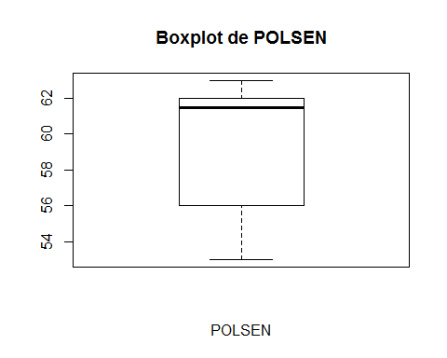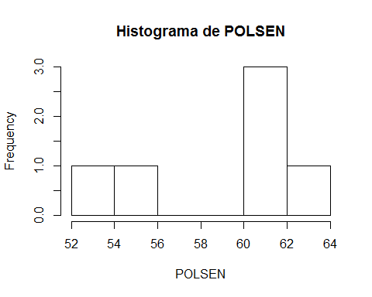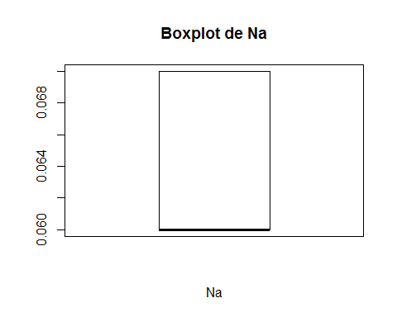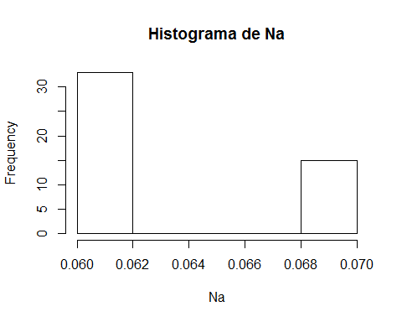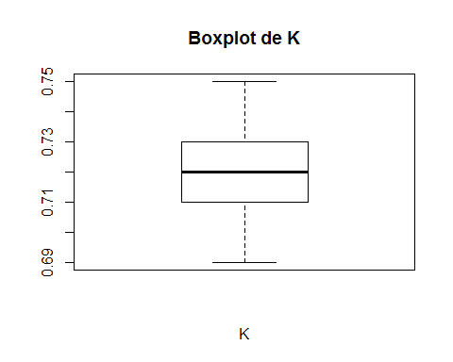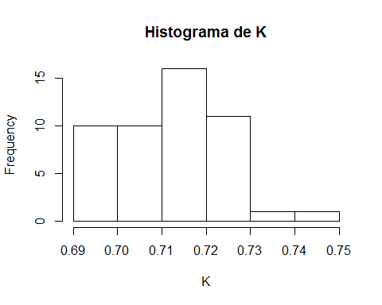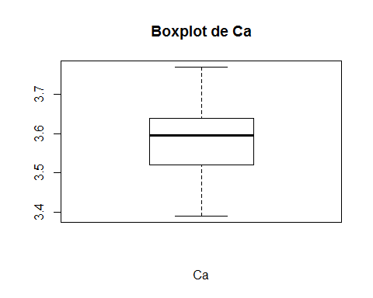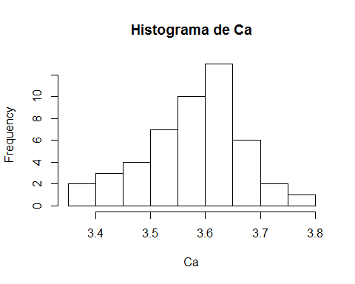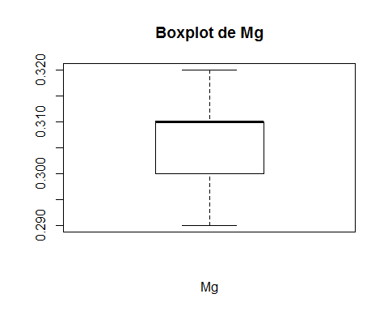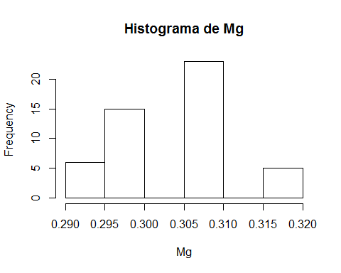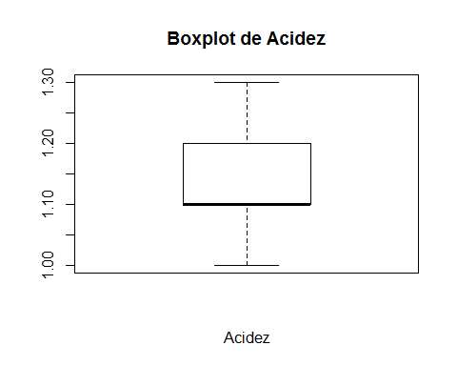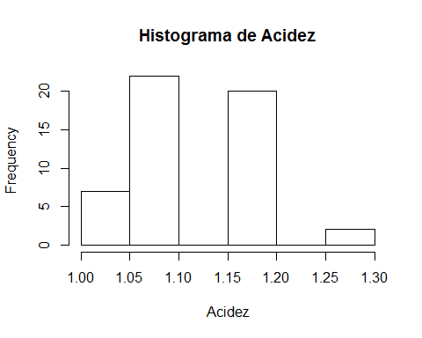

## TABLAS DE DATOS

### Datos eliminados de los cálculos por ser outliers

|  |  |  |  |  |  |  |  |  |  |  |  |
| --- | --- | --- | --- | --- | --- | --- | --- | --- | --- | --- | --- |
| Humedad | pH | CE | MO | CTOTAL | NTOTAL | POLSEN | Na | K | Ca | Mg | Acidez |
| 2.07 |  | 0.097 |  |  |  |  |  |  | 3.33 |  | 1.4 |
| 2.09 |  | 0.11 |  |  |  |  |  |  |  |  | 0.9 |
|  |  | 0.097 |  |  |  |  |  |  |  |  | 0.9 |
|  |  |  |  |  |  |  |  |  |  |  | 1.4 |

### 

### Datos de referencia

|  |  |  |  |  |
| --- | --- | --- | --- | --- |
| método | media | desviación | numero | año |
| Humedad | 2.03 | 0.1520 | 21 | 2017 |
| pH | 5.41 | 0.0630 | 59 | 2018 |
| CE | 0.10 | 0.0031 | 55 | 2018 |
| MO | 52.60 | 0.7860 | 65 | 2015 |
| CTOTAL | 21.92 | 0.5900 | 24 | 2018 |
| NTOTAL | 2.18 | 0.1070 | 23 | 2018 |
| POLSEN | 59.00 | 3.2580 | 21 | 2018 |
| Na | 0.06 | 0.0040 | 21 | 2018 |
| K | 0.71 | 0.0130 | 21 | 2017 |
| Ca | 3.55 | 0.0800 | 21 | 2017 |
| Mg | 0.30 | 0.0090 | 21 | 2017 |
| Acidez | 1.21 | 0.0850 | 18 | 2017 |

### Datos originales utilizados en los cálculos

|  |  |  |  |  |  |  |  |  |  |  |  |
| --- | --- | --- | --- | --- | --- | --- | --- | --- | --- | --- | --- |
| Humedad | pH | CE | MO | CTOTAL | NTOTAL | POLSEN | Na | K | Ca | Mg | Acidez |
| 2.06 | 5.39 | 0.1 | 50.2 | 21.3 | 2.35 | 63 | 0.06 | 0.7 | 3.52 | 0.3 | 1.2 |
| 1.97 | 5.36 | 0.1 | 52.8 | 20.6 | 2.27 | 61 | 0.06 | 0.69 | 3.39 | 0.29 | 1.1 |
| 1.96 | 5.39 | 0.1 | 51.3 | 21.1 | 2.34 | 56 | 0.06 | 0.72 | 3.58 | 0.3 | 1.2 |
| 1.95 | 5.39 | 0.1 | 52.8 | 21.1 | 2.24 | 62 | 0.06 | 0.7 | 3.45 | 0.29 | 1.1 |
| 1.84 | 5.42 | 0.099 | 51.8 | 21.5 | 2.41 | 53 | 0.06 | 0.7 | 3.54 | 0.3 | 1.2 |
| 1.91 | 5.42 | 0.1 | 53.4 | 21.1 | 2.23 | 62 | 0.06 | 0.7 | 3.39 | 0.29 | 1.2 |
| 1.86 | 5.41 | 0.1 | 54 | 21 | 2.32 |  | 0.06 | 0.73 | 3.6 | 0.31 | 1.1 |
| 1.98 | 5.36 | 0.1 | 50.2 | 20.6 | 2.09 |  | 0.07 | 0.72 | 3.56 | 0.31 | 1.2 |
| 1.93 | 5.37 | 0.1 | 51.7 | 21.5 | 2.37 |  | 0.07 | 0.73 | 3.72 | 0.31 | 1.3 |
| 1.93 | 5.45 | 0.1 | 53.2 | 22 | 2.1 |  | 0.06 | 0.71 | 3.52 | 0.3 | 1.2 |
| 1.90 | 5.46 | 0.099 | 52.1 |  |  |  | 0.06 | 0.72 | 3.61 | 0.3 | 1.1 |
| 1.95 | 5.46 | 0.1 | 53.2 |  |  |  | 0.06 | 0.73 | 3.62 | 0.32 | 1.1 |
| 1.83 | 5.46 | 0.1 | 53.3 |  |  |  | 0.06 | 0.72 | 3.52 | 0.31 | 1.2 |
| 1.92 | 5.42 | 0.1 | 53.2 |  |  |  | 0.06 | 0.72 | 3.62 | 0.31 | 1.1 |
| 1.84 | 5.47 | 0.1 | 50.2 |  |  |  | 0.06 | 0.71 | 3.57 | 0.3 | 1.1 |
| 1.95 | 5.53 | 0.097 | 52.3 |  |  |  | 0.06 | 0.73 | 3.65 | 0.31 | 1.1 |
| 2.00 | 5.46 | 0.098 | 52.2 |  |  |  | 0.06 | 0.73 | 3.61 | 0.31 | 1.2 |
| 1.97 | 5.49 | 0.1 | 51.7 |  |  |  | 0.07 | 0.73 | 3.64 | 0.31 | 1.1 |
| 1.95 | 5.46 | 0.098 | 53.8 |  |  |  | 0.06 | 0.72 | 3.65 | 0.31 | 1.1 |
| 2.07 | 5.51 | 0.1 | 51.6 |  |  |  | 0.07 | 0.72 | 3.58 | 0.31 | 1 |
| 1.94 | 5.48 | 0.1 | 54.8 |  |  |  | 0.07 | 0.71 | 3.48 | 0.3 | 1.4 |
| 1.91 | 5.4 | 0.1 | 52.4 |  |  |  | 0.07 | 0.72 | 3.61 | 0.31 | 1 |
| 1.90 | 5.49 | 0.1 | 53.3 |  |  |  | 0.06 | 0.73 | 3.68 | 0.31 | 1.1 |
| 1.93 | 5.35 | 0.1 | 51.1 |  |  |  | 0.06 | 0.69 | 3.33 | 0.29 | 1.2 |
| 1.88 | 5.52 | 0.1 | 52 |  |  |  | 0.07 | 0.72 | 3.68 | 0.31 | 1.1 |
| 1.87 | 5.45 | 0.1 | 54 |  |  |  | 0.06 | 0.72 | 3.63 | 0.31 | 1.1 |
| 1.92 | 5.44 | 0.1 | 53.7 |  |  |  | 0.07 | 0.73 | 3.7 | 0.32 | 1.1 |
| 1.93 | 5.47 | 0.11 | 52.7 |  |  |  | 0.07 | 0.72 | 3.6 | 0.32 | 1.2 |
| 1.84 | 5.42 | 0.1 | 51.8 |  |  |  | 0.07 | 0.73 | 3.56 | 0.31 | 1.2 |
| 1.83 | 5.46 | 0.1 | 51.3 |  |  |  | 0.07 | 0.73 | 3.67 | 0.31 | 0.9 |
| 1.92 | 5.45 | 0.1 | 52.5 |  |  |  | 0.06 | 0.71 | 3.68 | 0.31 | 1.1 |
| 1.92 | 5.58 | 0.1 | 53.5 |  |  |  | 0.06 | 0.72 | 3.56 | 0.31 | 1.2 |
| 1.81 | 5.52 | 0.099 | 52.1 |  |  |  | 0.06 | 0.72 | 3.62 | 0.31 | 1.3 |
| 1.84 | 5.51 | 0.097 | 52.4 |  |  |  | 0.06 | 0.71 | 3.46 | 0.3 | 1.2 |
| 1.84 | 5.42 | 0.1 | 52.6 |  |  |  | 0.06 | 0.69 | 3.44 | 0.29 | 1.2 |
| 1.92 | 5.51 | 0.1 | 53.1 |  |  |  | 0.07 | 0.74 | 3.77 | 0.32 | 1.2 |
| 1.89 | 5.43 | 0.1 | 53.5 |  |  |  | 0.06 | 0.72 | 3.62 | 0.31 | 1.2 |
| 1.77 | 5.5 | 0.1 | 52 |  |  |  | 0.06 | 0.71 | 3.64 | 0.3 | 1.2 |
| 1.82 | 5.53 | 0.1 | 52.4 |  |  |  | 0.06 | 0.7 | 3.51 | 0.3 | 0.9 |
| 1.80 | 5.54 | 0.099 | 52.5 |  |  |  | 0.06 | 0.7 | 3.41 | 0.29 | 1.1 |
| 1.84 | 5.55 | 0.098 | 52.5 |  |  |  | 0.07 | 0.71 | 3.7 | 0.3 | 1 |
| 1.81 | 5.56 | 0.1 | 52.5 |  |  |  |  | 0.71 | 3.55 | 0.32 | 1.2 |
| 1.84 | 5.61 | 0.099 | 51.7 |  |  |  | 0.06 | 0.71 | 3.5 | 0.3 | 1.1 |
| 1.82 | 5.38 | 0.098 | 52.8 |  |  |  | 0.06 | 0.7 | 3.54 | 0.3 | 1.1 |
| 1.86 | 5.55 | 0.099 | 51.3 |  |  |  | 0.06 | 0.71 | 3.49 | 0.3 | 1.2 |
| 1.85 | 5.6 | 0.098 | 54.1 |  |  |  | 0.06 | 0.72 | 3.57 | 0.3 | 1.1 |
| 1.89 | 5.6 | 0.1 | 50.9 |  |  |  | 0.07 | 0.75 | 3.74 | 0.31 | 1.2 |
| 1.86 |  | 0.1 | 52 |  |  |  | 0.06 | 0.72 | 3.59 | 0.31 | 1.4 |
| 1.82 |  | 0.099 | 53.1 |  |  |  | 0.07 | 0.73 | 3.64 | 0.31 | 1.1 |
| 1.93 |  | 0.099 | 52.7 |  |  |  |  |  |  |  | 1 |
| 2.01 |  |  | 53.7 |  |  |  |  |  |  |  | 1 |
| 1.81 |  |  | 53.2 |  |  |  |  |  |  |  | 1.1 |
| 2.09 |  |  | 54 |  |  |  |  |  |  |  | 1.1 |
| 1.82 |  |  | 52.1 |  |  |  |  |  |  |  | 1 |
| 1.82 |  |  | 54.3 |  |  |  |  |  |  |  | 1 |
| 1.93 |  |  | 52.6 |  |  |  |  |  |  |  |  |
| 1.87 |  |  | 53.6557 |  |  |  |  |  |  |  |  |
| 1.76 |  |  | 53.4 |  |  |  |  |  |  |  |  |
| 1.92 |  |  | 53.6 |  |  |  |  |  |  |  |  |
| 1.89 |  |  | 52.8 |  |  |  |  |  |  |  |  |
| 1.76 |  |  | 53.5 |  |  |  |  |  |  |  |  |
| 1.91 |  |  | 53.9 |  |  |  |  |  |  |  |  |
| 1.90 |  |  | 50.7 |  |  |  |  |  |  |  |  |
| 1.76 |  |  |  |  |  |  |  |  |  |  |  |
| 1.84 |  |  |  |  |  |  |  |  |  |  |  |
| 1.85 |  |  |  |  |  |  |  |  |  |  |  |
| 1.94 |  |  |  |  |  |  |  |  |  |  |  |

Cálculos realizados en el software r utilizando la función del LAFIGA testm y los data.frames nuevo (conjunto de nuevos datos para cada uno de los métodos de análisis que se quieren comparar con el valor de referencia) y antiguo (incluye las medias, desviaciones estandar, numero de valores y año de los valores de referencia utilizados)