Estudio del patrón de suelos PSI

## CALCULOS ESTADÍSTICOS

Se realizan los cálculos siguiendo el manual “Guidelines for quality management in soil and plant laboratories” (FAO, soils bulletin 74 pag:132 ISBN: 92-5-104065-6, 1998) adaptado de Massart et tal. 1988.Se eliminan automaticamente los outliers.

## [1] "CE"  
## [1] "Como n1 y n2 son >=30 se utiliza un t-test normal, n inicial= 271 n de datos= 223"  
## [1] "media datos matriz= 0.0680986547085202"  
## [1] "desviación estandar datos matriz= 0.0564157599537134"  
## [1] "tcal= 6.05146587313667"  
## [1] "grados de libertad matriz(df)= 492"  
## [1] "ttab= 1.96479735565394"  
## [1] "las medias son estadisticamente DIFERENTES pues 6.05146587313667 > 1.96479735565394"  
## [1] "------------------------------------------------------------"

## GRÁFICOS

Gráficos Boxplot e Histograma para cada método:

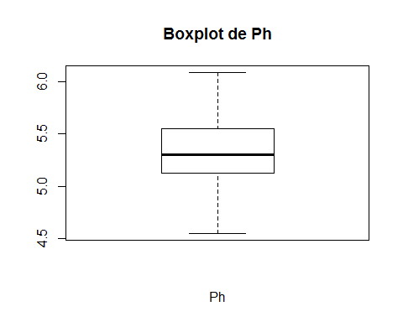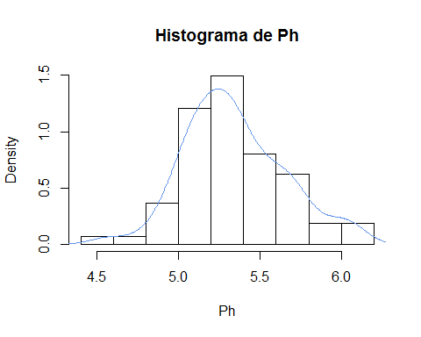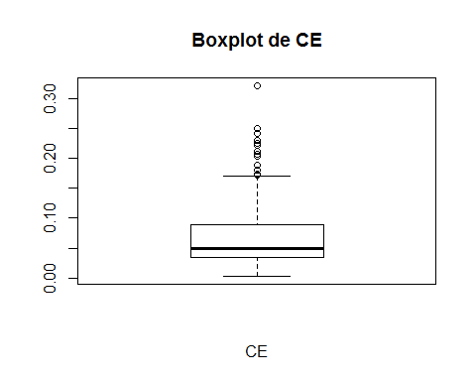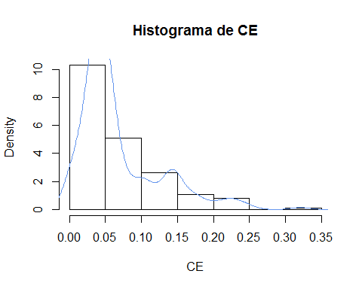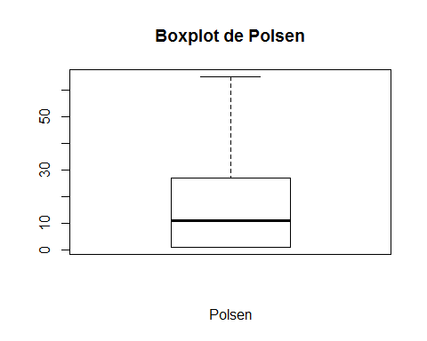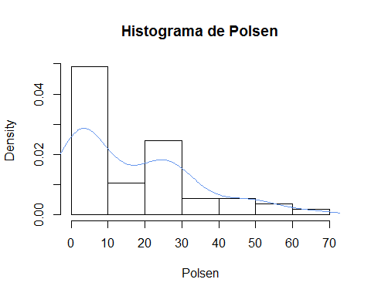

## TABLAS DE DATOS

### Datos eliminados de los cálculos por ser outliers

|  |  |  |
| --- | --- | --- |
| Ph | CE | Polsen |
| 9.01 | 1.455 | 139 |
| 9.01 | 1.690 |  |
| 7.4 | 0.609 |  |
| 7.43 | 0.501 |  |
| 7.57 | 1.670 |  |
| 6.71 | 0.472 |  |
| 7.33 | 1.331 |  |
| 3.99 | 0.497 |  |
| 7 | 1.403 |  |
| 9 | 0.410 |  |
| 3.98 | 0.494 |  |
| 7.53 | 1.344 | 147 |
| 6.99 | 1.392 |  |
| 8.99 | 0.497 |  |
| 3.98 | 1.287 |  |
| 4.01 | 1.466 |  |
| 6.99 | 0.664 |  |
| 8.98 | 0.382 |  |
| 4 | 0.495 |  |
| 6.98 | 1.280 |  |
| 8.97 | 0.491 |  |
| 8.17 | 1.410 |  |
| 6.82 | 0.767 | 140 |
| 7 | 0.422 |  |
| 8.18 | 0.391 |  |
| 4 | 0.487 |  |
| 6.98 | 1.400 |  |
| 9.01 | 0.511 |  |
| 8.96 | 0.504 |  |
| 7.29 | 1.439 |  |
| 7.3 | 0.501 |  |
|  | 1.428 |  |
|  | 0.499 |  |
| 7.53 | 0.709 | 100 |
|  | 1.403 |  |
|  | 1.549 |  |
|  | 0.497 |  |
|  | 1.395 |  |
| 7.43 | 0.491 |  |
| 4.01 | 1.374 |  |
| 3.99 | 0.476 |  |
| 7.43 | 2.876 |  |
| 9.01 | 0.521 |  |
| 3.99 | 2.798 | 184 |
| 7.43 | 0.489 | 139 |
| 9.01 | 1.376 |  |
| 4 | 0.474 |  |
| 7 | 1.338 |  |

### Datos de referencia

|  |  |  |  |  |
| --- | --- | --- | --- | --- |
| método | media | desviación | numero | año |
| pH | 5.806369 | 1.1307454 | 179 | 2021 |
| CE | 0.235321 | 0.4506313 | 271 | 2021 |
| polsen | 37.500000 | 47.2137692 | 26 | 2021 |

### Datos originales utilizados en los cálculos

|  |  |  |
| --- | --- | --- |
| Ph | CE | Polsen |
| 9.01 | 1.455 | 54 |
| 7.43 | 0.501 | 43 |
| 4.01 | 0.153 | 25 |
| 5.77 | 0.053 | 21 |
| 5.22 | 0.052 | 27 |
| 5.77 | 0.033 | 1 |
| 5.43 | 0.051 | 1 |
| 5.11 | 0.048 | 39 |
| 5.01 | 0.033 | 24 |
| 6.06 | 0.037 | 1 |
| 5.33 | 0.033 | 1 |
| 4.95 | 0.032 | 33 |
| 5.2 | 0.058 | 27 |
| 5.27 | 0.033 | 1 |
| 9.01 | 0.050 | 1 |
| 7.43 | 0.054 | 33 |
| 4.01 | 0.050 | 19 |
| 3.99 | 0.033 | 1 |
| 7.43 | 0.033 | 1 |
| 9.01 | 0.063 | 49 |
| 5.28 | 0.052 | 1 |
| 7.53 | 0.037 | 139 |
| 6.82 | 0.044 | 10 |
| 5.3 | 0.033 | 147 |
| 5.49 | 0.112 | 140 |
| 4.91 | 0.003 | 100 |
| 4.74 | 0.003 | 4 |
| 4.97 | 1.466 | 9 |
| 4.8 | 0.511 | 5 |
| 5.22 | 0.153 | 18 |
| 5.05 | 0.053 | 3 |
| 6.05 | 0.052 | 6 |
| 5.06 | 0.146 | 4 |
| 7.53 | 0.491 | 11 |
| 3.99 | 1.374 | 4 |
| 7.43 | 0.007 | 6 |
| 9.01 | 0.004 | 6 |
| 4 | 0.101 | 3 |
| 7 | 0.476 | 26 |
| 9.01 | 2.876 | 1 |
| 5.27 | 0.521 | 9 |
| 7.4 | 1.344 | 1 |
| 4.55 | 0.767 | 184 |
| 6.09 | 0.709 | 27 |
| 7.57 | 0.222 | 3 |
| 6.71 | 0.049 | 29 |
| 4.92 | 0.089 | 15 |
| 7.33 | 0.057 | 139 |
| 5.24 | 0.048 | 51 |
| 5.16 | 0.049 | 23 |
| 5.55 | 0.141 | 46 |
| 5.64 | 0.050 | 65 |
| 5.4 | 2.798 | 25 |
| 5.06 | 0.050 | 19 |
| 5.75 | 0.053 | 1 |
| 5.9 | 0.146 | 1 |
| 5.69 | 0.489 | 28 |
| 5.03 | 1.376 | 15 |
| 5.17 | 0.051 | 1 |
| 5.56 | 0.474 | 1 |
| 5.19 | 1.338 | 25 |
| 4.99 | 0.003 | 30 |
| 5.43 | 0.003 | 26 |
| 5.47 | 0.098 |  |
| 5.37 | 1.690 |  |
| 4.96 | 0.035 |  |
| 4.99 | 0.027 |  |
| 5.46 | 0.029 |  |
| 5.6 | 0.031 |  |
| 5.1 | 0.020 |  |
| 5.35 | 0.027 |  |
| 5.67 | 0.019 |  |
| 5.4 | 0.170 |  |
| 5.11 | 0.180 |  |
| 5.69 | 0.091 |  |
| 5.75 | 0.609 |  |
| 4.57 | 1.670 |  |
| 5.55 | 0.174 |  |
| 5.1 | 0.051 |  |
| 5.72 | 0.472 |  |
| 3.99 | 1.331 |  |
| 7 | 0.054 |  |
| 9 | 0.152 |  |
| 3.98 | 0.497 |  |
| 6.99 | 1.403 |  |
| 8.99 | 0.004 |  |
| 5.27 | 0.003 |  |
| 5.34 | 0.110 |  |
| 5.06 | 0.180 |  |
| 5.68 | 0.250 |  |
| 6.02 | 0.037 |  |
| 6.09 | 0.046 |  |
| 5.69 | 0.035 |  |
| 5.74 | 0.036 |  |
| 5.95 | 0.034 |  |
| 5.93 | 0.035 |  |
| 5.15 | 0.097 |  |
| 5.36 | 0.057 |  |
| 5.63 | 0.038 |  |
| 5.7 | 0.029 |  |
| 5.42 | 0.034 |  |
| 5.09 | 0.027 |  |
| 5.6 | 0.031 |  |
| 5.57 | 0.033 |  |
| 5.31 | 0.044 |  |
| 5.22 | 0.410 |  |
| 5.36 | 0.052 |  |
| 5.55 | 0.034 |  |
| 5.17 | 0.038 |  |
| 4.99 | 0.230 |  |
| 5.37 | 0.063 |  |
| 5.43 | 0.062 |  |
| 5.2 | 0.170 |  |
| 5.39 | 0.040 |  |
| 5.39 | 0.061 |  |
| 5.64 | 0.054 |  |
| 5.33 | 0.151 |  |
| 5.26 | 0.494 |  |
| 5.39 | 1.392 |  |
| 5.48 | 0.051 |  |
| 5.25 | 0.140 |  |
| 5.51 | 0.497 |  |
| 5.33 | 1.287 |  |
| 5.15 | 0.004 |  |
| 5.36 | 0.003 |  |
| 5.33 | 0.099 |  |
| 3.98 | 0.050 |  |
| 6.99 | 0.034 |  |
| 8.98 | 0.036 |  |
| 4 | 0.040 |  |
| 6.98 | 0.033 |  |
| 8.97 | 0.033 |  |
| 5.25 | 0.041 |  |
| 5.15 | 0.035 |  |
| 5.51 | 0.040 |  |
| 6 | 0.037 |  |
| 5.42 | 0.042 |  |
| 5.55 | 0.024 |  |
| 5.69 | 0.017 |  |
| 8.17 | 0.045 |  |
| 5.58 | 0.664 |  |
| 5.02 | 0.382 |  |
| 5.87 | 0.103 |  |
| 7 | 0.206 |  |
| 4.89 | 0.077 |  |
| 5.32 | 0.081 |  |
| 5.09 | 0.046 |  |
| 5.77 | 0.321 |  |
| 5.54 | 0.063 |  |
| 5.13 | 0.038 |  |
| 5.29 | 0.034 |  |
| 5.36 | 0.104 |  |
| 5.26 | 0.038 |  |
| 5.23 | 0.051 |  |
| 5.02 | 0.140 |  |
| 5.28 | 0.495 |  |
| 5.13 | 1.280 |  |
| 5.22 | 0.053 |  |
| 5.17 | 0.144 |  |
| 5.29 | 0.491 |  |
| 5.13 | 1.410 |  |
| 5.15 | 0.005 |  |
| 4.87 | 0.003 |  |
| 5.25 | 0.101 |  |
| 5.22 | 0.025 |  |
| 5.1 | 0.039 |  |
| 5.25 | 0.131 |  |
| 5.44 | 0.076 |  |
| 5.06 | 0.017 |  |
| 5.16 | 0.230 |  |
| 8.18 | 0.052 |  |
| 5.24 | 0.422 |  |
| 5.07 | 0.056 |  |
| 5.07 | 0.042 |  |
| 4 | 0.045 |  |
| 6.98 | 0.188 |  |
| 8.96 | 0.058 |  |
| 7.29 | 0.034 |  |
| 7.3 | 0.040 |  |
|  | 0.204 |  |
|  | 0.059 |  |
|  | 0.049 |  |
|  | 0.043 |  |
|  | 0.171 |  |
|  | 0.050 |  |
|  | 0.043 |  |
|  | 0.042 |  |
|  | 0.242 |  |
|  | 0.024 |  |
|  | 0.391 |  |
|  | 0.048 |  |
|  | 0.053 |  |
|  | 0.143 |  |
|  | 0.487 |  |
|  | 1.400 |  |
|  | 0.055 |  |
|  | 0.146 |  |
|  | 0.504 |  |
|  | 1.439 |  |
|  | 0.005 |  |
|  | 0.003 |  |
|  | 0.108 |  |
|  | 0.142 |  |
|  | 0.077 |  |
|  | 0.041 |  |
|  | 0.033 |  |
|  | 0.043 |  |
|  | 0.044 |  |
|  | 0.133 |  |
|  | 0.029 |  |
|  | 0.020 |  |
|  | 0.012 |  |
|  | 0.039 |  |
|  | 0.021 |  |
|  | 0.030 |  |
|  | 0.039 |  |
|  | 0.077 |  |
|  | 0.062 |  |
|  | 0.053 |  |
|  | 0.158 |  |
|  | 0.075 |  |
|  | 0.054 |  |
|  | 0.055 |  |
|  | 0.212 |  |
|  | 0.131 |  |
|  | 0.062 |  |
|  | 0.144 |  |
|  | 0.053 |  |
|  | 0.061 |  |
|  | 0.055 |  |
|  | 0.145 |  |
|  | 0.501 |  |
|  | 1.428 |  |
|  | 0.051 |  |
|  | 0.142 |  |
|  | 0.499 |  |
|  | 1.403 |  |
|  | 0.005 |  |
|  | 0.003 |  |
|  | 0.105 |  |
|  | 0.225 |  |
|  | 0.109 |  |
|  | 0.022 |  |
|  | 0.023 |  |
|  | 0.059 |  |
|  | 0.048 |  |
|  | 0.034 |  |
|  | 0.088 |  |
|  | 0.077 |  |
|  | 0.128 |  |
|  | 0.029 |  |
|  | 0.029 |  |
|  | 0.034 |  |
|  | 0.032 |  |
|  | 0.023 |  |
|  | 0.043 |  |
|  | 1.549 |  |
|  | 0.123 |  |
|  | 0.127 |  |
|  | 0.064 |  |
|  | 0.013 |  |
|  | 0.020 |  |
|  | 0.035 |  |
|  | 0.072 |  |
|  | 0.107 |  |
|  | 0.032 |  |
|  | 0.075 |  |
|  | 0.051 |  |
|  | 0.142 |  |
|  | 0.497 |  |
|  | 1.395 |  |

Cálculos realizados en el software r utilizando la función del LAFIGA testm y los data.frames nuevo (conjunto de nuevos datos para cada uno de los métodos de análisis que se quieren comparar con el valor de referencia) y antiguo (incluye las medias, desviaciones estandar, numero de valores y año de los valores de referencia utilizados)