**HW6**

**-Daksh Thapar 2018137**

**-Tanmaya Gupta 2018200**

Verilog Codes

`timescale 1ns / 1ps

//////////////////////////////////////////////////////////////////////////////////

// Company:

// Engineer:

//

// Create Date: 24.09.2019 19:59:42

// Design Name:

// Module Name: top

// Project Name:

// Target Devices:

// Tool Versions:

// Description:

//

// Dependencies:

//

// Revision:

// Revision 0.01 - File Created

// Additional Comments:

//

//////////////////////////////////////////////////////////////////////////////////

module top(

input clk_100M,

inout [7:0] JA,

output [3:0] anode,

output [7:0] cathode,

input enter

);

wire clk_5ms, clk_1K, clk_7M;

wire [3:0] decode;

clk_wiz_0 c11(.clk_in1(clk_100M),.clk_out1(clk_7M));

clk_div #(13) u1( .clk_in(clk_7M) , .clk_out(clk_1K));

clk_div #(15) u2(.clk_in(clk_7M),.clk_out(clk_5ms));

Decoder s11(.clk(clk_100M),.Row(JA[7:4]),.Col(JA[3:0]),.DecodeOut(decode),.clking(bouncer),.enter(enter));

wire temp_bouncer;

debouncer d1(.clk_in(clk_5ms),.clr_o(temp_bouncer),.clr_i(bouncer));

wire [7:0] number;

wire [3:0] ones,tens,hundreds,thousands;

fsm_moore_ccd moore(.clk(temp_bouncer),.din(decode),.present_state(number),.enter(enter));

reg [3:0] first,second,third,fourth;

always @( * )

if ( number == 8'd6)

first <= 4'd1;

else if ( number == 8'd4)

first<= 4'd0;

else if (number == 8'd5 )

first <= 4'd7;

else

first <= 4'd0;

always @( * )

if ( number == 8'd6)

second <= 4'd2;

else if ( number == 8'd4)

second<= 4'd4;

else if (number == 8'd5 )

second <= 4'd2;

else

second <= 4'd0;

always @( * )

if ( number == 8'd6)

third <= 4'd3;

else if ( number == 8'd4)

third<= 4'd5;

else if (number == 8'd5 )

third <= 4'd4;

else

third <= 4'd0;

always @( * )

if ( number == 8'd6)

fourth <= 4'd3;

else if ( number == 8'd4)

fourth<= 4'd6;

else if (number == 8'd5 )

fourth <= 4'd8;

else

fourth <= 4'd0;

sevenSeg s1(.clk(clk_1K),.ones(fourth),.tens(third),.thousands(first),.hundreds(second),.anode(anode),.cathode(cathode));

endmodule

`timescale 1ns / 1ps

//////////////////////////////////////////////////////////////////////////////////

// Company:

// Engineer:

//

// Create Date: 24.09.2019 20:02:17

// Design Name:

// Module Name: Decoder

// Project Name:

// Target Devices:

// Tool Versions:

// Description:

//

// Dependencies:

//

// Revision:

// Revision 0.01 - File Created

// Additional Comments:

//

//////////////////////////////////////////////////////////////////////////////////

module Decoder(

input clk,

input [3:0] Row,

output reg [3:0] Col,

output clking,

output reg [3:0] DecodeOut,

input enter

);

reg [3:0] temp;

reg [19:0] sclk = 0 ;

always @ (posedge clk)

begin

if (sclk == 20'b00011000011010100000)

begin

Col <= 4'b0111;

sclk <= sclk + 1'b1;

temp[0] <= 1'b1;

end

else if(sclk ==20'b00011000011010101000)

begin

if (Row==4'b0111) begin

DecodeOut <= 4'b0001;

end

else if (Row == 4'b1011) begin

DecodeOut <= 4'b0100;

end

else if (Row == 4'b1101) begin

DecodeOut <= 4'b0111;

end

else if (Row == 4'b1110) begin

DecodeOut <= 4'b0000;

end

else begin

temp[0] = 1'b0;

end

sclk <= sclk + 1'b1;

end

else if (sclk == 20'b00110000110101000000) begin

Col <= 4'b1011;

sclk <= sclk +1'b1;

temp[1]<= 1'b1;

end

else if (sclk == 20'b00110000110101001000) begin

if (Row==4'b0111) begin

DecodeOut <= 4'b0010;

end

else if (Row == 4'b1011) begin

DecodeOut <= 4'b0101;

end

else if (Row == 4'b1101) begin

DecodeOut <= 4'b1000;

end

else if (Row == 4'b1110) begin

DecodeOut <= 4'b1111;

end

else

begin

temp[1] <= 1'b0;

end

sclk <= sclk + 1'b1;

end

else if (sclk == 20'b01001001001111100000) begin

Col <= 4'b1101;

sclk <= sclk +1'b1;

temp[2]<= 1'b1;

end

else if (sclk == 20'b01001001001111101000) begin

if (Row==4'b0111) begin

DecodeOut <= 4'b0011;

end

else if (Row == 4'b1011) begin

DecodeOut <= 4'b0110;

end

else if (Row == 4'b1101) begin

DecodeOut <= 4'b1001;

end

else if (Row == 4'b1110) begin

DecodeOut <= 4'b1110;

end

else

begin

temp[2]<=1'b0;

end

sclk <= sclk + 1'b1;

end

else if (sclk == 20'b01100001101010000000) begin

Col <= 4'b1110;

sclk <= sclk +1'b1;

temp[3]<= 1'b1;

end

else if (sclk == 20'b01100001101010001000) begin

if (Row==4'b0111) begin

DecodeOut <= 4'b1010;

end

else if (Row == 4'b1011) begin

DecodeOut <= 4'b1011;

end

else if (Row == 4'b1101) begin

DecodeOut <= 4'b1100;

end

else if (Row == 4'b1110) begin

DecodeOut <= 4'b1101;

end

else

begin

temp[3] <= 1'b0;

end

sclk <= 20'b00000000000000000000;

end

else begin

sclk <= sclk + 1'b1;

end

end

assign clking = temp[0]|temp[1]|temp[2]|temp[3]|enter;

endmodule

`timescale 1ns / 1ps

//////////////////////////////////////////////////////////////////////////////////

// Company:

// Engineer:

//

// Create Date: 24.09.2019 20:04:50

// Design Name:

// Module Name: debouncer

// Project Name:

// Target Devices:

// Tool Versions:

// Description:

//

// Dependencies:

//

// Revision:

// Revision 0.01 - File Created

// Additional Comments:

//

//////////////////////////////////////////////////////////////////////////////////

module debouncer(

input clk_in,

input clr_i,

output clr_o

);

reg d1, d2, d3;

always @(posedge clk_in)

begin

d1 <= clr_i;

d2 <= d1;

d3 <= d2;

end

assign clr_o = d1 && d2 && !d3;

endmodule

`timescale 1ns / 1ps

//////////////////////////////////////////////////////////////////////////////////

// Company:

// Engineer:

//

// Create Date: 24.09.2019 20:06:18

// Design Name:

// Module Name: fsm_moore_ccd

// Project Name:

// Target Devices:

// Tool Versions:

// Description:

//

// Dependencies:

//

// Revision:

// Revision 0.01 - File Created

// Additional Comments:

//

//////////////////////////////////////////////////////////////////////////////////

module fsm_moore_ccd(

input clk,

input enter,

input [3:0] din,

output reg [3:0] present_state

);

reg [3:0] next_state;

parameter s0=4'd0, s1=4'd1, s2=4'd2, s3=4'd3, s4=4'd4, s5=4'd5, s6=4'd6, s7=4'd7, s8=4'd8, s9=4'd9, s10=4'd10, s11=4'd11, s12=4'd12;

// s4- invalid

// s6- pass

// s5- fail

always @(posedge clk)

begin

present_state <= next_state;

end

always @( present_state )

begin

case ( present_state )

s0 :if ( enter )

next_state <= s4;

else if (din == 4'd12)

next_state <= s1;

else

next_state <= s7;

s1 :if ( enter )

next_state <= s4;

else if (din == 4'd12)

next_state <= s2;

else

next_state <= s8;

s2 :if ( enter )

next_state <= s4;

else if ( din == 4'd13 )

next_state <= s3;

else

next_state <= s9;

s3: if ( enter )

next_state <= s6;

else

next_state <= s10;

s7 : if ( enter )

next_state <= s4;

else

next_state <=s8;

s8: if ( enter )

next_state <= s4;

else

next_state <= s9;

s9 :if ( enter )

next_state <= s5;

else

next_state <= s10;

s10 : if ( enter )

next_state <= s4;

else

next_state <= s10;

s4 : if ( din == 4'd12 )

next_state <= s1;

else

next_state <= s7;

s6 : if ( din == 4'd12 )

next_state <= s1;

else

next_state <= s7;

s5 : if ( din == 4'd12 )

next_state <= s1;

else

next_state <= s7;

default : next_state <= s0;

endcase

end

endmodule

`timescale 1ns / 1ps

//////////////////////////////////////////////////////////////////////////////////

// Company:

// Engineer:

//

// Create Date: 24.09.2019 20:11:00

// Design Name:

// Module Name: clk_div

// Project Name:

// Target Devices:

// Tool Versions:

// Description:

//

// Dependencies:

//

// Revision:

// Revision 0.01 - File Created

// Additional Comments:

//

//////////////////////////////////////////////////////////////////////////////////

module clk_div

#(

parameter divide_by = 19

)

( input clk_in,

output clk_out );

reg [divide_by-1:0] count = 0 ;

always @ (posedge clk_in)

begin

count = count+1 ;

end

assign clk_out = count[divide_by-1] ;

endmodule

`timescale 1ns / 1ps

//////////////////////////////////////////////////////////////////////////////////

// Company:

// Engineer:

//

// Create Date: 24.09.2019 20:12:43

// Design Name:

// Module Name: sevenSeg

// Project Name:

// Target Devices:

// Tool Versions:

// Description:

//

// Dependencies:

//

// Revision:

// Revision 0.01 - File Created

// Additional Comments:

//

//////////////////////////////////////////////////////////////////////////////////

module sevenSeg(

input clk,

input [3:0] ones,

input [3:0] tens,

input [3:0] hundreds,

input [3:0] thousands,

output [3:0] anode,

output [7:0] cathode

);

reg [6:0] cathode_temp = 7'b1111111;

reg [3:0] anode_temp = 4'b1110;

reg [1:0] count = 0;

always @(posedge clk)

begin

count = count + 1;

end

always @ (posedge clk)

begin

case(count)

2'b00:

begin

case(ones)

4'd1:cathode_temp = 7'b0011000;

4'd2:cathode_temp = 7'b0001000;

4'd3:cathode_temp = 7'b0100100;

4'd4:cathode_temp = 7'b1001111;

4'd5:cathode_temp = 7'b1101010;

4'd6:cathode_temp = 7'b1000001;

4'd7:cathode_temp = 7'b0111000;

4'd8:cathode_temp = 7'b1110001;

default:cathode_temp = 7'b1111111;

endcase

anode_temp = 4'b1110;

end

2'b01:

begin

case(tens)

4'd1 : cathode_temp = 7'b0011000;

4'd2:cathode_temp = 7'b0001000;

4'd3:cathode_temp = 7'b0100100;

4'd4:cathode_temp = 7'b1001111;

4'd5:cathode_temp = 7'b1101010;

4'd6:cathode_temp = 7'b1000001;

4'd7:cathode_temp = 7'b0111000;

4'd8:cathode_temp = 7'b1110001;

default:cathode_temp = 7'b1111111;

endcase

anode_temp = 4'b1101;

end

2'b10:

begin

case(hundreds)

4'd1 : cathode_temp = 7'b0011000;

4'd2:cathode_temp = 7'b0001000;

4'd3:cathode_temp = 7'b0100100;

4'd4:cathode_temp = 7'b1001111;

4'd5:cathode_temp = 7'b1101010;

4'd6:cathode_temp = 7'b1000001;

4'd7:cathode_temp = 7'b0111000;

4'd8:cathode_temp = 7'b1110001;

default:cathode_temp = 7'b1111111;

endcase

anode_temp = 4'b1011;

end

2'b11:

begin

case(thousands)

4'd1 : cathode_temp = 7'b0011000;

4'd2:cathode_temp = 7'b0001000;

4'd3:cathode_temp = 7'b0100100;

4'd4:cathode_temp = 7'b1001111;

4'd5:cathode_temp = 7'b1101010;

4'd6:cathode_temp = 7'b1000001;

4'd7:cathode_temp = 7'b0111000;

4'd8:cathode_temp = 7'b1110001;

default:cathode_temp = 7'b1111111;

endcase

anode_temp = 4'b0111;

end

endcase

end

assign anode = anode_temp;

assign cathode = {cathode_temp,1'b1};

endmodule

## This file is a general .xdc for the Basys3 rev B board

## To use it in a project:

## - uncomment the lines corresponding to used pins

## - rename the used ports (in each line, after get_ports) according to the top level signal names in the project

# Clock signal

set_property PACKAGE_PIN W5 [get_ports clk_100M]

set_property IOSTANDARD LVCMOS33 [get_ports clk_100M]

# create_clock -add -name sys_clk_pin -period 10.00 -waveform {0 5} [get_ports clk]

## Switches

#set_property PACKAGE_PIN V17 [get_ports {sw[0]}]

# set_property IOSTANDARD LVCMOS33 [get_ports {sw[0]}]

#set_property PACKAGE_PIN V16 [get_ports {sw[1]}]

# set_property IOSTANDARD LVCMOS33 [get_ports {sw[1]}]

#set_property PACKAGE_PIN W16 [get_ports {sw[2]}]

# set_property IOSTANDARD LVCMOS33 [get_ports {sw[2]}]

#set_property PACKAGE_PIN W17 [get_ports {sw[3]}]

# set_property IOSTANDARD LVCMOS33 [get_ports {sw[3]}]

#set_property PACKAGE_PIN W15 [get_ports {sw[4]}]

# set_property IOSTANDARD LVCMOS33 [get_ports {sw[4]}]

#set_property PACKAGE_PIN V15 [get_ports {sw[5]}]

# set_property IOSTANDARD LVCMOS33 [get_ports {sw[5]}]

#set_property PACKAGE_PIN W14 [get_ports {sw[6]}]

# set_property IOSTANDARD LVCMOS33 [get_ports {sw[6]}]

#set_property PACKAGE_PIN W13 [get_ports {sw[7]}]

# set_property IOSTANDARD LVCMOS33 [get_ports {sw[7]}]

#set_property PACKAGE_PIN V2 [get_ports {sw[8]}]

# set_property IOSTANDARD LVCMOS33 [get_ports {sw[8]}]

#set_property PACKAGE_PIN T3 [get_ports {sw[9]}]

# set_property IOSTANDARD LVCMOS33 [get_ports {sw[9]}]

#set_property PACKAGE_PIN T2 [get_ports {sw[10]}]

# set_property IOSTANDARD LVCMOS33 [get_ports {sw[10]}]

#set_property PACKAGE_PIN R3 [get_ports {sw[11]}]

# set_property IOSTANDARD LVCMOS33 [get_ports {sw[11]}]

#set_property PACKAGE_PIN W2 [get_ports {sw[12]}]

# set_property IOSTANDARD LVCMOS33 [get_ports {sw[12]}]

#set_property PACKAGE_PIN U1 [get_ports {sw[13]}]

# set_property IOSTANDARD LVCMOS33 [get_ports {sw[13]}]

#set_property PACKAGE_PIN T1 [get_ports {sw[14]}]

# set_property IOSTANDARD LVCMOS33 [get_ports {sw[14]}]

#set_property PACKAGE_PIN R2 [get_ports {sw[15]}]

# set_property IOSTANDARD LVCMOS33 [get_ports {sw[15]}]

## LEDs

#set_property PACKAGE_PIN U16 [get_ports {led[0]}]

# set_property IOSTANDARD LVCMOS33 [get_ports {led[0]}]

#set_property PACKAGE_PIN E19 [get_ports {led[1]}]

# set_property IOSTANDARD LVCMOS33 [get_ports {led[1]}]

#set_property PACKAGE_PIN U19 [get_ports {led[2]}]

# set_property IOSTANDARD LVCMOS33 [get_ports {led[2]}]

#set_property PACKAGE_PIN V19 [get_ports {led[3]}]

# set_property IOSTANDARD LVCMOS33 [get_ports {led[3]}]

#set_property PACKAGE_PIN W18 [get_ports {led[4]}]

# set_property IOSTANDARD LVCMOS33 [get_ports {led[4]}]

#set_property PACKAGE_PIN U15 [get_ports {led[5]}]

# set_property IOSTANDARD LVCMOS33 [get_ports {led[5]}]

#set_property PACKAGE_PIN U14 [get_ports {led[6]}]

# set_property IOSTANDARD LVCMOS33 [get_ports {led[6]}]

#set_property PACKAGE_PIN V14 [get_ports {led[7]}]

# set_property IOSTANDARD LVCMOS33 [get_ports {led[7]}]

#set_property PACKAGE_PIN V13 [get_ports {led[8]}]

# set_property IOSTANDARD LVCMOS33 [get_ports {led[8]}]

#set_property PACKAGE_PIN V3 [get_ports {led[9]}]

# set_property IOSTANDARD LVCMOS33 [get_ports {led[9]}]

#set_property PACKAGE_PIN W3 [get_ports {led[10]}]

# set_property IOSTANDARD LVCMOS33 [get_ports {led[10]}]

#set_property PACKAGE_PIN U3 [get_ports {led[11]}]

# set_property IOSTANDARD LVCMOS33 [get_ports {led[11]}]

#set_property PACKAGE_PIN P3 [get_ports {led[12]}]

# set_property IOSTANDARD LVCMOS33 [get_ports {led[12]}]

#set_property PACKAGE_PIN N3 [get_ports {led[13]}]

# set_property IOSTANDARD LVCMOS33 [get_ports {led[13]}]

#set_property PACKAGE_PIN P1 [get_ports {led[14]}]

# set_property IOSTANDARD LVCMOS33 [get_ports {led[14]}]

#set_property PACKAGE_PIN L1 [get_ports {led[15]}]

# set_property IOSTANDARD LVCMOS33 [get_ports {led[15]}]

##7 segment display

set_property PACKAGE_PIN W7 [get_ports {cathode[7]}]

set_property IOSTANDARD LVCMOS33 [get_ports {cathode[7]}]

set_property PACKAGE_PIN W6 [get_ports {cathode[6]}]

set_property IOSTANDARD LVCMOS33 [get_ports {cathode[6]}]

set_property PACKAGE_PIN U8 [get_ports {cathode[5]}]

set_property IOSTANDARD LVCMOS33 [get_ports {cathode[5]}]

set_property PACKAGE_PIN V8 [get_ports {cathode[4]}]

set_property IOSTANDARD LVCMOS33 [get_ports {cathode[4]}]

set_property PACKAGE_PIN U5 [get_ports {cathode[3]}]

set_property IOSTANDARD LVCMOS33 [get_ports {cathode[3]}]

set_property PACKAGE_PIN V5 [get_ports {cathode[2]}]

set_property IOSTANDARD LVCMOS33 [get_ports {cathode[2]}]

set_property PACKAGE_PIN U7 [get_ports {cathode[1]}]

set_property IOSTANDARD LVCMOS33 [get_ports {cathode[1]}]

set_property PACKAGE_PIN V7 [ get_ports {cathode[0] }]

set_property IOSTANDARD LVCMOS33 [get_ports {cathode[0] }]

set_property PACKAGE_PIN U2 [get_ports {anode[0]}]

set_property IOSTANDARD LVCMOS33 [get_ports {anode[0]}]

set_property PACKAGE_PIN U4 [get_ports {anode[1]}]

set_property IOSTANDARD LVCMOS33 [get_ports {anode[1]}]

set_property PACKAGE_PIN V4 [get_ports {anode[2]}]

set_property IOSTANDARD LVCMOS33 [get_ports {anode[2]}]

set_property PACKAGE_PIN W4 [get_ports {anode[3]}]

set_property IOSTANDARD LVCMOS33 [get_ports {anode[3]}]

##Buttons

set_property PACKAGE_PIN U18 [get_ports enter]

set_property IOSTANDARD LVCMOS33 [get_ports enter]

#set_property PACKAGE_PIN T18 [get_ports btnU]

#set_property IOSTANDARD LVCMOS33 [get_ports btnU]

#set_property PACKAGE_PIN W19 [get_ports btnL]

#set_property IOSTANDARD LVCMOS33 [get_ports btnL]

#set_property PACKAGE_PIN T17 [get_ports btnR]

#set_property IOSTANDARD LVCMOS33 [get_ports btnR]

#set_property PACKAGE_PIN U17 [get_ports btnD]

#set_property IOSTANDARD LVCMOS33 [get_ports btnD]

##Pmod Header JA

##Sch name = JA1

set_property PACKAGE_PIN J1 [get_ports {JA[0]}]

set_property IOSTANDARD LVCMOS33 [get_ports {JA[0]}]

#Sch name = JA2

set_property PACKAGE_PIN L2 [get_ports {JA[1]}]

set_property IOSTANDARD LVCMOS33 [get_ports {JA[1]}]

#Sch name = JA3

set_property PACKAGE_PIN J2 [get_ports {JA[2]}]

set_property IOSTANDARD LVCMOS33 [get_ports {JA[2]}]

#Sch name = JA4

set_property PACKAGE_PIN G2 [get_ports {JA[3]}]

set_property IOSTANDARD LVCMOS33 [get_ports {JA[3]}]

#Sch name = JA7

set_property PACKAGE_PIN H1 [get_ports {JA[4]}]

set_property IOSTANDARD LVCMOS33 [get_ports {JA[4]}]

#Sch name = JA8

set_property PACKAGE_PIN K2 [get_ports {JA[5]}]

set_property IOSTANDARD LVCMOS33 [get_ports {JA[5]}]

#Sch name = JA9

set_property PACKAGE_PIN H2 [get_ports {JA[6]}]

set_property IOSTANDARD LVCMOS33 [get_ports {JA[6]}]

#Sch name = JA10

set_property PACKAGE_PIN G3 [get_ports {JA[7]}]

set_property IOSTANDARD LVCMOS33 [get_ports {JA[7]}]

##Pmod Header JB

##Sch name = JB1

#set_property PACKAGE_PIN A14 [get_ports {JB[0]}]

#set_property IOSTANDARD LVCMOS33 [get_ports {JB[0]}]

##Sch name = JB2

#set_property PACKAGE_PIN A16 [get_ports {JB[1]}]

#set_property IOSTANDARD LVCMOS33 [get_ports {JB[1]}]

##Sch name = JB3

#set_property PACKAGE_PIN B15 [get_ports {JB[2]}]

#set_property IOSTANDARD LVCMOS33 [get_ports {JB[2]}]

##Sch name = JB4

#set_property PACKAGE_PIN B16 [get_ports {JB[3]}]

#set_property IOSTANDARD LVCMOS33 [get_ports {JB[3]}]

##Sch name = JB7

#set_property PACKAGE_PIN A15 [get_ports {JB[4]}]

#set_property IOSTANDARD LVCMOS33 [get_ports {JB[4]}]

##Sch name = JB8

#set_property PACKAGE_PIN A17 [get_ports {JB[5]}]

#set_property IOSTANDARD LVCMOS33 [get_ports {JB[5]}]

##Sch name = JB9

#set_property PACKAGE_PIN C15 [get_ports {JB[6]}]

#set_property IOSTANDARD LVCMOS33 [get_ports {JB[6]}]

##Sch name = JB10

#set_property PACKAGE_PIN C16 [get_ports {JB[7]}]

#set_property IOSTANDARD LVCMOS33 [get_ports {JB[7]}]

##Pmod Header JC

##Sch name = JC1

#set_property PACKAGE_PIN K17 [get_ports {JC[0]}]

#set_property IOSTANDARD LVCMOS33 [get_ports {JC[0]}]

##Sch name = JC2

#set_property PACKAGE_PIN M18 [get_ports {JC[1]}]

#set_property IOSTANDARD LVCMOS33 [get_ports {JC[1]}]

##Sch name = JC3

#set_property PACKAGE_PIN N17 [get_ports {JC[2]}]

#set_property IOSTANDARD LVCMOS33 [get_ports {JC[2]}]

##Sch name = JC4

#set_property PACKAGE_PIN P18 [get_ports {JC[3]}]

#set_property IOSTANDARD LVCMOS33 [get_ports {JC[3]}]

##Sch name = JC7

#set_property PACKAGE_PIN L17 [get_ports {JC[4]}]

#set_property IOSTANDARD LVCMOS33 [get_ports {JC[4]}]

##Sch name = JC8

#set_property PACKAGE_PIN M19 [get_ports {JC[5]}]

#set_property IOSTANDARD LVCMOS33 [get_ports {JC[5]}]

##Sch name = JC9

#set_property PACKAGE_PIN P17 [get_ports {JC[6]}]

#set_property IOSTANDARD LVCMOS33 [get_ports {JC[6]}]

##Sch name = JC10

#set_property PACKAGE_PIN R18 [get_ports {JC[7]}]

#set_property IOSTANDARD LVCMOS33 [get_ports {JC[7]}]

##Pmod Header JXADC

##Sch name = XA1_P

#set_property PACKAGE_PIN J3 [get_ports {JXADC[0]}]

#set_property IOSTANDARD LVCMOS33 [get_ports {JXADC[0]}]

##Sch name = XA2_P

#set_property PACKAGE_PIN L3 [get_ports {JXADC[1]}]

#set_property IOSTANDARD LVCMOS33 [get_ports {JXADC[1]}]

##Sch name = XA3_P

#set_property PACKAGE_PIN M2 [get_ports {JXADC[2]}]

#set_property IOSTANDARD LVCMOS33 [get_ports {JXADC[2]}]

##Sch name = XA4_P

#set_property PACKAGE_PIN N2 [get_ports {JXADC[3]}]

#set_property IOSTANDARD LVCMOS33 [get_ports {JXADC[3]}]

##Sch name = XA1_N

#set_property PACKAGE_PIN K3 [get_ports {JXADC[4]}]

#set_property IOSTANDARD LVCMOS33 [get_ports {JXADC[4]}]

##Sch name = XA2_N

#set_property PACKAGE_PIN M3 [get_ports {JXADC[5]}]

#set_property IOSTANDARD LVCMOS33 [get_ports {JXADC[5]}]

##Sch name = XA3_N

#set_property PACKAGE_PIN M1 [get_ports {JXADC[6]}]

#set_property IOSTANDARD LVCMOS33 [get_ports {JXADC[6]}]

##Sch name = XA4_N

#set_property PACKAGE_PIN N1 [get_ports {JXADC[7]}]

#set_property IOSTANDARD LVCMOS33 [get_ports {JXADC[7]}]

##VGA Connector

#set_property PACKAGE_PIN G19 [get_ports {vgaRed[0]}]

#set_property IOSTANDARD LVCMOS33 [get_ports {vgaRed[0]}]

#set_property PACKAGE_PIN H19 [get_ports {vgaRed[1]}]

#set_property IOSTANDARD LVCMOS33 [get_ports {vgaRed[1]}]

#set_property PACKAGE_PIN J19 [get_ports {vgaRed[2]}]

#set_property IOSTANDARD LVCMOS33 [get_ports {vgaRed[2]}]

#set_property PACKAGE_PIN N19 [get_ports {vgaRed[3]}]

#set_property IOSTANDARD LVCMOS33 [get_ports {vgaRed[3]}]

#set_property PACKAGE_PIN N18 [get_ports {vgaBlue[0]}]

#set_property IOSTANDARD LVCMOS33 [get_ports {vgaBlue[0]}]

#set_property PACKAGE_PIN L18 [get_ports {vgaBlue[1]}]

#set_property IOSTANDARD LVCMOS33 [get_ports {vgaBlue[1]}]

#set_property PACKAGE_PIN K18 [get_ports {vgaBlue[2]}]

#set_property IOSTANDARD LVCMOS33 [get_ports {vgaBlue[2]}]

#set_property PACKAGE_PIN J18 [get_ports {vgaBlue[3]}]

#set_property IOSTANDARD LVCMOS33 [get_ports {vgaBlue[3]}]

#set_property PACKAGE_PIN J17 [get_ports {vgaGreen[0]}]

#set_property IOSTANDARD LVCMOS33 [get_ports {vgaGreen[0]}]

#set_property PACKAGE_PIN H17 [get_ports {vgaGreen[1]}]

#set_property IOSTANDARD LVCMOS33 [get_ports {vgaGreen[1]}]

#set_property PACKAGE_PIN G17 [get_ports {vgaGreen[2]}]

#set_property IOSTANDARD LVCMOS33 [get_ports {vgaGreen[2]}]

#set_property PACKAGE_PIN D17 [get_ports {vgaGreen[3]}]

#set_property IOSTANDARD LVCMOS33 [get_ports {vgaGreen[3]}]

#set_property PACKAGE_PIN P19 [get_ports Hsync]

#set_property IOSTANDARD LVCMOS33 [get_ports Hsync]

#set_property PACKAGE_PIN R19 [get_ports Vsync]

#set_property IOSTANDARD LVCMOS33 [get_ports Vsync]

##USB-RS232 Interface

#set_property PACKAGE_PIN B18 [get_ports RsRx]

#set_property IOSTANDARD LVCMOS33 [get_ports RsRx]

#set_property PACKAGE_PIN A18 [get_ports tx]

#set_property IOSTANDARD LVCMOS33 [get_ports tx]

#USB HID (PS/2)

##Quad SPI Flash

##Note that CCLK_0 cannot be placed in 7 series devices. You can access it using the

##STARTUPE2 primitive.

#set_property PACKAGE_PIN D18 [get_ports {QspiDB[0]}]

#set_property IOSTANDARD LVCMOS33 [get_ports {QspiDB[0]}]

#set_property PACKAGE_PIN D19 [get_ports {QspiDB[1]}]

#set_property IOSTANDARD LVCMOS33 [get_ports {QspiDB[1]}]

#set_property PACKAGE_PIN G18 [get_ports {QspiDB[2]}]

#set_property IOSTANDARD LVCMOS33 [get_ports {QspiDB[2]}]

#set_property PACKAGE_PIN F18 [get_ports {QspiDB[3]}]

#set_property IOSTANDARD LVCMOS33 [get_ports {QspiDB[3]}]

#set_property PACKAGE_PIN K19 [get_ports QspiCSn]

#set_property IOSTANDARD LVCMOS33 [get_ports QspiCSn]

Elaborated Design

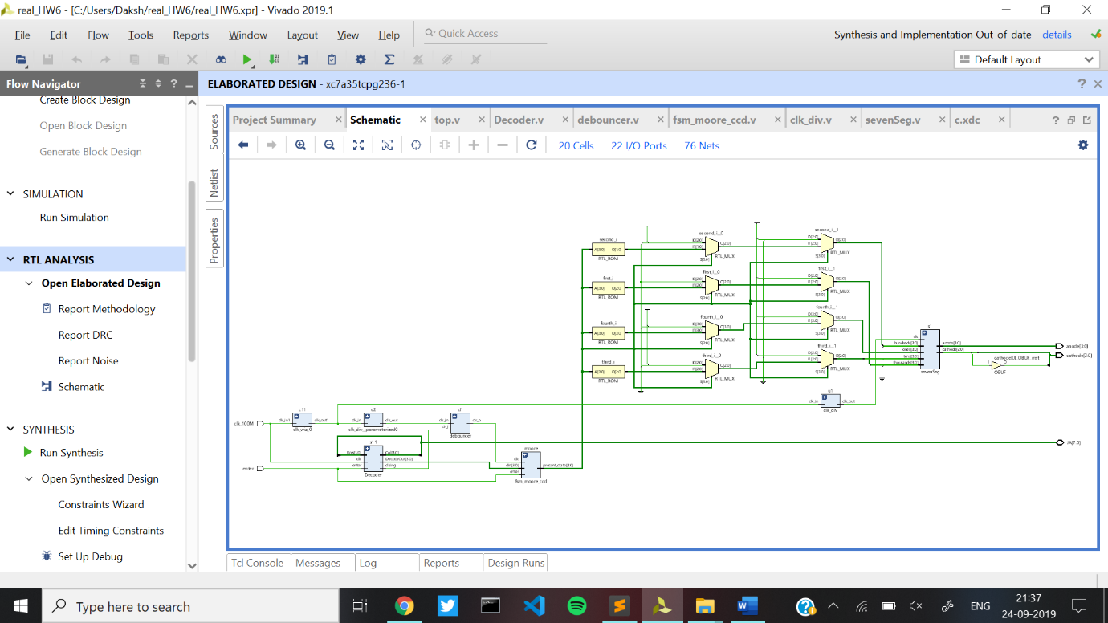

Synthesised Design-

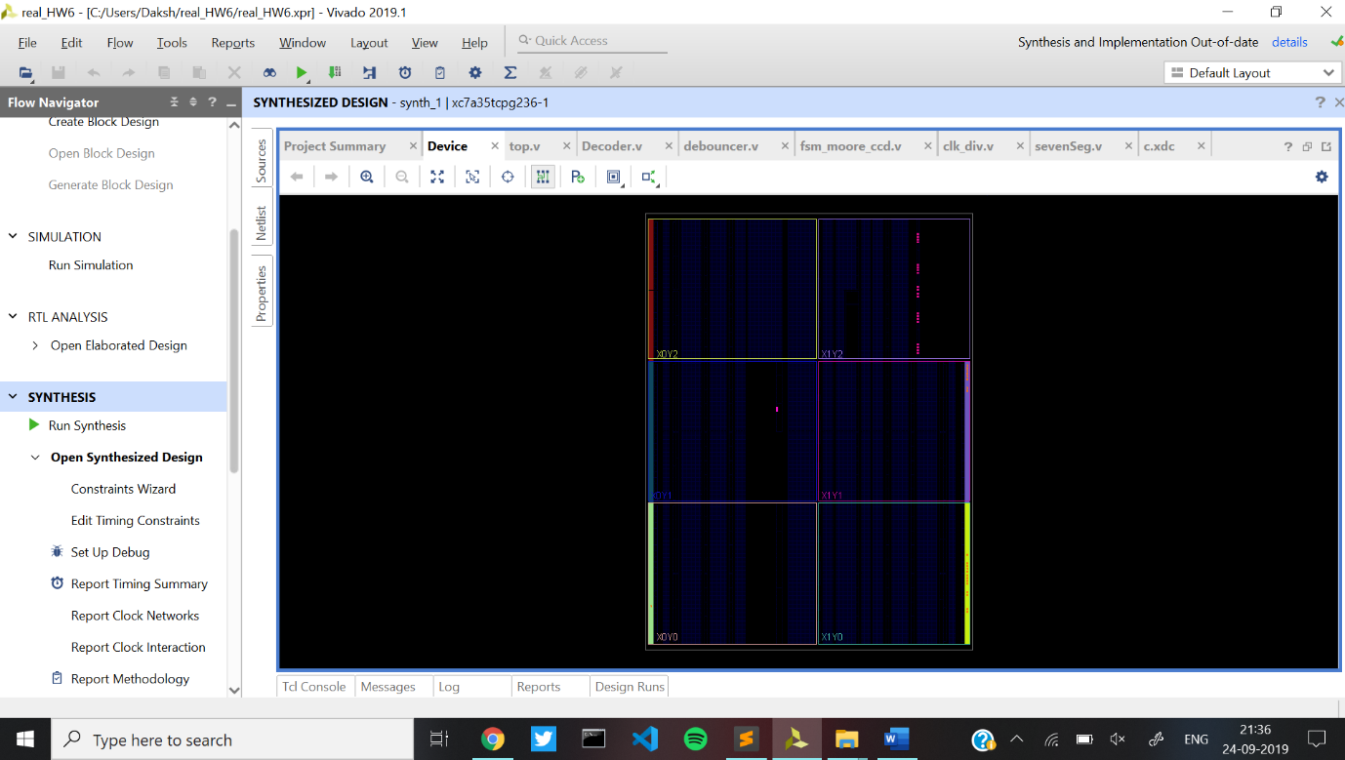

Implemented Design

