**HW8**

**-Daksh Thapar 2018137**

**-Tanmaya Gupta 2018200**

module top

#(

parameter integer C_S_AXIS_X_TDATA_WIDTH = 32,

parameter integer C_S_AXIS_T_TDATA_WIDTH = 32,

parameter integer C_S_AXIS_N_TDATA_WIDTH = 32

)

(

input s_aclk,

input s_aresetn,

input [C_S_AXIS_X_TDATA_WIDTH-1:0] s_x_tdata,

input s_x_tvalid,

input [C_S_AXIS_X_TDATA_WIDTH-1:0] s_alpha_tdata,

input s_alpha_tvalid,

input [C_S_AXIS_T_TDATA_WIDTH-1:0] s_t_tdata,

input s_t_tvalid,

input [C_S_AXIS_N_TDATA_WIDTH-1:0] s_n_tdata,

input s_n_tvalid,

output s_x_tready,

output s_t_tready,

output s_n_tready,

output s_alpha_tready,

output final_q_valid,

output [31:0] final_q

);

//1

wire float_x_valid, float_x_ready;

wire [31:0] float_x;

floating_point_0 fx(

.aclk(s_aclk),

.aresetn(s_aresetn),

.s_axis_a_tvalid(s_x_tvalid),

.s_axis_a_tready(s_x_tready),

.s_axis_a_tdata(s_x_tdata),

.m_axis_result_tvalid(float_x_valid),

.m_axis_result_tready(float_x_ready),

.m_axis_result_tdata(float_x)

);

//2

wire float_t_valid, float_t_ready;

wire [31:0] float_t;

floating_point_0 ft(

.aclk(s_aclk),

.aresetn(s_aresetn),

.s_axis_a_tvalid(s_t_tvalid),

.s_axis_a_tready(s_t_tready),

.s_axis_a_tdata(s_t_tdata),

.m_axis_result_tvalid(float_t_valid),

.m_axis_result_tready(float_t_ready),

.m_axis_result_tdata(float_t)

);

//3

wire float_n_valid, float_n_ready;

wire [31:0] float_n;

floating_point_0 fn(

.aclk(s_aclk),

.aresetn(s_aresetn),

.s_axis_a_tvalid(s_n_tvalid),

.s_axis_a_tready(s_n_tready),

.s_axis_a_tdata(s_n_tdata),

.m_axis_result_tvalid(float_n_valid),

.m_axis_result_tready(float_n_ready),

.m_axis_result_tdata(float_n)

);

//4

wire float_alpha_valid, float_alpha_ready;

wire [31:0] float_alpha;

floating_point_0 falpha(

.aclk(s_aclk),

.aresetn(s_aresetn),

.s_axis_a_tvalid(s_alpha_tvalid),

.s_axis_a_tready(s_alpha_tready),

.s_axis_a_tdata(s_alpha_tdata),

.m_axis_result_tvalid(float_alpha_valid),

.m_axis_result_tready(float_alpha_ready),

.m_axis_result_tdata(float_alpha)

);

//5

wire div1_valid,div1_ready;

wire [31:0] div1_data;

divide x_by_t(

.aclk(s_aclk),

.aresetn(s_aresetn),

.s_axis_a_tvalid(float_x_valid),

.s_axis_a_tready(float_x_ready),

.s_axis_a_tdata(float_x),

.s_axis_b_tvalid(float_t_valid),

.s_axis_b_tready(float_t_ready),

.s_axis_b_tdata(float_t),

.m_axis_result_tvalid(div1_valid),

.m_axis_result_tready(div1_ready),

.m_axis_result_tdata(div1_data)

);

//8

wire log1_valid, log1_ready;

wire [31:0] log1_data;

logarithm log_n(

.aclk(s_aclk),

.aresetn(s_aresetn),

.s_axis_a_tvalid(float_n_valid),

.s_axis_a_tready(float_n_ready),

.s_axis_a_tdata(float_n),

.m_axis_result_tvalid(log1_valid),

.m_axis_result_tready(log1_ready),

.m_axis_result_tdata(log1_data)

);

//14

wire mul3_valid, mul3_ready;

wire [31:0] mul3_data;

multiply alpha_into_lnn(

.aclk(s_aclk),

.aresetn(s_aresetn),

.s_axis_a_tvalid(float_alpha_valid),

.s_axis_a_tready(float_alpha_ready),

.s_axis_a_tdata(float_alpha),

.s_axis_b_tvalid(log1_valid),

.s_axis_b_tready(log1_ready),

.s_axis_b_tdata(log1_data),

.m_axis_result_tvalid(mul3_valid),

.m_axis_result_tready(mul3_ready),

.m_axis_result_tdata(mul3_data)

);

//7

wire div3_valid,div3_ready;

wire [31:0] div3_data;

divide two_lnn_by_t(

.aclk(s_aclk),

.aresetn(s_aresetn),

.s_axis_a_tvalid(mul3_valid),

.s_axis_a_tready(mul3_ready),

.s_axis_a_tdata(mul3_data),

.s_axis_b_tvalid(float_t_valid),

// .s_axis_b_tready(float_t_ready),

.s_axis_b_tdata(float_t),

.m_axis_result_tvalid(div3_valid),

.m_axis_result_tready(div3_ready),

.m_axis_result_tdata(div3_data)

);

//12

wire mul1_valid, mul1_ready;

wire [31:0] mul1_data;

multiply m_into_m(

.aclk(s_aclk),

.aresetn(s_aresetn),

.s_axis_a_tvalid(div1_valid),

.s_axis_a_tready(div1_ready),

.s_axis_a_tdata(div1_data),

.s_axis_b_tvalid(div1_valid),

// .s_axis_b_tready(div1_ready),

.s_axis_b_tdata(div1_data),

.m_axis_result_tvalid(mul1_valid),

.m_axis_result_tready(mul1_ready),

.m_axis_result_tdata(mul1_data)

);

//9

wire sub1_valid,sub1_ready;

wire [31:0] sub1_data;

subtract m_minus_msquare(

.aclk(s_aclk),

.aresetn(s_aresetn),

.s_axis_a_tvalid(div1_valid),

// .s_axis_a_tready(div1_ready),

.s_axis_a_tdata(div1_data),

.s_axis_b_tvalid(mul1_valid),

.s_axis_b_tready(mul1_ready),

.s_axis_b_tdata(mul1_data),

.m_axis_result_tvalid(sub1_valid),

.m_axis_result_tready(sub1_ready),

.m_axis_result_tdata(sub1_data)

);

//16

wire sr2_valid, sr2_ready;

wire [31:0] sr2_data;

sqr_root two_ln_n_by_t(

.aclk(s_aclk),

.aresetn(s_aresetn),

.s_axis_a_tvalid(div3_valid),

.s_axis_a_tready(div3_ready),

.s_axis_a_tdata(div3_data),

.m_axis_result_tvalid(sr2_valid),

.m_axis_result_tready(sr2_ready),

.m_axis_result_tdata(sr2_data)

);

//11

wire add2_valid, add2_ready;

wire [31:0] add2_data;

add minus_msquare_plus_blah(

.aclk(s_aclk),

.aresetn(s_aresetn),

.s_axis_a_tvalid(sub1_valid),

.s_axis_a_tready(sub1_ready),

.s_axis_a_tdata(sub1_data),

.s_axis_b_tvalid(sr2_valid),

.s_axis_b_tready(sr2_ready),

.s_axis_b_tdata(sr2_data),

.m_axis_result_tvalid(add2_valid),

.m_axis_result_tready(add2_ready),

.m_axis_result_tdata(add2_data)

);

//13

wire mul2_valid, mul2_ready;

wire [31:0] mul2_data;

multiply blah_into_t(

.aclk(s_aclk),

.aresetn(s_aresetn),

.s_axis_a_tvalid(add2_valid),

.s_axis_a_tready(add2_ready),

.s_axis_a_tdata(add2_data),

.s_axis_b_tvalid(float_t_valid),

// .s_axis_b_tready(float_t_ready),

.s_axis_b_tdata(float_t),

.m_axis_result_tvalid(mul2_valid),

.m_axis_result_tready(mul2_ready),

.m_axis_result_tdata(mul2_data)

);

//6

wire div2_valid,div2_ready;

wire [31:0] div2_data;

divide lnn_by_blah(

.aclk(s_aclk),

.aresetn(s_aresetn),

.s_axis_a_tvalid(log1_valid),

// .s_axis_a_tready(log1_ready),

.s_axis_a_tdata(log1_data),

.s_axis_b_tvalid(mul2_valid),

.s_axis_b_tready(mul2_ready),

.s_axis_b_tdata(mul2_data),

.m_axis_result_tvalid(div2_valid),

.m_axis_result_tready(div2_ready),

.m_axis_result_tdata(div2_data)

);

//15

wire sr1_valid, sr1_ready;

wire [31:0] sr1_data;

sqr_root blah(

.aclk(s_aclk),

.aresetn(s_aresetn),

.s_axis_a_tvalid(div2_valid),

.s_axis_a_tready(div2_ready),

.s_axis_a_tdata(div2_data),

.m_axis_result_tvalid(sr1_valid),

.m_axis_result_tready(sr1_ready),

.m_axis_result_tdata(sr1_data)

);

//10

add m_plus_blah(

.aclk(s_aclk),

.aresetn(s_aresetn),

.s_axis_a_tvalid(div1_valid),

// .s_axis_a_tready(div1_ready),

.s_axis_a_tdata(div1_data),

.s_axis_b_tvalid(sr1_valid),

.s_axis_b_tready(sr1_ready),

.s_axis_b_tdata(sr1_data),

.m_axis_result_tvalid(final_q_valid),

.m_axis_result_tready(1),

.m_axis_result_tdata(final_q)

);

endmodule

module testbench(

);

reg s_aclk = 0;

always #5 s_aclk = ~ s_aclk;

reg s_aresetn = 0;

reg [31:0] x_tdata;

reg x_tvalid;

reg [31:0] t_tdata;

reg t_tvalid;

reg [31:0] n_tdata;

reg n_tvalid;

reg [31:0] alpha_tdata;

reg alpha_tvalid;

wire final_q_valid;

wire [31:0] final_q;

top

#(

.C_S_AXIS_X_TDATA_WIDTH(32),

.C_S_AXIS_T_TDATA_WIDTH(32),

.C_S_AXIS_N_TDATA_WIDTH(32)

)

t1(

.final_q_valid(final_q_valid),

.final_q(final_q),

.s_aclk(s_aclk),

.s_aresetn(s_aresetn),

.s_x_tvalid(x_tvalid),

.s_x_tdata(x_tdata),

.s_t_tvalid(t_tvalid),

.s_t_tdata(t_tdata),

.s_n_tvalid(n_tvalid),

.s_n_tdata(n_tdata),

.s_alpha_tvalid(alpha_tvalid),

.s_alpha_tdata(alpha_tdata)

);

initial

begin

#0 s_aresetn=0;

x_tdata = 32'd0;

t_tdata = 32'd0;

n_tdata = 32'd0;

alpha_tdata = 32'd0;

#100 s_aresetn = 1;

#10 x_tdata = 32'd4;

t_tdata = 32'd2;

n_tdata = 32'd100;

alpha_tdata = 32'd2;

#4 x_tvalid = 1;

t_tvalid = 1;

n_tvalid = 1;

alpha_tvalid = 1;

#4 x_tvalid = 0;

t_tvalid = 0;

n_tvalid = 0;

alpha_tvalid = 0;

end

endmodule

**My TestBench-**

X=4

T=2

N=100

Alpha=2

Calculated correct value-

**=5.97175…**

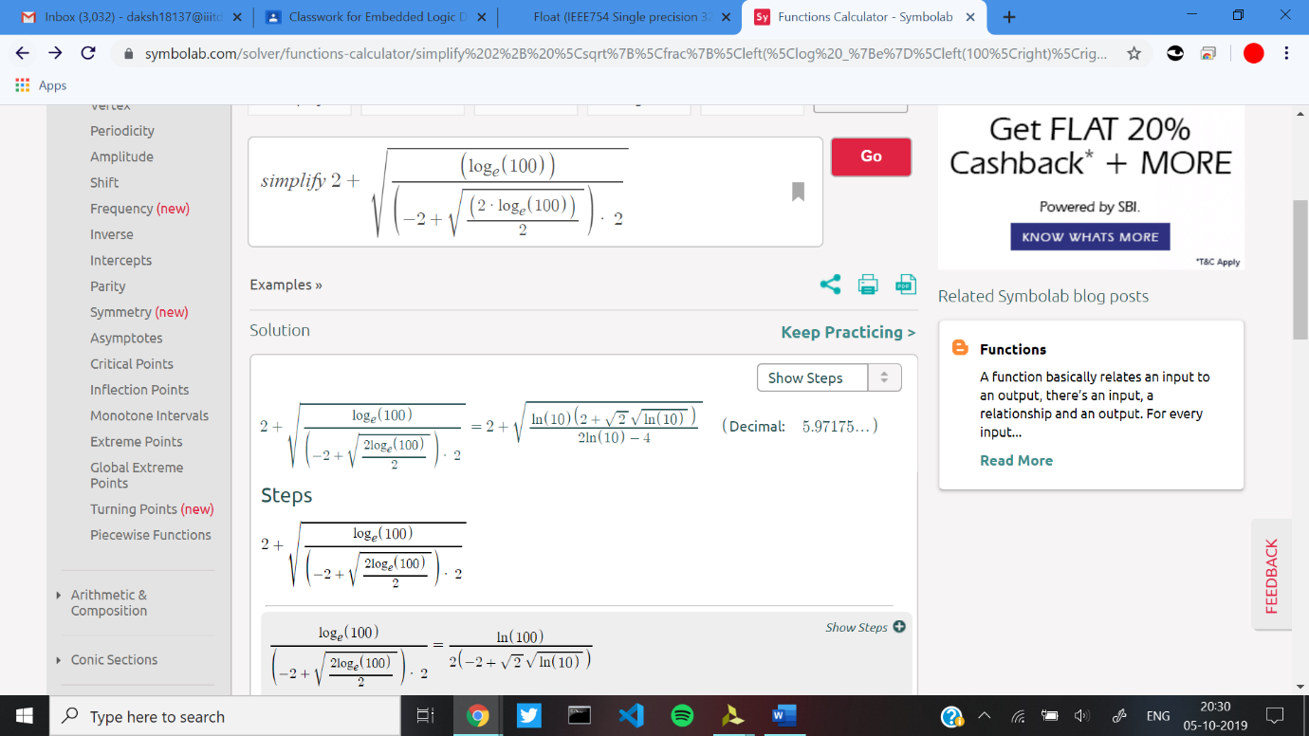

Observed Value-

**=5.97175312042236328125**

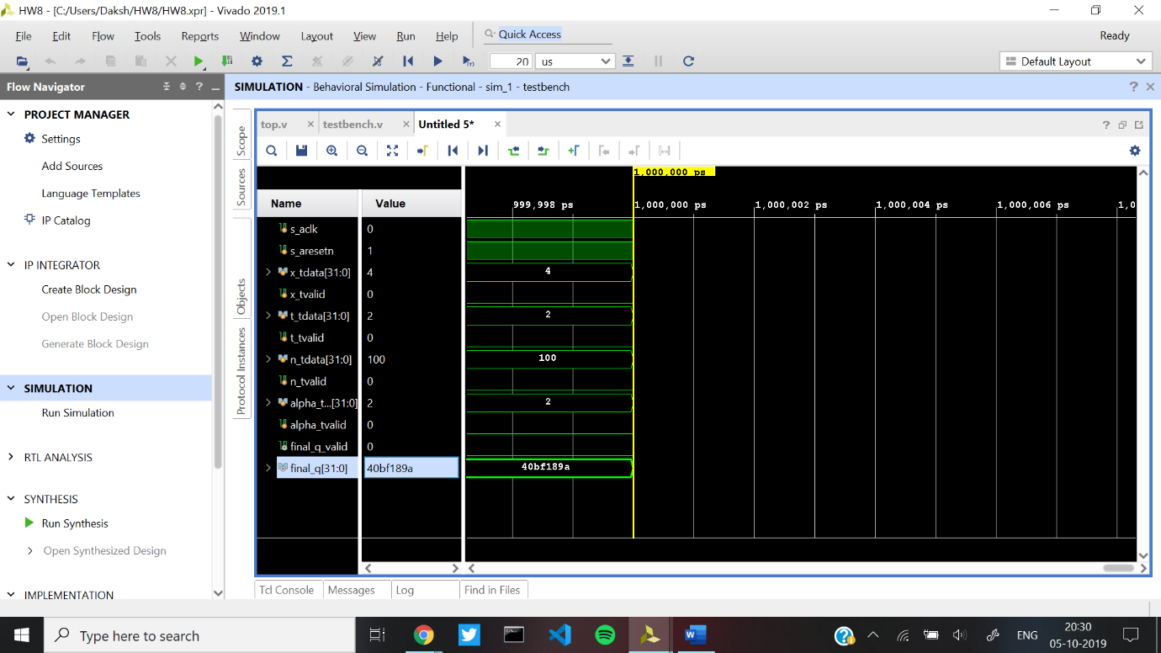

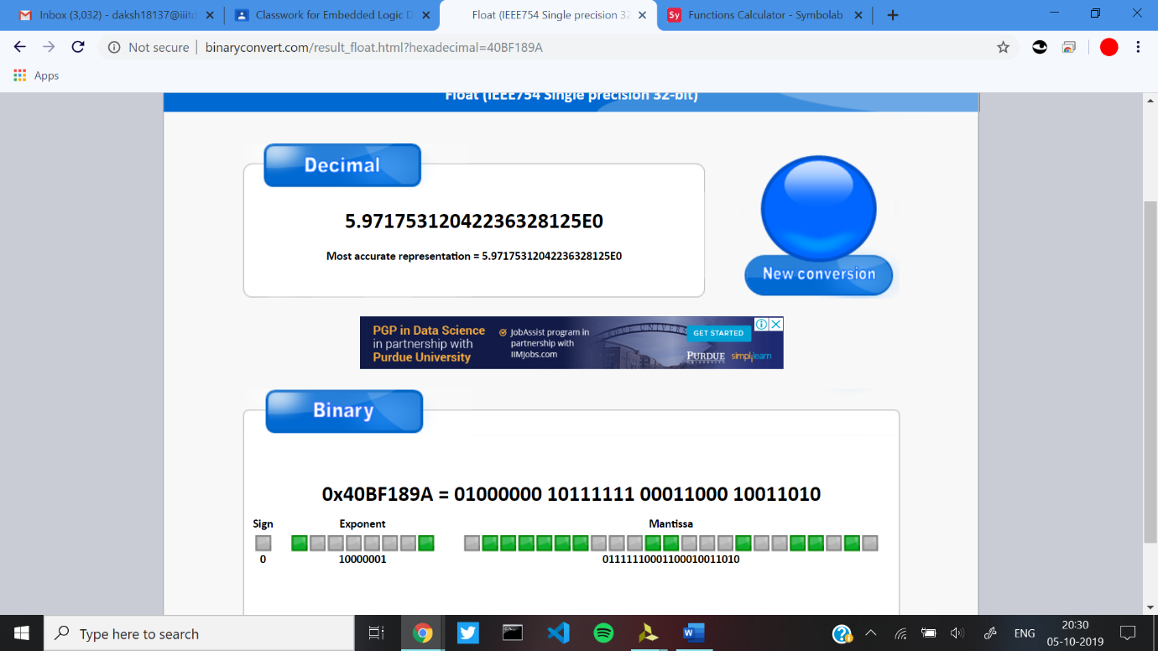

Elaborated Design-

­­