**Report**

Sampling Frequency- 6000hz (6kHz)

Time for Input signal- 1s

* 6000 values of Input

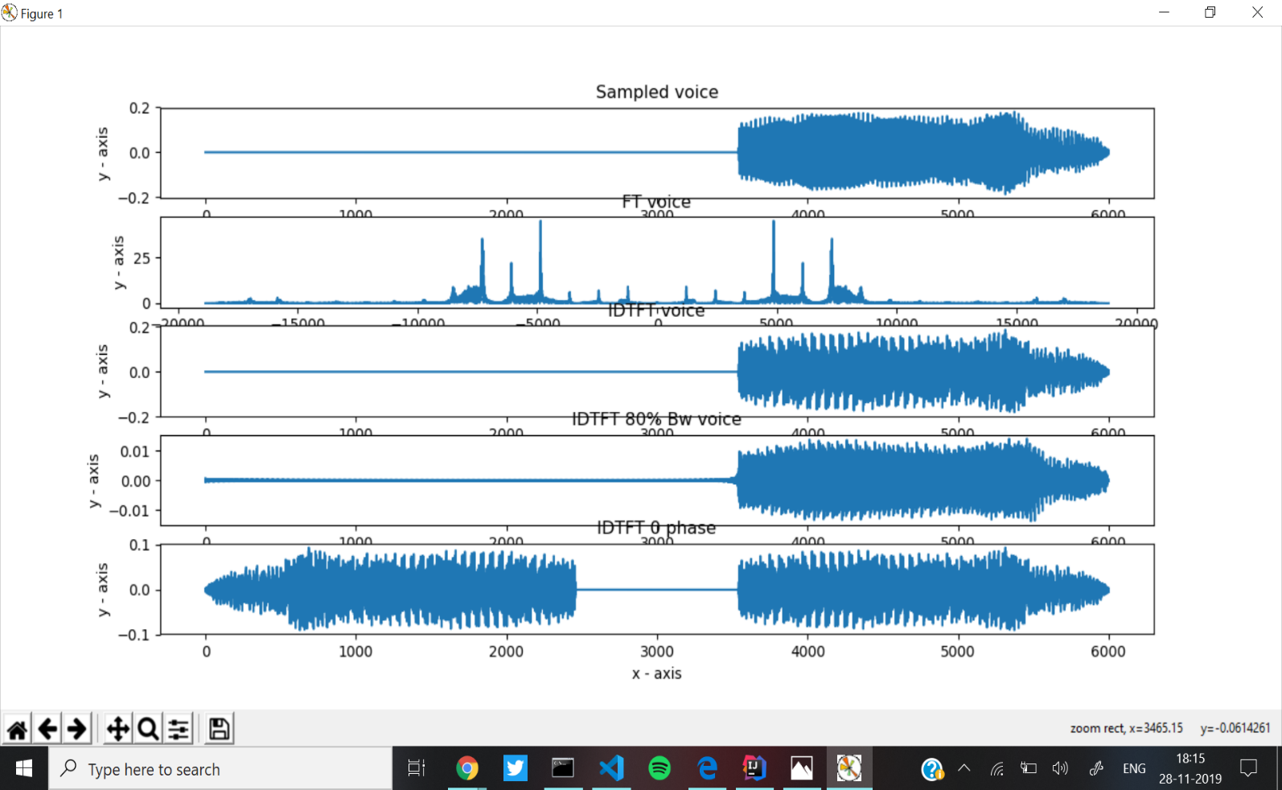

If we observe FT domain plot, last value of w at which signal peaks is ~7400rad from the center 0rad.

=>7400x 80%= 5920rad.

=>5920/2pi= 942.19Hz ~ 942Hz

If signal is from 0 to 6000Hz

So now we take signal from (3000-942) to (3000+942)

* 2058Hz to 3942Hz

**Part 6-**

If we reduce the Bandwidth, some of the higher frequencies causing noise get removed, this can be seen from the peaks in graphs 3 and 4, in 4 the peak is much lower, and also the shape of the graph changes slightly as some frequencies that contributed to the signal were removed.

**Part 7-**

Phase response 0 means we only plot the real part of the signal vs time, i.e. imaginary part of the whole signal becomes 0, which leads us to the last graph.

-Daksh Thapar

2018137, Grp 2