THE GEORGE WASHINGTON UNIVERSITY
School of Engineering and Applied Science
Department of Computer Science

Preliminary Design Report

for the

Isometric Real-time Simulation Engine and Demo,
Project: SciSearch

By

David Kahler

CSci 195-11
Senior Computer Science Design Project
October 8, 2003

ABSTRACT

Abstract of the Preliminary Design Report for the
Isometric Real-time Simulation Engine and Demo, Project: SciSearch
by
David Kahler

This report is the preliminary design of an isometric real-time simulation game, tentatively titled “Project: SciSearch.” The program allows the player to build a simulated research laboratory, and subsequently manage the laboratory, hire employees, and negotiate positive and negative simulation events. The program consists of three main modules, each of which is divided into smaller sub-modules. The three main modules are display, interface, and simulation. Display controls graphical output to the screen, interface controls the means by which the user interacts with the system, and simulation executes the real-time processes of the game. The program will run on the Game Boy Advance platform. This platform has ten means of input: four directional arrows and six buttons. It has a 240x160 pixel screen capable of displaying 32,000 colors. It also contains 256KB of RAM and up to 32MB of secondary EEPROM on a removable cartridge.

The project will require 36 weeks to complete and will expend an estimated 714 person hours of labor at an estimated total labor cost of $27,440. The Critical Design Review will be on November 5, 2003, and the Final Design should be completed by December 3, 2003. A working prototype should be available by April 21, 2004. Estimated total cost for the prototype is $92,198. A preliminary Economic Analysis has determined that we will sell about 100,000 copies of this program at a cost to the company of $10.08 per copy, shipped on a GBA cartridge, including indirect costs, A & G costs, and a 20% profit. Estimated retail price for the program is $26.44. We will recuperate our prototype costs with the sale of the first 20,000 programs and we estimate a total profit of approximately $323,518. To date, an expenditure of $4,950 has been made to develop this design.

TABLE OF CONTENTS

ABSTRACT ii
LIST OF FIGURES iv
LIST OF TABLES v
LIST OF APPENDICES vi
1 INTRODUCTION 1
2 DESCRIPTION 2
3 SPECIFICATIONS 8
4 INTERFACE MOCKUP 9
5 TESTS TO VERIFY DESIGN AND IMPLEMENTATION 10
6 TIME AND COST ANALYSIS 11
7 LABOR COSTS VS. TIME GRAPH 12
8 COMPARATIVE MARKET SURVEY 13
9 ECONOMIC ANALYSIS 14
10 STATUS MATRICES 16
11 CONCLUSIONS 20
Appendix A – Task Table A
Appendix B – Gantt Chart D

LIST OF FIGURES

Figure 1: Main Module Summary 2
Figure 2: Display Module 3
Figure 3: Interface Module 4
Figure 4: Simulation Module 5
Figure 5: Data Flow 7
Figure 6: Interface Mockup 9
Figure 7: Labor Costs vs. Time 12

LIST OF TABLES

Table 1: Prototype Costs 14
Table 2: Profits 15
Table 3: Outline Matrix 16
Table 4: Design Matrix 16
Table 5: Construct Matrix 17
Table 6: Integrate Matrix 17
Table 7: Test Matrix 18
Table 8: Document Matrix 18
Table 9: Total Matrix 19

LIST OF APPENDICES

Appendix A – Task Table A
Appendix B – Gantt Chart D
.
- INTRODUCTION

Project: SciSearch is centered around the concept of a functioning scientific research laboratory. The player is in charge of constructing, maintaining, and managing the research laboratory. To accomplish this task, three game modes will be provided for the player: construction, purchasing, and management. These three modes interact to form a seamless gaming experience. For example, the player must first purchase a new development laboratory, construct it in the desired location, and finally manage its team of scientists and research capabilities.

The game does not have a “finish”; the simulation simply continues until the player turns off the machine. This provides maximum replayability, as well as very long playtimes. Long playtimes are an essential component of a handheld game, as such devices tend to be taken on long trips where extended entertainment may be necessary.

The prototype being developed for Project: SciSearch includes an engine and a demo. The engine will have all the functionality needed to incorporate a full, finished game after the completion of the prototype. In order to demonstrate the functionality of the engine, a limited amount of game content will be created as a part of the module construction process. The economic analysis for sales of the product is based on the sales of the final game
- DESCRIPTION

Project: SciSearch has three main modules, Display, Interface, and Simulation, as shown in Figure 1. Display controls all aspects of the graphical display, including the four graphical layers that interpose on top of each other. The interface module is rendered at the top of the display, and facilitates the user’s interaction with the gaming environment. Finally, the simulation module actually runs the game, keeps track of game time, and allows the game units to interact appropriately.

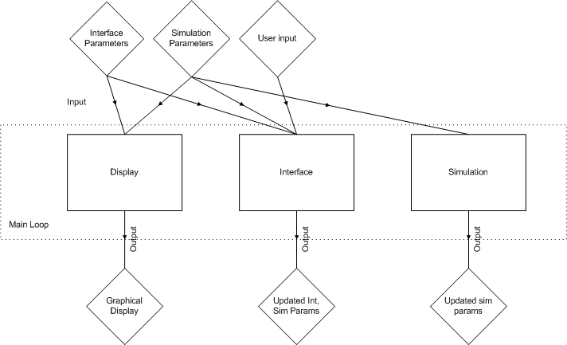
Figure 1: Main Module Summary

As shown in Figure 2, the Display module takes as input the interface and simulation parameters, and the isometric display is its output. The display is further divided into four sub-modules, or graphical layers, Ground, Objects, Non-Playable Character (NPC), and Interface. The Ground layer controls the repeated tiling graphics that are placed beneath all other graphics to simulate the foundation of the virtual space. The Objects layer represents any inanimate objects which reside above the ground, such as office space, tables and chairs. The NPC layer draws the current position and states of all “living” objects in the world, such as people and animals. Finally, the Interface layer is a 2D overlay that is drawn over top of the rest of the graphics, and is the means by which the user interacts with the system.

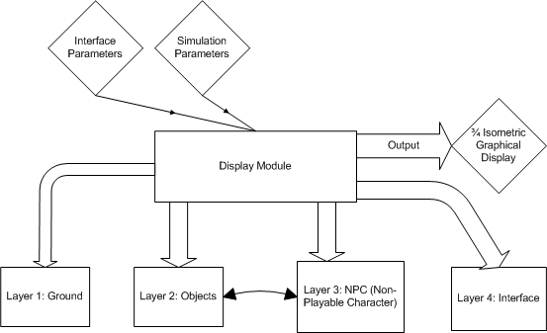
Figure 2: Display Module

As shown in Figure 3, the Interface module has the interface parameters, simulation parameters, and user input as its input. The Interaction Modes sub-module chooses which mode to run based on these parameters. Each mode consists of several sub-modes which assist the user in the navigation of the interface. Construction mode allows the user to access the current list of purchased items and place these items in the world using the Build sub-mode. Purchasing mode allows the user to select an item to purchase from a category-organized listing of available items. Finally, Management mode allows the user to edit existing objects in the world. These modes also include help menus to assist the user with any questions he or she may have. The modes send their changes to the Flag Updater, which integrates them back into the interface and simulation parameter structures.

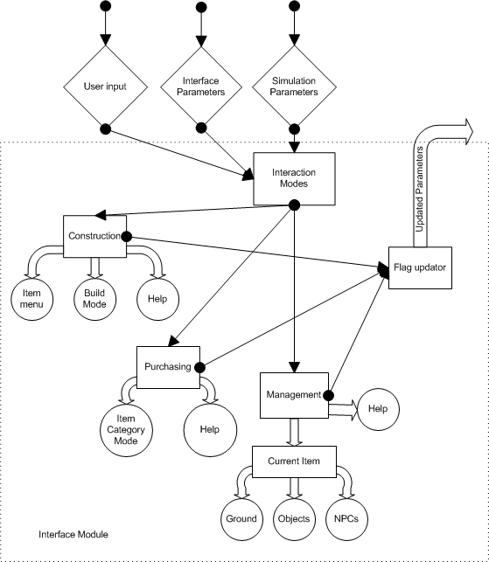
Figure 3: Interface Module

As shown in Figure 4, the Simulation module is comprised of two sub-modules, Environment Interaction and AI Management. These sub-modules are run by the main Simulation module, and they use the simulation parameters for their data. The Environment Interaction sub-module processes the data it receives from its own sub-modules. These sub-modules are currently Risk Level, Profitability, Upkeep, Level, Money, and Time.

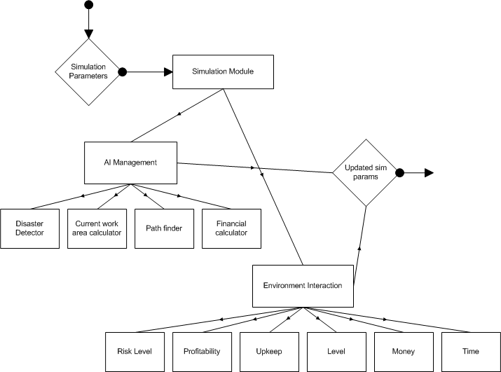
Figure 4: Simulation Module

Risk Level is calculated on a per-cell basis (where a cell is one position in the 2D simulation grid). The tentative calculation to achieve the current cell’s risk level is as follows:

Object over cell risk (type of object + upkeep) +
Object x₁+x₂+…+x_{n} object risk (where x is any object within radius y of cell) +
Floor type risk (e.g. carpet, concrete, etc.) +

Profitability is calculated on a per-object basis, and its calculation is tentatively based on the following structure:

Number of employees assigned factor +
Object risk factor +
Object level factor +
Funding factor

Upkeep is calculated on a per-object basis, and its calculation is tentatively based on the following structure:

Object funding factor +
Current upkeep +
Time decay factor

Level is calculated on a per-object basis. It represents how technologically advanced the current object is. This factor is user-upgradeable, given the appropriate amount of money and technology.

Money is the gross financial sum the user currently has to spend, and is influenced by Profitability and the spending habits of the user.

Time is the real-time clock that is continuously updated on a per-frame basis.

The AI Management module controls every aspect of the behavior of the NPCs. It is subdivided into four sub-modules, Disaster Detector, Current Work Area Calculator, Path Finder, and Financial Calculator.

The tentative formula for triggering a disaster will be calculated as follows:

Cell x risk (cell currently occupied by NPC) +
AI Risk
Earnings +
Education +
Time at company

This number is then multiplied by a percentage likelihood of a disaster happening on any given frame. For example, each frame may have a disaster likelihood of 0.0005%. If this product crosses a defined threshold, a disaster event is triggered.

The Current Work Area Calculator is based around a time loop which cycles the area the NPC should currently be occupying. For example, the NPC may occupy its assigned work area for three hours, then move to the cafeteria, then move back to the work area, and continue.

The path finder will be run whenever the Current Work Area Calculator changes the current work area and the NPC is not in the correct work area. The path finder will use the heuristic A* algorithm to find the optimal path from its current node to the goal node, and this path will be used to traverse the simulation area.

The financial calculator for each NPC simply uses the information stored about the NPC’s current salary and subtracts it over time from the gross Money total.

Figure 5 represents the logical data flow within the Project: SciSearch program structure. The main program loop calls each sub-module, and the appropriate parameters flow from each module to the next, finally returning to begin the loop again.

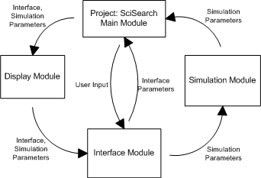
Figure 5: Data Flow
- SPECIFICATIONS

The Project: SciSearch game is a real-time simulation designed to execute on Nintendo’s Game Boy Advance (GBA) platform. The goal of the game is to provide an entertaining experience for the user for long, continuous timeframes. To use the final product, the following hardware is required:

Nintendo Game Boy Advance or Game Boy Advance SP
Project: SciSearch game cartridge
Batteries or AC adaptor

In addition to the development of the final product, a functional engine must be built for the Project: SciSearch game logic to wrap around. In order to use and develop the engine for the game, the following hardware and software are required:

Microsoft Visual Studio 6.0 (Visual C++ 6.0)
Microsoft Windows PC capable of running Visual C++ 6.0
Nintendo Game Boy Advance .ROM Emulator (for testing)
- INTERFACE MOCKUP

Figure 6 demonstrates the expected look and functionality of the interface. The mode is chosen by the mode wheel at the lower left. Some of the more important simulation parameters are displayed in bar form above the mode wheel. There is also a status bar output that alerts the player to important events. To the right of the status bar, the Money and Time parameters are displayed, and finally there is a zoomed-out view of the map. The game play area occupies the largest portion of the display.

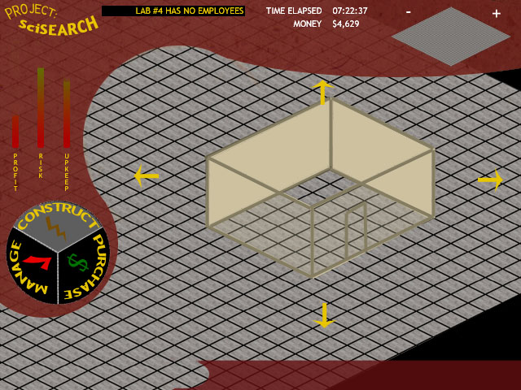
Figure 6: Interface Mockup

- TESTS TO VERIFY DESIGN AND IMPLEMENTATION

The functionality tests for the program are divided into the three main modules:

Display Module:
- Test scrolling capability; do previously hidden areas properly render? Does the screen stop scrolling when the end of the map is reached?
- Test depth algorithm; do objects properly render on top of ground? Do NPCs properly render with respect to objects? Does interface always render on top of everything?
- Test rendering speed; does speed update at an acceptable real-time rate? Is scrolling responsive? Does the selection system allow quick selection of any given item (where quick is defined as less than two seconds)?

Interface Module:
1) Systematically test all components in all three modes; do all links go to proper places?
2) Do the followed links then return the game to the proper state afterward?
3) Do all interface options properly set environment variables for the simulation and display modules to use?

Simulation Module:
1) Does user input properly control all three modules together?
2) Do the various environment objects and NPCs react properly to changes in the game state?
3) Does the AI behave in a believable manner?
a) Do NPCs refrain from walking through objects?
b) Do disasters happen at an acceptable rate (e.g. once a month in game-world time)?

- TIME AND COST ANALYSIS

Appendix A shows the Task Table that shows the estimated time and cost analysis for this project. It is separated into numerous sections, PPR, PDR, CDR, FDR, Build and Test Phase 1, Build and Test Phase 2, Test, Integrate and Document Phase, and finally the Final Review. Each of the stages is dependent on the previous stage to begin development. Appendix B is the Gantt chart representation of this data. These charts visually demonstrate the total prototype development time of 714 hours, at a cost of $27,440. The Gantt chart shows how each section of the project is divided, and how much of the total time each section occupies.
- LABOR COSTS VS. TIME GRAPH

Figure 7 shows the estimated cost trend over the course of the development of this project.

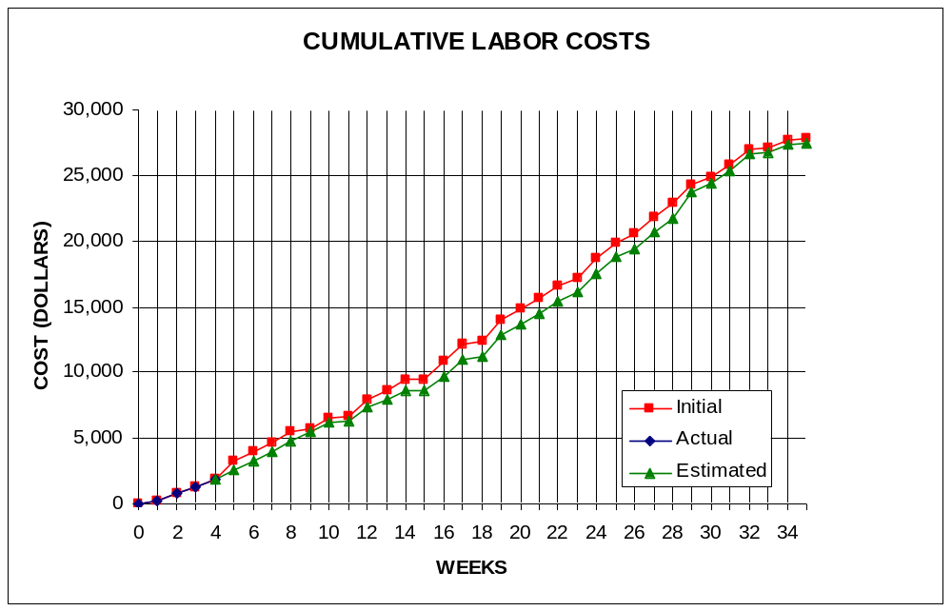
David Kahler
Figure 7: Labor Costs vs. Time
- COMPARATIVE MARKET SURVEY

Several products currently on the market for the Game Boy Advance use similar game play features and techniques as Project: SciSearch, although Project: SciSearch still maintains many unique features. The top GBA titles on the market sell upwards of 100,000 copies. The products currently on the market include:

Advance Wars (54,000 sold – 7/2003)
A turn-based war strategy game, Advance Wars is one of the most popular and successful Game Boy Advance games currently on the market. It uses a top-down view, which is similar in function to Project: SciSearch’s ¾ view. The continuously-flowing nature of the game is also similar to Project: SciSearch’s model.

Jurassic Park III – Park Builder (Number sold unavailable)
This game is very similar in function to Project: SciSearch, although its premise differs significantly. The player is charged with creating a virtual Jurassic Park, similar to the park in the movie of the same title. The player then works to maintain and expand the park. This game also uses an isometric view with an angle similar to Project: SciSearch’s ¾ angle.

Sim City 2000 (Not yet available)
A classic game ported to the Game Boy Advance, Sim City 2000 is largely credited with starting the “God-simulation”-type game genre craze. In Sim City 2000, the player is the mayor of a growing city and must control aspects such as building construction, transportation, waste disposal, and tourism. Like Project: SciSearch, this game also has no set “ending”.

- ECONOMIC ANALYSIS

Table 1 and Table 2 demonstrate the projected costs of the prototype development for Project: SciSearch, and the projected company profits, respectively.

Table 1: Prototype Costs
PERSON | LABOR RATE | INITIAL EST. HRS. | INITIAL EST. COST | CURRENT EST. HRS. | CURRENT EST. COST
COMP. SYSTEMS ANALYST | $45.00 | 150 | $6,750.00 | 143 | $6,435.00
COMP. PROGRAMMER | $40.00 | 204 | $8,160.00 | 204 | $8,160.00
TEST PROGRAMMER | $35.00 | 104 | $3,640.00 | 99 | $3,465.00
TECHNICAL WRITER | $35.00 | 271 | $9,485.00 | 268 | $9,380.00
SUBTOTAL |  | 729 | $28,035.00 | 714 | $27,440.00
ENGINE @ 70% |  | 510 | $19,624.50 | 500 | $19,208.00
GAME @ 30% |  | 219 | $8,410.50 | 214 | $8,232.00
DIRECT OVERHEAD @ 100% |  |  | $28,035.00 |  | $27,440.00
SUBTOTAL |  |  | $56,070.00 |  | $54,880.00
A & G COSTS @ 40% |  |  | $22,428.00 |  | $21,952.00
SUBTOTAL |  |  | $78,498.00 |  | $76,832.00
PROFIT @ 20% |  |  | $15,699.60 |  | $15,366.40
TOTAL COST OF PROTOTYPE |  |  | $94,197.60 |  | $92,198.40

Table 2: Profits
SELL CARTRIDGES TO A WHOLESELLER
SELL CARTRIDGE
HARDWARE PRODUCES 10 CARTRIDGES AT A TIME
COSTS | RATE | HOURS | INITIAL COST/COPY |  | CURRENT COST/COPY
CONSTRUCTION TIME | $20.00 | 0.25 | $0.50 |  | $0.50
SUBTOTAL DIRECT LABOR |  |  | $0.50 |  | $0.50
INDIRECT OVERHEAD @ 100% |  |  | $0.50 |  | $0.50
SUBTOTAL |  |  | $1.00 |  | $1.00
DOCUMENTATION |  |  | $2.00 |  | $2.00
PACKAGING |  |  | $3.00 |  | $3.00
SUBTOTAL |  |  | $6.00 |  | $6.00
A & G @ 40% |  |  | $2.40 |  | $2.40
SUBTOTAL |  |  | $8.40 |  | $8.40
PROFIT @ 20% |  |  | $1.68 |  | $1.68
SUBTOTAL |  |  | $10.08 |  | $10.08
RECOUP COST OF PROTOTYPE | COSTS | UNITS TO
 |  | SELL
INITIAL | $94,197.60 | 100000 | $4.71
CURRENT | $92,198.40 | 100000 |  |  | $4.61
RECOUP OVER |  | 20000
MANUFACTURING COSTS |  |  | $14.79 |  | $14.69
WHOLESALE MARKUP @ 20% |  |  | $2.96 |  | $2.94
SUBTOTAL |  |  | $17.75 |  | $17.63
RETAIL MARKUP @ 50% |  |  | $8.87 |  | $8.81
TOTAL RETAIL COST |  |  | $26.62 |  | $26.44
PROFIT (ON FIRST 20,000) |  |  | $33,600.00 |  | $33,600.00
PROFIT (ON THE REST) |  |  | $292,708.08 |  | $289,918.72
TOTAL PROFIT |  |  | $326,308.08 |  | $323,518.72

- STATUS MATRICES

This report concentrates on the initial design of the project. This design process is documented in Table 4 below. The report documentation time is shown in Table 8. The remaining tables represent future development stages of the project which have not yet begun, and Table 9 is the gross totals of all previous tables.

Table 3: Outline Matrix
OUTLINE | INT EST LOC | INT EST HOURS | CUR EST LOC | CUR EST HRS | WORK TO-DATE HRS | % WORK COMP | TIME TO COMP HRS
DISPLAY | 2000 | 13 | 2000 | 13 | 13 | 100 | 0
GROUND | 500 | 4 | 500 | 4 | 4 | 100 | 0
OBJECTS | 500 | 3 | 500 | 3 | 3 | 100 | 0
NPC | 500 | 3 | 500 | 3 | 3 | 100 | 0
INTERFACE | 500 | 3 | 500 | 3 | 3 | 100 | 0
INTERFACE | 2500 | 12 | 2500 | 12 | 12 | 100 | 0
CONSTRUCT | 500 | 3 | 500 | 3 | 3 | 100 | 0
PURCHASE | 500 | 3 | 500 | 3 | 3 | 100 | 0
MANAGE | 500 | 4 | 500 | 4 | 4 | 100 | 0
INPUT | 1000 | 2 | 1000 | 2 | 2 | 100 | 0
SIMULATION | 3000 | 8 | 3000 | 8 | 8 | 100 | 0
ENVIRON | 1500 | 4 | 1500 | 4 | 4 | 100 | 0
AI | 1500 | 4 | 1500 | 4 | 4 | 100 | 0
TOTALS | 7500 | 33 | 7500 | 33 | 33 | 100 | 0

Table 4: Design Matrix
DESIGN | INT EST LOC | INT EST HOURS | CUR EST LOC | CUR EST HRS | WORK TO-DATE HRS | % WORK COMP | TIME TO COMP HRS
DISPLAY | 2000 | 60 | 2000 | 47 | 20 | 43 | 27
GROUND | 500 | 15 | 500 | 12 | 5 | 42 | 7
OBJECTS | 500 | 15 | 500 | 12 | 5 | 42 | 7
NPC | 500 | 15 | 500 | 12 | 3 | 25 | 9
INTERFACE | 500 | 15 | 500 | 11 | 7 | 64 | 4
INTERFACE | 2500 | 60 | 2500 | 31 | 11 | 35 | 20
CONSTRUCT | 500 | 15 | 500 | 7 | 2 | 29 | 5
PURCHASE | 500 | 15 | 500 | 7 | 2 | 29 | 5
MANAGE | 500 | 15 | 500 | 7 | 2 | 29 | 5
INPUT | 1000 | 15 | 1000 | 10 | 5 | 50 | 5
SIMULATION | 3000 | 40 | 3000 | 26 | 15 | 58 | 11
ENVIRON | 1500 | 20 | 1500 | 14 | 7 | 50 | 7
AI | 1500 | 20 | 1500 | 12 | 8 | 67 | 4
TOTALS | 7500 | 160 | 7500 | 104 | 46 | 44 | 58

Table 5: Construct Matrix
CONSTRUCT | INT EST LOC | INT EST HOURS | CUR EST LOC | CUR EST HRS | WORK TO-DATE HRS | % WORK COMP | TIME TO COMP HRS
DISPLAY | 2000 | 52 | 2000 | 32 | 0 | 0 | 32
GROUND | 500 | 13 | 500 | 8 | 0 | 0 | 8
OBJECTS | 500 | 13 | 500 | 8 | 0 | 0 | 8
NPC | 500 | 13 | 500 | 8 | 0 | 0 | 8
INTERFACE | 500 | 13 | 500 | 8 | 0 | 0 | 8
INTERFACE | 2500 | 128 | 2500 | 51 | 0 | 0 | 51
CONSTRUCT | 500 | 30 | 500 | 12 | 0 | 0 | 12
PURCHASE | 500 | 30 | 500 | 12 | 0 | 0 | 12
MANAGE | 500 | 30 | 500 | 12 | 0 | 0 | 12
INPUT | 1000 | 38 | 1000 | 15 | 0 | 0 | 15
SIMULATION | 3000 | 76 | 3000 | 56 | 0 | 0 | 56
ENVIRON | 1500 | 38 | 1500 | 28 | 0 | 0 | 28
AI | 1500 | 38 | 1500 | 28 | 0 | 0 | 28
TOTALS | 7500 | 256 | 7500 | 139 | 0 | 0 | 139

Table 6: Integrate Matrix
INTEGRATE | INT EST LOC | INT EST HOURS | CUR EST LOC | CUR EST HRS | WORK TO-DATE HRS | % WORK COMP | TIME TO COMP HRS
DISPLAY | 2000 | 12 | 2000 | 40 | 0 | 0 | 40
GROUND | 500 | 3 | 500 | 10 | 0 | 0 | 10
OBJECTS | 500 | 3 | 500 | 10 | 0 | 0 | 10
NPC | 500 | 3 | 500 | 10 | 0 | 0 | 10
INTERFACE | 500 | 3 | 500 | 10 | 0 | 0 | 10
INTERFACE | 2500 | 13 | 2500 | 40 | 0 | 0 | 40
CONSTRUCT | 500 | 3 | 500 | 10 | 0 | 0 | 10
PURCHASE | 500 | 3 | 500 | 10 | 0 | 0 | 10
MANAGE | 500 | 4 | 500 | 10 | 0 | 0 | 10
INPUT | 1000 | 3 | 1000 | 10 | 0 | 0 | 10
SIMULATION | 3000 | 8 | 3000 | 20 | 0 | 0 | 20
ENVIRON | 1500 | 4 | 1500 | 10 | 0 | 0 | 10
AI | 1500 | 4 | 1500 | 10 | 0 | 0 | 10
TOTALS | 7500 | 33 | 7500 | 100 | 0 | 0 | 100

Table 7: Test Matrix
TEST | INT EST LOC | INT EST HOURS | CUR EST LOC | CUR EST HRS | WORK TO-DATE HRS | % WORK COMP | TIME TO COMP HRS
DISPLAY | 2000 | 8 | 2000 | 40 | 0 | 0 | 40
GROUND | 500 | 2 | 500 | 10 | 0 | 0 | 10
OBJECTS | 500 | 2 | 500 | 10 | 0 | 0 | 10
NPC | 500 | 2 | 500 | 10 | 0 | 0 | 10
INTERFACE | 500 | 2 | 500 | 10 | 0 | 0 | 10
INTERFACE | 2500 | 13 | 2500 | 37 | 0 | 0 | 37
CONSTRUCT | 500 | 3 | 500 | 10 | 0 | 0 | 10
PURCHASE | 500 | 3 | 500 | 10 | 0 | 0 | 10
MANAGE | 500 | 3 | 500 | 10 | 0 | 0 | 10
INPUT | 1000 | 4 | 1000 | 7 | 0 | 0 | 7
SIMULATION | 3000 | 9 | 3000 | 30 | 0 | 0 | 30
ENVIRON | 1500 | 4 | 1500 | 15 | 0 | 0 | 15
AI | 1500 | 5 | 1500 | 15 | 0 | 0 | 15
TOTALS | 7500 | 30 | 7500 | 107 | 0 | 0 | 107

Table 8: Document Matrix
DOCUMENT | INT EST LOC | INT EST HOURS | CUR EST LOC | CUR EST HRS | WORK TO-DATE HRS | % WORK COMP | TIME TO COMP HRS
DISPLAY | 2000 | 24 | 2000 | 24 | 0 | 0 | 24
GROUND | 500 | 5 | 500 | 7 | 0 | 0 | 7
OBJECTS | 500 | 5 | 500 | 7 | 0 | 0 | 7
NPC | 500 | 6 | 500 | 8 | 0 | 0 | 8
INTERFACE | 500 | 8 | 500 | 8 | 0 | 0 | 8
INTERFACE | 2500 | 26 | 2500 | 23 | 0 | 0 | 23
CONSTRUCT | 500 | 5 | 500 | 5 | 0 | 0 | 5
PURCHASE | 500 | 5 | 500 | 5 | 0 | 0 | 5
MANAGE | 500 | 5 | 500 | 5 | 0 | 0 | 5
INPUT | 1000 | 11 | 1000 | 8 | 0 | 0 | 8
SIMULATION | 3000 | 22 | 3000 | 20 | 0 | 0 | 20
ENVIRON | 1500 | 11 | 1500 | 10 | 0 | 0 | 10
AI | 1500 | 11 | 1500 | 10 | 0 | 0 | 10
REPORTS |  | 61 |  | 80 | 25 | 31 | 55
PPR |  | 15 |  | 15 | 15 | 100 | 0
PDR |  | 6 |  | 10 | 10 | 100 | 0
CDR |  | 6 |  | 10 | 0 | 0 | 10
FDR |  | 6 |  | 10 | 0 | 0 | 10
PR1 |  | 5 |  | 7 | 0 | 0 | 7
PR2 |  | 5 |  | 6 | 0 | 0 | 6
PR3 |  | 5 |  | 6 | 0 | 0 | 6
PR4 |  | 5 |  | 6 | 0 | 0 | 6
FR |  | 8 |  | 10 | 0 | 0 | 10
TOTALS | 7500 | 133 | 7500 | 147 | 25 | 17 | 122
Table 9: Total Matrix
TOTAL | INT EST LOC | INT EST HOURS | CUR EST LOC | CUR EST HRS | WORK TO-DATE HRS | % WORK COMP | TIME TO COMP HRS
DISPLAY | 2000 | 169 | 2000 | 196 | 33 | 17 | 163
GROUND | 500 | 42 | 500 | 51 | 9 | 18 | 42
OBJECTS | 500 | 41 | 500 | 50 | 8 | 16 | 42
NPC | 500 | 42 | 500 | 51 | 6 | 12 | 45
INTERFACE | 500 | 44 | 500 | 50 | 10 | 20 | 40
INTERFACE | 2500 | 252 | 2500 | 194 | 23 | 12 | 171
CONSTRUCT | 500 | 59 | 500 | 47 | 5 | 11 | 42
PURCHASE | 500 | 59 | 500 | 47 | 5 | 11 | 42
MANAGE | 500 | 61 | 500 | 48 | 6 | 13 | 42
INPUT | 1000 | 73 | 1000 | 52 | 7 | 13 | 45
SIMULATION | 3000 | 163 | 3000 | 160 | 23 | 14 | 137
ENVIRON | 1500 | 81 | 1500 | 81 | 11 | 14 | 70
AI | 1500 | 82 | 1500 | 79 | 12 | 15 | 67
REPORTS |  | 61 |  | 80 | 25 | 31 | 55
CLASS TIME |  | 84 |  | 84 | 18 | 21 | 66
GRAND TOTAL | 7500 | 729 | 7500 | 714 | 122 | 17 | 537
- CONCLUSIONS

Project: SciSearch, in its current design iteration, is demonstrated above to be a real-time simulation game utilizing a ¾ isometric view output. The logical flow of the program is demonstrated, as well as its detailed specifications and time requirements. Further, its closest competition has been analyzed, and a detailed estimated cost module has been approximated. With approximately half of the design work finished, Project: SciSearch is prepared to move forward and develop into a profitable simulation game for the Game Boy Advance platform.

Appendix A – Task Table

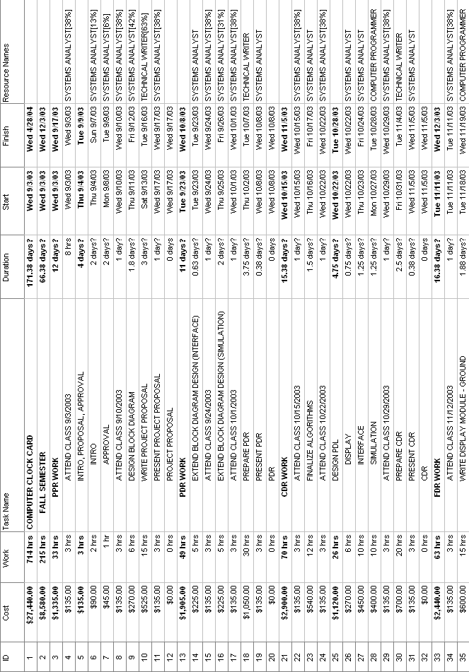
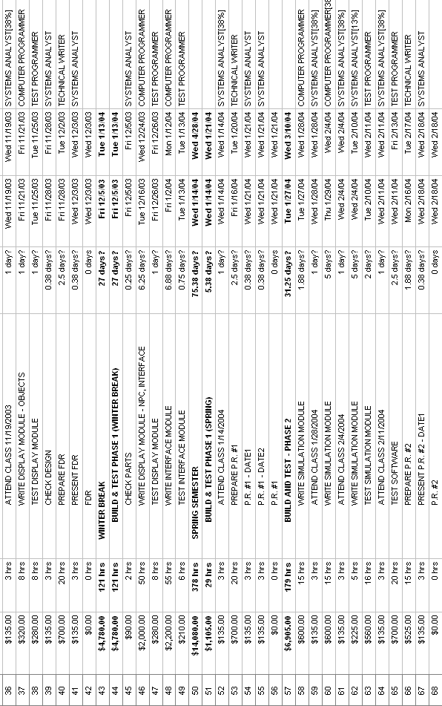
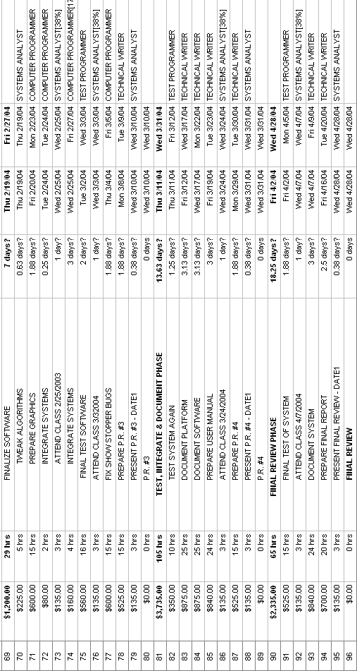
Appendix B – Gantt Chart

