THE GEORGE WASHINGTON UNIVERSITY
School of Engineering and Applied Science
Department of Computer Science

Project Proposal Report

for the

Isometric Real-time Simulation Game,
Project: SciSearch

By

David Kahler

CSci 195-11
Senior Computer Science Design Project
September 17, 2003

ABSTRACT

Abstract of the Project Proposal Report for the
Isometric Real-time Simulation Game, Project: SciSearch
by
David Kahler

This report is a proposal to build an isometric real-time simulation game, tentatively titled “Project: SciSearch.” The program allows the player to build a simulated research laboratory, and subsequently manage the laboratory, hire employees, and negotiate positive and negative simulation events. The program consists of three main modules, each of which is broken into smaller sub-modules. The three main modules are display, interface, and simulation. Display controls graphical output to the screen, interface controls the means by which the user interacts with the system, and simulation executes the real-time processes of the game. The program will run on the Game Boy Advance (GBA) platform. This platform has ten means of input: four directional arrows and six buttons. It has a 240x160 pixel screen capable of displaying 32,000 colors. It also contains 256KB of RAM and up to 32MB of secondary EEPROM on a removable cartridge.

The project will require 36 weeks to complete and will expend an estimated 712 person hours of labor at an estimated total labor cost of $27,775. The Critical Design Review will be on November 5, 2003, and the Final Design should be completed by December 3, 2003. A working prototype should be available by April 21, 2004. Estimated total cost for the prototype is $93,324. A preliminary Economic Analysis has determined that we will sell approximately 100,000 copies of this program at a cost to the company of $10.08 per copy, shipped on a GBA cartridge, including indirect costs, A & G costs, and a 20% profit. Estimated retail price for the program is $26.54. We will recuperate our prototype costs with the sale of the first 55,550 programs and we estimate a total profit of $168,000. To date, an expenditure of $1,335 has been made to develop this proposal.

TABLE OF CONTENTS

ABSTRACT ii
LIST OF FIGURES iv
LIST OF TABLES v
1 DESCRIPTION 1
2 SPECIFICATIONS 3
3 TESTS TO VERIFY DESIGN AND IMPLEMENTATION 4
4 TIME AND COST ANALYSIS 5
5 LABOR COSTS vs. TIME GRAPH 11
6 COMPARATIVE MARKET SURVEY 12
7 ECONOMIC ANALYSIS 13
8 STATUS MATRICES 15
9 CONCLUSIONS 19

LIST OF FIGURES

Figure 1: Block Diagram 2
Figure 2: Labor Costs vs. Time 11

LIST OF TABLES

Table 1: Gantt Chart – Entry Table 6
Table 2: Gantt Chart - Timeline 9
Table 3: Prototype Costs 13
Table 4: Profits 14
Table 5: Outline Matrix 15
Table 6: Design Matrix 15
Table 7: Construct Matrix 16
Table 8: Integrate Matrix 16
Table 9: Test Matrix 17
Table 10: Document Matrix 17
Table 11: Total Matrix 18

- DESCRIPTION

This game is centered around the concept of a functioning scientific research laboratory. The player is in charge of constructing, maintaining, and managing the research laboratory. To accomplish this task, three game modes will be provided for the player: construction, purchasing, and management. These three modes interact to form a seamless gaming experience. For example, the player must first purchase a new development laboratory, construct it in the desired location, and finally manage its team of scientists and research capabilities.

The game does not have a “finish”; the simulation simply continues until the player turns off the machine. This provides maximum replayability, as well as very long playtimes. Long playtimes are an essential component of a handheld game, as such devices tend to be taken on long trips where extended entertainment may be necessary.

The program has three main modules, display, interface, and simulation. Display controls all aspects of the graphical display, including the four graphical layers that interpose over top of each other. The interface module is rendered on top of the display, and facilitates the user’s interaction with the gaming environment. Finally, the simulation module actually runs the game, keeps track of game time, and allows the game units to interact appropriately. The block diagram, Figure 1, below, graphically demonstrates these principles.
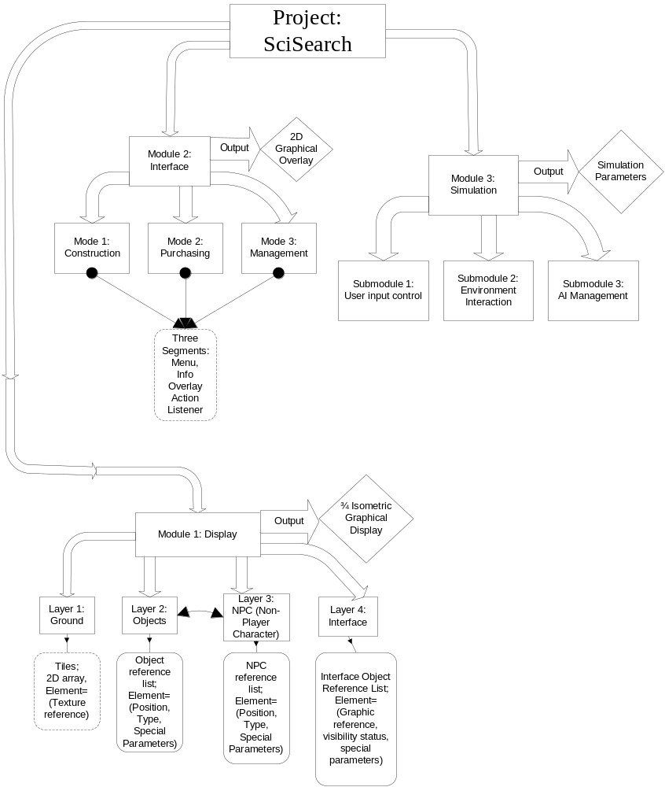
Figure 1: Block Diagram
- SPECIFICATIONS

The Project: SciSearch game is a real-time simulation designed to execute on Nintendo’s Game Boy Advance platform. The goal of the game is to provide an entertaining experience for the user for long, continuous timeframes. To use the product, the following hardware is required:

Nintendo Game Boy Advance or Game Boy Advance SP
Project: SciSearch game cartridge
Batteries or AC adaptor
- TESTS TO VERIFY DESIGN AND IMPLEMENTATION

The functionality tests for the program are broken up into the three main modules:

Module One (Display):
- Test scrolling capability; do previously hidden areas properly render? Does the screen stop scrolling when the end of the map is reached?
- Test depth algorithm; do objects properly render on top of ground? Do NPCs properly render with respect to objects? Does interface always render on top of everything?
- Test rendering speed; does speed update at an acceptable real-time rate? Is scrolling responsive and easy to use?

Module Two (Interface):
1) Systematically test all components in all three modes; do all links go to proper places?
2) Do the followed links then return the game to the proper state afterward?
3) Do all interface options properly set environment variables for the simulation and display modules to use?

Module Three (Simulation):
1) Does user input properly control all three modules together?
2) Do the various environment objects and NPCs react properly to changes in the game state?
3) Does the AI behave in a believable mannerism?
- TIME AND COST ANALYSIS

Table 1 is the Gantt chart that shows the estimated time and cost analysis for this project. It is separated into numerous sections, PPR, PDR, CDR, FDR, Build and Test Phase 1, Build and Test Phase 2, Test, Integrate and Document Phase, and finally the Final Review. Each of the stages is dependent on the previous stage to begin development. Table 2 is the timeline representation of this data.
Table 1: Gantt Chart – Entry Table
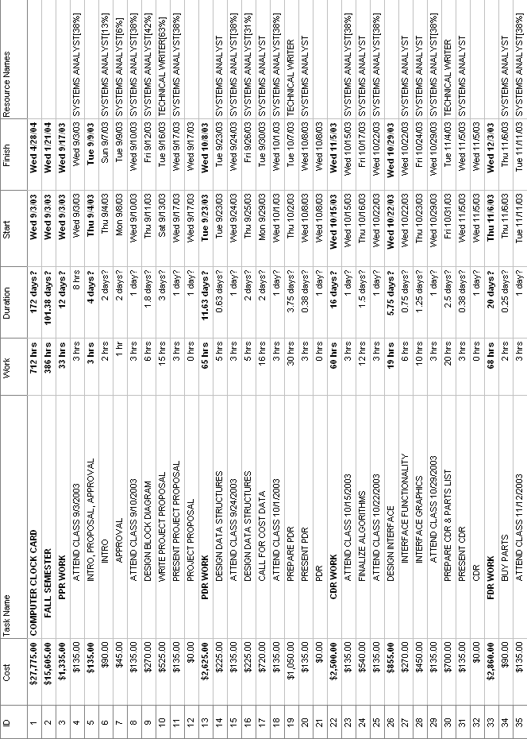
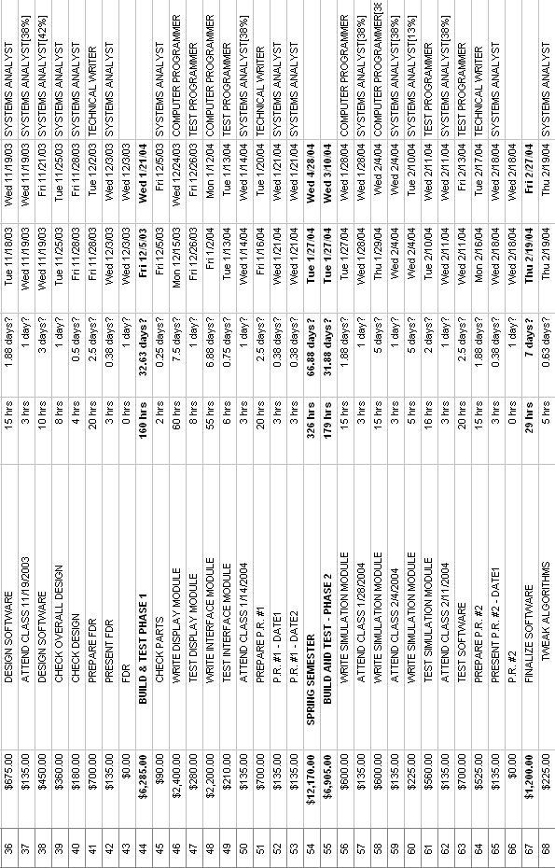
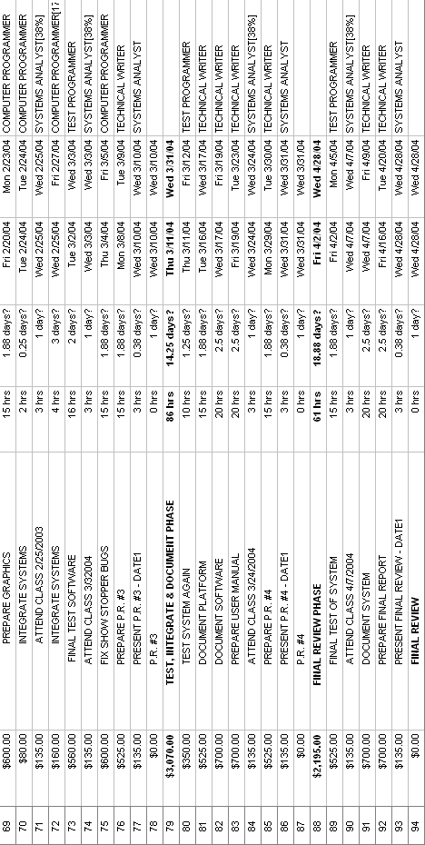

Table 2: Gantt Chart - Timeline
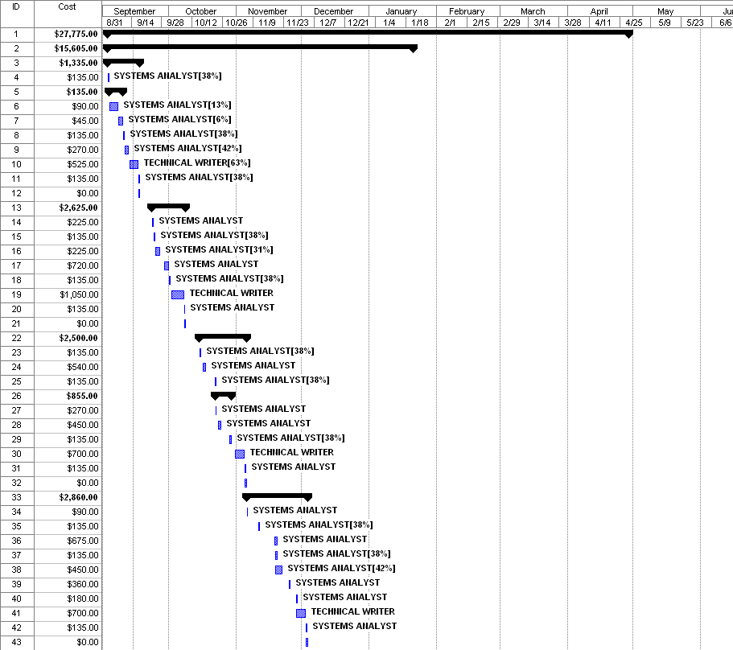
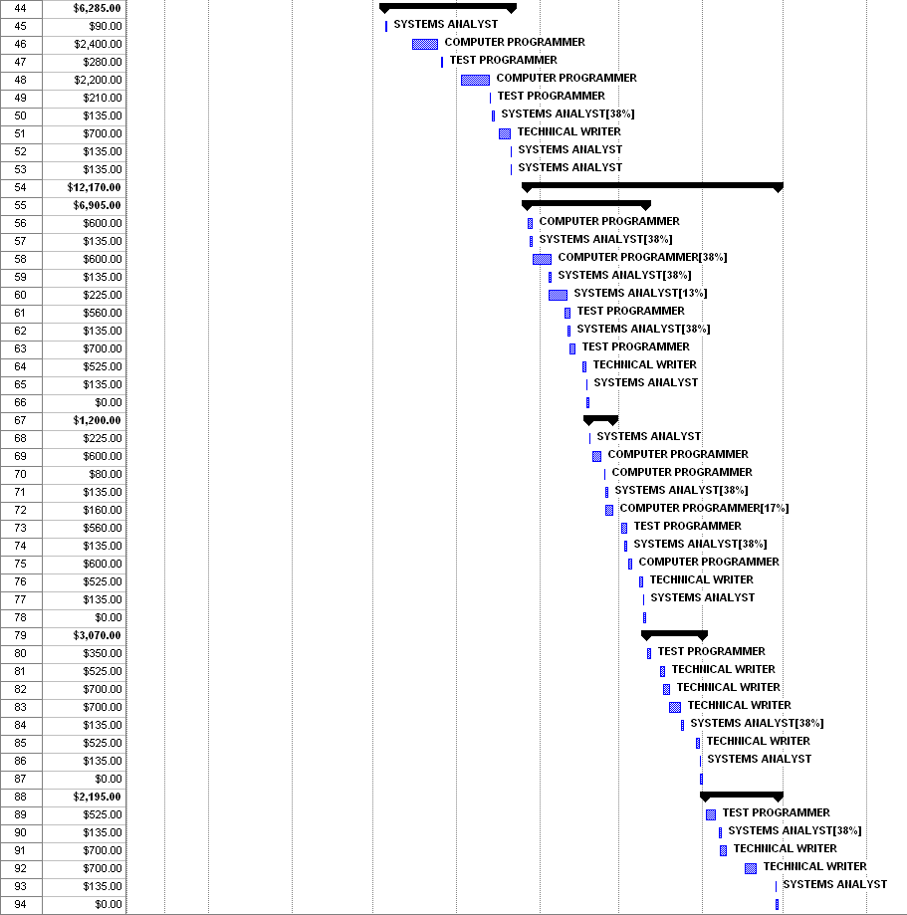
- LABOR COSTS vs. TIME GRAPH

Figure 2, below, shows the estimated cost trend over the course of the development of this project.

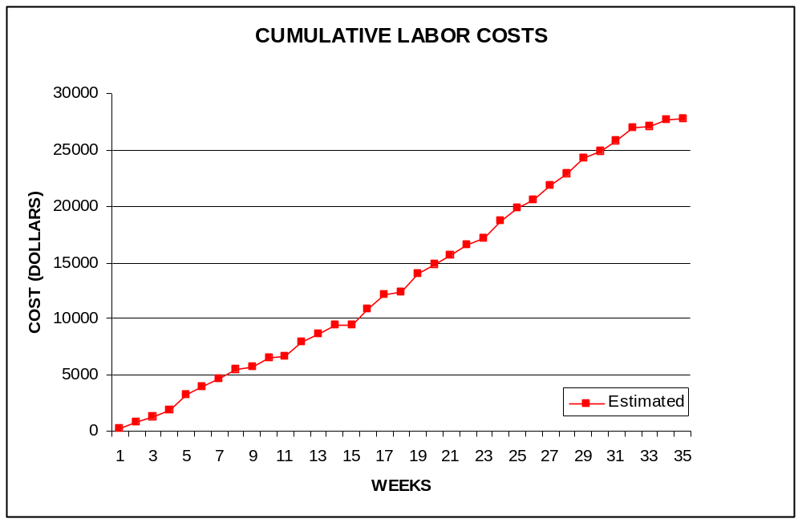
David Kahler
Figure 2: Labor Costs vs. Time
- COMPARATIVE MARKET SURVEY

Several products currently out on the market for the Game Boy Advance use similar game play features and techniques as Project: SciSearch, although Project: SciSearch still maintains many unique features. The products currently on the market include:

Advance Wars
A turn-based war strategy game, Advance Wars is one of the most popular and successful Game Boy Advance games currently on the market. It uses a top-down view, which is similar in function to Project: SciSearch’s ¾ view. The continuously-flowing nature of the game is also similar to Project: SciSearch’s model.

Jurassic Park III – Park Builder
This game is very similar in function to Project: SciSearch, although its premise differs significantly. The player is charged with creating a virtual Jurassic Park, similar to the park in the movie of the same title. The player then works to maintain and expand the park. This game also uses an isometric view with an angle similar to Project: SciSearch’s ¾ angle.

Sim City 2000
A classic game ported to the Game Boy Advance, Sim City 2000 is largely credited with starting the “God-simulation”-type game genre craze. In Sim City 2000, the player is the mayor of a growing city and must control aspects such as building construction, transportation, waste disposal, and tourism. Like Project: SciSearch, this game also has no set “ending”.
- ECONOMIC ANALYSIS

The following tables demonstrate the projected costs of the prototype development for Project: SciSearch, and the projected company profits, respectably.

Table 3: Prototype Costs
PERSON | LABOR RATE | INITIAL EST. HRS. | INITIAL EST. COST | CURRENT EST. HRS. | CURRENT EST. COST
COMP. SYSTEMS ANALYST | $45.00 | 195 | $8,775.00 | 195 | $8,775.00
COMP. PROGRAMMER | $40.00 | 181 | $7,240.00 | 181 | $7,240.00
TEST PROGRAMMER | $35.00 | 91 | $3,185.00 | 91 | $3,185.00
TECHNICAL WRITER | $35.00 | 245 | $8,575.00 | 245 | $8,575.00
TOTAL |  | 712 | $27,775.00 | 712 | $27,775.00
DIRECT OVERHEAD @ 100% |  |  | $27,775.00 |  | $27,775.00
SUBTOTAL |  |  | $55,550.00 |  | $55,550.00
A & G COSTS @ 40% |  |  | $22,220.00 |  | $22,220.00
SUBTOTAL |  |  | $77,770.00 |  | $77,770.00
PROFIT @ 20% |  |  | $15,554.00 |  | $15,554.00
TOTAL COST OF PROTOTYPE |  |  | $93,324.00 |  | $93,324.00

Table 4: Profits
SELL CARTRIDGES TO A WHOLESELLER
SELL CARTRIDGE
HARDWARE PRODUCES 10 CARTRIDGES AT A TIME
COSTS | RATE | HOURS | INITIAL COST/COPY |  | CURRENT COST/COPY
CONSTRUCTION TIME | $20.00 | 0.25 | $0.50 |  | $0.50
SUBTOTAL DIRECT LABOR |  |  | $0.50 |  | $0.50
INDIRECT OVERHEAD @ 100% |  |  | $0.50 |  | $0.50
SUBTOTAL |  |  | $1.00 |  | $1.00
DOCUMENTATION |  |  | $2.00 |  | $2.00
PACKAGING |  |  | $3.00 |  | $3.00
SUBTOTAL |  |  | $6.00 |  | $6.00
A & G @ 40% |  |  | $2.40 |  | $2.40
SUBTOTAL |  |  | $8.40 |  | $8.40
PROFIT @ 20% |  |  | $1.68 |  | $1.68
SUBTOTAL |  |  | $10.08 |  | $10.08
RECOUP COST OF PROTOTYPE | COSTS | UNITS TO
 |  | SELL
INITIAL | $93,324.00 | 100000 | $4.67
CURRENT | $93,324.00 | 0 |  |  | $4.67
RECOUP OVER |  | 55550
MANUFACTURING COSTS |  |  | $14.75 |  | $14.75
WHOLESALE MARKUP @ 20% |  |  | $2.95 |  | $2.95
SUBTOTAL |  |  | $17.70 |  | $17.70
RETAIL MARKUP @ 50% |  |  | $8.85 |  | $8.85
TOTAL RETAIL COST |  |  | $26.54 |  | $26.54
PROFIT (ON FIRST 100,000) |  |  | $168,000.00 |  | $168,000.00
PROFIT (ON THE REST) |  |  | $0.00 |  | $0.00
TOTAL PROFIT |  |  | $168,000.00 |  | $168,000.00

- STATUS MATRICES

This proposal concentrates on outlining the project for review. This outlining process is documented in Table 5 below. The report documentation time is shown in Table 10. The remaining tables represent future development stages of the project which have not yet begun, and Table 11 is the gross totals of all previous tables.

Table 5: Outline Matrix
OUTLINE | INT EST HOURS | CUR EST HRS | WORK TO-DATE HRS | % WORK COMP | TIME TO COMP HRS
MODULE 1 | 13 | 13 | 11 | 85 | 2
MODULE 1A | 4 | 4 | 4 | 100 | 0
MODULE 1B | 3 | 3 | 2 | 67 | 1
MODULE 1C | 3 | 3 | 2 | 67 | 1
MODULE 1D | 3 | 3 | 3 | 100 | 0
MODULE 2 | 10 | 10 | 7 | 70 | 3
MODULE 2A | 3 | 3 | 2 | 67 | 1
MODULE 2B | 3 | 3 | 2 | 67 | 1
MODULE 2C | 4 | 4 | 3 | 75 | 1
MODULE 3 | 10 | 10 | 8 | 80 | 2
MODULE 3A | 2 | 2 | 2 | 100 | 0
MODULE 3B | 4 | 4 | 3 | 75 | 1
MODULE 3C | 4 | 4 | 3 | 75 | 1

Table 6: Design Matrix
DESIGN | INT EST HOURS | CUR EST HRS | WORK TO-DATE HRS | % WORK COMP | TIME TO COMP HRS
MODULE 1 | 60 | 60 | 0 | 0 | 60
MODULE 1A | 15 | 15 | 0 | 0 | 15
MODULE 1B | 15 | 15 | 0 | 0 | 15
MODULE 1C | 15 | 15 | 0 | 0 | 15
MODULE 1D | 15 | 15 | 0 | 0 | 15
MODULE 2 | 45 | 45 | 0 | 0 | 45
MODULE 2A | 15 | 15 | 0 | 0 | 15
MODULE 2B | 15 | 15 | 0 | 0 | 15
MODULE 2C | 15 | 15 | 0 | 0 | 15
MODULE 3 | 55 | 55 | 0 | 0 | 55
MODULE 3A | 15 | 15 | 0 | 0 | 15
MODULE 3B | 20 | 20 | 0 | 0 | 20
MODULE 3C | 20 | 20 | 0 | 0 | 20

Table 7: Construct Matrix
CONSTRUCT | INT EST LOC | INT EST HOURS | CUR EST LOC | CUR EST HRS | WORK TO-DATE HRS | % WORK COMP | TIME TO COMP HRS
MODULE 1 | 2000 | 52 | 2000 | 52 | 0 | 0 | 52
MODULE 1A | 500 | 13 | 500 | 13 | 0 | 0 | 13
MODULE 1B | 500 | 13 | 500 | 13 | 0 | 0 | 13
MODULE 1C | 500 | 13 | 500 | 13 | 0 | 0 | 13
MODULE 1D | 500 | 13 | 500 | 13 | 0 | 0 | 13
MODULE 2 | 1500 | 90 | 1500 | 90 | 0 | 0 | 90
MODULE 2A | 500 | 30 | 500 | 30 | 0 | 0 | 30
MODULE 2B | 500 | 30 | 500 | 30 | 0 | 0 | 30
MODULE 2C | 500 | 30 | 500 | 30 | 0 | 0 | 30
MODULE 3 | 4000 | 114 | 4000 | 114 | 0 | 0 | 114
MODULE 3A | 1000 | 38 | 1000 | 38 | 0 | 0 | 38
MODULE 3B | 1500 | 38 | 1500 | 38 | 0 | 0 | 38
MODULE 3C | 1500 | 38 | 1500 | 38 | 0 | 0 | 38

Table 8: Integrate Matrix
INTEGRATE | INT EST HOURS | CUR EST HRS | WORK TO-DATE HRS | % WORK COMP | TIME TO COMP HRS
MODULE 1 | 12 | 12 | 0 | 0 | 12
MODULE 1A | 3 | 3 | 0 | 0 | 3
MODULE 1B | 3 | 3 | 0 | 0 | 3
MODULE 1C | 3 | 3 | 0 | 0 | 3
MODULE 1D | 3 | 3 | 0 | 0 | 3
MODULE 2 | 10 | 10 | 0 | 0 | 10
MODULE 2A | 3 | 3 | 0 | 0 | 3
MODULE 2B | 3 | 3 | 0 | 0 | 3
MODULE 2C | 4 | 4 | 0 | 0 | 4
MODULE 3 | 11 | 11 | 0 | 0 | 11
MODULE 3A | 3 | 3 | 0 | 0 | 3
MODULE 3B | 4 | 4 | 0 | 0 | 4
MODULE 3C | 4 | 4 | 0 | 0 | 4

Table 9: Test Matrix
TEST | INT EST HOURS | CUR EST HRS | WORK TO-DATE HRS | % WORK COMP | TIME TO COMP HRS
MODULE 1 | 8 | 8 | 0 | 0 | 8
MODULE 1A | 2 | 2 | 0 | 0 | 2
MODULE 1B | 2 | 2 | 0 | 0 | 2
MODULE 1C | 2 | 2 | 0 | 0 | 2
MODULE 1D | 2 | 2 | 0 | 0 | 2
MODULE 2 | 9 | 9 | 0 | 0 | 9
MODULE 2A | 3 | 3 | 0 | 0 | 3
MODULE 2B | 3 | 3 | 0 | 0 | 3
MODULE 2C | 3 | 3 | 0 | 0 | 3
MODULE 3 | 13 | 13 | 0 | 0 | 13
MODULE 3A | 4 | 4 | 0 | 0 | 4
MODULE 3B | 4 | 4 | 0 | 0 | 4
MODULE 3C | 5 | 5 | 0 | 0 | 5

Table 10: Document Matrix
DOCUMENT | INT EST HOURS | CUR EST HRS | WORK TO-DATE HRS | % WORK COMP | TIME TO COMP HRS
MODULE 1 | 24 | 24 | 0 | 0 | 24
MODULE 1A | 5 | 5 | 0 | 0 | 5
MODULE 1B | 5 | 5 | 0 | 0 | 5
MODULE 1C | 6 | 6 | 0 | 0 | 6
MODULE 1D | 8 | 8 | 0 | 0 | 8
MODULE 2 | 15 | 15 | 0 | 0 | 15
MODULE 2A | 5 | 5 | 0 | 0 | 5
MODULE 2B | 5 | 5 | 0 | 0 | 5
MODULE 2C | 5 | 5 | 0 | 0 | 5
MODULE 3 | 33 | 33 | 0 | 0 | 33
MODULE 3A | 11 | 11 | 0 | 0 | 11
MODULE 3B | 11 | 11 | 0 | 0 | 11
MODULE 3C | 11 | 11 | 0 | 0 | 11
REPORTS | 50 | 50 | 15 | 30 | 35

Table 11: Total Matrix
TOTAL | INT EST LOC | INT EST HOURS | CUR EST LOC | CUR EST HRS | WORK TO-DATE HRS | % WORK COMP | TIME TO COMP HRS
MODULE 1 | 2000 | 169 | 2000 | 169 | 11 | 7 | 158
MODULE 1A | 500 | 42 | 500 | 42 | 4 | 10 | 38
MODULE 1B | 500 | 41 | 500 | 41 | 2 | 5 | 39
MODULE 1C | 500 | 42 | 500 | 42 | 2 | 5 | 40
MODULE 1D | 500 | 44 | 500 | 44 | 3 | 7 | 41
MODULE 2 | 1500 | 179 | 1500 | 179 | 7 | 4 | 172
MODULE 2A | 500 | 59 | 500 | 59 | 2 | 3 | 57
MODULE 2B | 500 | 59 | 500 | 59 | 2 | 3 | 57
MODULE 2C | 500 | 61 | 500 | 61 | 3 | 5 | 58
MODULE 3 | 4000 | 236 | 4000 | 236 | 8 | 3 | 228
MODULE 3A | 1000 | 73 | 1000 | 73 | 2 | 3 | 71
MODULE 3B | 1500 | 81 | 1500 | 81 | 3 | 4 | 78
MODULE 3C | 1500 | 82 | 1500 | 82 | 3 | 4 | 79
REPORTS |  | 50 |  | 50 | 15 | 30 | 35
CLASS TIME |  | 78 |  | 78 | 6 | 8 | 72
GRAND TOTAL | 7500 | 712 | 7500 | 712 | 47 | 7 | 630
- CONCLUSIONS

Project: SciSearch, as proposed, is demonstrated above to be a real-time simulation game utilizing a ¾ isometric view output. The logical flow of the program is demonstrated, as well as its detailed specifications and time requirements. Further, its closest competition has been analyzed, and a detailed estimated cost module has been approximated. With the acceptance of this proposal, Project: SciSearch is prepared to move forward and develop into a ground-breaking, profitable simulation game for the Game Boy Advance platform.

