THE GEORGE WASHINGTON UNIVERSITY
School of Engineering and Applied Science
Department of Computer Science

Final Design Report

for the

Isometric Real-time Simulation Engine and Demo,
Project: SciSearch

By

David Kahler

CSci 195-11
Senior Computer Science Design Project
December 3, 2003

ABSTRACT

Abstract of the First Progress Review Report for the
Isometric Real-time Simulation Engine and Demo, Project: SciSearch
by
David Kahler

This report is the final design of an isometric real-time simulation game, entitled “Project: SciSearch.” The program allows the player to build a simulated research laboratory, and subsequently manage the laboratory, hire employees, and negotiate positive and negative simulation events. The program consists of three main modules, each of which is divided into smaller sub-modules. The three main modules are display, interface, and simulation. Display controls graphical output to the screen, interface controls the means by which the user interacts with the system, and simulation executes the real-time processes of the game. The program will run on the Game Boy Advance platform. This platform has ten means of input: four directional arrows and six buttons. It has a 240x160 pixel screen capable of displaying 32,000 colors. It also contains 256KB of RAM and up to 32MB of secondary EEPROM on a removable cartridge.

The project will require 36 weeks to complete and will expend an estimated 740 person hours of labor at an estimated total labor cost of $28,530. A working prototype should be available by April 21, 2004. Estimated total cost for the prototype is $95,861. A preliminary Economic Analysis has determined that we will sell about 100,000 copies of this program at a cost to the company of $10.08 per copy, shipped on a GBA cartridge, including indirect costs, A & G costs, and a 20% profit. Estimated retail price for the program is $26.77. We will recuperate our prototype costs with the sale of the first 20,000 programs and we estimate a total profit of approximately $328,629. To date, an expenditure of $10,225 has been made to develop this design and begin construction.

TABLE OF CONTENTS

ABSTRACT ii
LIST OF FIGURES iv
LIST OF TABLES v
1 INTRODUCTION 1
2 DESCRIPTION 2
2.1 Block Diagrams 2
2.2 Environment Calculations 5
2.3 AI Calculations 6
2.4 PDL 8
3 THEORY 11
4 SPECIFICATIONS 12
5 INTERFACE MOCKUP 13
6 TESTS TO VERIFY DESIGN AND IMPLEMENTATION 14
7 TIME AND COST ANALYSIS 15
8 LABOR COSTS VS. TIME GRAPH 16
9 COMPARATIVE MARKET SURVEY 17
10 ECONOMIC ANALYSIS 18
11 STATUS MATRICES 20
12 CONCLUSIONS 20
APPENDIX A A
APPENDIX B B
APPENDIX C C
APPENDIX D D
APPENDIX E E
APPENDIX F F

LIST OF FIGURES

Figure 1: Main Module Summary 2
Figure 2: Display Module 3
Figure 3: Interface Module 4
Figure 4: Simulation Module 5
Figure 5: Data Flow 7
Figure 6: Interface Mockup 13
Figure 7: Labor Costs vs. Time 16

LIST OF TABLES

Table 1: Prototype Costs 18
Table 2: Profits 19
Table 3: Outline Matrix 20
Table 4: Design Matrix 20
Table 5: Construct Matrix 20
Table 6: Integrate Matrix 20
Table 7: Test Matrix 20
Table 8: Document Matrix 20
Table 9: Total Matrix 20

- INTRODUCTION

Project: SciSearch is centered around the concept of a functioning scientific research laboratory. The player is in charge of constructing, maintaining, and managing the research laboratory. To accomplish this task, three game modes will be provided for the player: construction, purchasing, and management. These three modes interact to form a seamless gaming experience. For example, the player must first purchase a new development laboratory, construct it in the desired location, and finally manage its team of scientists and research capabilities.

The game does not have a “finish”; the simulation simply continues until the player turns off the machine. This provides maximum replayability, as well as very long playtimes. Long playtimes are an essential component of a handheld game, as such devices tend to be taken on long trips where extended entertainment may be necessary.

The prototype being developed for Project: SciSearch includes an engine and a demo. The engine will have all the functionality needed to develop a full, finished game after the completion of the prototype. In order to demonstrate the functionality of the engine, a limited amount of game content will be created as a part of the module construction process. The economic analysis for sales of the product is based on the sales of the final game.
- DESCRIPTION

- Block Diagrams

Project: SciSearch has three main modules, Display, Interface, and Simulation, as shown in Figure 1. Display controls all aspects of the graphical display, including the four graphical layers that interpose on top of each other. The interface module is rendered at the top of the display, and facilitates the user’s interaction with the gaming environment. Finally, the simulation module actually runs the game, keeps track of game time, and allows the game units to interact appropriately.

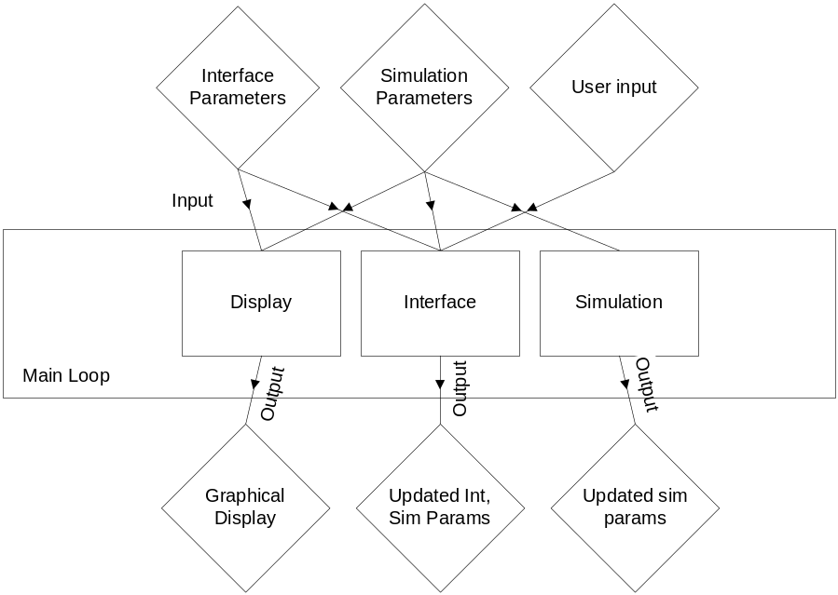
Figure 1: Main Module Summary

As shown in Figure 2, the Display module takes as input the interface and simulation parameters, and the isometric display is its output. The display is further divided into four sub-modules, or graphical layers, Ground, Objects, Non-Playable Character (NPC), and Interface. The Ground layer controls the repeated tiling graphics that are placed beneath all other graphics to simulate the foundation of the virtual space. The Objects layer represents any inanimate objects which reside above the ground, such as office space, tables and chairs. The NPC layer draws the current position and states of all “living” objects in the world, such as people and animals. Finally, the Interface layer is a 2D overlay that is drawn over top of the rest of the graphics, and is the means by which the user interacts with the system.

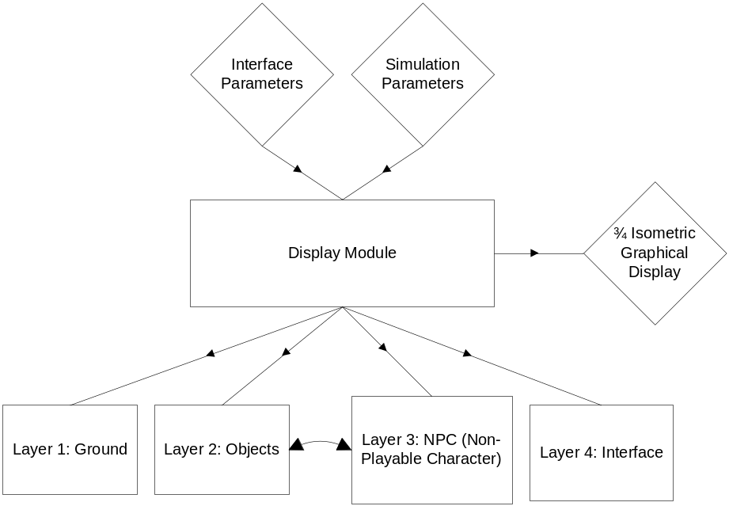
Figure 2: Display Module

As shown in Figure 3, the Interface module has the interface parameters, simulation parameters, and user input as its input. The Interface Control sub-module chooses which section to run based on these parameters. Each section controls a unique aspect of the interface. The Menu section controls the function and flow of the menu structure within the different Interface modes. The Mode section determines the current Mode of the Interface and the resulting functions of that mode. The User Input Processor takes the User Input and outputs the necessary changes to the simulation and interface parameters. Finally, the Help mode is invoked by the user to provide further game play instruction.

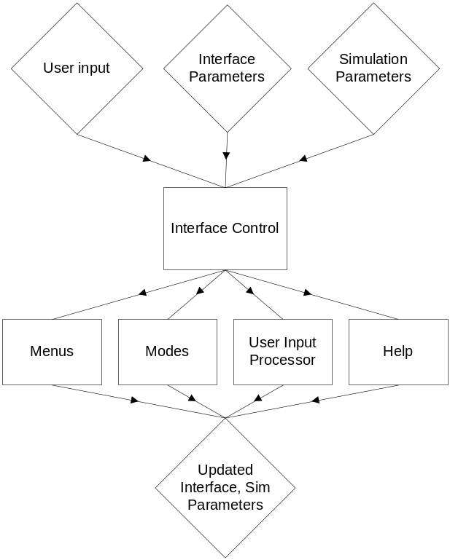
Figure 3: Interface Module

As shown in Figure 4, the Simulation module is comprised of two sub-modules, Environment Interaction and AI Management. These sub-modules are run by the main Simulation module, and they use the simulation parameters for their data. The Environment Interaction sub-module processes the data it receives from its own sub-modules. These sub-modules are currently Risk Level, Profitability, Maintenance, Level, Money, and Time.

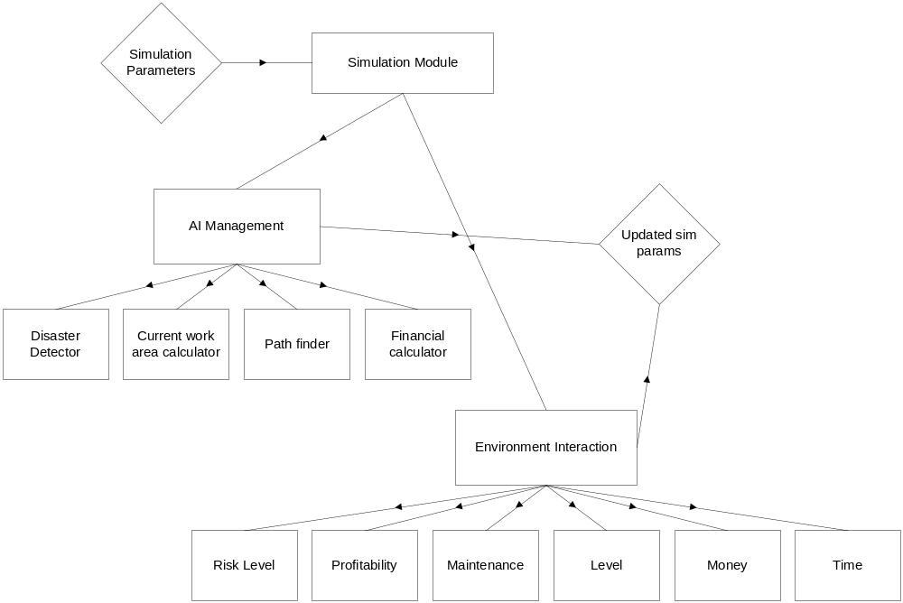
Figure 4: Simulation Module

- Environment Calculations

Risk Level is calculated on a per-cell basis, where a cell is one position in the 2D simulation grid. The tentative calculation to achieve the current cell’s risk level is as follows:

Object over cell risk (type of object + upkeep) +
Object x₁+x₂+…+x_{n} object risk (where x is any object within radius y of cell) +
Floor type risk (e.g. carpet, concrete, etc.) +

Profitability is calculated on a per-object basis, and its calculation is tentatively based on the following structure:

Number of employees assigned factor +
Object risk factor +
Object level factor +
Funding factor

Maintenance is calculated on a per-object basis, and its calculation is tentatively based on the following structure:

Object funding factor +
Current maintenance +
Time decay factor

Level is calculated on a per-object basis. It represents how technologically advanced the current object is. This factor is user-upgradeable, given the appropriate amount of money and technology. Money is the gross financial sum the user currently has to spend, and is influenced by Profitability and the spending habits of the user. Finally, time is the real-time clock that is continuously updated on a per-frame basis.

- AI Calculations

The AI Management module controls every aspect of the behavior of the NPCs. It is subdivided into four sub-modules, Disaster Detector, Current Work Area Calculator, Path Finder, and Financial Calculator.

The tentative formula for triggering a disaster will be calculated as follows:

Cell x risk (cell currently occupied by NPC) +
AI Risk
Earnings +
Education +
Time at company

This number is then multiplied by a percentage likelihood of a disaster happening on any given frame. For example, each frame may have a disaster likelihood of 0.0005%. If this product crosses a defined threshold, a disaster event is triggered.

The Current Work Area Calculator is based around a time loop which cycles the area the NPC should currently be occupying. For example, the NPC may occupy its assigned work area for three hours, then move to the cafeteria, then move back to the work area, and continue.

The path finder will be run whenever the Current Work Area Calculator changes the current work area and the NPC is not in the correct work area. The path finder will use the heuristic Best First Search (BFS) algorithm to find the optimal path from its current node to the goal node, and this path will be used to traverse the simulation area. Best First Search uses an arbitrary heuristic to attempt to traverse a given search space in an optimal fashion, both with regards to search speed and final path length determination. The heuristic used for Project: SciSearch will be a simple straight-distance calculation from the current candidate node to the goal node. A further explanation of Best First Search can be found at the reference listed in Appendix F.

The financial calculator for each NPC simply uses the information stored about the NPC’s current salary and subtracts it over time from the gross Money total. This allows each NPC to have an individual factor in the overall financial status of the simulation.

Figure 5 represents the logical data flow within the Project: SciSearch program structure. The main program loop calls each sub-module, and the appropriate parameters flow from each module to the next, finally returning to begin the loop again.

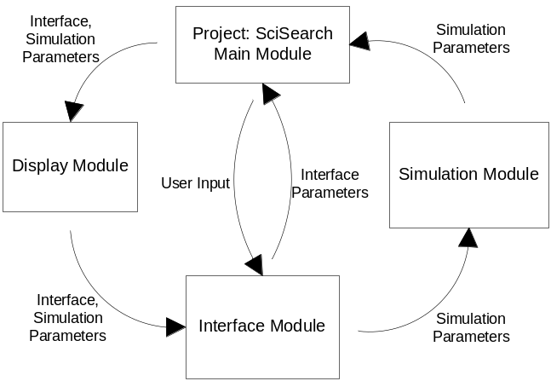
Figure 5: Data Flow
- PDL

The Program Design Language Outline for Project: SciSearch is organized by module.

Main Loop:
1. Initialize System
2. Enter main system loop
2.1 Call Display
2.2 Check for user input
- If new input, call Interface
2.3 Call Simulation

Display:
1. Call Ground sub-module
2. Call Objects/NPCs sub-module
3. Call Interface sub-module

Display→Ground:
1. Filter grid down to section currently visible
2. Loop through ground grid rows of visible section
2.1 Loop through ground grid columns of visible section
2.1a Render current texture in grid to appropriate offset
on display at lowest depth level

Display→Objects/NPCs:
1. Filter list of Objects/NPCs into currently visible Object/NPC list
2. Blit sprite graphic memory if necessary
3. Sort current-visible list by increasing y-value
4. Draw Objects/NPCs in order (referring to individual lists for graphic references)

Display→Interface:
1. Loop through interface parameters, put into currently visible list
2. Sort current-visible list by increasing depth value
3. Draw visible list in sort order, referencing Interface graphics

Interface:
1. Call input sub-module
1.1 Call current active mode with new input (menu, mode, help)

Interface→Menus:
1. Input user input
2. If input is d-pad
- Update menu position
3. If input is ‘A’
- Activate current menu selection
4. If input is ‘B’
- Close menu, set interface to “Mode”

Interface→Modes:
1. Input user input
2. If input is ‘L’ or ‘R’
- Change mode (move mode wheel)
3. If input is ‘A’
- Activate current mode’s current action
4. If input is d-pad
- Move current mode’s current action

Interface→Help:
1. Input user input
2. If input is ‘A’ or ‘B’
- Exit “help” mode, go to “Mode” mode
3. If input is d-pad up or down:
- Scroll if applicable

Simulation:
1. Call AI Management sub-module
2. Call Environment Interaction sub-module

Simulation→Environment Interaction:
1. Update all parameters
1.1 Call Risk function
1.2 Call Profit function
1.3 Call Maintenance function
1.4 Call Level function
1.5 Call Money function
1.6 Call Time function
2. Trigger necessary events
2.1 Update specifics

Simulation→AI Management:
Disaster Detector:
1. Calculate disaster likelihood for this frame for this NPC
(see formulas)
2. Trigger disaster if necessary
Current work area calculator:
1. Check work area cycle list
2. If time has expired
2.1 Set new work area
2.2 Reset timer
Path finder:
1. If new work area is detected
1.1 Find path using BFS (see reference)
1.2 Negotiate path until at goal (each frame)
Financial Calculator:
1. Subtract this NPC’s salary from total per tick

- Software Module List

Module Name | Module Function | Called By | Calls | Est. LOC | Est. Time (hrs) | Cost
Display | Graphical Output | Main Loop | Ground,Object,  NPC,Interface | 2,000 | 150 | $6,000
Ground | Draw Ground | Display | None | 500 | 35 | $1,500
Object | Draw Objects | Display | None | 500 | 35 | $1,500
NPC | Draw NPCs | Display | None | 500 | 35 | $1,500
Interface | Draw Interface | Display | None | 500 | 45 | $1,500
Interface | Handle Interface Updates | Main Loop | Menus,Modes,Help,Input | 2,500 | 150 | $6,000
Menus | Handle Menu Structure | Input | None | 500 | 35 | $1,500
Modes | Handle Modes | Input | None | 500 | 35 | $1,500
Help | Handle Help System | Input | None | 500 | 35 | $1,500
Input | Handle User Input | Interface | Menus,Modes,Help | 1,000 | 45 | $1,500
Simulation | Handle sim events | Main Loop | Environ, AI | 3,000 | 200 | $8,000
Environ | Handle Environ Cues | Simulation | None | 1,500 | 100 | $4,000
AI | Handle AI responses | Simulation | None | 1,500 | 100 | $4,000
THEORY

The Game Boy Advance architecture is very similar to that of a normal desktop computer, except on a much smaller scale. There are six different graphical modes which may be used for the development of a game. Modes 0-2 are “tile” modes. These modes allow the programmer to divide memory and screen space up into distinctive “tiles”, which can be an optimal model for games with continuously repeating and scrolling backgrounds, such as side-scrollers or puzzle games. These modes are implemented in hardware, and thus are reasonably fast.
Modes 3-5 are bitmap modes. These modes allow greater control of the graphics on the screen, as they allow direct pixel-by-pixel writing to the video buffer. Project: SciSearch uses Mode 4, which is a compromise between modes 3 and 5. Mode 4 is a 8-bit indexed color palette mode which allows for the use of two video buffers, a technique known as double buffering. There is one major difference between this mode and each of the two other bitmap modes. Mode 3 allows a 16-bit Red-Green-Blue (RGB) color palette, but does not allow hardware double buffering, which significantly handicaps its smooth animation capabilities. Mode 5 also allows a 16-bit color palette, and allows hardware double buffering. However, Mode 5 is limited to a 160x128 screen size, significantly less than the 240x160 capability of the LCD.
All graphical modes also support a maximum of 128 hardware-rendered sprites. The memory space available for the graphics data for these sprites is very limited, however, and must be used sparingly. Reusing graphics for multiple sprites is a necessity. These sprites should be used for as much rendering as possible, as writing a pixel directly to the screen in software is a very expensive process.
The main challenge of writing an effective GBA rendering system is managing hardware sprite memory space. Graphical data can be swapped in and out of this memory space, and sprite pointers into the space can be altered. However, any sprite currently being displayed on screen must have its data stored in this space. A further limitation of Mode 4, Project: SciSearch’s mode, is that its hardware sprite space is half that of the other two modes to accommodate the second video buffer.
All of the above information, including many other GBA topics, can be obtained from GBA Dev Online, referenced in Appendix F.
- SPECIFICATIONS

The Project: SciSearch game is a real-time simulation designed to execute on Nintendo’s Game Boy Advance (GBA) platform. The goal of the game is to provide an entertaining experience for the user for long, continuous timeframes. To use the final product, the following hardware is required:

Nintendo Game Boy Advance or Game Boy Advance SP
Project: SciSearch game cartridge
Batteries or AC adaptor

In addition to the development of the final product, a functional engine must be built for the Project: SciSearch game logic to wrap around. In order to use and develop the engine for the game, the following hardware and software are required:

Microsoft Visual Studio 6.0 (Visual C++ 6.0)
Microsoft Windows PC capable of running Visual C++ 6.0
Nintendo Game Boy Advance .ROM Emulator (for testing)
- ORIGINAL INTERFACE MOCKUP

Figure 6 demonstrates the expected look and functionality of the interface. The mode is chosen by the mode wheel at the lower left. Some of the more important simulation parameters are displayed in bar form above the mode wheel. There is also a status bar output that alerts the player to important events. To the right of the status bar, the Money and Time parameters are displayed, and finally there is a zoomed-out view of the map. The game play area occupies the largest portion of the display.

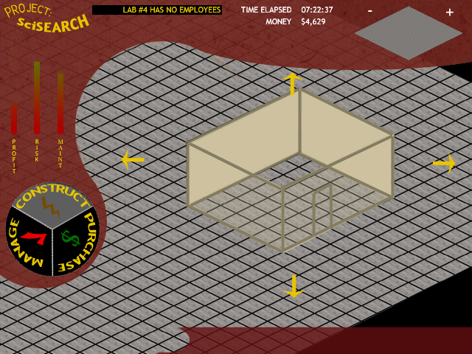
Figure 6: Interface Mockup

- TESTS TO VERIFY DESIGN AND IMPLEMENTATION

The functionality tests for the program are divided into the three main modules:

Display Module:
- Test scrolling capability; do previously hidden areas properly render? Does the screen stop scrolling when the end of the map is reached?
- Test depth algorithm; do objects properly render on top of ground? Do NPCs properly render with respect to objects? Does interface always render on top of everything?
- Test rendering speed; does speed update at or near 30 frames per second? Is scrolling responsive? Does the selection system allow quick selection of any given item (where quick is defined as less than two seconds)?

Interface Module:
1) Systematically test all components in all three modes; do all links go to proper places?
2) Do the followed links then return the game to the proper state afterward?
3) Do all interface options properly set environment variables for the simulation and display modules to use?

Simulation Module:
1) Does user input properly control all three modules together?
2) Do the various environment objects and NPCs react properly to changes in the game state?
3) Does the AI behave in a believable manner?
a) Do NPCs refrain from walking through objects?
b) Do disasters happen at an acceptable rate (e.g. once a month in game-world time)?

- REVISION HISTORY

This project began with three core modules, Display, Interface, and Simulation. While the number and names of the core modules has not been altered, some of their inner works have. All three were updated to better reflect the input and output each individual module used. The interface module was given a complete overhaul. The first design iteration documented the flow of the GUI, while the current design iteration more accurately documents the program flow of the modules and sub-modules. Finally, the simulation module received some more detail over the course of the design, further documenting individual simulation aspects such as path finding, risk calculation and time factors. Finally, data flow and Program Design Language structures were added to further explain the details of the program flow and design.

- TIME AND COST ANALYSIS

Appendix A shows the Task Table of the estimated time and cost analysis for this project. It is separated into numerous sections, PPR, PDR, CDR, FDR, Build and Test Phase 1, Build and Test Phase 2, Test, Integrate and Document Phase, and finally the Final Review. Each of the stages is dependent on the previous stage to begin development. Appendix B is the Gantt chart representation of this data. These charts visually demonstrate the total prototype development time of 740 hours, at a cost of $28,530. The Gantt chart shows how each section of the project is divided, and how much of the total time each section occupies.
- LABOR COSTS VS. TIME GRAPH

Figure 7 shows the estimated cost trend over the course of the development of this project. The current projected total cost for the project is $28,530, which is slightly above the initial estimate of $28,035.

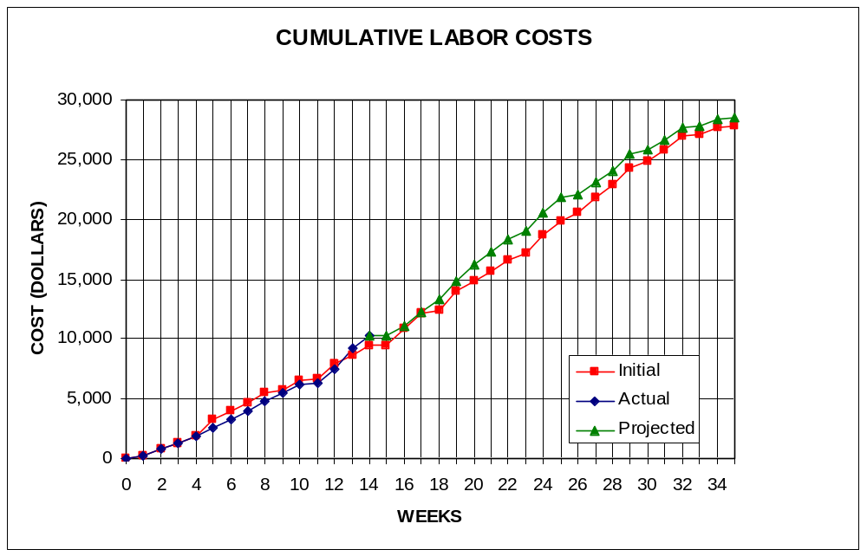
Figure 7: Labor Costs vs. Time
- COMPARATIVE MARKET SURVEY

Several products currently on the market for the Game Boy Advance use similar game play features and techniques as Project: SciSearch, although Project: SciSearch still maintains many unique features. The top GBA titles on the market sell upwards of 100,000 copies. The products currently on the market include:

Advance Wars (54,000 sold – 7/2003)
A turn-based war strategy game, Advance Wars is one of the most popular and successful Game Boy Advance games currently on the market. It uses a top-down view, which is similar in function to Project: SciSearch’s ¾ view. The continuously-flowing nature of the game is also similar to Project: SciSearch’s model.

Jurassic Park III – Park Builder (Number sold unavailable)
This game is very similar in function to Project: SciSearch, although its premise differs significantly. The player is charged with creating a virtual Jurassic Park, similar to the park in the movie of the same title. The player then works to maintain and expand the park. This game also uses an isometric view with an angle similar to Project: SciSearch’s ¾ angle.

Sim City 2000 (Not yet available)
A classic game ported to the Game Boy Advance, Sim City 2000 is largely credited with starting the “God-simulation”-type game genre craze. In Sim City 2000, the player is the mayor of a growing city and must control aspects such as building construction, transportation, waste disposal, and tourism. Like Project: SciSearch, this game also has no set “ending”.

- ECONOMIC ANALYSIS

Table 1 and Table 2 demonstrate the projected costs of the prototype development for Project: SciSearch, and the unit costs, respectively.

Table 1: Prototype Costs
PERSON | LABOR RATE | INITIAL EST. HRS. | INITIAL EST. COST | CURRENT EST. HRS. | CURRENT EST. COST
COMP. SYSTEMS ANALYST | $45.00 | 150 | $6,750 | 131 | $5,895
COMP. PROGRAMMER | $40.00 | 204 | $8,160 | 264 | $10,560
TEST PROGRAMMER | $35.00 | 104 | $3,640 | 95 | $3,325
TECHNICAL WRITER | $35.00 | 271 | $9,485 | 250 | $8,750
SUBTOTAL |  | 729 | $28,035 | 740 | $28,530
ENGINE @ 70% |  | 510 | $19,625 | 518 | $19,971
GAME @ 30% |  | 219 | $8,411 | 222 | $8,559
TOTAL |  | 729 | $28,035 | 740 | $28,530
DIRECT OVERHEAD @ 100% |  |  | $28,035 |  | $28,530
SUBTOTAL |  |  | $56,070 |  | $57,060
A & G COSTS @ 40% |  |  | $22,428 |  | $22,824
SUBTOTAL |  |  | $78,498 |  | $79,884
PROFIT @ 20% |  |  | $15,700 |  | $15,977
TOTAL COST OF PROTOTYPE |  |  | $94,198 |  | $95,861

Table 2: Profits
SELL CARTRIDGES TO A WHOLESELLER
SELL CARTRIDGE
HARDWARE PRODUCES 10 CARTRIDGES AT A TIME
COSTS | RATE | HOURS | INITIAL COST/COPY |  | CURRENT COST/COPY
CONSTRUCTION TIME | $20.00 | 0.25 | $0.50 |  | $0.50
SUBTOTAL DIRECT LABOR |  |  | $0.50 |  | $0.50
INDIRECT OVERHEAD @ 100% |  |  | $0.50 |  | $0.50
SUBTOTAL |  |  | $1.00 |  | $1.00
DOCUMENTATION |  |  | $2.00 |  | $2.00
PACKAGING |  |  | $3.00 |  | $3.00
SUBTOTAL |  |  | $6.00 |  | $6.00
A & G @ 40% |  |  | $2.40 |  | $2.40
SUBTOTAL |  |  | $8.40 |  | $8.40
PROFIT @ 20% |  |  | $1.68 |  | $1.68
SUBTOTAL |  |  | $10.08 |  | $10.08
RECOUP COST OF PROTOTYPE | COSTS | UNITS TO
 |  | SELL
INITIAL | $94,198 | 100,000 | $4.71
CURRENT | $95,861 | 100,000 |  |  | $4.79
RECOUP OVER |  | 20,000
MANUFACTURING COSTS |  |  | $14.79 |  | $14.87
WHOLESALE MARKUP @ 20% |  |  | $2.96 |  | $2.97
SUBTOTAL |  |  | $17.75 |  | $17.85
RETAIL MARKUP @ 50% |  |  | $8.87 |  | $8.92
TOTAL RETAIL COST |  |  | $26.62 |  | $26.77
PROFIT (ON FIRST 20,000) |  |  | $33,600 |  | $33,600
PROFIT (ON THE REST) |  |  | $292,708 |  | $295,029
TOTAL PROFIT |  |  | $326,308 |  | $328,629

- STATUS MATRICES

This report concentrates on the construction of the project. This construction process is documented in Table 5 below. The report documentation time is shown in Table 8. The remaining tables represent other development stages of the project which have either been completed or are in progress, and Table 9 is the gross totals of all previous tables.

Table 3: Outline Matrix
OUTLINE | INT EST LOC | INT EST HOURS | CUR EST LOC | CUR EST HRS | WORK TO-DATE HRS | % WORK COMP | TIME TO COMP HRS
DISPLAY | 2000 | 13 | 2000 | 13 | 13 | 100 | 0
GROUND | 500 | 4 | 500 | 4 | 4 | 100 | 0
OBJECTS | 500 | 3 | 500 | 3 | 3 | 100 | 0
NPC | 500 | 3 | 500 | 3 | 3 | 100 | 0
INTERFACE | 500 | 3 | 500 | 3 | 3 | 100 | 0
INTERFACE | 2500 | 12 | 2500 | 12 | 12 | 100 | 0
MENUS | 500 | 3 | 500 | 3 | 3 | 100 | 0
MODES | 500 | 3 | 500 | 3 | 3 | 100 | 0
HELP | 500 | 4 | 500 | 4 | 4 | 100 | 0
INPUT | 1000 | 2 | 1000 | 2 | 2 | 100 | 0
SIMULATION | 3000 | 8 | 3000 | 8 | 8 | 100 | 0
ENVIRON | 1500 | 4 | 1500 | 4 | 4 | 100 | 0
AI | 1500 | 4 | 1500 | 4 | 4 | 100 | 0
TOTALS | 7500 | 33 | 7500 | 33 | 33 | 100 | 0

Table 4: Design Matrix
DESIGN | INT EST LOC | INT EST HOURS | CUR EST LOC | CUR EST HRS | WORK TO-DATE HRS | % WORK COMP | TIME TO COMP HRS
DISPLAY | 2000 | 60 | 2000 | 47 | 47 | 100 | 0
GROUND | 500 | 15 | 500 | 12 | 12 | 100 | 0
OBJECTS | 500 | 15 | 500 | 12 | 12 | 100 | 0
NPC | 500 | 15 | 500 | 12 | 12 | 100 | 0
INTERFACE | 500 | 15 | 500 | 11 | 11 | 100 | 0
INTERFACE | 2500 | 60 | 2500 | 31 | 31 | 100 | 0
MENUS | 500 | 15 | 500 | 7 | 7 | 100 | 0
MODES | 500 | 15 | 500 | 7 | 7 | 100 | 0
HELP | 500 | 15 | 500 | 7 | 7 | 100 | 0
INPUT | 1000 | 15 | 1000 | 10 | 10 | 100 | 0
SIMULATION | 3000 | 40 | 3000 | 26 | 26 | 100 | 0
ENVIRON | 1500 | 20 | 1500 | 14 | 14 | 100 | 0
AI | 1500 | 20 | 1500 | 12 | 12 | 100 | 0
TOTALS | 7500 | 160 | 7500 | 104 | 104 | 100 | 0

Table 5: Construct Matrix
CONSTRUCT | INT EST LOC | INT EST HOURS | CUR EST LOC | CUR EST HRS | WORK TO-DATE HRS | % WORK COMP | TIME TO COMP HRS
DISPLAY | 2000 | 52 | 2000 | 69 | 37 | 54 | 32
GROUND | 500 | 13 | 500 | 30 | 25 | 83 | 5
OBJECTS | 500 | 13 | 500 | 10 | 7 | 70 | 3
NPC | 500 | 13 | 500 | 14 | 0 | 0 | 14
INTERFACE | 500 | 13 | 500 | 15 | 5 | 33 | 10
INTERFACE | 2500 | 128 | 2500 | 65 | 3 | 5 | 62
MENUS | 500 | 30 | 500 | 15 | 0 | 0 | 15
MODES | 500 | 30 | 500 | 15 | 0 | 0 | 15
HELP | 500 | 30 | 500 | 15 | 0 | 0 | 15
INPUT | 1000 | 38 | 1000 | 20 | 3 | 15 | 17
SIMULATION | 3000 | 76 | 3000 | 80 | 0 | 0 | 80
ENVIRON | 1500 | 38 | 1500 | 40 | 0 | 0 | 40
AI | 1500 | 38 | 1500 | 40 | 0 | 0 | 40
TOTALS | 7500 | 256 | 7500 | 214 | 40 | 19 | 174

Table 6: Integrate Matrix
INTEGRATE | INT EST LOC | INT EST HOURS | CUR EST LOC | CUR EST HRS | WORK TO-DATE HRS | % WORK COMP | TIME TO COMP HRS
DISPLAY | 2000 | 12 | 2000 | 58 | 0 | 0 | 58
GROUND | 500 | 3 | 500 | 13 | 0 | 0 | 13
OBJECTS | 500 | 3 | 500 | 12 | 0 | 0 | 12
NPC | 500 | 3 | 500 | 13 | 0 | 0 | 13
INTERFACE | 500 | 3 | 500 | 20 | 0 | 0 | 20
INTERFACE | 2500 | 13 | 2500 | 48 | 0 | 0 | 48
MENUS | 500 | 3 | 500 | 11 | 0 | 0 | 11
MODES | 500 | 3 | 500 | 12 | 0 | 0 | 12
HELP | 500 | 4 | 500 | 10 | 0 | 0 | 10
INPUT | 1000 | 3 | 1000 | 15 | 0 | 0 | 15
SIMULATION | 3000 | 8 | 3000 | 40 | 0 | 0 | 40
ENVIRON | 1500 | 4 | 1500 | 20 | 0 | 0 | 20
AI | 1500 | 4 | 1500 | 20 | 0 | 0 | 20
TOTALS | 7500 | 33 | 7500 | 146 | 0 | 0 | 146

Table 7: Test Matrix
TEST | INT EST LOC | INT EST HOURS | CUR EST LOC | CUR EST HRS | WORK TO-DATE HRS | % WORK COMP | TIME TO COMP HRS
DISPLAY | 2000 | 8 | 2000 | 40 | 0 | 0 | 40
GROUND | 500 | 2 | 500 | 11 | 0 | 0 | 11
OBJECTS | 500 | 2 | 500 | 8 | 0 | 0 | 8
NPC | 500 | 2 | 500 | 8 | 0 | 0 | 8
INTERFACE | 500 | 2 | 500 | 13 | 0 | 0 | 13
INTERFACE | 2500 | 13 | 2500 | 48 | 0 | 0 | 48
MENUS | 500 | 3 | 500 | 11 | 0 | 0 | 11
MODES | 500 | 3 | 500 | 11 | 0 | 0 | 11
HELP | 500 | 3 | 500 | 14 | 0 | 0 | 14
INPUT | 1000 | 4 | 1000 | 12 | 0 | 0 | 12
SIMULATION | 3000 | 9 | 3000 | 51 | 0 | 0 | 51
ENVIRON | 1500 | 4 | 1500 | 25 | 0 | 0 | 25
AI | 1500 | 5 | 1500 | 26 | 0 | 0 | 26
TOTALS | 7500 | 30 | 7500 | 139 | 0 | 0 | 139

Table 8: Document Matrix
DOCUMENT | INT EST LOC | INT EST HOURS | CUR EST LOC | CUR EST HRS | WORK TO-DATE HRS | % WORK COMP | TIME TO COMP HRS
DISPLAY | 2000 | 24 | 2000 | 34 | 30 | 88 | 4
GROUND | 500 | 5 | 500 | 8 | 8 | 100 | 0
OBJECTS | 500 | 5 | 500 | 8 | 7 | 88 | 1
NPC | 500 | 6 | 500 | 9 | 8 | 89 | 1
INTERFACE | 500 | 8 | 500 | 9 | 7 | 78 | 2
INTERFACE | 2500 | 26 | 2500 | 40 | 29 | 73 | 11
MENUS | 500 | 5 | 500 | 10 | 6 | 60 | 4
MODES | 500 | 5 | 500 | 10 | 8 | 80 | 2
HELP | 500 | 5 | 500 | 10 | 7 | 70 | 3
INPUT | 1000 | 11 | 1000 | 10 | 8 | 80 | 2
SIMULATION | 3000 | 22 | 3000 | 30 | 17 | 57 | 13
ENVIRON | 1500 | 11 | 1500 | 15 | 9 | 60 | 6
AI | 1500 | 11 | 1500 | 15 | 8 | 53 | 7
TOTALS | 7500 | 72 | 7500 | 140 | 76 | 54 | 28
Table 9: Total Matrix
TOTAL | INT EST LOC | INT EST HOURS | CUR EST LOC | CUR EST HRS | WORK TO-DATE HRS | % WORK COMP | TIME TO COMP HRS
DISPLAY | 2000 | 169 | 2000 | 261 | 127 | 49 | 134
GROUND | 500 | 42 | 500 | 78 | 49 | 63 | 29
OBJECTS | 500 | 41 | 500 | 53 | 29 | 55 | 24
NPC | 500 | 42 | 500 | 59 | 23 | 39 | 36
INTERFACE | 500 | 44 | 500 | 71 | 26 | 37 | 45
INTERFACE | 2500 | 252 | 2500 | 244 | 75 | 31 | 169
MENUS | 500 | 59 | 500 | 57 | 16 | 28 | 41
MODES | 500 | 59 | 500 | 58 | 18 | 31 | 40
HELP | 500 | 61 | 500 | 60 | 18 | 30 | 42
INPUT | 1000 | 73 | 1000 | 69 | 23 | 33 | 46
SIMULATION | 3000 | 163 | 3000 | 235 | 51 | 22 | 184
ENVIRON | 1500 | 81 | 1500 | 118 | 27 | 23 | 91
AI | 1500 | 82 | 1500 | 117 | 24 | 21 | 93
CLASS TIME |  | 84 |  | 84 | 42 | 50 | 42
GRAND TOTAL | 7500 | 584 | 7500 | 740 | 295 | 40 | 529
- CONCLUSIONS

Project: SciSearch, in its current design iteration, is demonstrated above to be a real-time simulation game utilizing a ¾ isometric view output. The logical flow of the program is demonstrated, as well as its detailed specifications and time requirements. Further, its closest competition has been analyzed, and a detailed estimated cost module has been approximated. With all design work finished and development commenced, Project: SciSearch is prepared to move forward as a profitable simulation game for the Game Boy Advance platform.

APPENDIX A
TASK TABLE

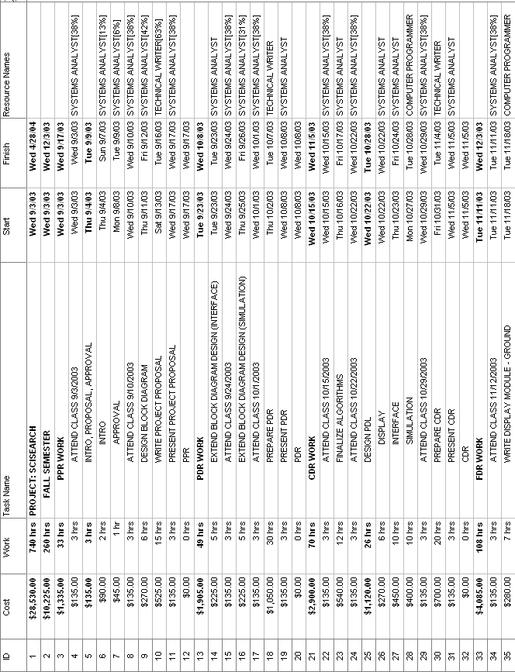
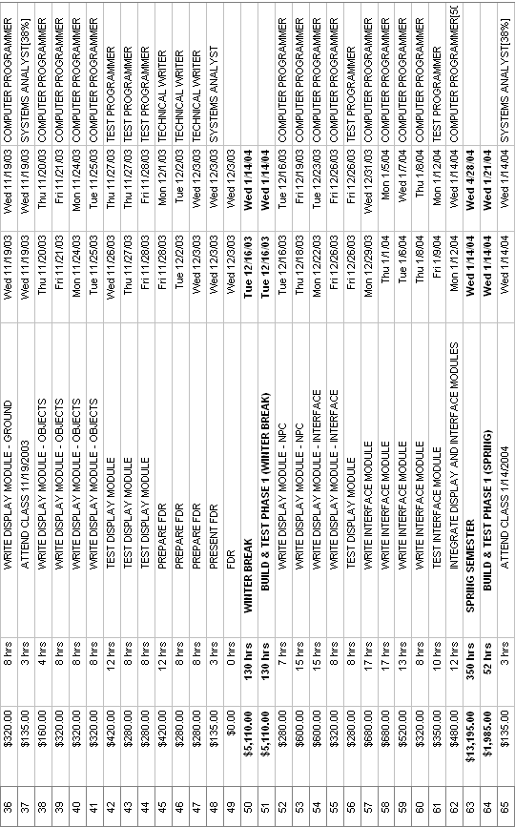
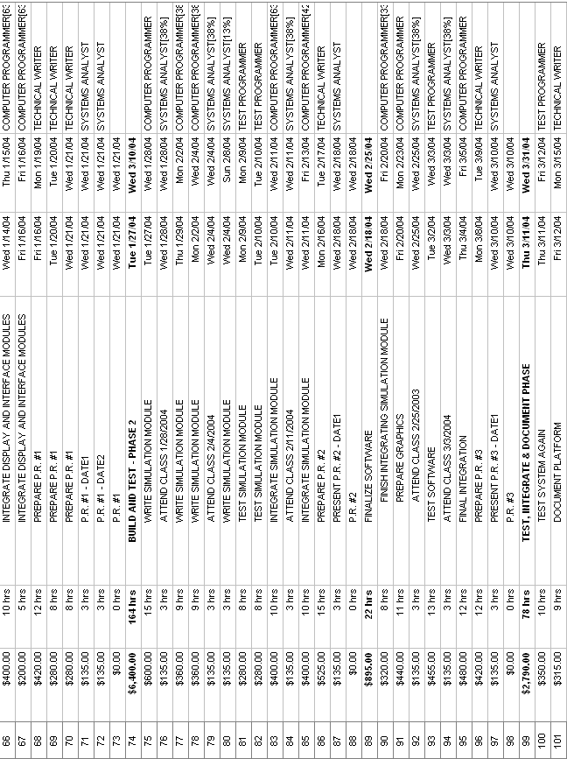
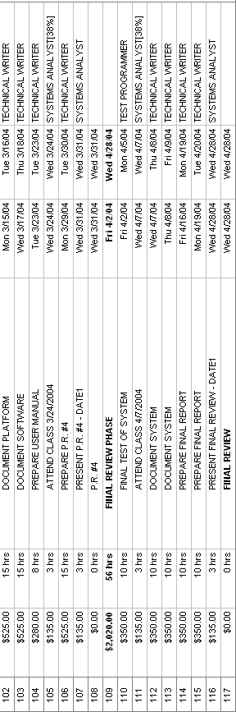

APPENDIX B
GANTT CHART

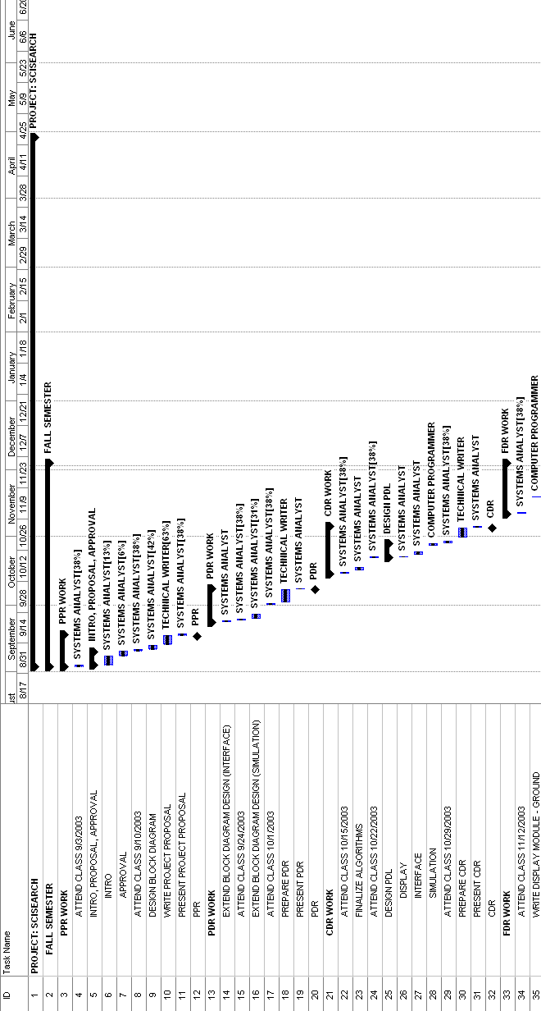
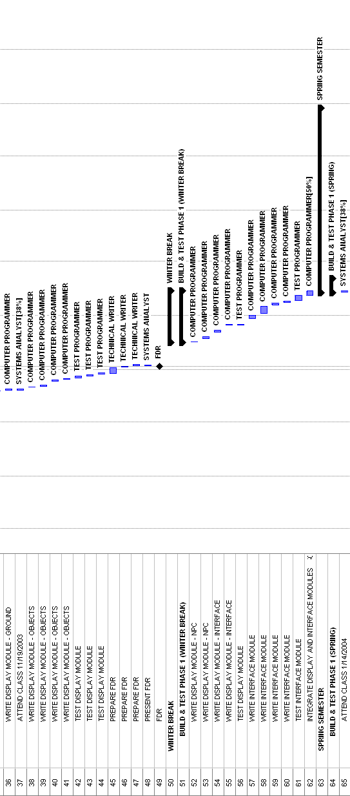

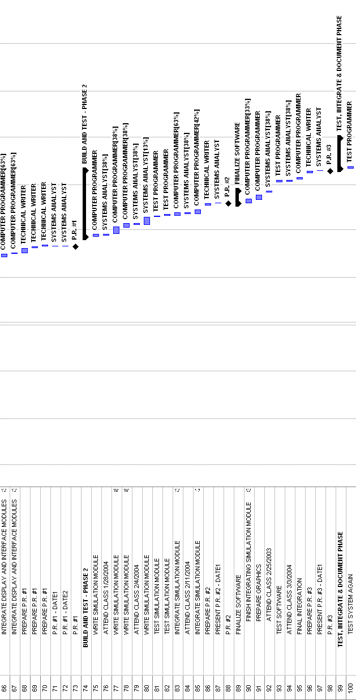
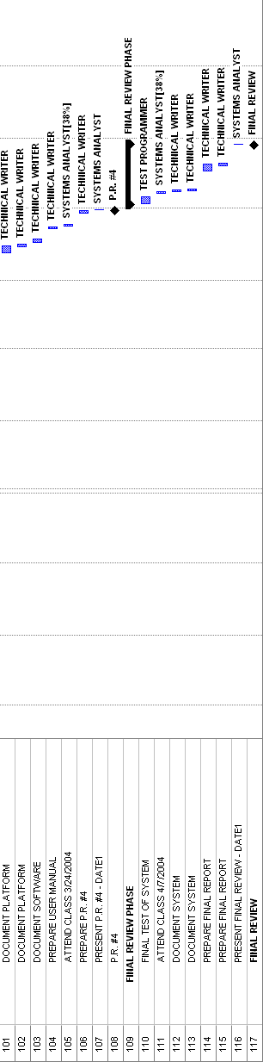

APPENDIX C
PROTOTYPE USER MANUAL
USER MANUAL TABLE OF CONTENTS

1 INSTALLATION GUIDE E-20
2 GAMEPLAY E-20
3 SOFTWARE STRUCTURE E-20
4 TROUBLESHOOTING E-20

- INSTALLATION GUIDE

To develop a game based on the Project: SciSearch engine, the following products must first be installed:

Microsoft Visual C++ 6.0
Nintendo Game Boy Advance SDK

Upon installing the required software, the user can commence development of a game based on the engine. For a further understanding of the inner workings of the Project: SciSearch engine, please see the Software Structure section on Page E-5.

To play a game based on the Project: SciSearch engine or demo, insert the game cartridge into an approved Game Boy Advance handheld console device. Turn the device on, and follow the on-screen instructions to play the game.
- GAMEPLAY

The demo accompanying the Project: SciSearch game engine has three modes of play: Construction, Purchasing, and Management. These three modes determine what the player can and cannot do within the game environment. Construction mode is capable of building and destroying properties purchased through the Purchasing mode. Management mode allows the player to control various parameters of the running simulation.

Various game play factors must be balanced appropriately in order to play a successful game for the current simulation to be “profitable”. These factors include locations of properties, types of employees hired, project funding, and the current status of technological improvements. These various factors can be controlled using the menu system present in each of the three different modes. To receive additional help within the game about menu selections and game play, the player can invoke the Help screen for assistance.

While there is no winning scenario for the game (there is only a theoretical maximum profitability), there is a losing scenario: if the player cannot pay debts within a certain amount of time, he or she has automatically lost that game.
- SOFTWARE STRUCTURE

This section will contain the final structure of the program, including screen shots and program flow detail. The structure of the modules within the software are detailed in the Description section.
- TROUBLESHOOTING

In order to troubleshoot problems with the Game Boy Advance system, the user should refer to the documentation that was provided with the system. As the software is developed, a troubleshooting section will be written as possible program difficulties become more apparent.

APPENDIX D
REFERENCES
Best First Search
http://www.ryerson.ca/~dgrimsha/courses/cps721/nBest.html (12/03/2003)
GBA Dev Online
http://www.gbadev.org

