THE GEORGE WASHINGTON UNIVERSITY
School of Engineering and Applied Science
Department of Computer Science

First Progress Review Report

for the

Isometric Real-time Simulation Engine and Demo,
Project: SciSearch

By

David Kahler

CSci 195-11
Senior Computer Science Design Project
January 21, 2004

ABSTRACT

Abstract of the First Progress Review Report for the
Isometric Real-time Simulation Engine and Demo, Project: SciSearch
by
David Kahler

This report is the final design of an isometric real-time simulation game, entitled “Project: SciSearch.” The program allows the player to build a simulated research laboratory, and subsequently manage the laboratory, hire employees, and negotiate positive and negative simulation events. The program consists of three main modules, each of which is divided into smaller sub-modules. The three main modules are display, interface, and simulation. Display controls graphical output to the screen, interface controls the means by which the user interacts with the system, and simulation executes the real-time processes of the game. The program will run on the Game Boy Advance platform. This platform has ten means of input: four directional arrows and six buttons. It has a 240x160 pixel screen capable of displaying 32,000 colors. It also contains 256KB of RAM and up to 32MB of ROM on a removable cartridge.

The project will require 36 weeks to complete and will expend an estimated 675 person hours of labor at an estimated total labor cost of $25,950. A working prototype should be available by April 21, 2004. Estimated total cost for the prototype is $87,192. A preliminary Economic Analysis has determined that we will sell about 100,000 copies of this program at a cost to the company of $14.44 per copy, shipped on a GBA cartridge, including indirect costs, A & G costs, and a 20% profit. Estimated retail price for the program is $25.99. We will recuperate our prototype costs with the sale of the first 20,000 programs and we estimate a total profit of approximately $316,534. To date, an expenditure of $14,940 has been made to design and develop this project.

TABLE OF CONTENTS

ABSTRACT ii
LIST OF FIGURES iv
LIST OF TABLES v
1 INTRODUCTION 1
1.1 Block Diagram 1
1.2 Software Module List 3
2 TESTS TO VERIFY DESIGN AND IMPLEMENTATION 4
3 TIME AND COST ANALYSIS 5
4 LABOR COSTS VS. TIME GRAPH 6
5 ECONOMIC ANALYSIS 7
6 STATUS MATRICES 9
7 CONCLUSIONS 13
APPENDIX A: Task Table
APPENDIX B: Gantt Chart
APPENDIX C: References

LIST OF FIGURES

Figure 1: Main Module Summary 2
Figure 2: Labor Costs vs. Time 6

LIST OF TABLES

Table 1: Software Module List 3
Table 2: Prototype Costs 7
Table 3: Profits 8
Table 4: Outline Matrix 9
Table 5: Design Matrix 9
Table 6: Construct Matrix 10
Table 7: Integrate Matrix 10
Table 8: Test Matrix 11
Table 9: Document Matrix 11
Table 10: Total Matrix 12

- INTRODUCTION

Project: SciSearch is centered around the concept of a functioning scientific research laboratory. The player is in charge of constructing, maintaining, and managing the research laboratory. To accomplish this task, three game modes will be provided for the player: construction, purchasing, and management. These three modes interact to form a seamless gaming experience. For example, the player must first purchase a new development laboratory, construct it in the desired location, and finally manage its team of scientists and research capabilities.

The game does not have a “finish”; the simulation simply continues until the player turns off the machine. This provides maximum replayability, as well as very long playtimes. Long playtimes are an essential component of a handheld game, as such devices tend to be taken on long trips where extended entertainment may be necessary.

The prototype being developed for Project: SciSearch includes an engine and a demo. The engine will have all the functionality needed to develop a full, finished game after the completion of the prototype. In order to demonstrate the functionality of the engine, a limited amount of game content will be created as a part of the module construction process. The economic analysis for sales of the product is based on the sales of the final game.

- Block Diagram

Project: SciSearch has three main modules, Display, Interface, and Simulation, as shown in Figure 1. Display controls all aspects of the graphical display, including the four graphical layers that interpose on top of each other. The interface module is rendered at the top of the display, and facilitates the user’s interaction with the gaming environment. Finally, the simulation module actually runs the game, keeps track of game time, and allows the game units to interact appropriately.

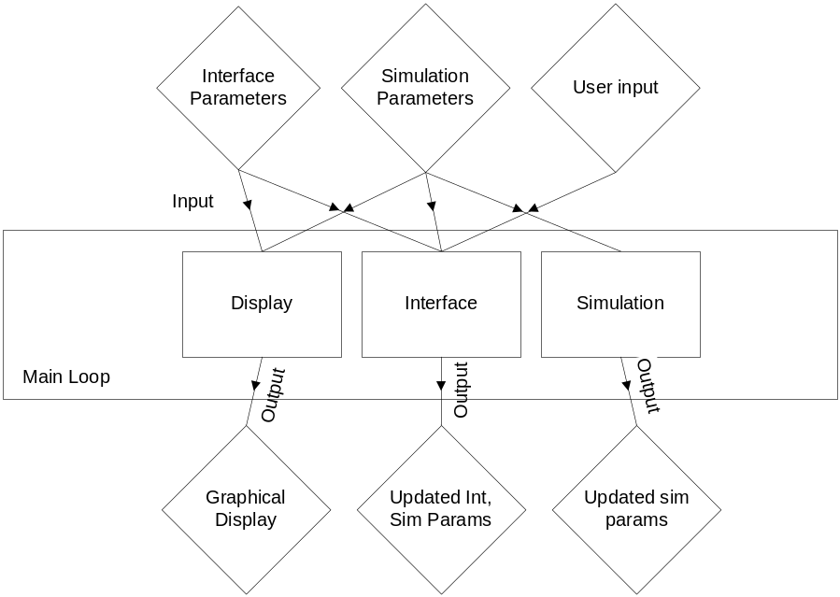
Figure 1: Main Module Summary

- Software Module List

The software module list provides a reference for all modules in the program and how they function. Each module is listed in a top-down fashion to the lowest sub-module.

Table 1: Software Module List
Module Name | Module Function | Called By | Calls | LOC  Current | LOC left | Hrs curr | Hrs left | % complete | Cost
Display | Graphical Output | Main Loop | Ground,Object,NPC,Interface | 1,200 | 200 | 80 | 10 | 89% | $6,000
Ground | Draw Ground | Display | None | 500 | 0 | 30 | 0 | 100% | $1,500
Object | Draw Objects | Display | None | 400 | 0 | 25 | 0 | 100% | $1,500
NPC | Draw NPCs | Display | None | 100 | 100 | 10 | 5 | 67% | $1,500
Interface | Draw Interface | Display | None | 200 | 100 | 15 | 5 | 75% | $1,500
Interface | Handle Interface Updates | Main Loop | Menus,Modes,Help,Input | 700 | 900 | 25 | 30 | 45% | $6,000
Menus | Handle Menu Structure | Input | None | 200 | 300 | 10 | 10 | 50% | $1,500
Modes | Handle Modes | Input | None | 200 | 200 | 5 | 10 | 33% | $1,500
Help | Handle Help System | Input | None | 100 | 200 | 2 | 5 | 29% | $1,500
Input | Handle User Input | Interface | Menus,Modes,Help | 200 | 200 | 8 | 5 | 62% | $1,500
Simulation | Handle sim events | Main Loop | Environ, AI | 0 | 2,000 | 0 | 60 | 0% | $8,000
Environ | Handle Environ Cues | Simulation | None | 0 | 1,000 | 0 | 30 | 0% | $4,000
AI | Handle AI responses | Simulation | None | 0 | 1,000 | 0 | 30 | 0% | $4,000
TOTAL |  |  |  | 1,900 | 3,100 | 105 | 100 | 51% | $20,000

- TESTS TO VERIFY DESIGN AND IMPLEMENTATION

The functionality tests for the program are divided into the three main modules:

Display Module:
Action | Expected Result
Scroll in all directions | Graphical layers render in correct order;  Objects selected/displayed as stored in system;  Scrolling stops at end of map
Place NPCs above/below objects | NPCs and Objects render in correct depth order
Test response time in emulator | Response time should be < 1/10 second

Interface Module:
Action | Expected Result
Select and deselect all interface components on at a time | Selection/deselection causes proper change in interface state
Place object in scene | Object adds correctly to simulation and displays
Place NPC in scene | NPC adds correctly to simulation and displays
Invoke help menu for each state | Proper help text is displayed

Simulation Module:
Action | Expected Result
Compare time to real-world clock | Time is synced to within 30 seconds an hour
Check new NPC paths | NPC paths should be close to optimal and correct
Check various simulation calculators | Calculators (e.g. Risk) should be at plausible values within the specified range
Place an overload of objects/NPCs in simulation | System should revert to software rendering and slow down, but not crash

- TIME AND COST ANALYSIS

Appendix A shows the Task Table of the estimated time and cost analysis for this project. It is separated into numerous sections, PPR, PDR, CDR, FDR, Build and Test Phase 1, Build and Test Phase 2, Test, Integrate and Document Phase, and finally the Final Review. Each of the stages is dependent on the previous stage to begin development. Appendix B is the Gantt chart representation of this data. These charts visually demonstrate the total prototype development time of 675 hours, at a cost of $25,950. The Gantt chart shows how each section of the project is divided, and how much of the total time each section occupies.

- LABOR COSTS VS. TIME GRAPH

Figure 2 shows the estimated cost trend over the course of the development of this project. The current projected total cost for the project is $25,950, which is under budget from the initial estimate of $28,035.

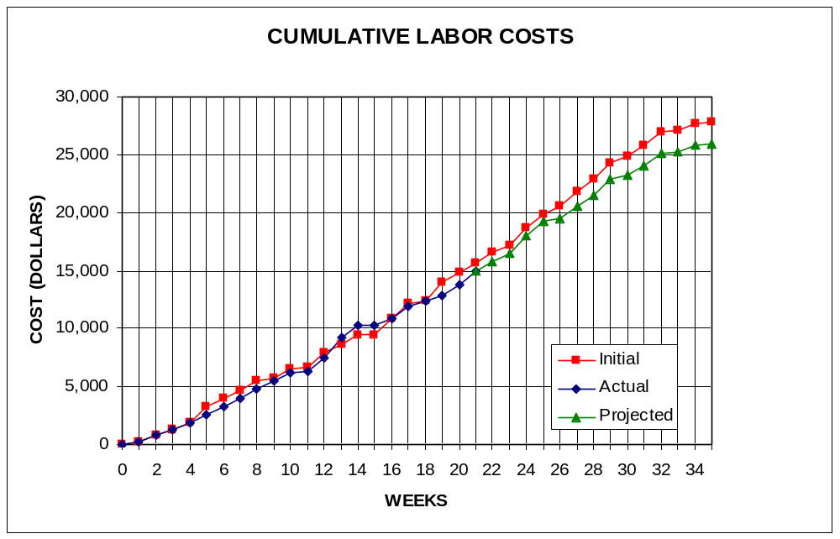
Figure 2: Labor Costs vs. Time

- ECONOMIC ANALYSIS

Table 2 and Table 3 demonstrate the projected costs of the prototype development for Project: SciSearch, and the unit costs, respectively.

Table 2: Prototype Costs
PERSON | LABOR RATE | INITIAL EST. HRS. | INITIAL EST. COST | CURRENT EST. HRS. | CURRENT EST. COST
COMP. SYSTEMS ANALYST | $45.00 | 150 | $6,750 | 131 | $5,895
COMP. PROGRAMMER | $40.00 | 204 | $8,160 | 203 | $8,120
TEST PROGRAMMER | $35.00 | 104 | $3,640 | 91 | $3,185
TECHNICAL WRITER | $35.00 | 271 | $9,485 | 250 | $8,750
SUBTOTAL |  | 729 | $28,035 | 675 | $25,950
ENGINE @ 70% |  | 510 | $19,625 | 473 | $18,165
GAME @ 30% |  | 219 | $8,411 | 203 | $7,785
TOTAL |  | 729 | $28,035 | 675 | $25,950
DIRECT OVERHEAD @ 100% |  |  | $28,035 |  | $25,950
SUBTOTAL |  |  | $56,070 |  | $51,900
A & G COSTS @ 40% |  |  | $22,428 |  | $20,760
SUBTOTAL |  |  | $78,498 |  | $72,660
PROFIT @ 20% |  |  | $15,700 |  | $14,532
TOTAL COST OF PROTOTYPE |  |  | $94,198 |  | $87,192

Table 3: Profits
SELL CARTRIDGES TO A WHOLESELLER
SELL CARTRIDGE
HARDWARE PRODUCES 10 CARTRIDGES AT A TIME
COSTS | RATE | HOURS | INITIAL COST/COPY |  | CURRENT COST/COPY
CONSTRUCTION TIME | $20.00 | 0.25 | $0.50 |  | $0.50
SUBTOTAL DIRECT LABOR |  |  | $0.50 |  | $0.50
INDIRECT OVERHEAD @ 100% |  |  | $0.50 |  | $0.50
SUBTOTAL |  |  | $1.00 |  | $1.00
DOCUMENTATION |  |  | $2.00 |  | $2.00
PACKAGING |  |  | $3.00 |  | $3.00
SUBTOTAL |  |  | $6.00 |  | $6.00
A & G @ 40% |  |  | $2.40 |  | $2.40
SUBTOTAL |  |  | $8.40 |  | $8.40
PROFIT @ 20% |  |  | $1.68 |  | $1.68
SUBTOTAL |  |  | $10.08 |  | $10.08
RECOUP COST OF PROTOTYPE | COSTS | UNITS TO
 |  | SELL
INITIAL | $94,198 | 100,000 | $4.71
CURRENT | $87,192 | 100,000 |  |  | $4.36
RECOUP OVER |  | 20,000
MANUFACTURING COSTS |  |  | $14.79 |  | $14.44
WHOLESALE MARKUP @ 20% |  |  | $2.96 |  | $2.89
SUBTOTAL |  |  | $17.75 |  | $17.33
RETAIL MARKUP @ 50% |  |  | $8.87 |  | $8.66
TOTAL RETAIL COST |  |  | $26.62 |  | $25.99
PROFIT (ON FIRST 20,000) |  |  | $33,600 |  | $33,600
PROFIT (ON THE REST) |  |  | $292,708 |  | $282,934
TOTAL PROFIT |  |  | $326,308 |  | $316,534

- STATUS MATRICES

This report concentrates on the construction of the project. This construction process is documented in Table 6 below. The report documentation time is shown in Table 9. The remaining tables represent other development stages of the project which have either been completed or are in progress, and Table 10 is the gross totals of all previous tables.

Table 4: Outline Matrix
OUTLINE | INT EST HOURS | CUR EST HRS | WORK TO-DATE HRS | % WORK COMP | TIME TO COMP HRS
DISPLAY | 13 | 13 | 13 | 100 | 0
GROUND | 4 | 4 | 4 | 100 | 0
OBJECTS | 3 | 3 | 3 | 100 | 0
NPC | 3 | 3 | 3 | 100 | 0
INTERFACE | 3 | 3 | 3 | 100 | 0
INTERFACE | 12 | 12 | 12 | 100 | 0
MENUS | 3 | 3 | 3 | 100 | 0
MODES | 3 | 3 | 3 | 100 | 0
HELP | 4 | 4 | 4 | 100 | 0
INPUT | 2 | 2 | 2 | 100 | 0
SIMULATION | 8 | 8 | 8 | 100 | 0
ENVIRON | 4 | 4 | 4 | 100 | 0
AI | 4 | 4 | 4 | 100 | 0
TOTALS | 33 | 33 | 33 | 100 | 0

Table 5: Design Matrix
DESIGN | INT EST HOURS | CUR EST HRS | WORK TO-DATE HRS | % WORK COMP | TIME TO COMP HRS
DISPLAY | 63 | 47 | 47 | 100 | 0
GROUND | 16 | 12 | 12 | 100 | 0
OBJECTS | 15 | 12 | 12 | 100 | 0
NPC | 17 | 12 | 12 | 100 | 0
INTERFACE | 15 | 11 | 11 | 100 | 0
INTERFACE | 62 | 31 | 31 | 100 | 0
MENUS | 15 | 7 | 7 | 100 | 0
MODES | 16 | 7 | 7 | 100 | 0
HELP | 15 | 7 | 7 | 100 | 0
INPUT | 16 | 10 | 10 | 100 | 0
SIMULATION | 40 | 26 | 26 | 100 | 0
ENVIRON | 20 | 14 | 14 | 100 | 0
AI | 20 | 12 | 12 | 100 | 0
TOTALS | 165 | 104 | 104 | 100 | 0

Table 6: Construct Matrix
CONSTRUCT | INT EST HOURS | CUR EST HRS | WORK TO-DATE HRS | % WORK COMP | TIME TO COMP HRS
DISPLAY | 56 | 51 | 47 | 92 | 4
GROUND | 15 | 25 | 25 | 100 | 0
OBJECTS | 13 | 8 | 8 | 100 | 0
NPC | 15 | 6 | 5 | 83 | 1
INTERFACE | 13 | 12 | 9 | 75 | 3
INTERFACE | 132 | 48 | 22 | 46 | 26
MENUS | 30 | 12 | 6 | 50 | 6
MODES | 32 | 12 | 7 | 58 | 5
HELP | 30 | 12 | 3 | 25 | 9
INPUT | 40 | 12 | 6 | 50 | 6
SIMULATION | 82 | 60 | 0 | 0 | 60
ENVIRON | 40 | 30 | 0 | 0 | 30
AI | 42 | 30 | 0 | 0 | 30
TOTALS | 270 | 159 | 69 | 43 | 90

Table 7: Integrate Matrix
INTEGRATE | INT EST HOURS | CUR EST HRS | WORK TO-DATE HRS | % WORK COMP | TIME TO COMP HRS
DISPLAY | 17 | 51 | 23 | 45 | 28
GROUND | 5 | 11 | 5 | 45 | 6
OBJECTS | 4 | 12 | 5 | 42 | 7
NPC | 3 | 13 | 5 | 38 | 8
INTERFACE | 5 | 15 | 8 | 53 | 7
INTERFACE | 16 | 48 | 20 | 42 | 28
MENUS | 4 | 11 | 5 | 45 | 6
MODES | 4 | 12 | 5 | 42 | 7
HELP | 5 | 10 | 4 | 40 | 6
INPUT | 3 | 15 | 6 | 40 | 9
SIMULATION | 10 | 40 | 0 | 0 | 40
ENVIRON | 5 | 20 | 0 | 0 | 20
AI | 5 | 20 | 0 | 0 | 20
TOTALS | 43 | 139 | 43 | 31 | 96

Table 8: Test Matrix
TEST | INT EST HOURS | CUR EST HRS | WORK TO-DATE HRS | % WORK COMP | TIME TO COMP HRS
DISPLAY | 15 | 40 | 25 | 63 | 15
GROUND | 3 | 11 | 8 | 73 | 3
OBJECTS | 4 | 8 | 6 | 75 | 2
NPC | 3 | 8 | 5 | 63 | 3
INTERFACE | 5 | 13 | 6 | 46 | 7
INTERFACE | 17 | 45 | 23 | 51 | 22
MENUS | 5 | 11 | 5 | 45 | 6
MODES | 4 | 11 | 6 | 55 | 5
HELP | 3 | 11 | 6 | 55 | 5
INPUT | 5 | 12 | 6 | 50 | 6
SIMULATION | 11 | 51 | 0 | 0 | 51
ENVIRON | 6 | 25 | 0 | 0 | 25
AI | 5 | 26 | 0 | 0 | 26
TOTALS | 43 | 136 | 48 | 35 | 88

Table 9: Document Matrix
DOCUMENT | INT EST HOURS | CUR EST HRS | WORK TO-DATE HRS | % WORK COMP | TIME TO COMP HRS
DISPLAY | 28 | 34 | 27 | 79 | 7
GROUND | 7 | 8 | 7 | 88 | 1
OBJECTS | 7 | 8 | 7 | 88 | 1
NPC | 7 | 9 | 6 | 67 | 3
INTERFACE | 7 | 9 | 7 | 78 | 2
INTERFACE | 36 | 40 | 26 | 65 | 14
MENUS | 8 | 10 | 6 | 60 | 4
MODES | 6 | 10 | 7 | 70 | 3
HELP | 9 | 10 | 6 | 60 | 4
INPUT | 13 | 10 | 7 | 70 | 3
SIMULATION | 27 | 30 | 17 | 57 | 13
ENVIRON | 14 | 15 | 9 | 60 | 6
AI | 13 | 15 | 8 | 53 | 7
TOTALS | 91 | 104 | 70 | 67 | 34
Table 10: Total Matrix
TOTAL | INT EST HOURS | CUR EST HRS | WORK TO-DATE HRS | % WORK COMP | TIME TO COMP HRS
DISPLAY | 192 | 236 | 182 | 77 | 54
GROUND | 50 | 71 | 61 | 86 | 10
OBJECTS | 46 | 51 | 41 | 80 | 10
NPC | 48 | 51 | 36 | 71 | 15
INTERFACE | 48 | 63 | 44 | 70 | 19
INTERFACE | 275 | 224 | 134 | 60 | 90
MENUS | 65 | 54 | 32 | 59 | 22
MODES | 65 | 55 | 35 | 64 | 20
HELP | 66 | 54 | 30 | 56 | 24
INPUT | 79 | 61 | 37 | 61 | 24
SIMULATION | 178 | 215 | 51 | 24 | 164
ENVIRON | 89 | 108 | 27 | 25 | 81
AI | 89 | 107 | 24 | 22 | 83
CLASS TIME | 84 | 84 | 45 | 54 | 39
GRAND TOTAL | 729 | 675 | 412 | 61 | 347
- CONCLUSIONS

Project: SciSearch, in its current design iteration, is demonstrated above to be a real-time simulation game utilizing a ¾ isometric view output. The logical flow of the program is demonstrated, as well as its detailed specifications and time requirements. Further, a detailed estimated cost module has been approximated. With all design work finished and development commenced, Project: SciSearch is prepared to move forward as a profitable simulation game for the Game Boy Advance platform.

APPENDIX A
TASK TABLE

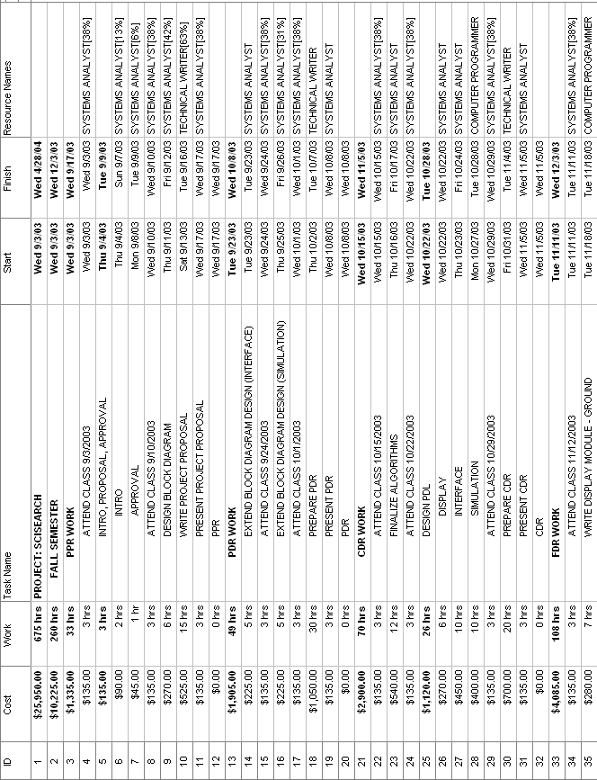
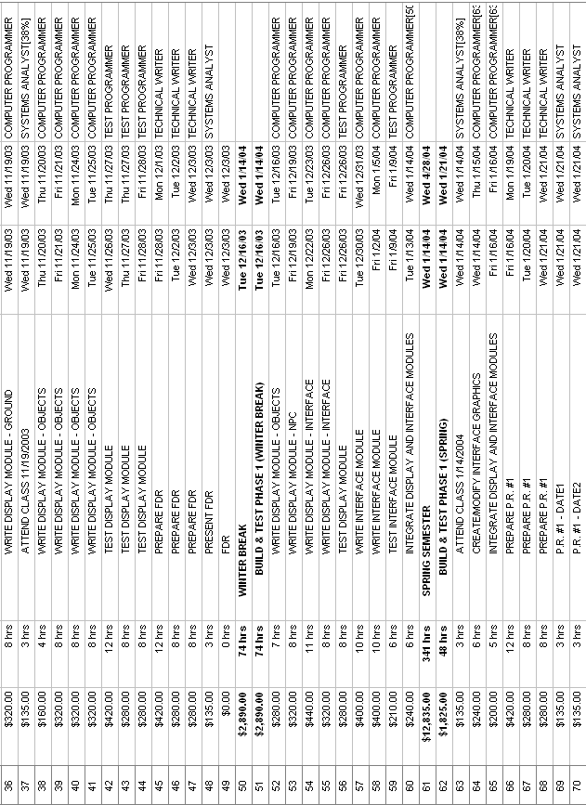
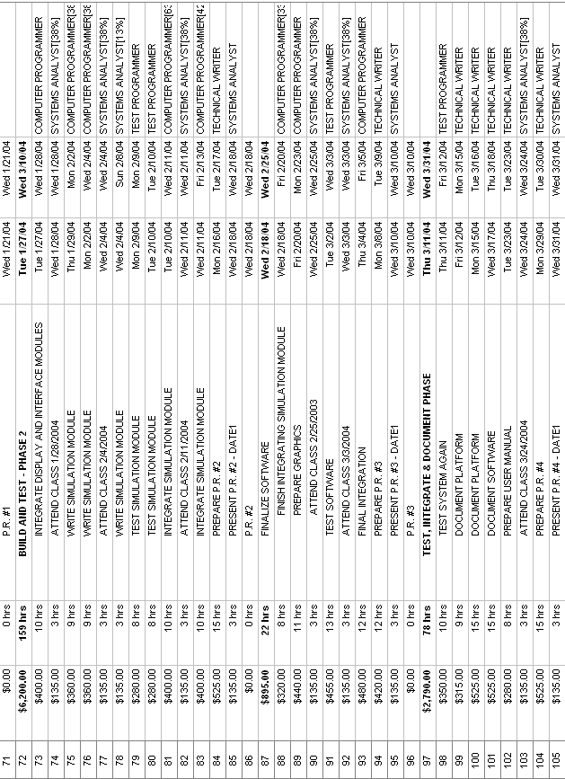
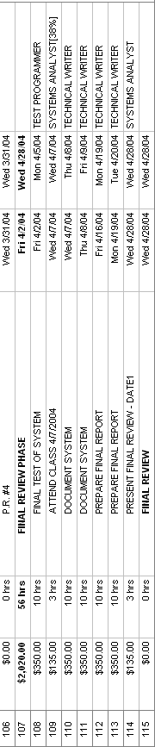

APPENDIX B
GANTT CHART

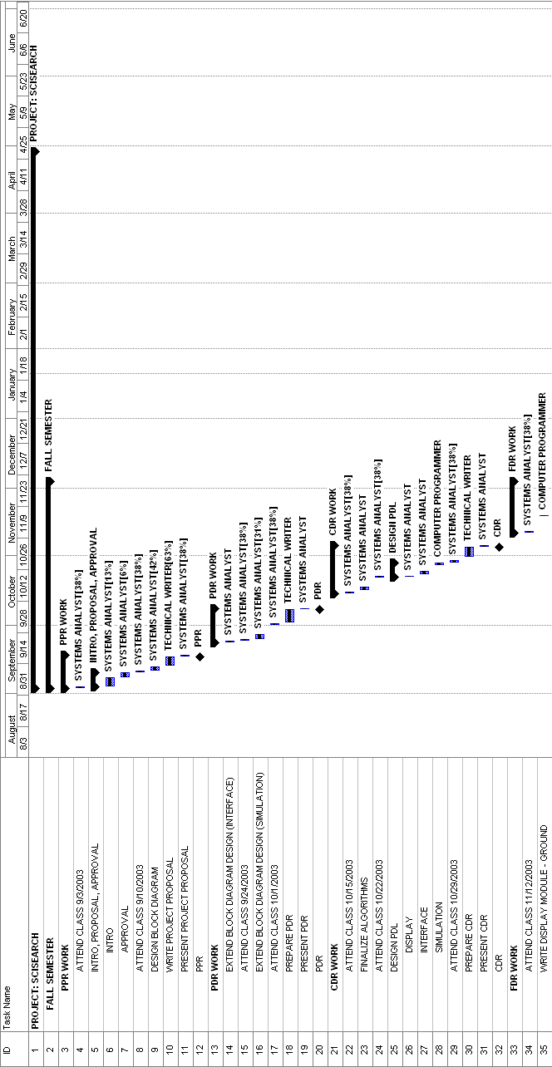
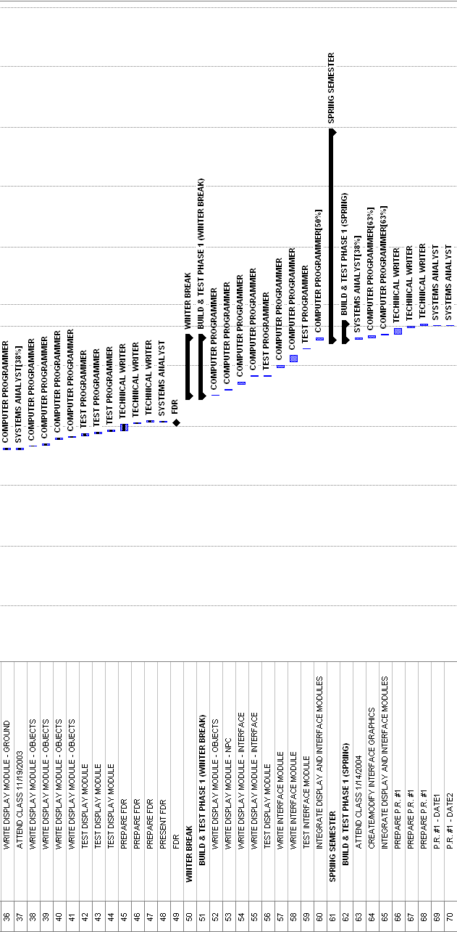

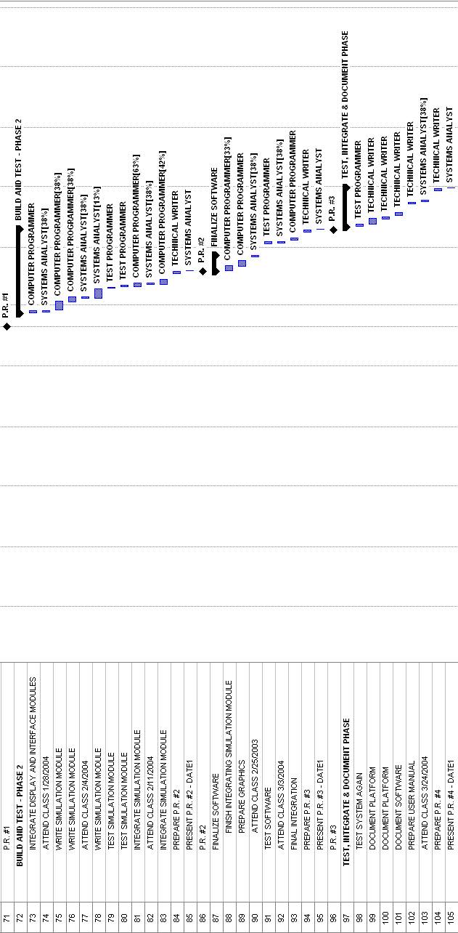
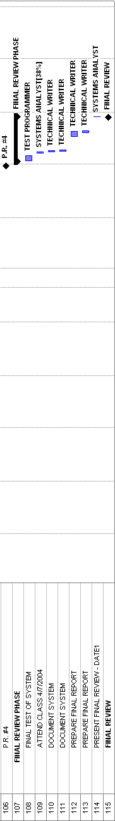

APPENDIX C
REFERENCES
Best First Search
http://www.ryerson.ca/~dgrimsha/courses/cps721/nBest.html (12/03/2003)
GBA Dev Online
http://www.gbadev.org

