THE GEORGE WASHINGTON UNIVERSITY
School of Engineering and Applied Science
Department of Computer Science

Third Progress Review Report

for the

Isometric Real-time Simulation Engine and Demo,
Project: SciSearch

By

David Kahler

CSci 196-11
Senior Computer Science Design Project
March 3, 2004

ABSTRACT

Abstract of the Third Progress Review Report for the
Isometric Real-time Simulation Engine and Demo, Project: SciSearch
by
David Kahler

This report is the construction progress of an isometric real-time simulation game, entitled “Project: SciSearch.” The game to be built around the engine will allow the player to build a simulated research laboratory, and subsequently manage the laboratory, hire employees, and negotiate positive and negative simulation events. The program consists of three main modules, each of which is divided into smaller sub-modules. The three main modules are display, interface, and simulation. Display controls graphical output to the screen, interface controls the means by which the user interacts with the system, and simulation executes the real-time processes of the game. The program will run on the Game Boy Advance platform. This platform has ten means of input: four directional arrows and six buttons. It has a 240x160 pixel screen capable of displaying 32,000 colors. It also contains 256KB of RAM and up to 32MB of ROM on a removable cartridge.

The project will require 36 weeks to complete and will expend an estimated 652 person hours of labor at an estimated total labor cost of $25,200. A working prototype should be available by April 21, 2004. Estimated total cost for the prototype is $84,672. A preliminary Economic Analysis has determined that we will sell about 100,000 copies of this program at a cost to the company of $14.31 per copy, shipped on a GBA cartridge, including indirect costs, A & G costs, and a 20% profit. Estimated retail price for the program is $25.76. We will recuperate our prototype costs with the sale of the first 20,000 programs and we estimate a total profit of approximately $313,018. To date, an expenditure of $19,230 has been made to design and develop this project.

To date, the Display and Interface modules, have been completed. The Simulation module is 41% complete, and will require an additional 26 hours of programming work to finish. Integration and testing of the modules are about 70% complete, with 26 hours of documentation remaining. This leaves approximately 127 person hours left to complete the prototype.

TABLE OF CONTENTS

ABSTRACT ii
LIST OF FIGURES iv
LIST OF TABLES v
1 INTRODUCTION 1
1.1 Block Diagram 1
1.2 GUI Changes 2
1.3 Software Module List 4
2 TESTS TO VERIFY DESIGN AND IMPLEMENTATION 5
3 TIME AND COST ANALYSIS 7
4 LABOR COSTS VS. TIME GRAPH 8
5 ECONOMIC ANALYSIS 9
6 STATUS MATRICES 11
7 CONCLUSIONS 15
APPENDIX A: Task Table
APPENDIX B: Gantt Chart
APPENDIX C: References

LIST OF FIGURES

Figure 1: Main Module Summary 2
Figure 2: Concept GUI Design 3
Figure 3: Functional GUI Design 3
Figure 4: Labor Costs vs. Time 8

LIST OF TABLES

Table 1: Software Module List 4
Table 2: Display Module Tests 5
Table 3: Interface Module Tests 5
Table 4: Simulation Module Tests 6
Table 5: Prototype Costs 9
Table 6: Profits 10
Table 7: Outline Matrix 11
Table 8: Design Matrix 11
Table 9: Construct Matrix 12
Table 10: Integrate Matrix 12
Table 11: Test Matrix 13
Table 12: Document Matrix 13
Table 13: Total Matrix 14

- INTRODUCTION

Project: SciSearch is a game centered around the concept of a functioning scientific research laboratory. The player is in charge of constructing, maintaining, and managing the research laboratory. To accomplish this task, three game modes will be provided for the player: construction, purchasing, and management. These three modes interact to form a seamless gaming experience. For example, the player must first purchase a new development laboratory, construct it in the desired location, and finally manage its team of scientists and research capabilities.

The game does not have a “finish”; the simulation simply continues until the player turns off the machine. This provides maximum replayability, as well as very long playtimes. Long playtimes are an essential component of a handheld game, as such devices tend to be taken on long trips where extended entertainment may be necessary.

The prototype being developed for Project: SciSearch includes an engine and a demo. The engine will have all the functionality needed to develop a full, finished game after the completion of the prototype. In order to demonstrate the functionality of the engine, a limited amount of game content will be created as a part of the module construction process. The economic analysis for sales of the product is based on the sales of the final game.

- Block Diagram

Project: SciSearch has three main modules, Display, Interface, and Simulation, as shown in Figure 1. Display controls all aspects of the graphical display, including the four graphical layers that interpose on top of each other. The interface module is rendered at the top of the display, and facilitates the user’s interaction with the gaming environment. Finally, the simulation module actually runs the game, keeps track of game time, and allows the game units to interact appropriately.

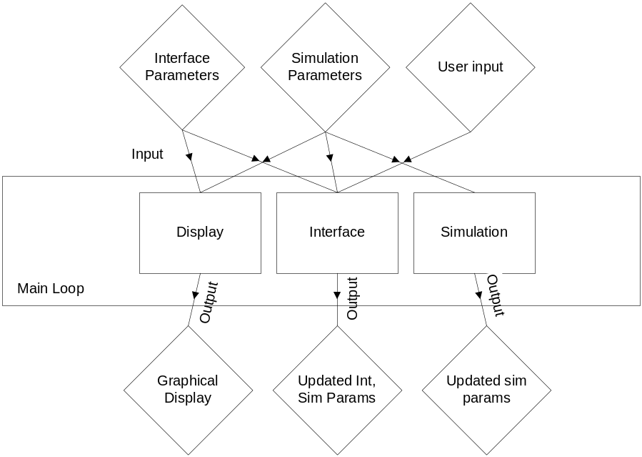
Figure 1: Main Module Summary

- GUI Changes

Figure 2 shows the original GUI conceptual design. This is a high-resolution version that was made to guide the construction of the actual in-game GUI. The in-game GUI is graphically simpler due to memory constraints, but follows the same design layout as the original. Figure 3 shows the current functional GUI.

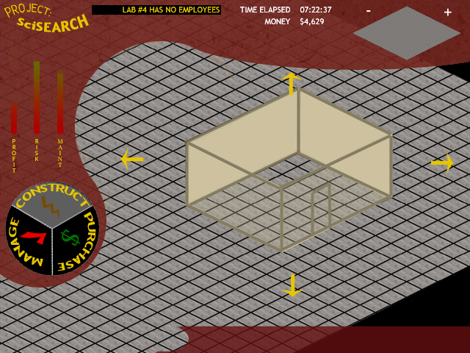
Figure 2: Concept GUI Design

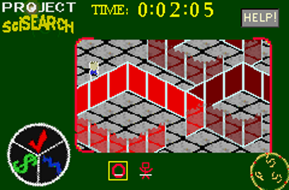
Figure 3: Functional GUI Design

- Software Module List

The software module list, Table 1, provides a reference for all modules in the program and how they function. Each module is listed in a top-down fashion to the lowest sub-module.

Table 1: Software Module List
Module Name | Module Function | Called By | Calls | LOC  Current | LOC left | Hrs curr | Hrs left | % complete | Cost
Display | Graphical Output | Main Loop | Ground,Object,NPC,Interface | 2,000 | 0 | 47 | 0 | 100% | $6,000
Ground | Draw Ground | Display | None | 500 | 0 | 25 | 0 | 100% | $1,500
Object | Draw Objects | Display | None | 700 | 0 | 8 | 0 | 100% | $1,500
NPC | Draw NPCs | Display | None | 300 | 0 | 5 | 0 | 100% | $1,500
Interface | Draw Interface | Display | None | 500 | 0 | 9 | 0 | 100% | $1,500
Interface | Handle Interface Updates | Main Loop | Menus,Modes,Help,Input | 2,000 | 0 | 32 | 0 | 100% | $6,300
Menus | Handle Menu Structure | Input | None | 600 | 0 | 9 | 0 | 100% | $1,500
Modes | Handle Modes | Input | None | 600 | 0 | 8 | 0 | 100% | $1,500
Help | Handle Help System | Input | None | 200 | 0 | 5 | 0 | 100% | $1,500
Input | Handle User Input | Interface | Menus,Modes,Help | 600 | 0 | 10 | 0 | 100% | $1,800
Simulation | Handle sim events | Main Loop | Environ, AI | 500 | 1,000 | 18 | 26 | 41% | $7,700
Environ | Handle Environ Cues | Simulation | None | 200 | 500 | 10 | 8 | 56% | $3,700
AI | Handle AI responses | Simulation | None | 300 | 500 | 8 | 18 | 31% | $4,000
TOTAL |  |  |  | 4,500 | 1,000 | 97 | 26 | 79% | $20,000

- TESTS TO VERIFY DESIGN AND IMPLEMENTATION

The functionality tests for the program are divided into the three main modules. Table 2 shows the tests for the Display module, Table 3 shows the tests for the Interface module, and Table 4 shows the tests for the Simulation module.

Table 2: Display Module Tests
Test | Input/Action | Expected Output | Results/Comments
Depth sorting | Place new NPCs near (above/below) object walls | New NPCs depth rendering consistent with real-world | Passed.
Scroll updating | Press scroll buttons | Display scrolls in appropriate direction and renders | Passed.
Response time | Measure framerate in emulator | Framerate >= 10fps | Passed.
Screen clearing | Enter and exit help mode | Help graphics clear from background | Passed.
Sprite display | Sprite list for one frame in emulator | Matching sprite display on screen | Passed.

Table 3: Interface Module Tests
Test | Input/Action | Expected Output | Results/Comments
L/R buttons 1 | Press L/R in main mode | Scrolling select through mode types | Passed.
L/R buttons 2 | Press L/R in sim mode | Scrolling through visible object selection | Passed.
B button | Press B button in any mode | Mode is exited if applicable | Passed.
A button 1 | Press A button in main mode | Selected mode is activated | Passed.
A button 2 | Press A button in obj creation mode | Selector appears/obj is created | Passed.
A button 3 | Press A button in obj deletion mode | Selected obj is deleted | Passed.
A button 4 | Press A button in npc creation mode | NPC is created at selected spot | Passed.
A button 5 | Press A button in npc deletion mode | Selected NPC is deleted. | Passed.

Table 4: Simulation Module Tests
Test | Input/Action | Expected Output | Results/Comments
Env. Risk | Inspect Risk for NPCs | Equal to Risk eq. | Pending.
Env. Profit | Inspect Profit for obj | Equal to Profit eq. | Passed.
Env. Maintenance | Inspect Maint. for obj | Equal to Maint. eq. | Passed.
Env. Level | Inspect Level for obj | Equal to Level eq. | Passed.
Env. Money | Inspect Money for sim | Equal to Money eq. | Passed.
Env. Time | Compare to real-world | Accurate to within 5sec/hr | Passed.
AI Disaster | Compare NPC disaster detector | Equal to DD eq. | Pending.
AI Current Work Area | Inspect WA Cycle | NPC follows timed cycle | Pending.
AI Path Finder | Inspect new path | Path conforms to BFS algorithm | Pending.
AI Money | Inspect AI salary | Salary subtracts from global money | Pending.
Sprite overload | Insert overload of Obj/NPC | System handles without crashing | Pending.

- TIME AND COST ANALYSIS

Appendix A shows the Task Table of the estimated time and cost analysis for this project. It is separated into numerous sections, PPR, PDR, CDR, FDR, Build and Test Phase 1, Build and Test Phase 2, Test, Integrate and Document Phase, and finally the Final Review. Each of the stages is dependent on the previous stage to begin development. Appendix B is the Gantt chart representation of this data. These charts visually demonstrate the total prototype development time of 652 hours, at a cost of $25,200. The Gantt chart shows how each section of the project is divided, and how much of the total time each section occupies.

- LABOR COSTS VS. TIME GRAPH

Figure 4 shows the estimated cost trend over the course of the development of this project. The current projected total cost for the project is $25,200, which is under budget from the initial estimate of $28,035.

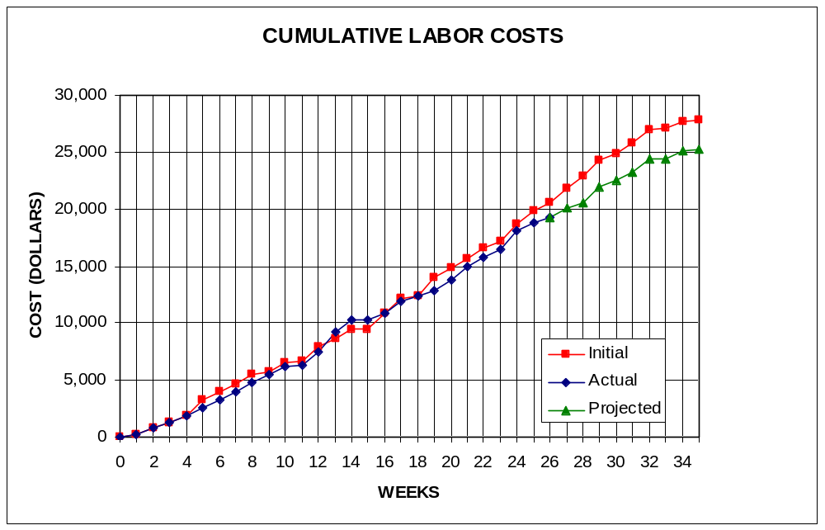
Figure 4: Labor Costs vs. Time

- ECONOMIC ANALYSIS

Table 5 and Table 6 demonstrate the projected costs of the prototype development for Project: SciSearch, and the unit costs, respectively. Game cartridges are sold to a wholesaler.

Table 5: Prototype Costs
PERSON | LABOR RATE | INITIAL EST. HRS. | INITIAL EST. COST | CURRENT EST. HRS. | CURRENT EST. COST
COMP. SYSTEMS ANALYST | $45.00 | 150 | $6,750 | 125 | $5,625
COMP. PROGRAMMER | $40.00 | 204 | $8,160 | 226 | $9,040
TEST PROGRAMMER | $35.00 | 104 | $3,640 | 78 | $2,730
TECHNICAL WRITER | $35.00 | 271 | $9,485 | 223 | $7,805
SUBTOTAL |  | 729 | $28,035 | 652 | $25,200
ENGINE @ 70% |  | 510 | $19,625 | 456 | $17,640
GAME @ 30% |  | 219 | $8,411 | 196 | $7,560
TOTAL |  | 729 | $28,035 | 652 | $25,200
DIRECT OVERHEAD @ 100% |  |  | $28,035 |  | $25,200
SUBTOTAL |  |  | $56,070 |  | $50,400
A & G COSTS @ 40% |  |  | $22,428 |  | $20,160
SUBTOTAL |  |  | $78,498 |  | $70,560
PROFIT @ 20% |  |  | $15,700 |  | $14,112
TOTAL COST OF PROTOTYPE |  |  | $94,198 |  | $84,672

Table 6: Profits
SELL CARTRIDGES TO A WHOLESELLER
SELL CARTRIDGE
HARDWARE PRODUCES 10 CARTRIDGES AT A TIME
COSTS | RATE | HOURS | INITIAL COST/COPY |  | CURRENT COST/COPY
CONSTRUCTION TIME | $20.00 | 0.25 | $0.50 |  | $0.50
SUBTOTAL DIRECT LABOR |  |  | $0.50 |  | $0.50
INDIRECT OVERHEAD @ 100% |  |  | $0.50 |  | $0.50
SUBTOTAL |  |  | $1.00 |  | $1.00
DOCUMENTATION |  |  | $2.00 |  | $2.00
PACKAGING |  |  | $3.00 |  | $3.00
SUBTOTAL |  |  | $6.00 |  | $6.00
A & G @ 40% |  |  | $2.40 |  | $2.40
SUBTOTAL |  |  | $8.40 |  | $8.40
PROFIT @ 20% |  |  | $1.68 |  | $1.68
SUBTOTAL |  |  | $10.08 |  | $10.08
RECOUP COST OF PROTOTYPE | COSTS | UNITS TO
 |  | SELL
INITIAL | $94,198 | 100,000 | $4.71
CURRENT | $84,672 | 100,000 |  |  | $4.23
RECOUP OVER |  | 20,000
MANUFACTURING COSTS |  |  | $14.79 |  | $14.31
WHOLESALE MARKUP @ 20% |  |  | $2.96 |  | $2.86
SUBTOTAL |  |  | $17.75 |  | $17.18
RETAIL MARKUP @ 50% |  |  | $8.87 |  | $8.59
TOTAL RETAIL COST |  |  | $26.62 |  | $25.76
PROFIT (ON FIRST 20,000) |  |  | $33,600 |  | $33,600
PROFIT (ON THE REST) |  |  | $292,708 |  | $279,418
TOTAL PROFIT |  |  | $326,308 |  | $313,018

- STATUS MATRICES

This report concentrates on the construction of the project. This construction process is documented in Table 9 below. The report documentation time is shown in Table 12. The remaining tables represent other development stages of the project which have either been completed or are in progress, and Table 13 is the gross totals of all previous tables.

Table 7: Outline Matrix
OUTLINE | INT EST HOURS | CUR EST HRS | WORK TO-DATE HRS | % WORK COMP | TIME TO COMP HRS
DISPLAY | 13 | 13 | 13 | 100 | 0
GROUND | 4 | 4 | 4 | 100 | 0
OBJECTS | 3 | 3 | 3 | 100 | 0
NPC | 3 | 3 | 3 | 100 | 0
INTERFACE | 3 | 3 | 3 | 100 | 0
INTERFACE | 12 | 12 | 12 | 100 | 0
MENUS | 3 | 3 | 3 | 100 | 0
MODES | 3 | 3 | 3 | 100 | 0
HELP | 4 | 4 | 4 | 100 | 0
INPUT | 2 | 2 | 2 | 100 | 0
SIMULATION | 8 | 8 | 8 | 100 | 0
ENVIRON | 4 | 4 | 4 | 100 | 0
AI | 4 | 4 | 4 | 100 | 0
TOTALS | 33 | 33 | 33 | 100 | 0

Table 8: Design Matrix
DESIGN | INT EST HOURS | CUR EST HRS | WORK TO-DATE HRS | % WORK COMP | TIME TO COMP HRS
DISPLAY | 63 | 47 | 47 | 100 | 0
GROUND | 16 | 12 | 12 | 100 | 0
OBJECTS | 15 | 12 | 12 | 100 | 0
NPC | 17 | 12 | 12 | 100 | 0
INTERFACE | 15 | 11 | 11 | 100 | 0
INTERFACE | 62 | 31 | 31 | 100 | 0
MENUS | 15 | 7 | 7 | 100 | 0
MODES | 16 | 7 | 7 | 100 | 0
HELP | 15 | 7 | 7 | 100 | 0
INPUT | 16 | 10 | 10 | 100 | 0
SIMULATION | 40 | 26 | 26 | 100 | 0
ENVIRON | 20 | 14 | 14 | 100 | 0
AI | 20 | 12 | 12 | 100 | 0
TOTALS | 165 | 104 | 104 | 100 | 0

Table 9: Construct Matrix
CONSTRUCT | INT EST HOURS | CUR EST HRS | WORK TO-DATE HRS | % WORK COMP | TIME TO COMP HRS
DISPLAY | 56 | 47 | 47 | 100 | 0
GROUND | 15 | 25 | 25 | 100 | 0
OBJECTS | 13 | 8 | 8 | 100 | 0
NPC | 15 | 5 | 5 | 100 | 0
INTERFACE | 13 | 9 | 9 | 100 | 0
INTERFACE | 132 | 32 | 32 | 100 | 0
MENUS | 30 | 9 | 9 | 100 | 0
MODES | 32 | 8 | 8 | 100 | 0
HELP | 30 | 5 | 5 | 100 | 0
INPUT | 40 | 10 | 10 | 100 | 0
SIMULATION | 82 | 44 | 18 | 41 | 26
ENVIRON | 40 | 18 | 10 | 56 | 8
AI | 42 | 26 | 8 | 31 | 18
TOTALS | 270 | 123 | 97 | 79 | 26

Table 10: Integrate Matrix
INTEGRATE | INT EST HOURS | CUR EST HRS | WORK TO-DATE HRS | % WORK COMP | TIME TO COMP HRS
DISPLAY | 17 | 28 | 27 | 96 | 1
GROUND | 5 | 4 | 4 | 100 | 0
OBJECTS | 4 | 8 | 8 | 100 | 0
NPC | 3 | 4 | 3 | 75 | 1
INTERFACE | 5 | 12 | 12 | 100 | 0
INTERFACE | 16 | 31 | 28 | 90 | 3
MENUS | 4 | 7 | 7 | 100 | 0
MODES | 4 | 8 | 7 | 88 | 1
HELP | 5 | 4 | 4 | 100 | 0
INPUT | 3 | 12 | 10 | 83 | 2
SIMULATION | 10 | 26 | 7 | 27 | 19
ENVIRON | 5 | 12 | 4 | 33 | 8
AI | 5 | 14 | 3 | 21 | 11
TOTALS | 43 | 85 | 62 | 73 | 23

Table 11: Test Matrix
TEST | INT EST HOURS | CUR EST HRS | WORK TO-DATE HRS | % WORK COMP | TIME TO COMP HRS
DISPLAY | 15 | 40 | 35 | 88 | 5
GROUND | 3 | 11 | 11 | 100 | 0
OBJECTS | 4 | 8 | 6 | 75 | 2
NPC | 3 | 8 | 6 | 75 | 2
INTERFACE | 5 | 13 | 12 | 92 | 1
INTERFACE | 17 | 39 | 32 | 82 | 7
MENUS | 5 | 10 | 8 | 80 | 2
MODES | 4 | 11 | 9 | 82 | 2
HELP | 3 | 6 | 5 | 83 | 1
INPUT | 5 | 12 | 10 | 83 | 2
SIMULATION | 11 | 28 | 9 | 32 | 19
ENVIRON | 6 | 13 | 5 | 38 | 8
AI | 5 | 15 | 4 | 27 | 11
TOTALS | 43 | 107 | 76 | 71 | 31

Table 12: Document Matrix
DOCUMENT | INT EST HOURS | CUR EST HRS | WORK TO-DATE HRS | % WORK COMP | TIME TO COMP HRS
DISPLAY | 28 | 39 | 38 | 97 | 1
GROUND | 7 | 10 | 10 | 100 | 0
OBJECTS | 7 | 8 | 8 | 100 | 0
NPC | 7 | 9 | 9 | 100 | 0
INTERFACE | 7 | 12 | 11 | 92 | 1
INTERFACE | 36 | 44 | 35 | 80 | 9
MENUS | 8 | 10 | 9 | 90 | 1
MODES | 6 | 12 | 10 | 83 | 2
HELP | 9 | 10 | 6 | 60 | 4
INPUT | 13 | 12 | 10 | 83 | 2
SIMULATION | 27 | 33 | 17 | 52 | 16
ENVIRON | 14 | 15 | 9 | 60 | 6
AI | 13 | 18 | 8 | 44 | 10
TOTALS | 91 | 116 | 90 | 78 | 26
Table 13: Total Matrix
TOTAL | INT EST HOURS | CUR EST HRS | WORK TO-DATE HRS | % WORK COMP | TIME TO COMP HRS
DISPLAY | 192 | 214 | 207 | 97 | 7
GROUND | 50 | 66 | 66 | 100 | 0
OBJECTS | 46 | 47 | 45 | 96 | 2
NPC | 48 | 41 | 38 | 93 | 3
INTERFACE | 48 | 60 | 58 | 97 | 2
INTERFACE | 275 | 189 | 170 | 90 | 19
MENUS | 65 | 46 | 43 | 93 | 3
MODES | 65 | 49 | 44 | 90 | 5
HELP | 66 | 36 | 31 | 86 | 5
INPUT | 79 | 58 | 52 | 90 | 6
SIMULATION | 178 | 165 | 85 | 52 | 80
ENVIRON | 89 | 76 | 46 | 61 | 30
AI | 89 | 89 | 39 | 44 | 50
CLASS TIME | 84 | 84 | 63 | 75 | 21
GRAND TOTAL | 729 | 652 | 525 | 81 | 127
- CONCLUSIONS

Project: SciSearch, in its current design iteration, is demonstrated above to be a real-time simulation game engine utilizing a ¾ isometric view output. The logical flow of the program is demonstrated, as well as its detailed specifications and time requirements. Further, a detailed estimated cost module has been approximated. Construction is nearly complete, with about 26 hours remaining. With the program nearing the end of construction, Project: SciSearch is prepared to move forward as a profitable simulation game engine for the Game Boy Advance platform.

APPENDIX A
TASK TABLE

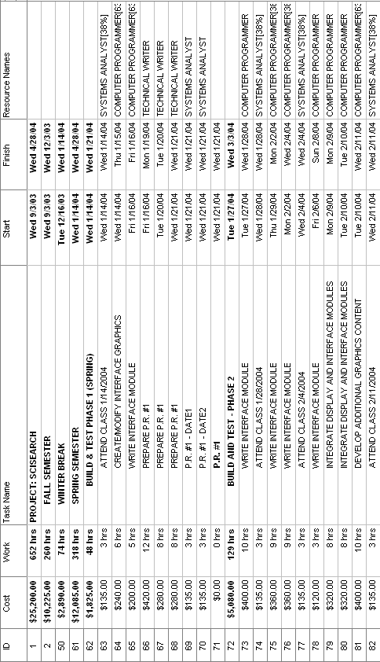
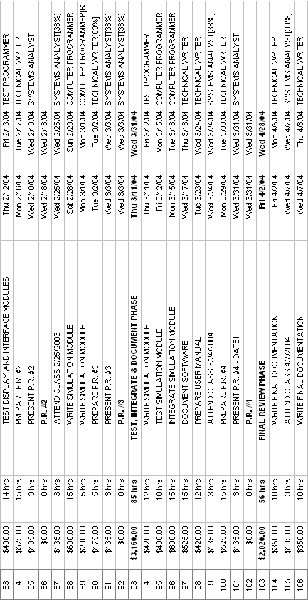
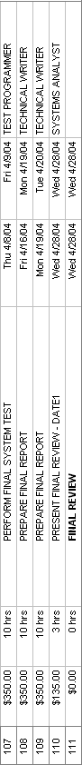

APPENDIX B
GANTT CHART

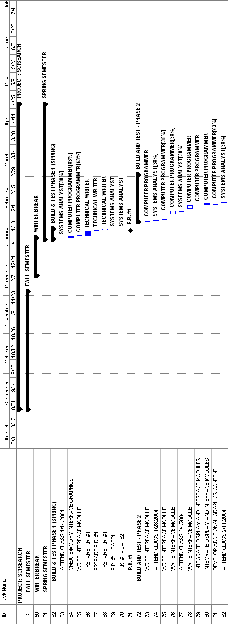
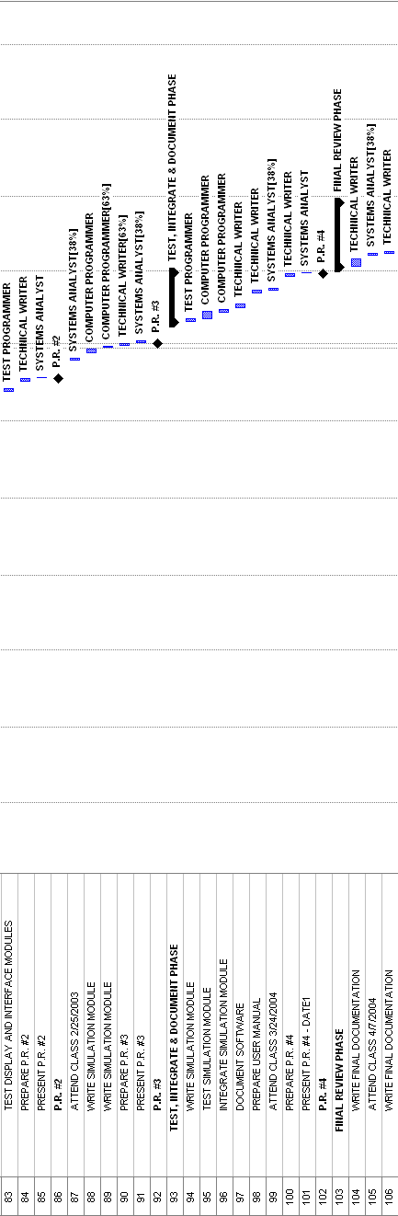

APPENDIX C
REFERENCES
Best First Search
http://www.ryerson.ca/~dgrimsha/courses/cps721/nBest.html (12/03/2003)
GBA Dev Online
http://www.gbadev.org

