**Application Dependencies:**

1. Node
2. NPM
3. MongoDB

**Installation Instructions:**

1) There are two zip files, leaderboard (UI app) and apiserver (backend app).

2) Download both files and unzip them.

3) Browse through each folder and then run below command inside terminal to install dependencies:

# **npm install**

4) After installation of dependencies, from the leaderboard folder, run the below command from terminal to start UI server:

# **npm start**

5) Upon successful start, you can see the app running from a browser using below url:

[**http://localhost:3000/login**](http://localhost:3000/login)

6) Then from the other folder apiserver, run the below command from terminal to start api server on port 5000:

# **npm run build**

This will listen to the requests from UI.

**How to use Application:**

1. Basically every user has to register to use this application.
2. There can be different types of users:
3. Player (who can join the tournament and play matches)
4. Referee (who manages scores of players in tournament)
5. Public Subscriber (Shows limited information on leaderboard, only player name)
6. Private Subscriber (Shows more information on leaderboard like player name and scores)
7. To login as different user, you must logout of previous session.

**Note:** Please follow the screenshots below.

**Registration Page:**

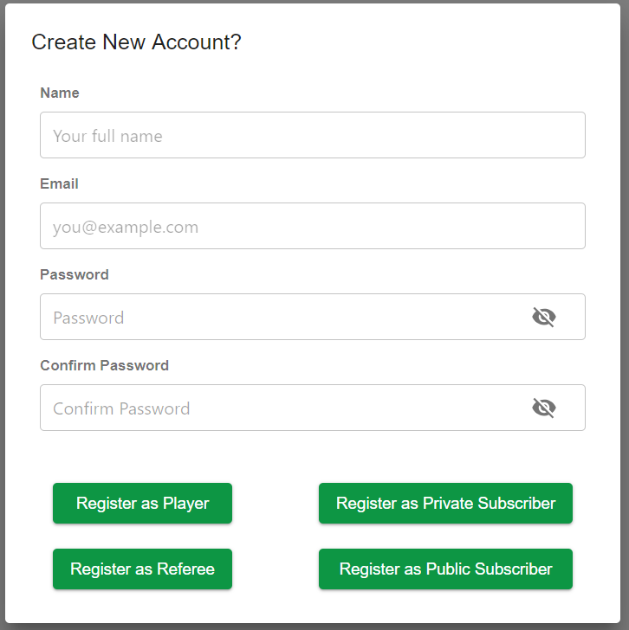

A popup will appear when you click create new account link on login page. Provide the information and choose the type of user from the below options by clicking appropriate button to complete registration.

**Login Page:**

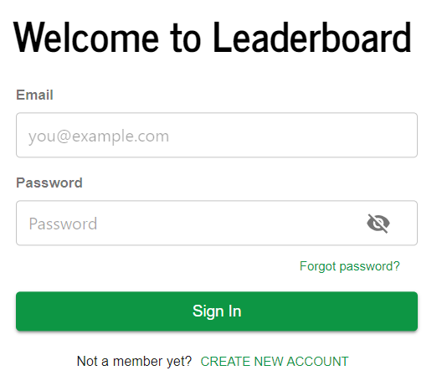

Use the credentials you have used while registering a user as a player, referee or subscriber.

**Player Pages:**

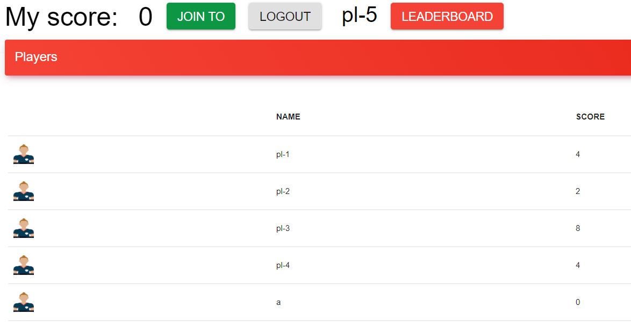

After login, a player can chose to join a tournament by clicking “JOIN TO” button.

Every player page displays all the other players who joined the tournament with their scores.

“LEADERBOARD” button can take you to the leaderboard page.

“LOGOUT” button can be used to logout.

Below image shows that a player has joined the tournament , so the “JOIN TO” button turned to “JOINED” and disabled. Now this player name listed in the below table, along with other joined players.

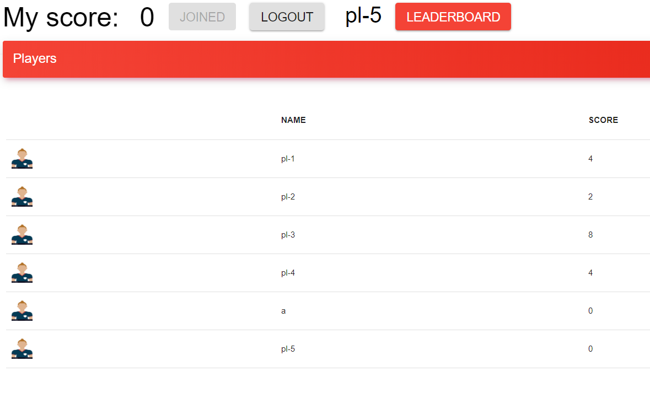

**Referee Pages:**

The below page is the landing page for Referee, who can see all the matches available and can choose the options ( Win, DRAW, RESET & FINISH MATCH ).

Every match will show the players of the respective match and option to choose who Wins or if the match is a DRAW. A win will gives 4 points, draw gives 2 points for each player and loss gives 1 point.

If a wrong score is assigned, it can be corrected by using “REST” link before clicking “FINISH MATCH” link, which concludes that match and its result.

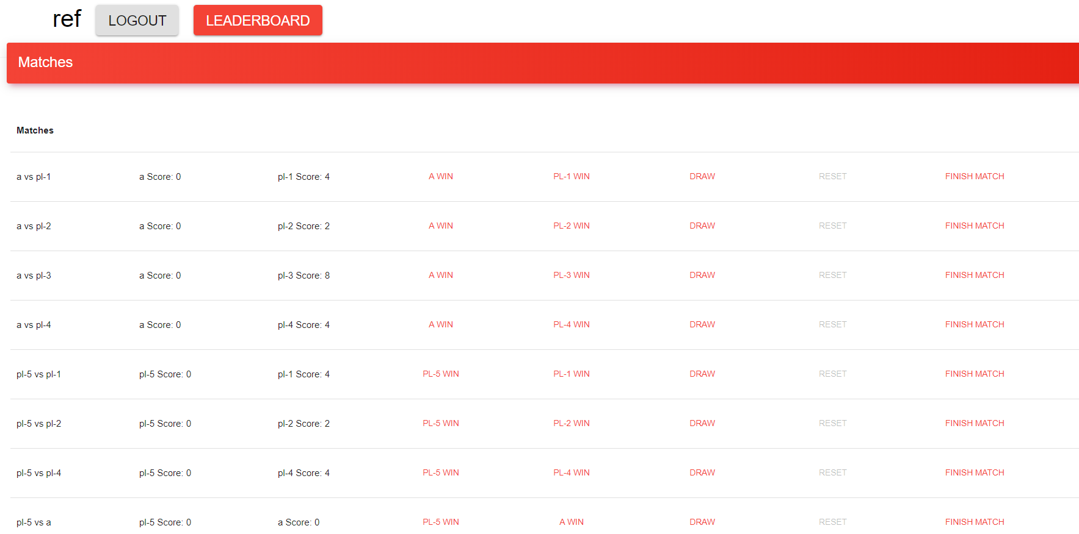

**Public Subscriber Leaderboard:**

This user gets limited information, so he can see only players on leaderboard.

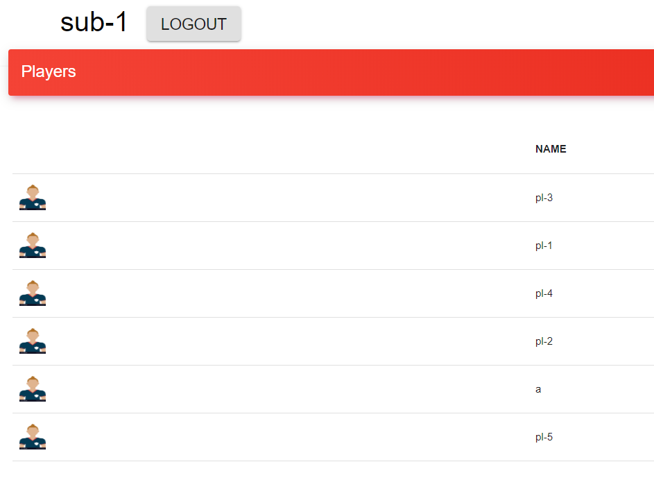

**Private Subscriber Leaderboard:**

This user gets details of scores and players on the leaderboard.

