* Exp no :13
* AIM : Design PDA using simulator to accept the input string aabb

INPUT:

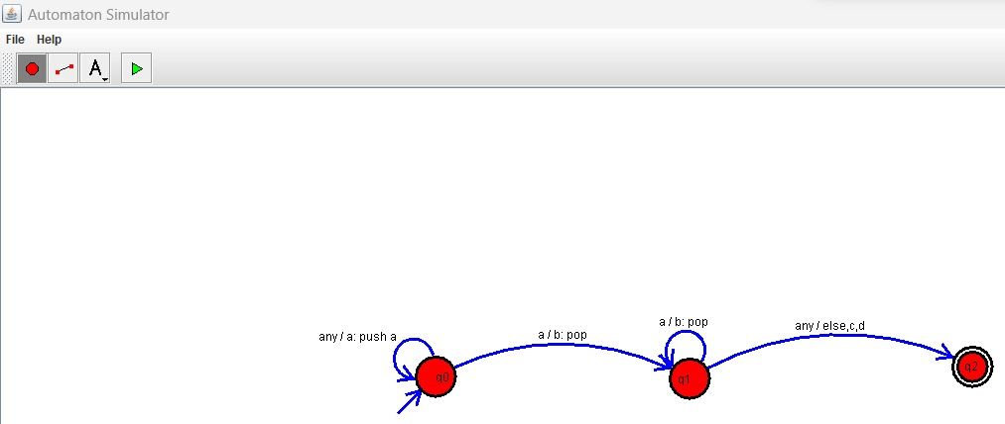

OUTPUT:

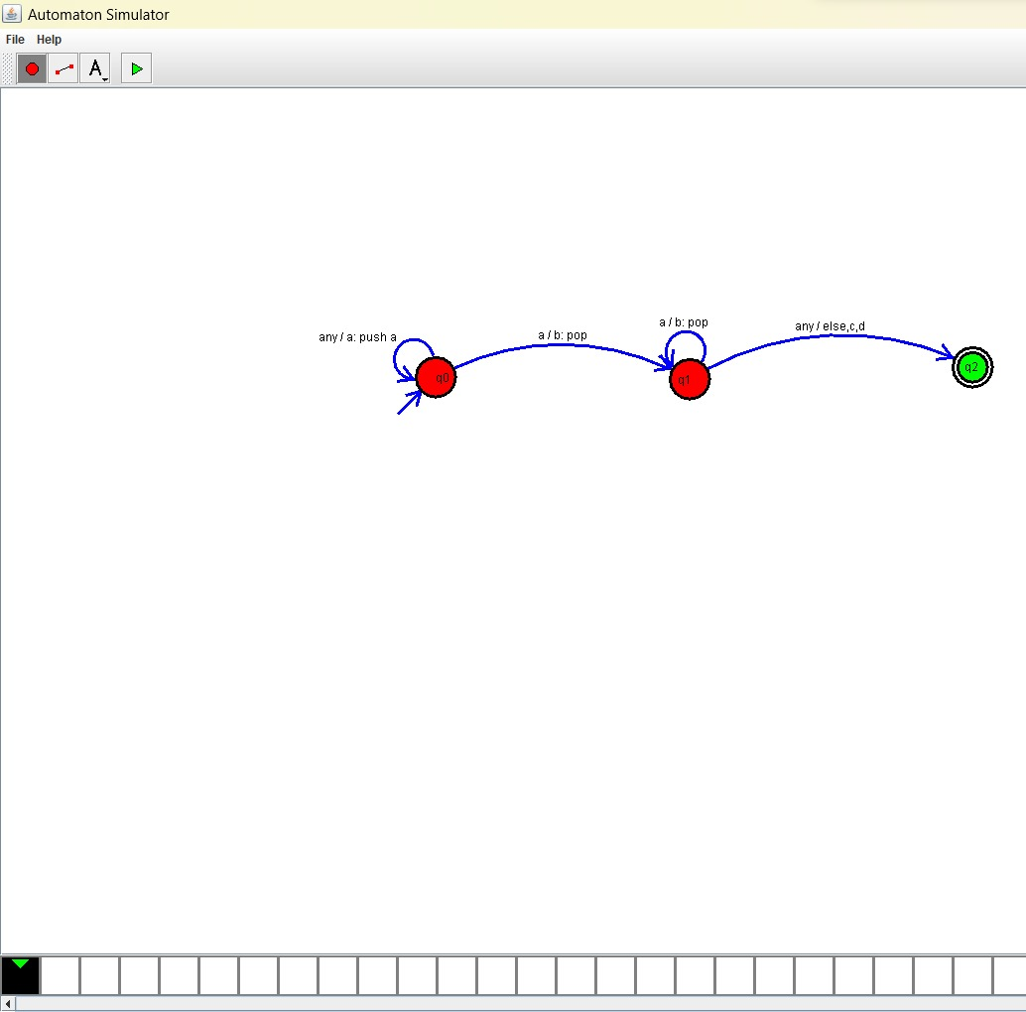

Result:

The simulator is accepted the given input string aabb by using the above PDA diagram