* EXP NO 14
* AIM: PDA using simulator to accept the input string anb2n

INPUT:

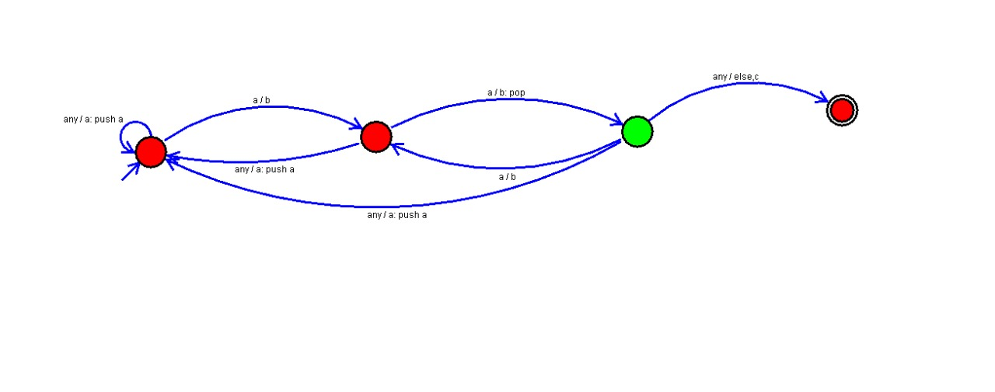

OUTPUT:

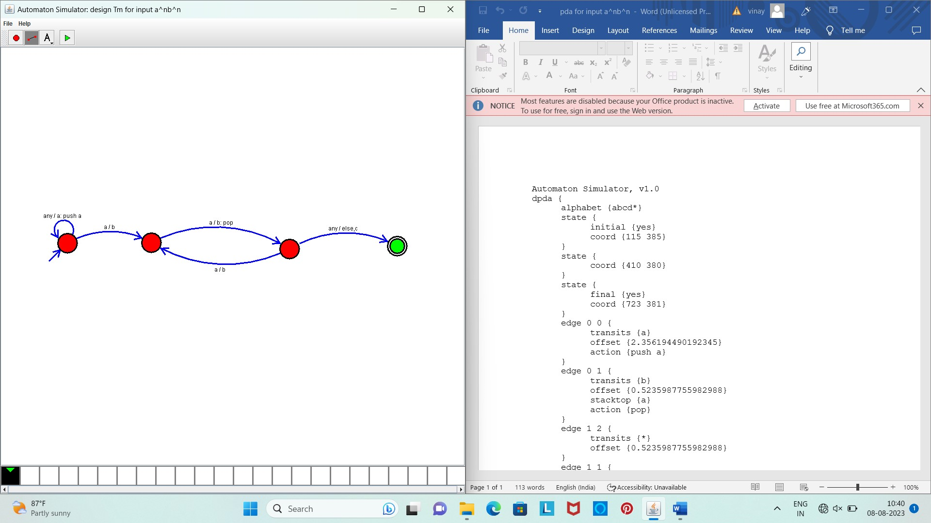

Result :

* The simulator is accepted the given input string anb2n by using the above PDA diagram