EXP NO:15

* AIM:Design TM using simulator to accept the input string anbn

INPUT:

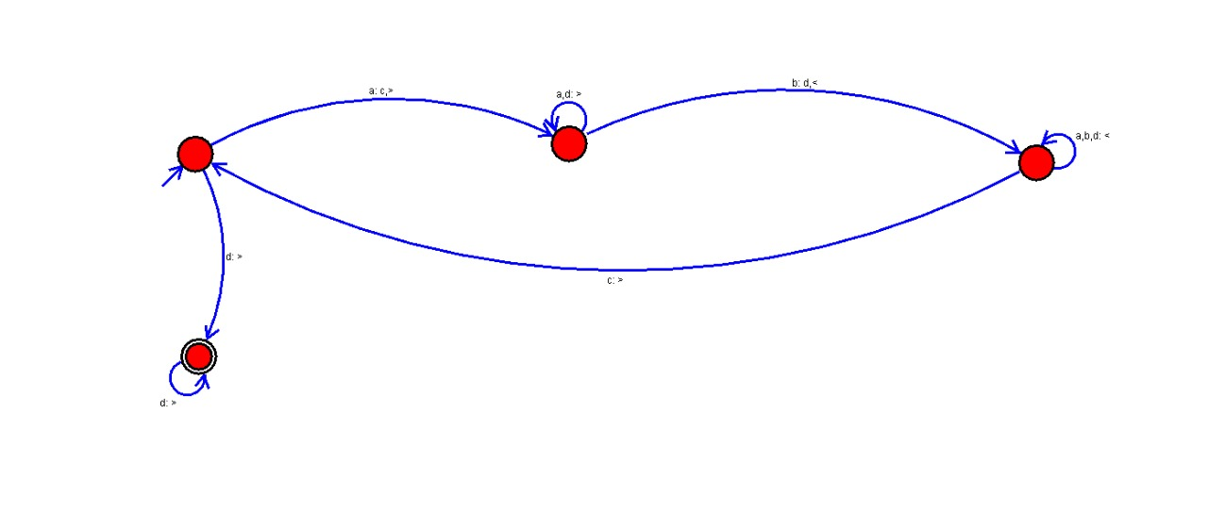

OUTPUT:

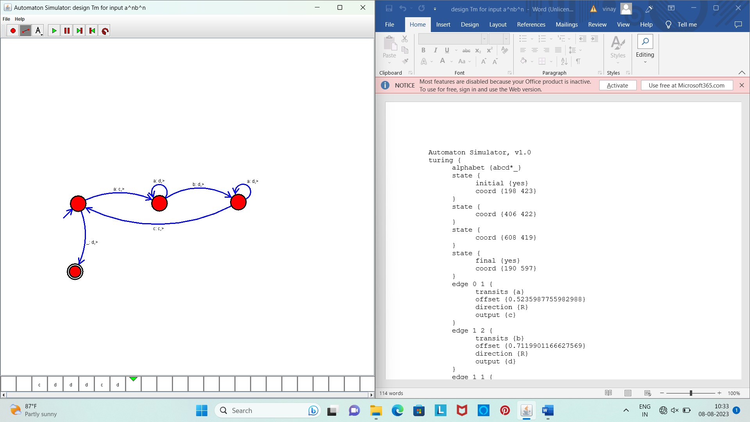

Result :

The simulator is accepted the given input string anbn  by using the above TM diagram.