* EXP NO :16
* AIM:Design TM using simulator to accept the input string anb2n

INPUT:

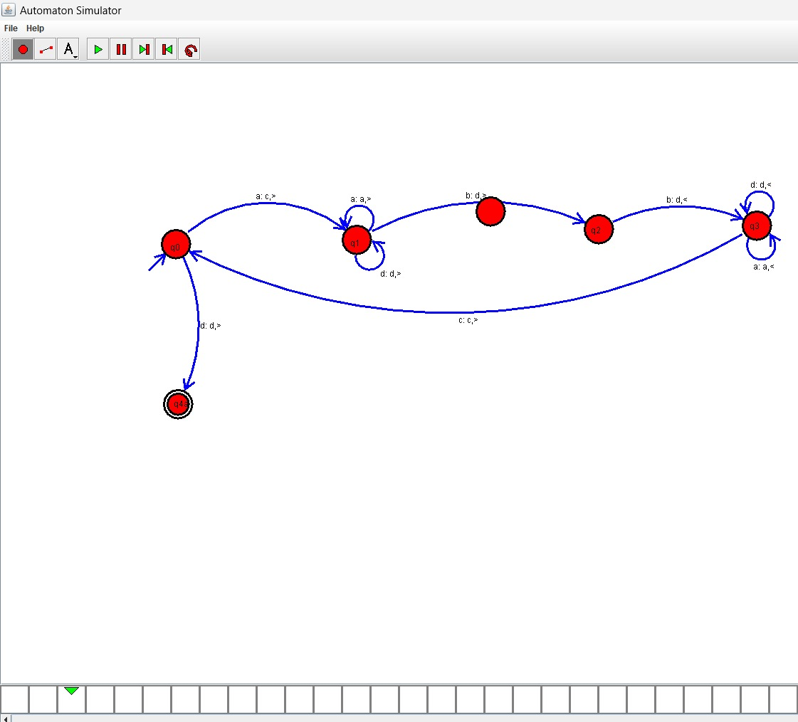

OUTPUT:

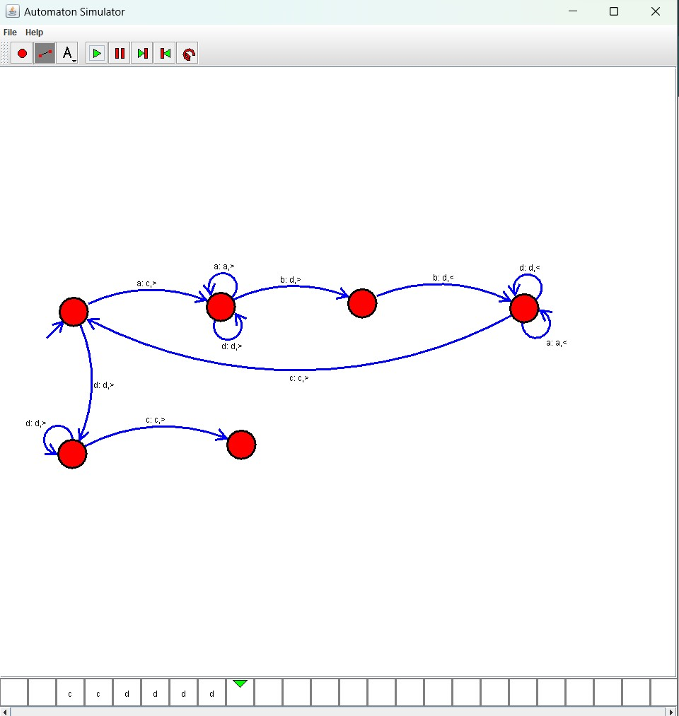

Result :

The simulator is accepted the input string anb2n by using the above TM diagram