* EXP NO :17
* AIM:Design TM using simulator to accept the input string Palindrome ababa

INPUT:

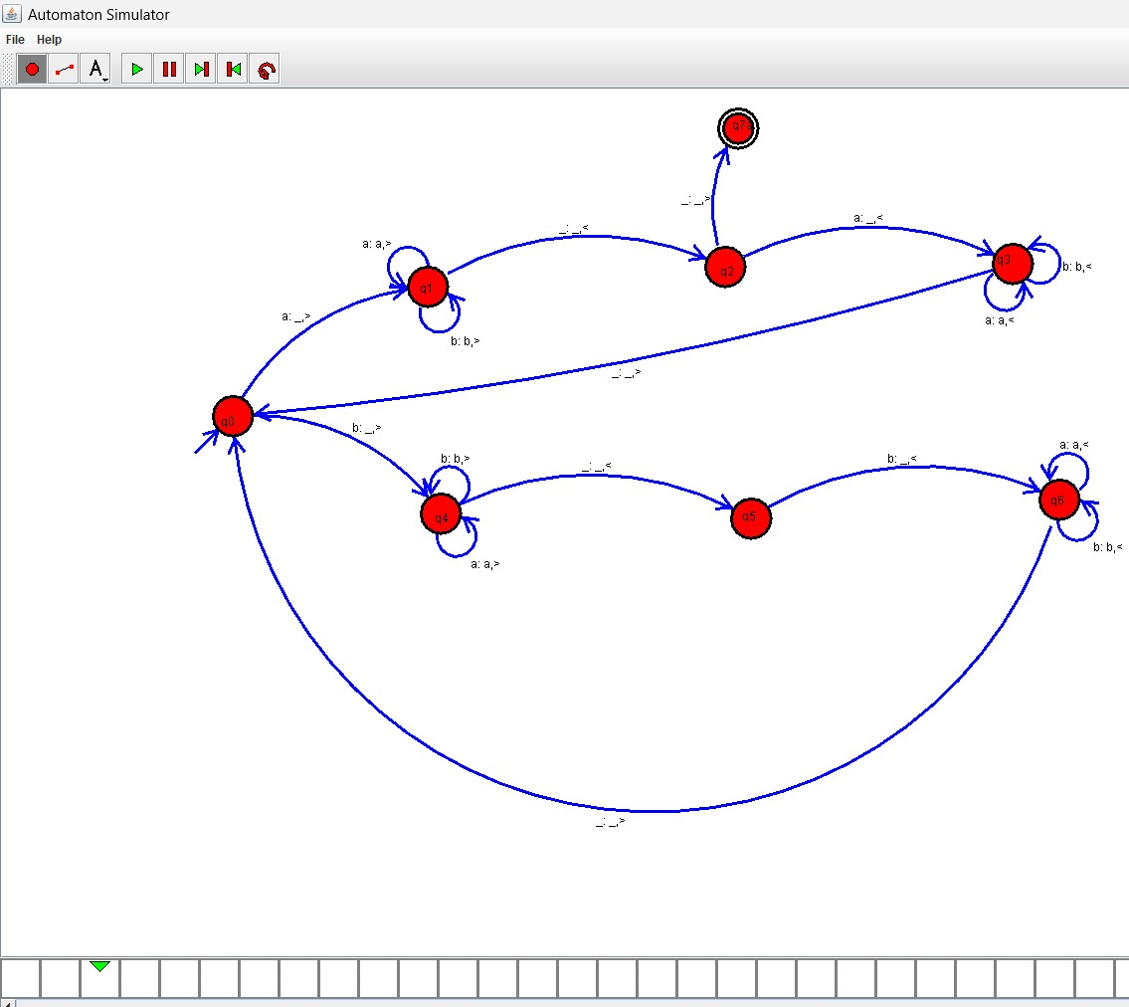

OUTPUT:

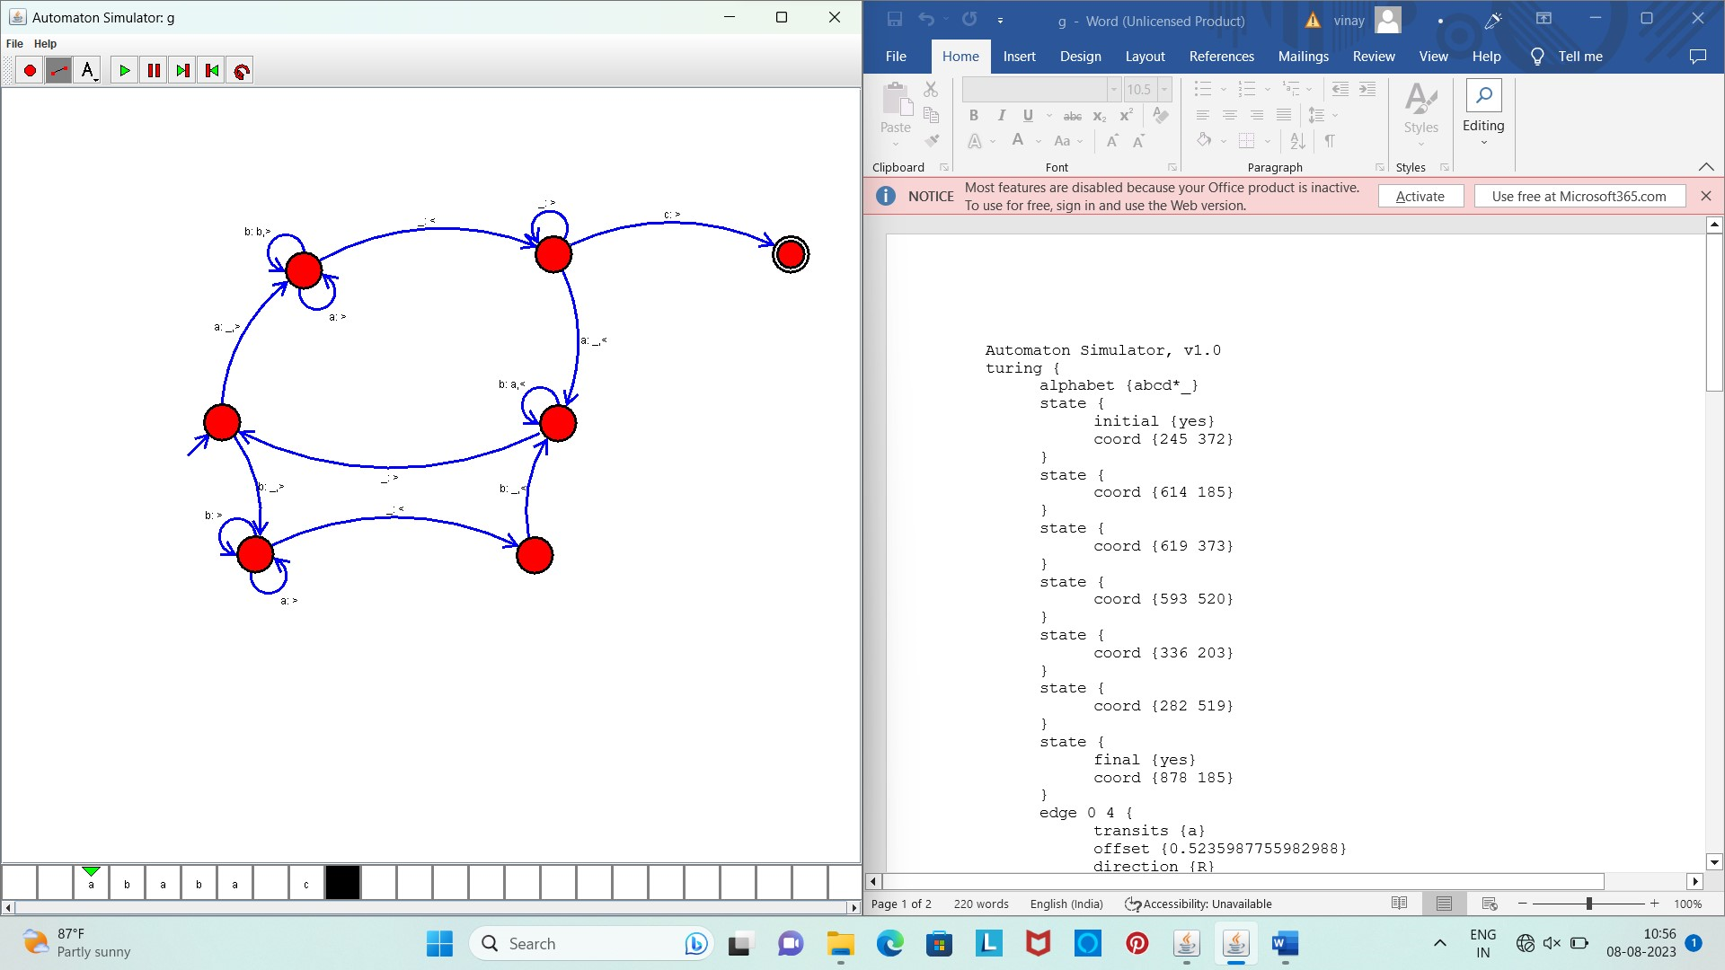

Result :

* The simulator is accepted the input string Palindrome ababa by using the above TM diagram