* EXP NO:19
* AIM:Design TM using simulator to perform addition of ‘aa’ and ‘aaa’

INPUT:

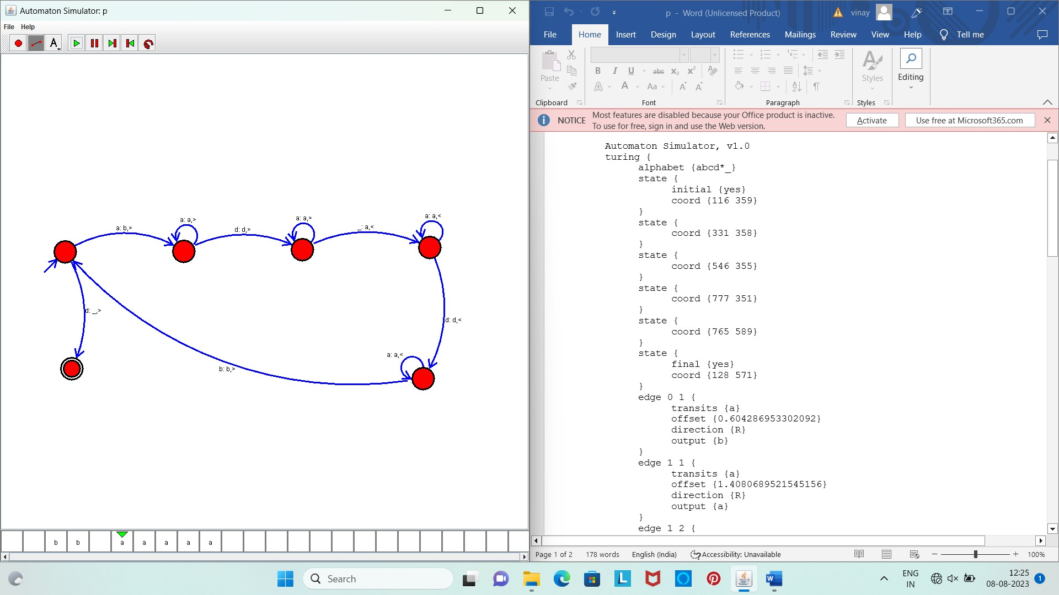

OUTPUT:

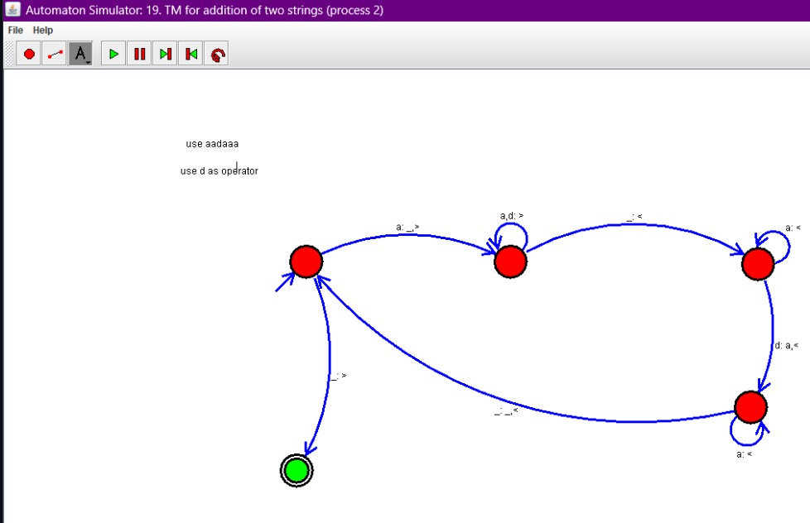

Result :

The simulator is accepted to perform addition for the strings of aa and aaa by using the above TM diagram