EXP NO 21

AIM:Design DFA using simulator to accept even number of a’s.

INPUT:

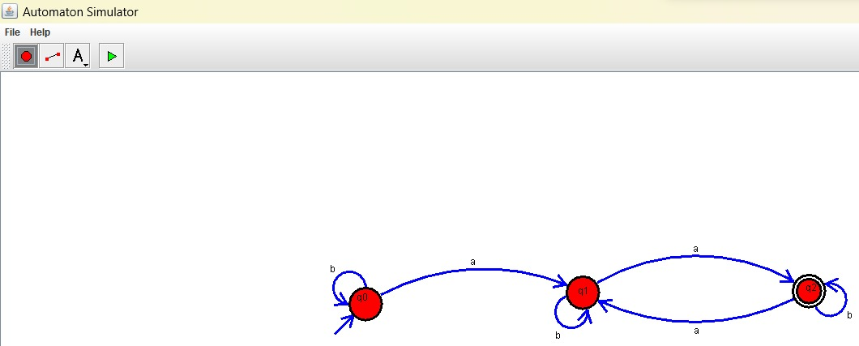

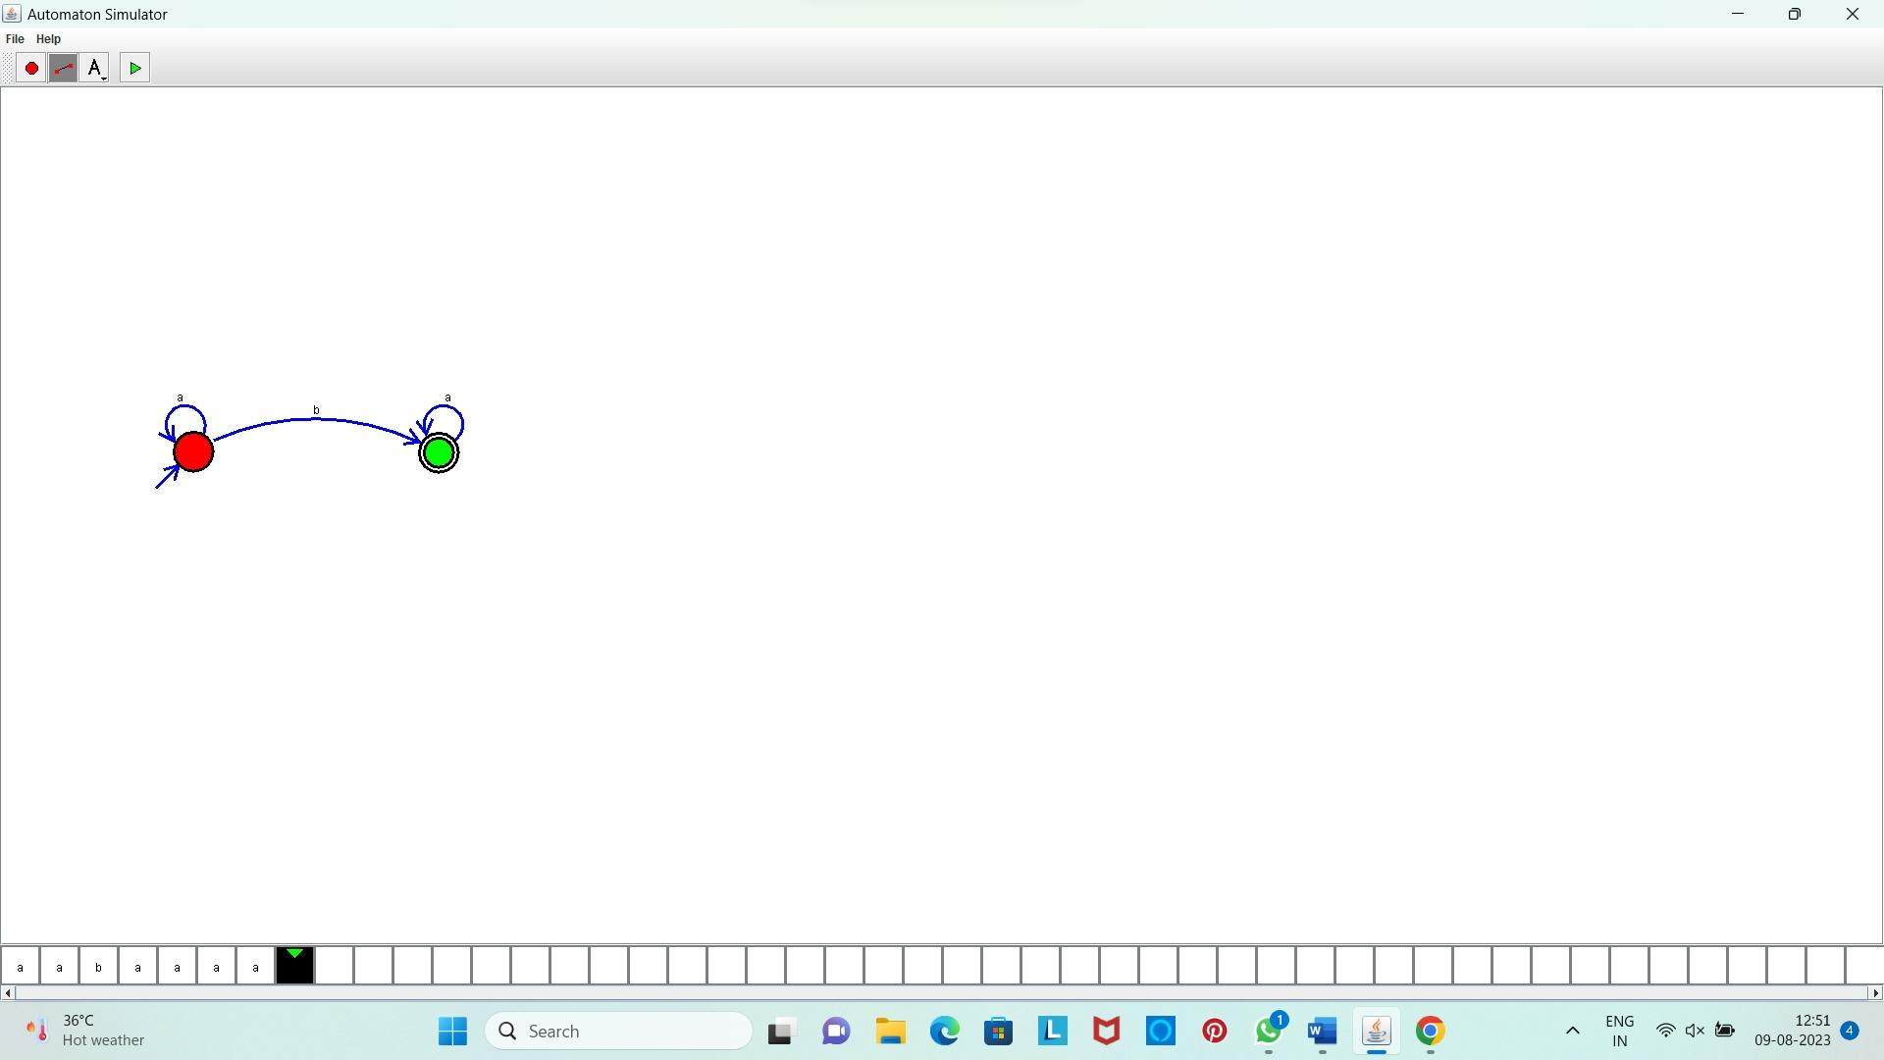**OUTPUT:**

**Result:** Hence, We designed a DFA using simulator to accept even number of a’s.