EXP NO 22

AIM: Design DFA using simulator to accept odd number of a’s

INPUT: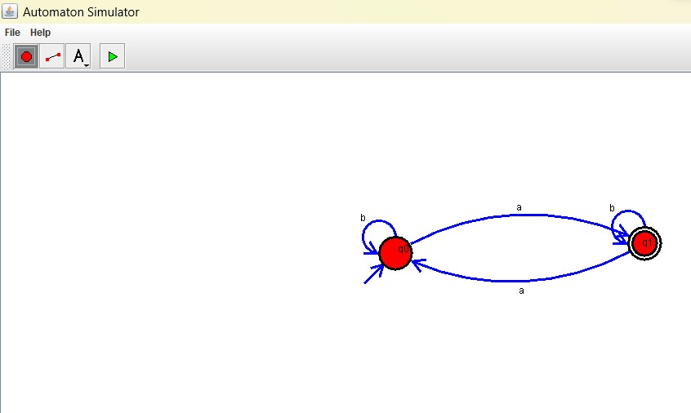

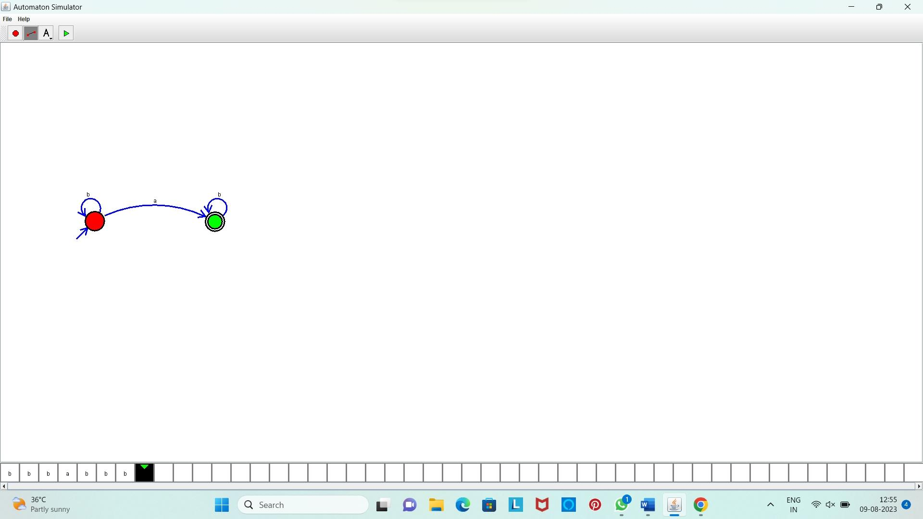OUTPUT:

**Result:** Hence, we Designed DFA using simulator to accept odd number of a’s