EXP NO:23

AIM:Design DFA using simulator to accept the string the end with ab over set {a,b)

W= aaabab

INPUT:

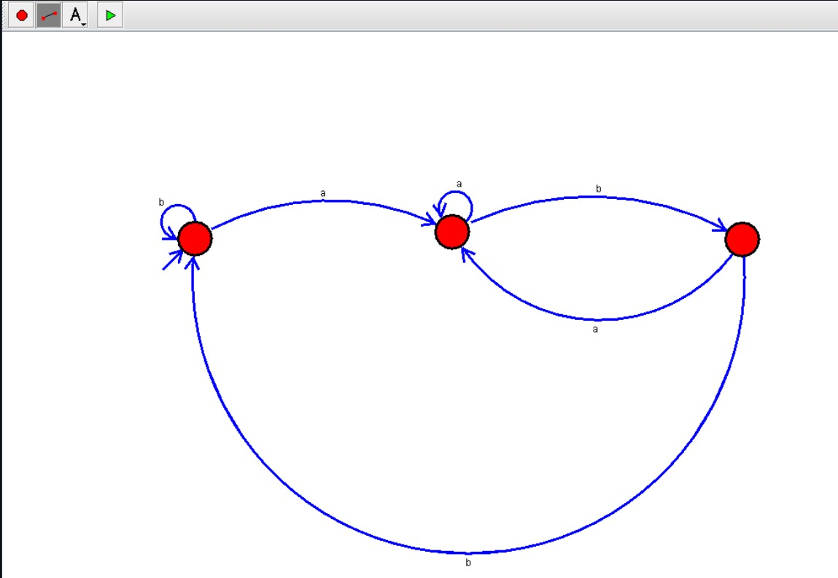

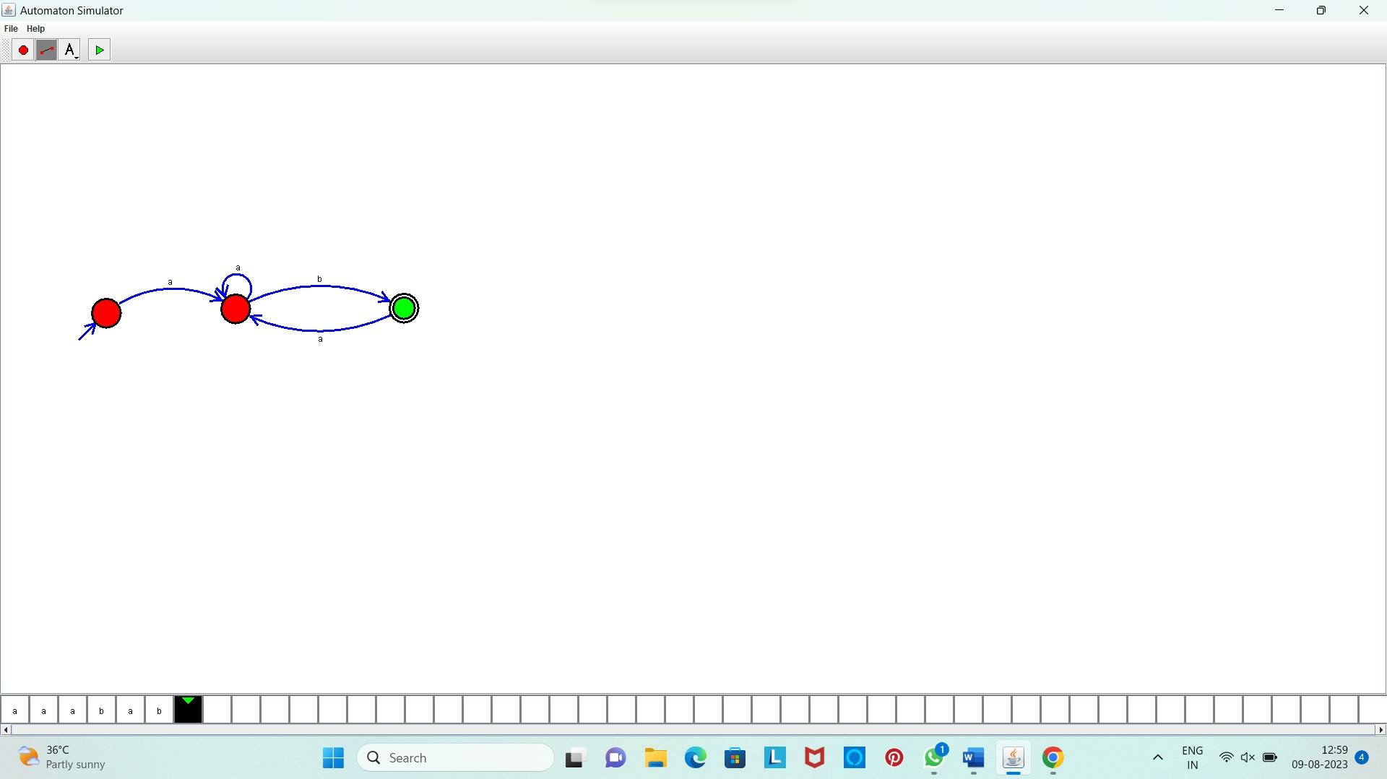OUTPUT:

**Result:** Hence, we Designed DFA using simulator to accept the string the end with ab over set {a,b)

W= aaabab