EXP NO:24

AIM:Design DFA using simulator to accept the string having ‘ab’ as substring over the set {a,b}

INPUT:

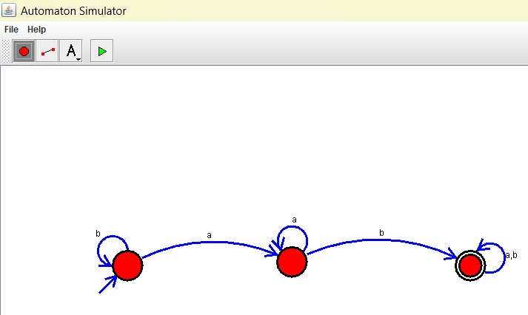

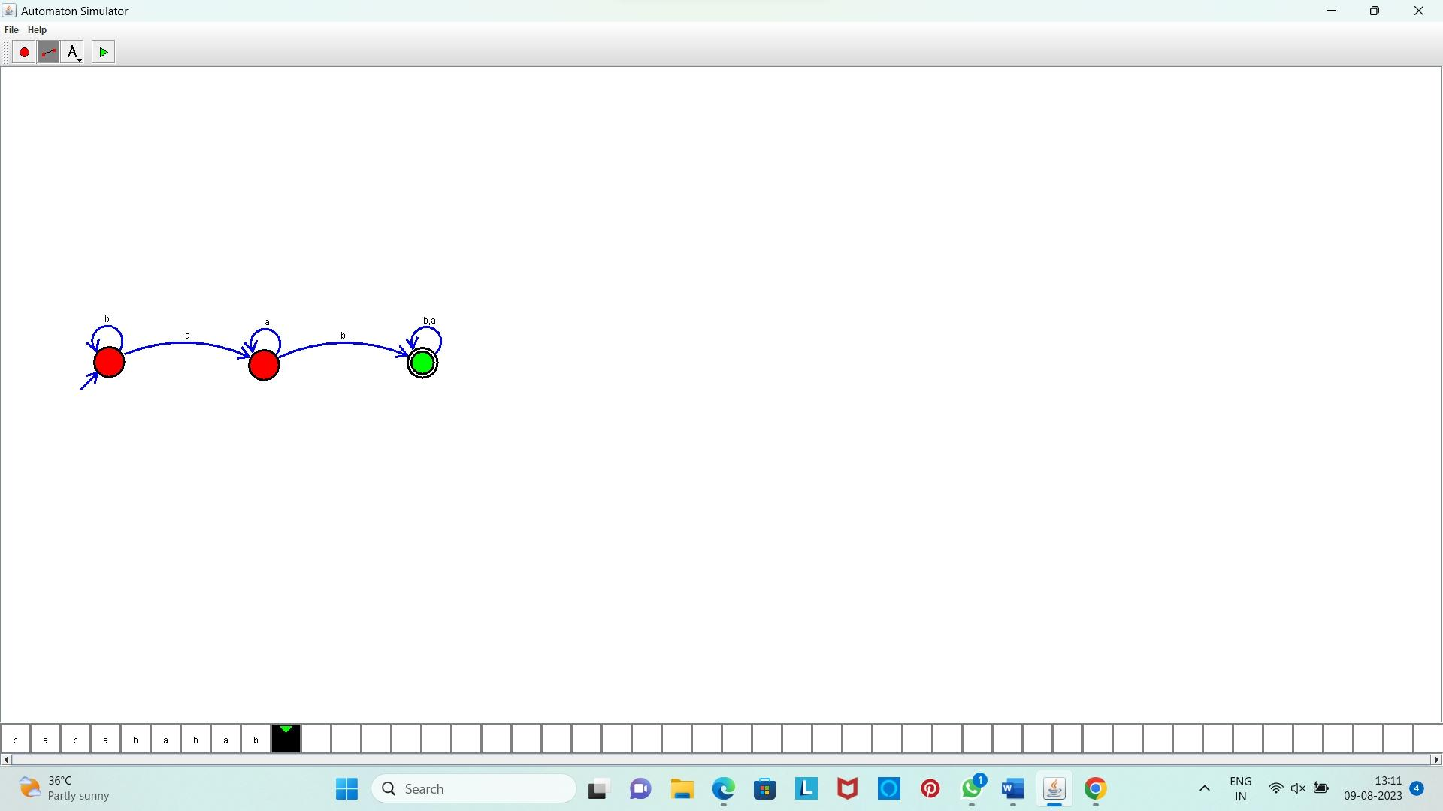OUTPUT:

**Result:** Hence, we Designed DFA using simulator to accept the string having ‘ab’ as substring over the set {a,b}