EXP NO 25

AIM:Design DFA using simulator to accept the string start with a or b over the set {a,b}

INPUT:

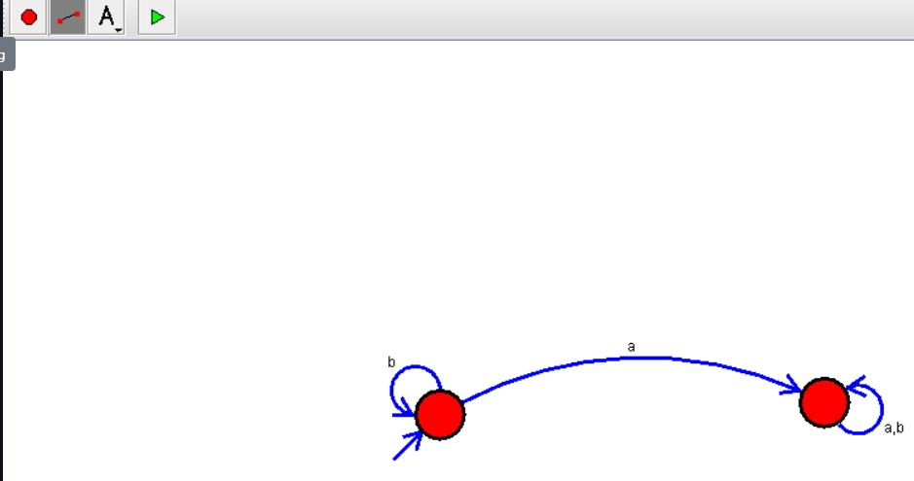

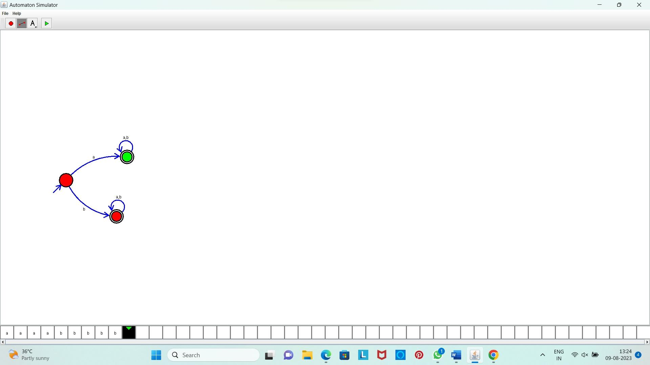OUTPUT:

**Result:** Hence, we designed DFA using simulator to accept the string start with a or b over the set {a,b}