EXP NO 26

AIM:Design TM using simulator to accept the input string Palindrome bbabb

OUTPUT:

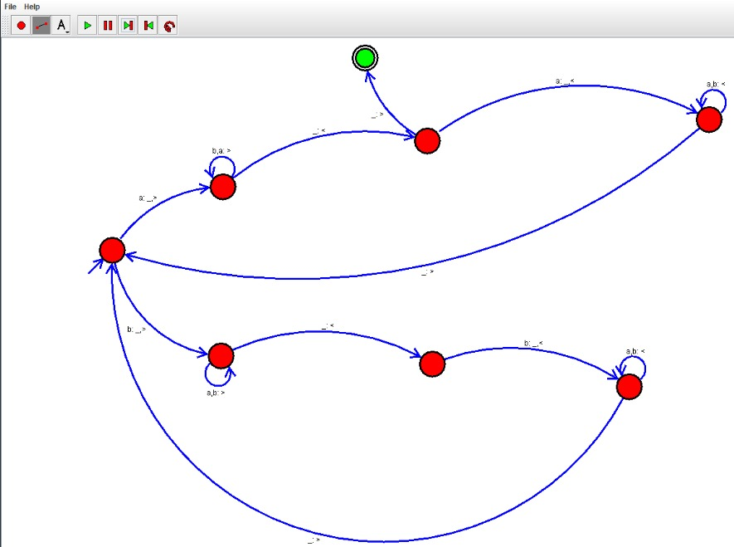

INPUT:

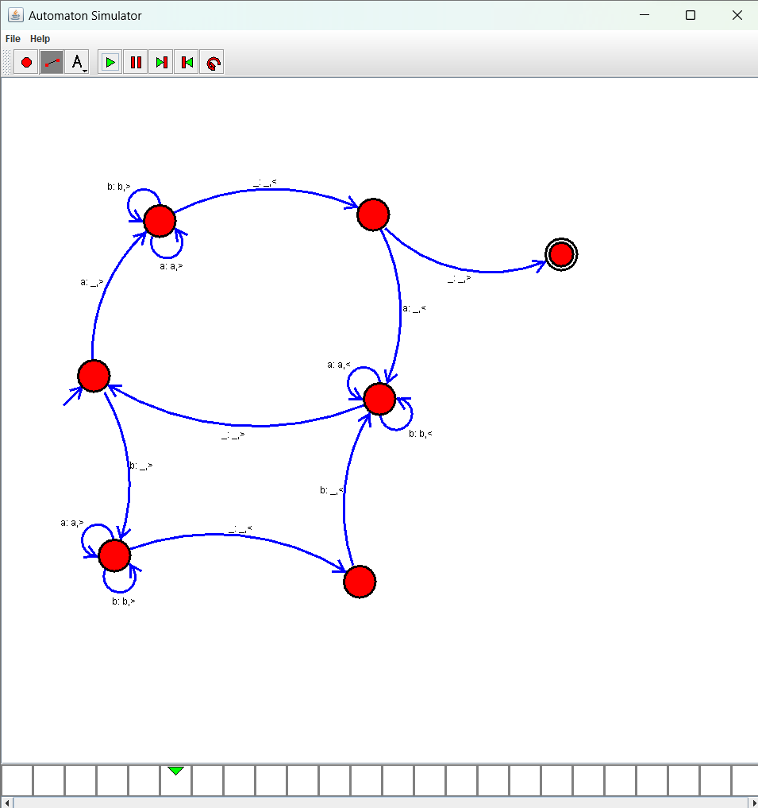

Result:

Accepted the string palindrome using the Turing machine simulator