EXP NO 27

AIM:Design TM using simulator to accept the input string wcw

INPUT:

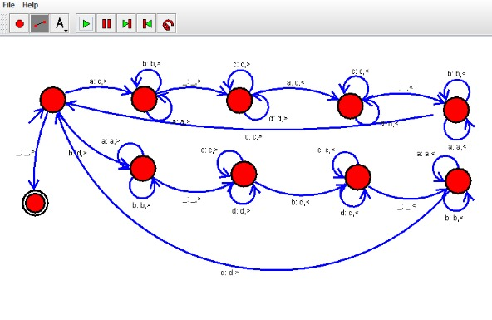

OUTPUT:

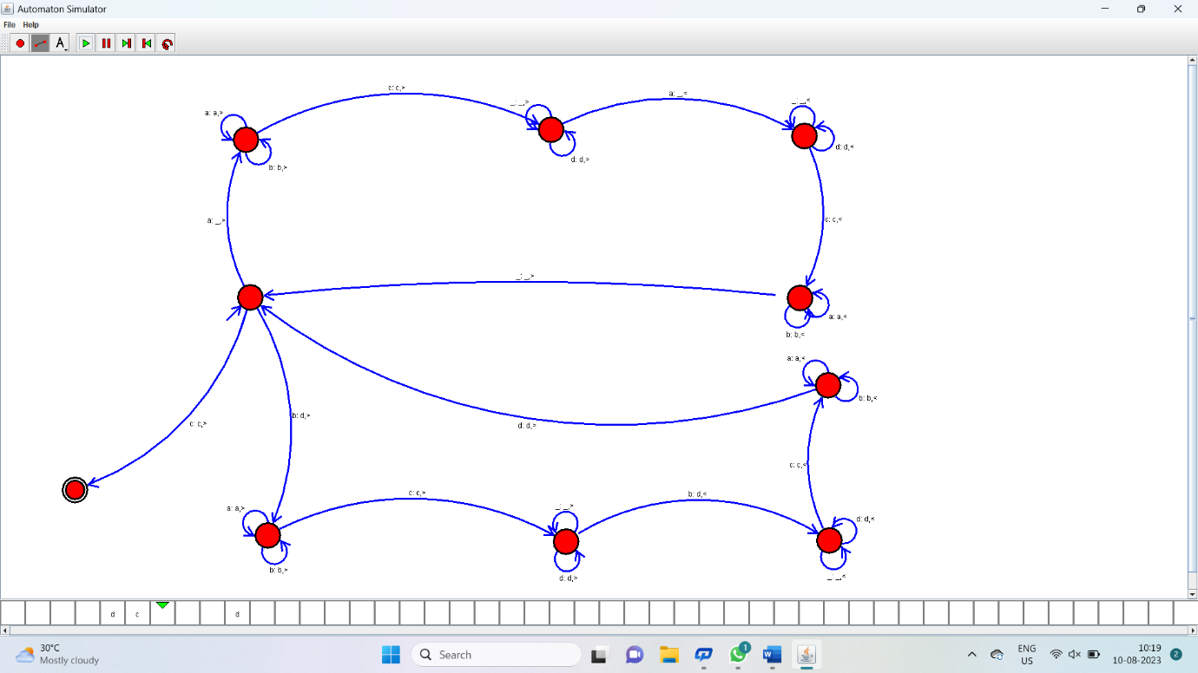

Result:

Hence it has accepted the input string wcw by using Turing machine simulator