EXP NO 28

AIM:Design DFA using simulator to accept the string the end with ab over set {a,b)

W= abbaabab

INPUT:

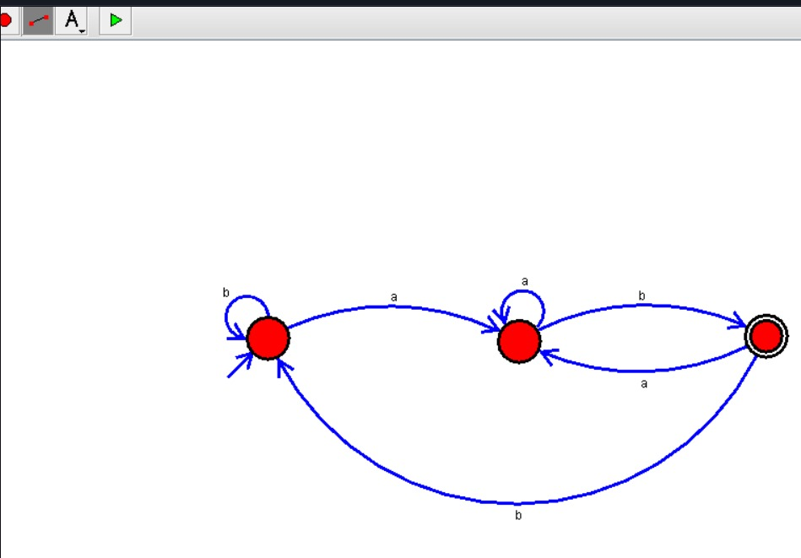

OUTPUT:

*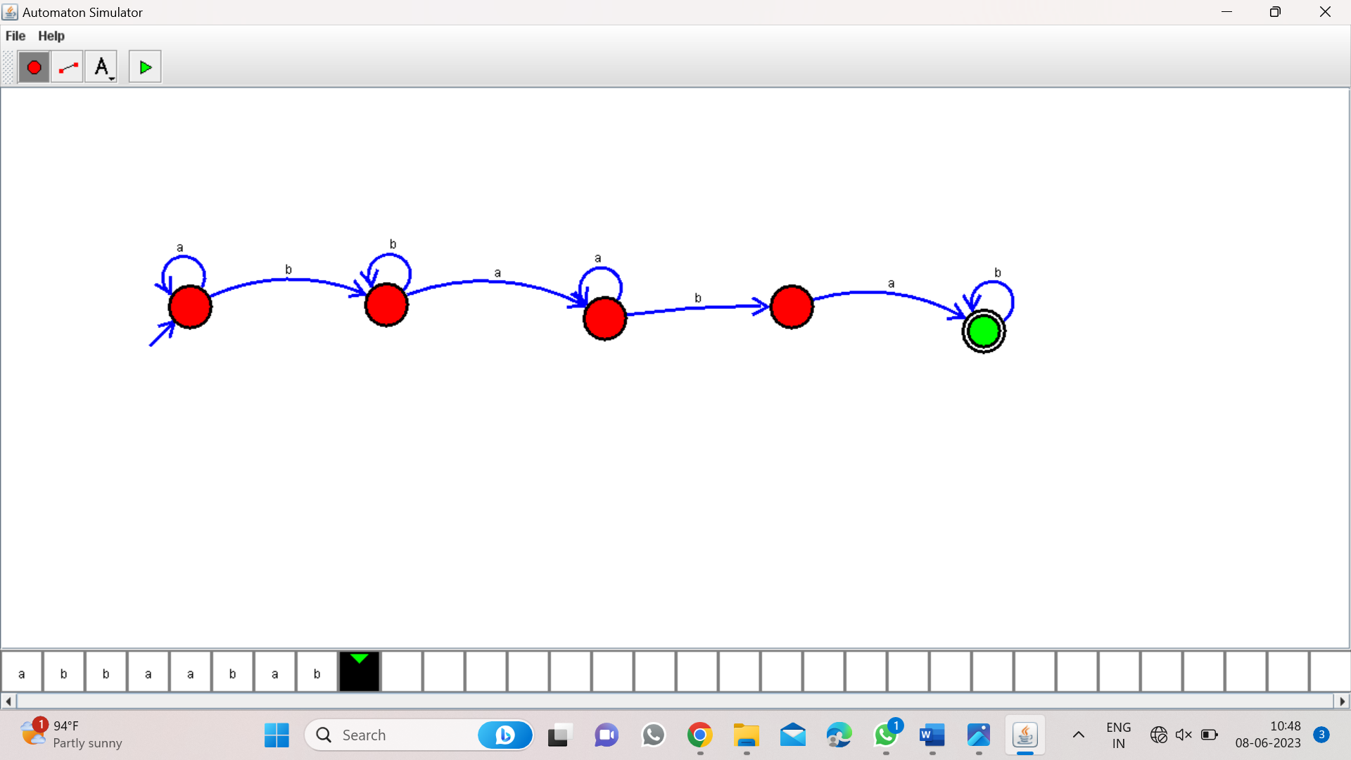*

Result:

Finally accepted the input string the end with ab over set{a,b} by using DFA simulator