EXP NO 29

AIM:Design DFA using simulator to accept the input string “bc” ,”c”,and ”bcaaa”.

INPUT:

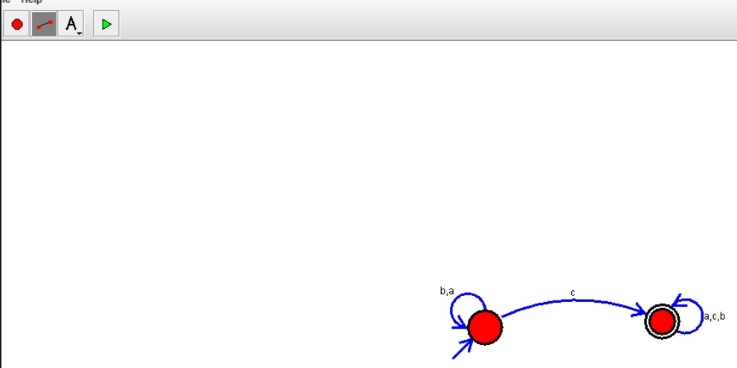

OUTPUT:

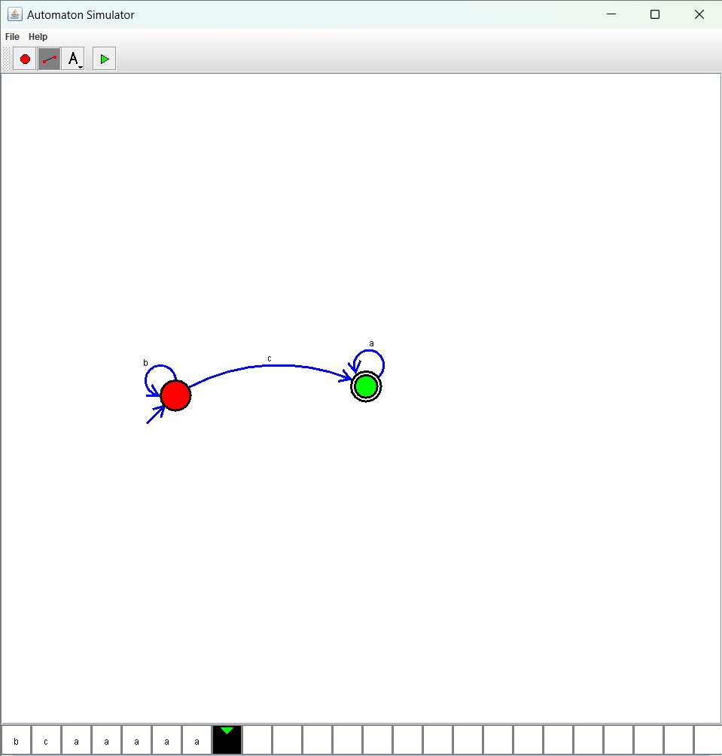

Result:

The given input string is accepted (“b,c”,”c”,”bcaaa”) by using the above DFA simulator