* EXP NO:31
* AIM:Design PDA using simulator to accept the input string anbn

INPUT:

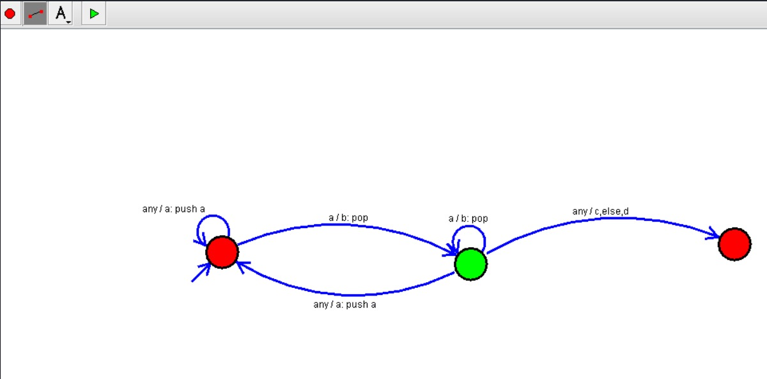

OUTPUT:

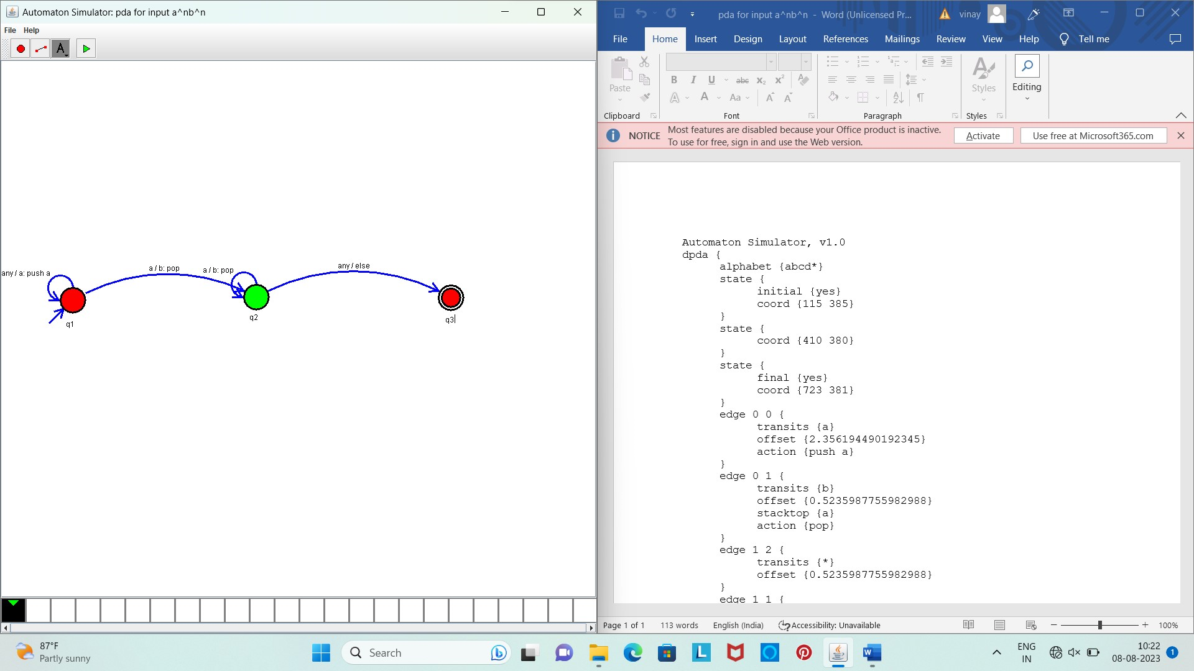

Result:

The given input string is accepted by the simulator by using the above PDA diagram