* EXP NO:32
* AIM:Design TM using simulator to perform string comparison where w={aba aba}

INPUT:

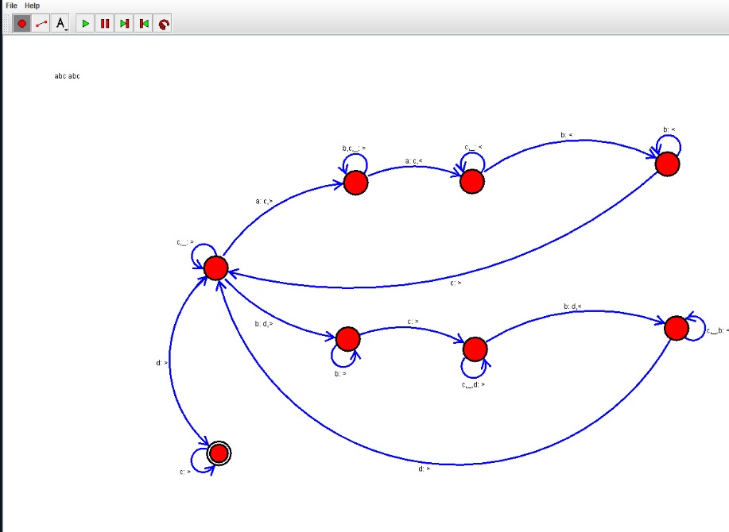

OUTPUT:

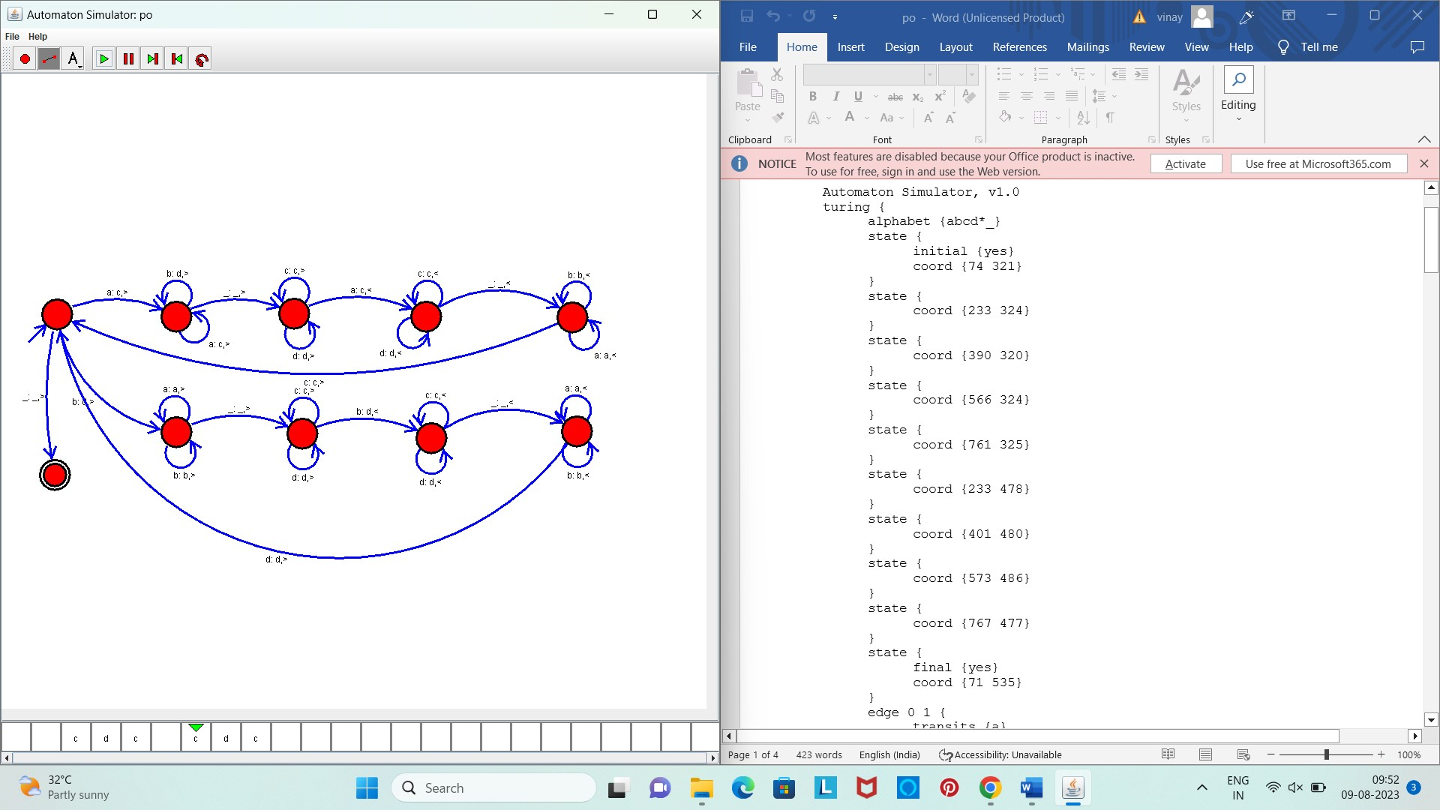

Result :

The given string comparision is performed well by the simulator by the above turing machine diagram