EXP NO:35

AIM:Design DFA using simulator to accept strings in which a’s always appear tripled over input {a,b}

INPUT:

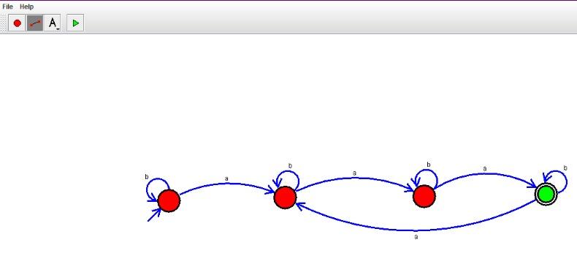

OUTPUT:

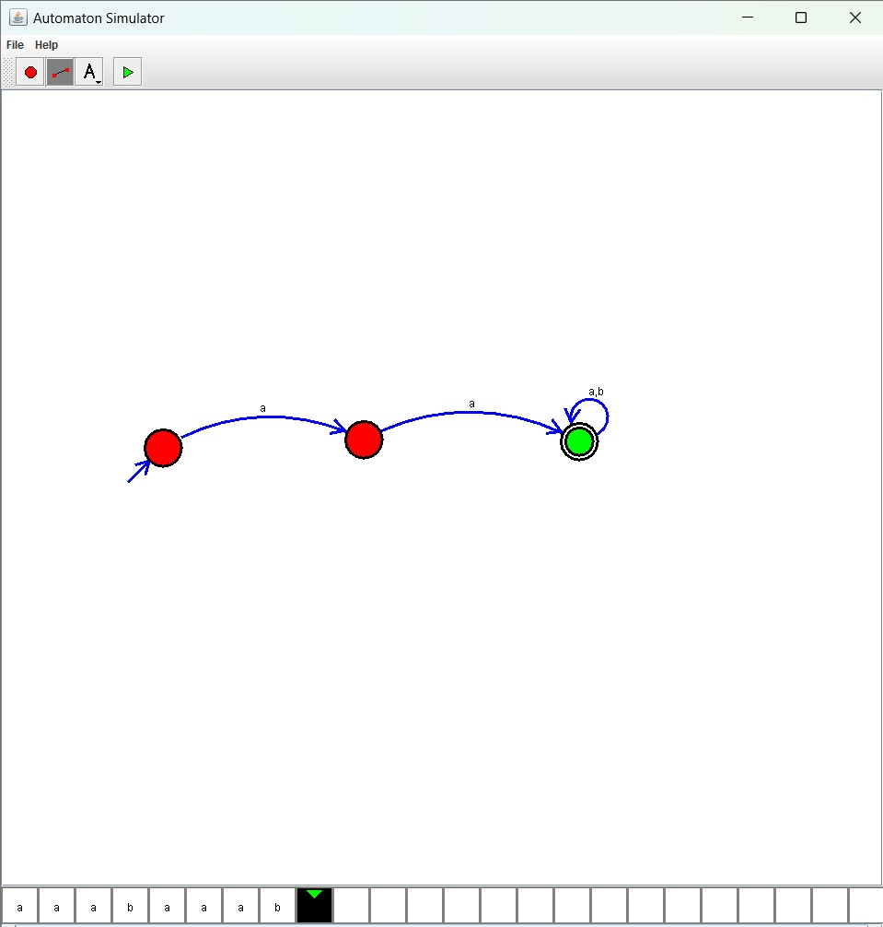

Result :

The simulator accepted strings in which a’s always appear tripled over input {a,b} by using the above DFA diagram