EXP N0 39

AIM:Design DFA using simulator to accept the string the end with abc over set {a,b,c)

W= abbaababc

INPUT:

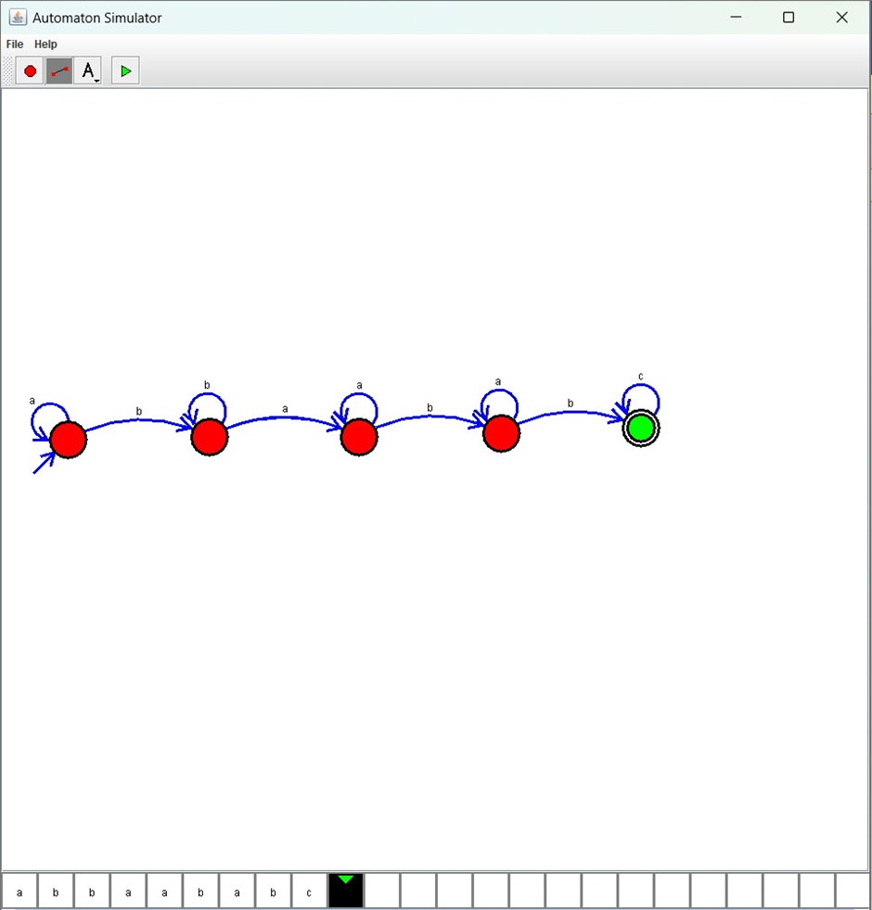

OUTPUT:

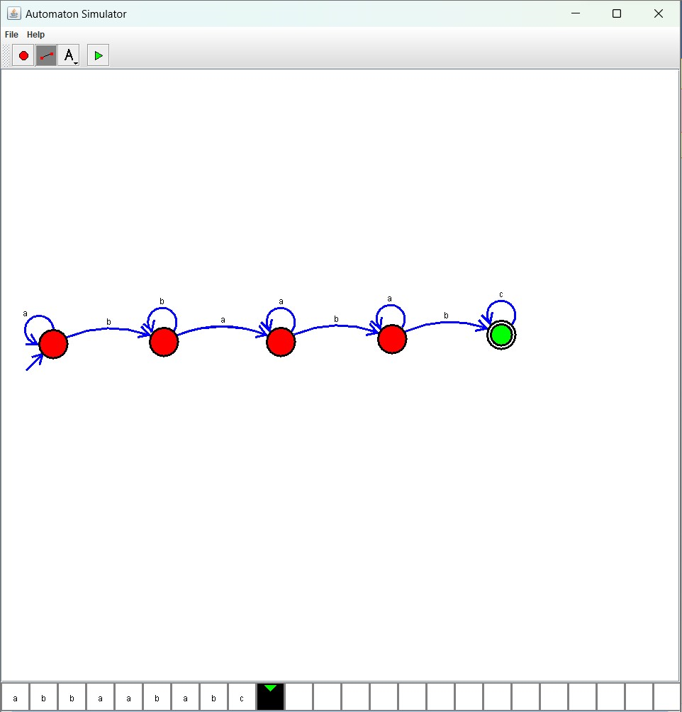

Result :

* The simulator is accepted accept the string the end with abc over set {a,b,c) W=abbaababc by using the above DFA diagram