EXP NO 40

AIM:Design NFA to accept any number of b’s where input={a,b}.

INPUT:

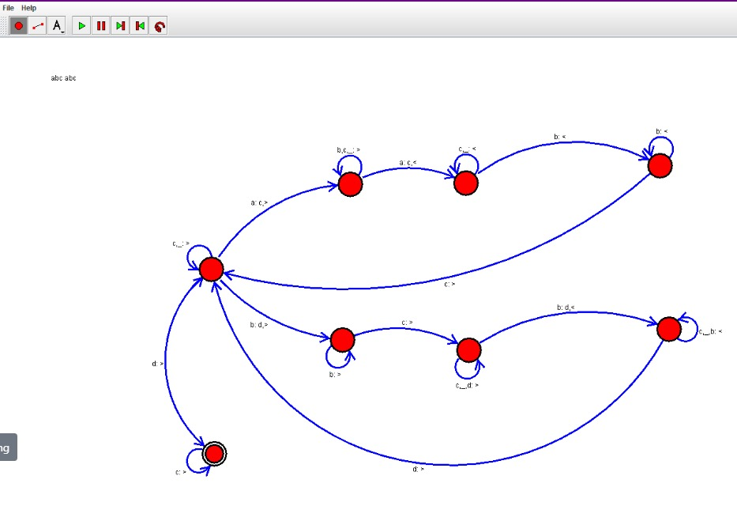

OUTPUT:  
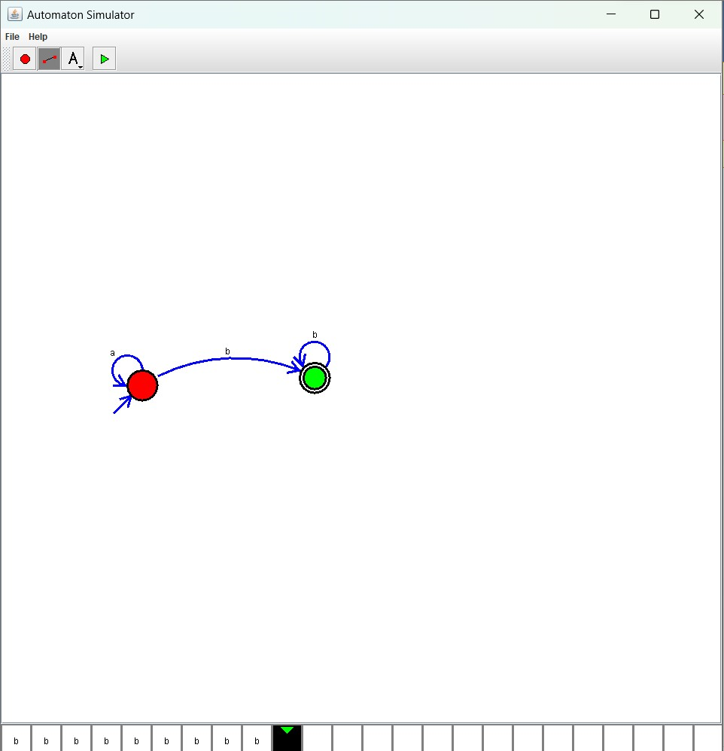  
  
Result:

The simulator is accepted the any number of b’s where input = {a,b} by using the above NFA diagram