EXP NO : 10:- write a C program to find ε-closure of a Non-Deterministic Finite

Automata with ε-moves

AIM:=

To write a C program to find ε-closure of a Non-Deterministic Finite

Automata with ε-moves

ALGORTIHM :

1. Get the following as input from the user.

i. Number of states in the NFA

ii. Number of symbols in the input alphabet including ε

iii. Input symbols

iv. Number of final states and their names

2. Declare a 3-dimensional matrix to store the transitions and initialize

all the entries with -1

3. Get the transitions from every state for every input symbol from the

user and store it in the matrix.

For example, consider the NFA shown below.

There are 3 states 0, 1, and 2

There are three input symbols ε, 0 and 1. As the array index always

starts with 0, we assume 0th symbol is ε, 1st symbol is 0 and 2nd

symbol is 1.

The transitions will be stored in the matrix as follows:

From state 0, for input ε, there is one transition to state 1, which can

be stored in the matrix as

m[0][0][0]=1

From state 0, for input 0, there is no transition.

From state 0, for input 1, there is one transition to state 1, whichcan

be stored in the matrix as

m[0][2][0]=1

Similarly, the other transitions can be stored as follows:

m[1][0][0]=2 (From state 1, for input ε, the transition is to state 2)

m[1][1][0]=1 (From state 1, for input 0, the transition is to state 1)

All the other entries in the matrix will be -1 indicating no moves

4. Initialize a two-dimensional matrix e_closure with -1 in all the

entries.

5. ε-closure of a state q is defined as the set of all states that can be

reached from state q using only ε-transitions.

Example:

Consider the NFA with ε-transitions given below:

ε-closure(0)={0,1,2)

ε-closure(1)={1,2}

ε-closure(2)={2}

Here, we see that ε-closure of every state contains that state first. So

initialize the first entry of the array e_closure with the same state.

e_closure(0,0)=0;

e_closure(1,0)=1;

e_closure(2,0)=2;

6. For every state i, find ε-closure as follows:

If there is an ε-transition from state i to state j, add j to the matrix

e_closure[i]. Call the recursive function find_e_closure(j) and add

the other states that are reachable from i using ε

7. For every state, print the ε-closure values

The function find_e_closure(i)

This function finds ε-closure of a state recursively by tracing all the εtransitions

PROGRAM :

#include<stdio.h>

#include<string.h>

int trans_table[10][5][3];

char symbol[5],a;

int e_closure[10][10],ptr,state;

void find_e_closure(int x);

int main()

{

int i,j,k,n,num_states,num_symbols;

for(i=0;i<10;i++)

{

for(j=0;j<5;j++)

{

for(k=0;k<3;k++)

{

trans_table[i][j][k]=-1;

}

}

}

printf("How may states in the NFA with e-moves:");

scanf("%d",&num_states);

printf("How many symbols in the input alphabet including e :");

scanf("%d",&num_symbols);

printf("Enter the symbols without space. Give 'e' first:");

scanf("%s",symbol);

for(i=0;i<num_states;i++)

{

for(j=0;j<num_symbols;j++)

{

printf("How many transitions from state %d for the input

%c:",i,symbol[j]);

scanf("%d",&n);

for(k=0;k<n;k++)

{

printf("Enter the transitions %d from state %d for the input

%c :", k+1,i,symbol[j]);

scanf("%d",&trans_table[i][j][k]);

}

}

}

for(i=0;i<10;i++)

{

for(j=0;j<10;j++)

{

e_closure[i][j]=-1;

}

}

for(i=0;i<num_states;i++)

e_closure[i][0]=i;

for(i=0;i<num_states;i++)

{

if(trans_table[i][0][0]==-1)

continue;

else

{

state=i;

ptr=1;

find_e_closure(i);

}

}

for(i=0;i<num_states;i++)

{

printf("e-closure(%d)= {",i);

for(j=0;j<num_states;j++)

{

if(e_closure[i][j]!=-1)

{

printf("%d, ",e_closure[i][j]);

}

}

printf("}\n");

}

}

void find_e_closure(int x)

{

int i,j,y[10],num_trans;

i=0;

while(trans_table[x][0][i]!=-1)

{

y[i]=trans_table[x][0][i];

i=i+1;

}

num_trans=i;

for(j=0;j<num_trans;j++)

{

e_closure[state][ptr]=y[j];

ptr++;

find_e_closure(y[j]);

}

}

Example:

Find ε-closure for all the states for the NFA with ε-moves given below:

TRANSITION TABLE :

State / Input ε 0 1

→ 0 1 - 1

1 2 {0,1} -

2 - - -

0 1 2

OUTPUT

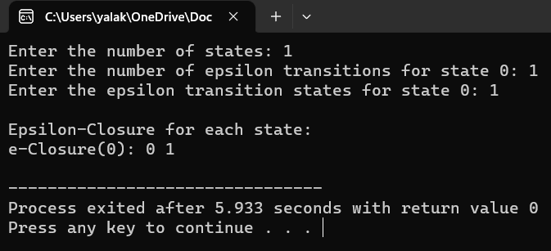

RESULT:-

PROGRAM EXECUTED SUCCESSFULLY.