Nama Peserta : Riyan Adriansyah

Kode Peserta : FSDO001ONL008

Tugas : Assignment 2

Github : https://github.com/dakdeung/OCBC-H8/tree/main/Assigment/RiyanAdriansyah_FSDO001ONL008_ASSIGNMENT2

**\*\*NOTE: Karena saya memasukan foreign key pada saat pembuatan table sehingga urutan pembuatan dan insert data tidak sesuai dengan nomor**

**\*\*Urutan :**

1. **Productlines**
2. **Product**
3. **Offices**
4. **Employees**
5. **Customers**
6. **Payments**
7. **Orders**
8. **Orderdetails**

**Soal No.1 :**

Customers => stores data customer

**Query Soal No.1 :**

CREATE TABLE customers(

customerNumber INT PRIMARY KEY IDENTITY(1,1),

customerName VARCHAR(50) NOT NULL,

contactLastName VARCHAR(20),

contactFirstName VARCHAR(20),

addressLine1 VARCHAR(50) NOT NULL,

addressLine2 VARCHAR(50),

city VARCHAR(20) NOT NULL,

state VARCHAR(20) NOT NULL,

postalCode VARCHAR(8) NOT NULL,

country VARCHAR(20) NOT NULL,

salesRepEmployeeNumber INT REFERENCES employees(employeeNumber) NOT NULL,

creditLimit DECIMAL(20,2)

);

INSERT INTO customers (customerName, contactLastName, contactFirstName, addressLine1, addressLine2, city, state, postalCode, country, salesRepEmployeeNumber, creditLimit)

VALUES

('Riyan', NULL, NULL, 'Jl. Sukarasa', NULL, 'Bandung', 'Indonesia', '40192', 'Indonesia', 5, NULL),

('Felia', NULL, NULL, 'Jl. Sukapura', NULL, 'Bandung', 'Indonesia', '40261', 'Indonesia', 2, NULL),

('Reva', NULL, NULL, 'Jl. Sukasenang', NULL, 'Cimahi', 'Indonesia', '40153', 'Indonesia', 3, NULL),

('Didit', NULL, NULL, 'Jl. Sukarajin', NULL, 'Bogor', 'Indonesia', '40113', 'Indonesia', 1, NULL),

('Ujang', NULL, NULL, 'Jl. Dago', NULL, 'Garut', 'Indonesia', '40151', 'Indonesia', 1, NULL);

SELECT * FROM customers;

**Screenshoot Soal No.1:**

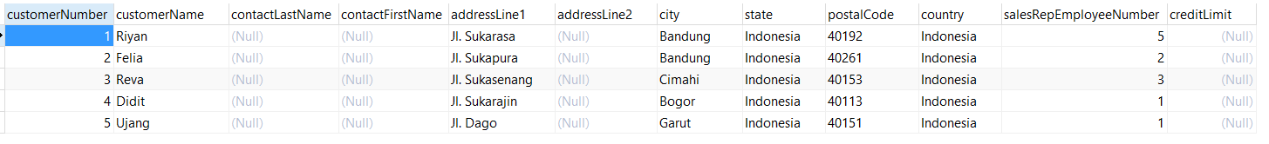

**Soal No.2 :**

Products => stores daftar/list model product ( dalam hal ini bisa mobil/motor dll )

**Query Soal No.2 :**

CREATE TABLE products(

productCode INT PRIMARY KEY IDENTITY(1,1),

productName VARCHAR(50) NOT NULL,

productLine INT REFERENCES productlines(productline) NOT NULL,

productScale INT NOT NULL,

productVendor VARCHAR(50) NOT NULL,

productDescription VARCHAR(100) NOT NULL,

quantityInStock INT NOT NULL,

buyPrice DECIMAL(20,2) NOT NULL,

MSRP DECIMAL(20,2) NOT NULL

)

INSERT INTO products (productName, productLine, productScale ,productVendor, productDescription, quantityinStock, buyPrice, MSRP)

VALUES

('X-Ride', 1, 1,'Yamaha', 'Sepeda motor Yamaha X-Ride', 10, 18000000, 17500000),

('Mio', 1, 1,'Yamaha', 'Sepeda motor Yamaha Mio', 30, 16000000, 15000000),

('Nmax', 1, 1,'Yamaha', 'Sepeda motor Yamaha Nmax', 15, 220000000, 215000000),

('Scoopy', 1, 1,'Honda', 'Sepeda motor Honda Mio', 25, 150000000, 140000000),

('KLX', 1, 1,'Kawasaki', 'Sepeda motor Kawasaki KLX', 8, 28000000, 27000000)

SELECT * FROM products;

**Screenshoot Soal No.2:**

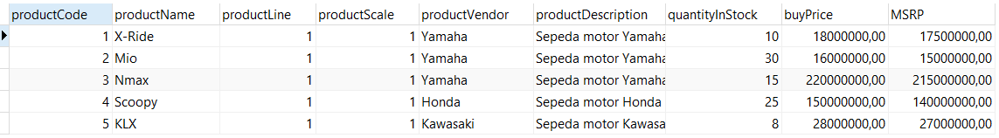

**Soal No.3 :**

Productlines => stores daftar/list kategori product

**Query Soal No.3 :**

CREATE TABLE productlines(

productLine int PRIMARY KEY IDENTITY(1,1),

textDescription VARCHAR(50),

htmlDescription VARCHAR(50),

image VARCHAR(50)

)

INSERT INTO productlines (textDescription, htmlDescription, image)

VALUES

('Motor', '<p>this is motor.</p>','https://www.OCBCBANK.com/Motor'),

('Mobil', '<p>this is mobil.</p>','https://www.OCBCBANK.com/Mobil'),

('Handphone', '<p>this is handphone.</p>','https://www.OCBCBANK.com/Handphone'),

('Laptop', '<p>this is laptop.</p>','https://www.OCBCBANK.com/Laptop'),

('Komputer', '<p>this is komputer.</p>','https://www.OCBCBANK.com/Komputer')

SELECT * FROM productlines;

**Screenshoot Soal No.3:**

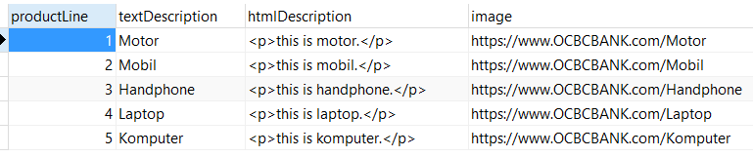

**Soal No.4 :**

Orders => store Order Sales oleh customer

**Query Soal No.4 :**

CREATE TABLE orders(

orderNumber INT PRIMARY KEY IDENTITY(1,1) ,

orderDate DATE NOT NULL,

requiredDate DATE NOT NULL,

shippedDate DATE NOT NULL,

status VARCHAR(20),

comments VARCHAR(50),

customerNumber INT REFERENCES customers(customerNumber) NOT NULL

)

INSERT INTO orders (orderDate, requiredDate, shippedDate, status, comments, customerNumber)

VALUES

('08-30-2021','09-1-2021', '09-1-2021', 'Proses', NULL, 2),

('09-2-2021','09-3-2021', '09-5-2021', 'Proses', NULL, 3),

('08-30-2021','09-1-2021', '09-2-2021', 'On Delivery', 'Barang Mudah Pecah', 1),

('08-1-2021','09-2-2021', '09-3-2021', 'Transit', NULL, 5),

('09-9-2021','09-12-2021', '09-12-2021', 'Proses', NULL, 4);

SELECT * FROM orders;

**Screenshoot Soal No.4:**

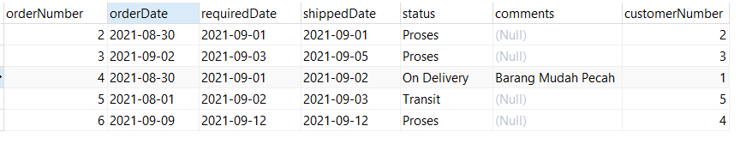

**Soal No.5 :**

OrderDetails => store Item Order sales dalam setiap order sales

**Query Soal No.5 :**

CREATE TABLE orderdetails(

orderNumber INT REFERENCES orders(orderNumber) NOT NULL,

productCode INT REFERENCES products(productCode) NOT NULL,

quantityOrdered INT NOT NULL,

priceEach INT NOT NULL,

orderLineNumber INT NOT NULL

)

INSERT INTO orderdetails (orderNumber, productCode, quantityOrdered, priceEach, orderLineNumber)

VALUES

(2, 1, 1, 18000000, 1),

(3, 1, 1, 18000000, 2),

(4, 3, 1, 22000000, 3),

(5, 5, 1, 28000000, 4),

(6, 1, 1, 18000000, 5);

SELECT * FROM orderdetails;

**Screenshoot Soal No.5:**

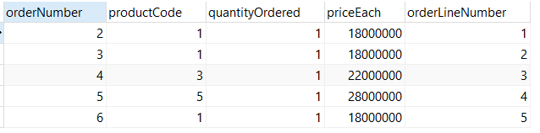

**Soal No.6 :**

Payments => store Pembayaran oleh customer sesuai dengan akun pembayaran

**Query Soal No.6 :**

CREATE TABLE payments(

customerNumber INT REFERENCES customers(customerNumber) NOT NULL,

checkNumber INT PRIMARY KEY IDENTITY(1,1),

paymentDate DATE NOT NULL,

amount DECIMAL(20,2) NOT NULL

);

INSERT INTO payments (customerNumber, paymentDate, amount)

VALUES

(1, '09-2-2021',18000000),

(2, '09-10-2021',18000000),

(3, '09-8-2021',12000000),

(4, '09-3-2021',28000000),

(5, '09-5-2021',10000000);

SELECT * FROM payments;

**Screenshoot Soal No.6:**

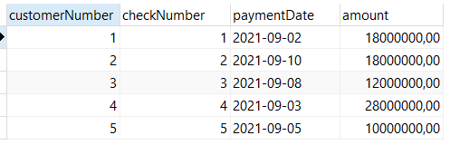

**Soal No.7 :**

Employee => store informasi karyawan dalam sebuah organisasi struktur

**Query Soal No.7 :**

CREATE TABLE employees(

employeeNumber INT PRIMARY KEY IDENTITY(1,1) ,

lastName VARCHAR(20),

firstName VARCHAR(20) NOT NULL,

extension VARCHAR(20),

email VARCHAR(30) NOT NULL,

officeCode INT REFERENCES offices(officeCode) NOT NULL,

reportsTo VARCHAR(20) NOT NULL,

jobTitle VARCHAR(20) NOT NULL

);

INSERT INTO employees (lastName, firstName, extension, email, officeCode, reportsTo, jobTitle)

VALUES

('Permana', 'Angga', NULL, 'angga@ocbcbank.com', 1, 'Indra', 'Sales'),

('Devianti', 'Ayu', NULL, 'ayu@ocbcbank.com', 1, 'Indra', 'Accounting'),

(NULL, 'Herawati', NULL, 'herawati@ocbcbank.com', 1, 'Indra', 'IT'),

('Ratnasari', 'Desi', NULL, 'desi@ocbcbank.com', 1, 'Indra', 'Sales'),

( 'Simatupang', 'Derry', NULL, 'derry@ocbcbank.com', 1, 'Indra', 'Officer');

SELECT * FROM employees;

**Screenshoot Soal No.7:**

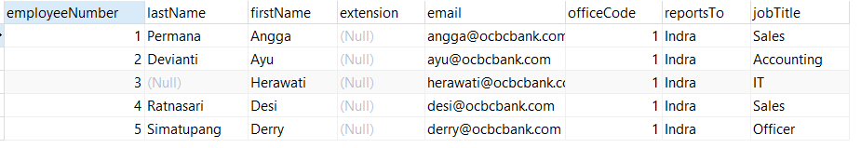

**Soal No.8 :**

Offices => store data sales office

**Query Soal No.8 :**

CREATE TABLE offices(

officeCode INT PRIMARY KEY IDENTITY(1,1) ,

city VARCHAR(20) NOT NULL,

phone VARCHAR(20) NOT NULL,

addressLine1 VARCHAR(50) NOT NULL,

addressLine2 VARCHAR(50),

state VARCHAR(20) NOT NULL,

country VARCHAR(20) NOT NULL,

postalCode VARCHAR(20) NOT NULL,

teritory VARCHAR(20)

);

INSERT INTO offices (city, phone, addressLine1, addressLine2, state, country, postalCode, teritory)

VALUES

('Bandung', '02287238', 'Jl Cihapit', NULL, 'Indonesia', 'Indonesia', '40121', 'Bandung'),

('Jakarta', '02287124', 'Jl Lebak Bulus', NULL, 'Indonesia', 'Indonesia', '40152', 'Jakarta'),

('Surabaya', '02287512', 'Jl Gatsu', NULL, 'Indonesia', 'Indonesia', '40235', 'Surabaya'),

('Semarang', '02287122', 'Jl Kosambi', NULL, 'Indonesia', 'Indonesia', '40235', 'Semarang'),

('Bekasi', '02287252', 'Jl Cicadas', NULL, 'Indonesia', 'Indonesia', '40235', 'Bekasi');

SELECT * FROM offices;

**Screenshoot Soal No.8:**

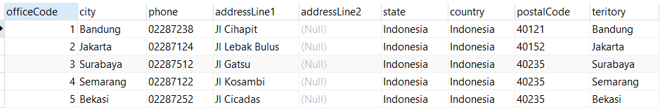

**Gambar ERD**

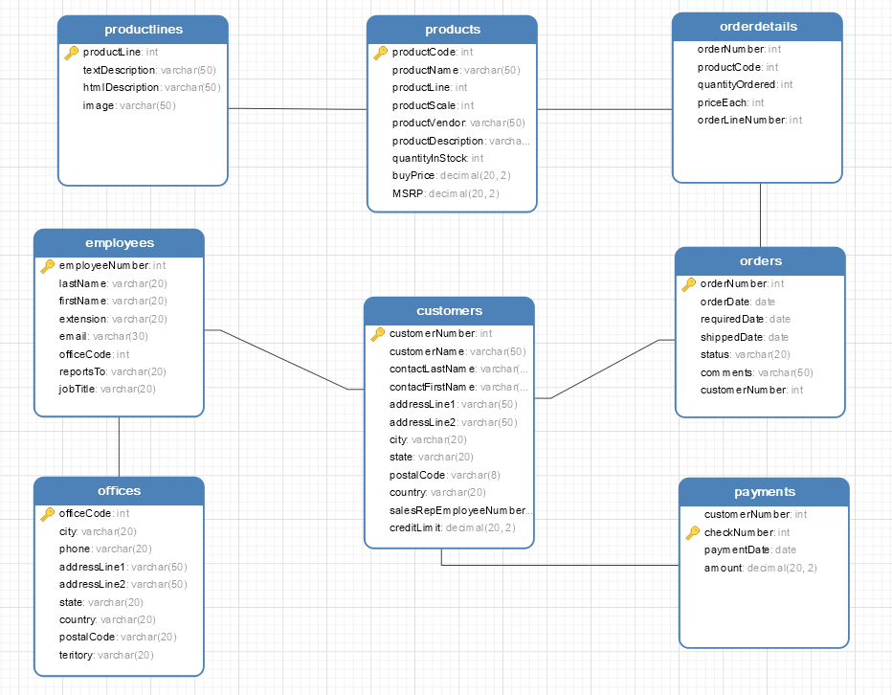

**Tambahan Query**

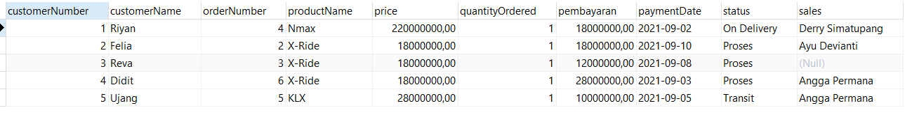

**Query:**

SELECT c.customerNumber, c.customerName, o.orderNumber, p.productName, p.buyPrice AS price ,od.quantityOrdered, py.amount

AS pembayaran , py.paymentDate, o.status, (e.firstName +' '+ e.lastName) AS sales

FROM customers c

JOIN orders o ON c.customerNumber = o.customerNumber

JOIN orderdetails od ON o.orderNumber = od.orderNumber

JOIN products p ON od.productCode = p.productCode

JOIN payments py ON py.customerNumber = c.customerNumber

JOIN employees e ON c.salesRepEmployeeNumber = e.employeeNumber;