题目1：Using File I/O in the Bright Fresh Milk System

Prerequisites, Goals, and Outcomes
Prerequisites: Before you begin this exercise, you need mastery of the following:
- Java API
  - Knowledge of the class StringTokenizer
- File I/O
  - Knowledge of file I/O
    - How to read data from a file
    - How to write data to a file
Goals: Reinforce your ability to use file I/O
Outcomes: You will master the following skills:
- Produce applications that read data from a file and parse it
- Produce applications that write data to a file

Background
In this assignment, you will create another version of the Bright Fresh Milk System. In previous versions, the data for the product catalog was hard-coded in the application. In this version, the data will be loaded from a file. Also, the user will be able to write the sales information to a file in one of three formats: plain text, HTML, or XML. Part of the work has been done for you and is provided in the student archive. You will implement the code that loads the product catalog and persists the sales information.

Description
The Bright Fresh Milk System sells four types of products: Pure Milk, Jelly, Yogurt, and Milk Drink. A file called catalog.dat stores the product data:
- catalog.dat. File with product data
Every line in catalog.dat contains exactly one product.
1）A line for a Pure Milk product has the following format:
PureMilk_code_description_price_productionDate_shelfLife_countryOfOrigin_butterfat_protein
where:
- "PureMilk" is a prefix that indicates the line type.
- code is a string that represents the code of the PureMilk.
- description is a string that represents the description of the PureMilk.
- price is a BigDecimal that represents the price of the PureMilk.
- productionDate is a Date that represents the production Date of the PureMilk.
- shelfLife is a string that represents the shelf life of the PureMilk.
- countryOfOrigin is a string that represents the origin of the PureMilk.
- butterfat is a string that represents the butterfat of the PureMilk.
- protein is a string that represents the protein of the PureMilk.
Tips：
- java.lang.String to java.util.Date
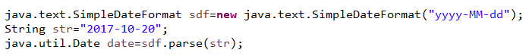
- java.lang.String to java.math.BigDecimal
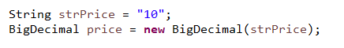
The fields are delimited by an underscore ( _ ). You can assume that the fields themselves do not contain any underscores.
2）A line for a Jelly has the following format:
Jelly_code_description_price_productionDate_shelfLife_type_diluteConcentration
where:
- "Jelly" is a prefix that indicates the line type.
- code is a string that represents the code of the Jelly.
- description is a string that represents the description of the Jelly.
- price is a BigDecimal that represents the price of the Jelly.
- productionDate is a Date that represents the production Date of the Jelly.
- shelfLife is a string that represents the shelf life of the Jelly.
- type is a string that represents the origin of the Jelly.
- diluteConcentration is a string that represents the dilute Concentration of the Jelly.
The fields are delimited by an underscore ( _ ). You can assume that the fields themselves do not contain any underscores.
3）A line for a Yogurt has the following format:
Yogurt_code_description_price_productionDate_shelfLife_flavor
where:
- "Yogurt" is a prefix that indicates the line type.
- code is a string that represents the code of the Yogurt.
- description is a string that represents the description of the Yogurt.
- price is a BigDecimal that represents the price of the Yogurt.
- productionDate is a Date that represents the production Date of the Yogurt.
- shelfLife is a string that represents the shelf life of the Yogurt.
- flavor is a string that represents the flavor of the Yogurt.
The fields are delimited by an underscore ( _ ). You can assume that the fields themselves do not contain any underscores.
4）A line for a MilkDrink has the following format:
MilkDrink_code_description_price_productionDate_shelfLife_flavor_sugar
where:
- "MilkDrink" is a prefix that indicates the line type.
- code is a string that represents the code of the MilkDrink.
- description is a string that represents the description of the MilkDrink.
- price is a BigDecimal that represents the price of the MilkDrink.
- productionDate is a Date that represents the production Date of the MilkDrink.
- shelfLife is a string that represents the shelf life of the MilkDrink.
- flavor is a string that represents the flavor of the MilkDrink.
- sugar is a string that represents the sugar of the MilkDrink.
The fields are delimited by an underscore ( _ ). You can assume that the fields themselves do not contain any underscores.

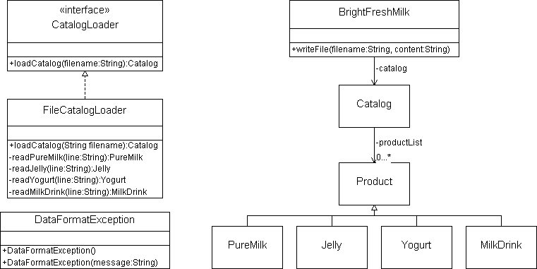
Figure 1 Portion of Bright Fresh Milk System class diagram
In this assignment, you will implement FileCatalogloader and complete the implementation of BrightFreshMilk.

Interface CatalogLoader
The interface CatalogLoader declares a method for producing a product catalog. A complete implementation of this interface is provided in the student archive.
Method:
- Catalog loadCatalog(String fileName)
- throws FileNotFoundException,
- IOException,
- DataFormatException
- ParseException
Loads the information in the specified file into a product catalog and returns the catalog.

Class DataFormatException
This exception is thrown when a line in the file being parsed has errors:
- The line does not have the expected number of tokens.
A complete implementation of this class is provided in the student archive.

Class FileCatalogLoader
The class FileCatalogLoader implements interface CatalogLoader. It is used to obtain a product catalog from a file. You should implement this class from scratch:
Methods:
- private PureMilk readPureMilk (String line)
- throws DataFormatException, ParseException
This method reads a line of PureMilk data. It uses the class StringTokenizer to extract the accessory data in the specified line. If the line is error free, this method returns a PureMilk object that encapsulates the accessory data. this method throws DataFormatException, ParseException that contains the line of malformed data.
- private Jelly readJelly(String line)
- throws DataFormatException, ParseException
This method reads a line of Jelly data. It uses the class StringTokenizer to extract the accessory data in the specified line. If the line is error free, this method returns a Jelly object that encapsulates the accessory data. this method throws DataFormatException, ParseException that contains the line of malformed data.
- private Yogurt readYogurt(String line)
- throws DataFormatException, ParseException
This method reads a line of Yogurt data. It uses the class StringTokenizer to extract the accessory data in the specified line. If the line is error free, this method returns a Yogurt object that encapsulates the accessory data. this method throws DataFormatException, ParseException that contains the line of malformed data.
- private MilkDrink readMilkDrink(String line)
- throws DataFormatException, ParseException
This method reads a line of MilkDrink data. It uses the class StringTokenizer to extract the accessory data in the specified line. If the line is error free, this method returns a MilkDrink object that encapsulates the accessory data. this method throws DataFormatException, ParseException that contains the line of malformed data.
- public Catalog loadCatalog(String filename)
- throws FileNotFoundException,
- IOException,
- DataFormatException
- ParseException
This method loads the information in the specified file into a product catalog and returns the catalog. It begins by opening the file for reading. It then proceeds to read and process each line in the file. The method String.startsWith is used to determine the line type:
  - If the line type is "PureMilk", the method readPureMilk is invoked.
  - If the line type is "Jelly", the method readJelly is invoked.
  - If the line type is "Yogurt", the method readYogurt is invoked.
  - If the line type is "MilkDrink", the method readMilkDrink is invoked.
After the line is processed, loadCatalog adds the product (PureMilk, Jelly, Yogurt or MilkDrink) to the catalog. When all the lines in the file have been processed, load returns the catalog to the calling method.
This method can throw the following exceptions:
- FileNotFoundException — if the specified file does not exist.
- IOException — if there is an error reading the information in the specified file.
- DataFormatException — if a line in the file has errors (the exception should contain the line of malformed data).
- ParseException — if the date contains badly-formed data.

Class BrightFreshMilk
A partial implementation of class BrightFreshMilk is provided in the student archive. You should implement writeFile, a method that writes sales information to a file:
- private void writeFile(String fileName, String content)
- throws IOException
This method creates a new file with the specified name, writes the specified string to the file, and then closes the file.

Class TestFileCatalogLoader
This class is a test driver for FileCatalogLoader. A complete implementation is included in the student archive. You should use this class to test your implementation of FileCatalogLoader.

Files
The following files are needed to complete this assignment:
- 第一题所需文件— Download this file. This archive contains the following:
  - Class files
    - Catalog.class
    - CurrentOrder.class
    - Jelly.class
    - MilkDrink.class
    - OrderItem.class
    - Product.class
    - PureMilk.class
    - Sale.class
    - Yogurt.class
    - SalesFormatter.class
    - PlainTextSalesFormatter.class use unit3
    - HTMLSalesFormatter.class use unit3
    - XMLSalesFormatter.class use unit3
  - Java files
    - CatalogLoader.java. A complete implementation
    - DataFormatException.java. A complete implementation
    - TestFileCatalogLoader.java. A complete implementation
    - BrightFreshMilk.java. Use this template to complete your implementation.
  - Data files for the test driver
    - catalog.dat. A file with product information
    - empty.dat. An empty file

Tasks
Implement the class FileCatalogLoader and the method BrightFreshMilk.writeFile. Document using Javadoc and follow Sun's code conventions. The following steps will guide you through this assignment. Work incrementally and test each increment. Save often.
- Add external class folder.
- Then, implement class FileCatalogLoader from scratch. Use the TestFileCatalogLoader driver to test your implementation.
- Next, implement the method BrightFreshMilk.writeFile.
- Finally, compile the class BrightFreshMilk, and execute the class BrightFreshMilk by issuing the following command at the command prompt:
C:\>java BrightFreshMilk catalog.dat
Sales information has been hard-coded in the BrightFreshMilk template provided by iCarnegie.
  - If the user displays the catalog, the output should be:
A001 milk,400ml 10
A002 skim milk,800ml 18
B001 solid,250ml 8.5
B002 solid,400ml 14
C001 chocolate flavor,270ml 5
C002 strawberry flavor,400ml 10
D001 taro flavor,250ml 13.1
D002 apple flavor,400ml 16
  - If the user saves the sales information in plain text, a file with the following content should be created:
------------------------
Order 1

5 C001 5

Total = 25
------------------------
Order 2

2 C002 10
2 A001 10

Total = 40
------------------------
Order 3

1 B002 14

Total = 14

  - If the user saves the sales information in HTML, a file with the following content should be created:
<html>
<body>
<center><h2>Orders</h2></center>
<hr>
<h4>Total = 25</h4>
<p>
<b>code:</b> C001<br>
<b>quantity:</b> 5<br>
<b>price:</b> 5
</p>
<hr>
<h4>Total = 40</h4>
<p>
<b>code:</b> C002<br>
<b>quantity:</b> 2<br>
<b>price:</b> 10
</p>
<p>
<b>code:</b> A001<br>
<b>quantity:</b> 2<br>
<b>price:</b> 10
</p>
<hr>
<h4>Total = 14</h4>
<p>
<b>code:</b> B002<br>
<b>quantity:</b> 1<br>
<b>price:</b> 14
</p>
</body>
</html>
  - If the user saves the sales information in XML, a file with the following content should be created:
<Sales>
<Order total="25">
<OrderItem quantity="5" price="5">C001</OrderItem>
</Order>
<Order total="40">
<OrderItem quantity="2" price="10">C002</OrderItem>
<OrderItem quantity="2" price="10">A001</OrderItem>
</Order>
<Order total="14">
<OrderItem quantity="1" price="14">B002</OrderItem>
</Order>
</Sales>

Submission
Upon completion, submit only the following:
- FileCatalogLoader.java
- BrightFreshMilk.java
Eclipse 填写运行参数的方法
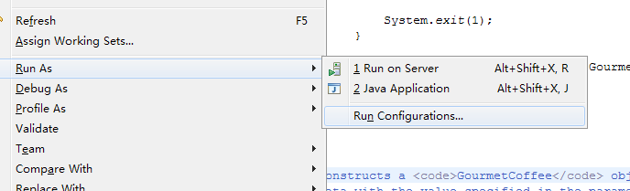
鼠标双击 Java Application 下方出现BrightFreshMilk，点击Arguments选项卡。
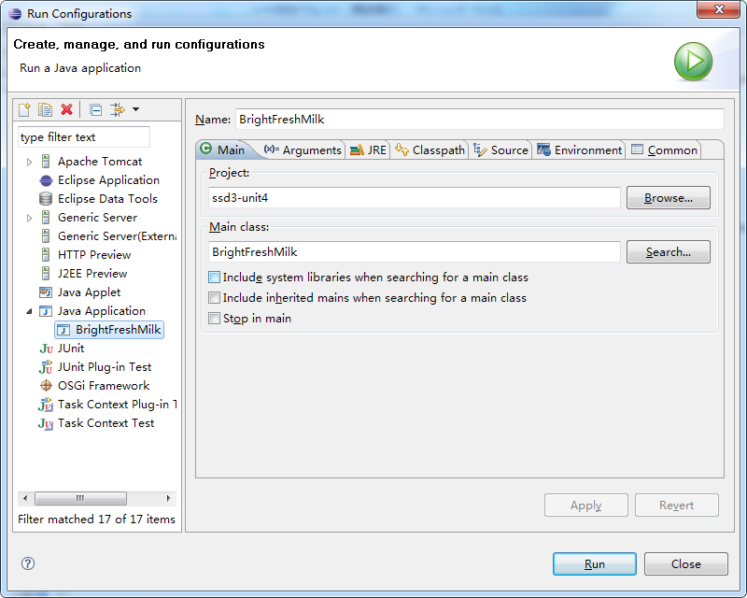

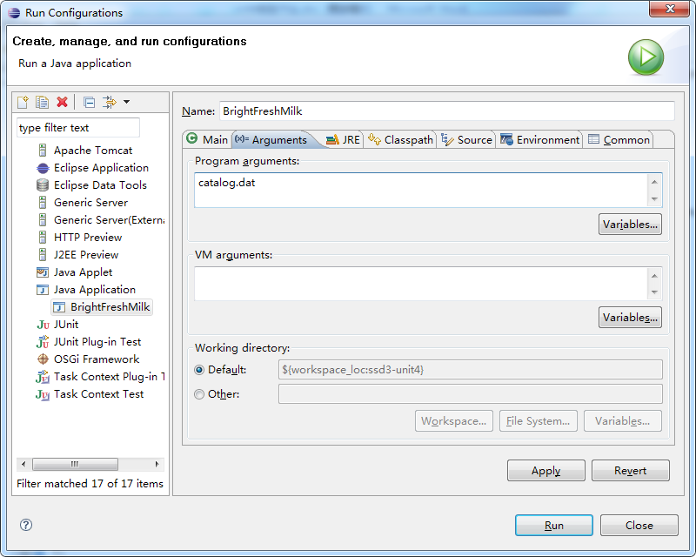

在Program arguments输入框内填写数据文件名称，该数据文件拷贝到工程项目目录文件下
