**DOCUMENTATION:**

* The App is easy to set up, just download the complete repo and open in android studio
* Here are some of the screenshots

INITIAL STATE OF THE APP

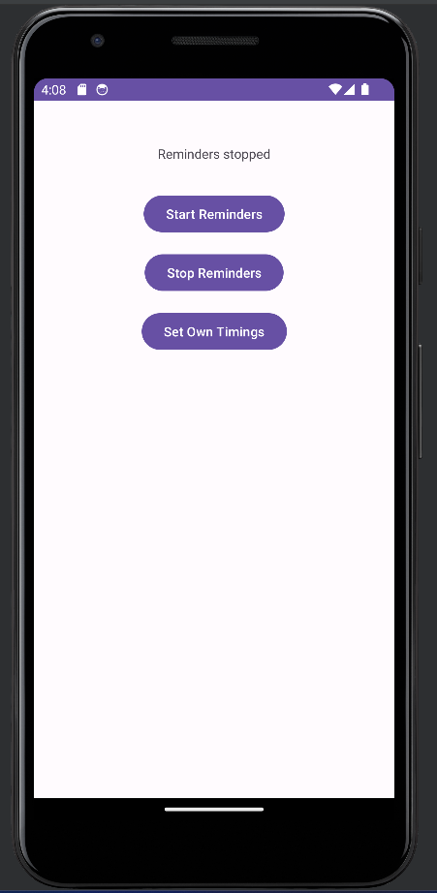

AFTER THE REMAINDER IS SET (Default timing is 8am to 8pm, every 2 hours reminder comes):

* Also even if the phone is restarted the remainders persist

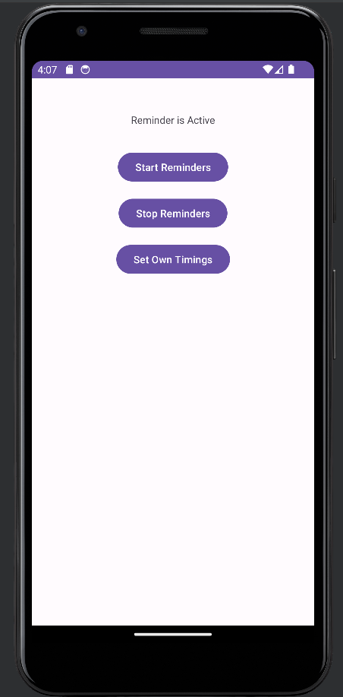

HERE THE USER CAN SET OWN TIMINGS AND INTERVALS

