# Project and Testing Report — Cloud Management System
## Team / Project Info
- Project name: Cloud Management System
- Type: UI driven system
- Features: Docker tasks + QEMU VM creation (interactive + JSON config)
- Repository: (https://github.com/dakhakhny-git/Cloud-Management-System.git)
---
## 1) Project Overview
This project is a simple menu-based Python program that helps the user do two main things:

1) **Docker operations**
- Create a Dockerfile
- Build a Docker image
- List local images
- List running containers
- Stop a container
- Search local images
- Search DockerHub images
- Pull an image from DockerHub

2) **VM operations using QEMU**
- Create a VM interactively (user enters CPU, memory, disk size, and disk path)
- Create a VM from a JSON config file

## 2) Design Choices (Why we built it this way)
### Why Python
- Python is simple and readable.
- It works on Windows, macOS, and Linux.

### Why a menu-based terminal UI
- It is easy for users to understand and use.
- The user does not need to memorize commands.

### Why we used `subprocess.run()` and the `run()` helper
- The program needs to call real system tools like `docker` and `qemu-system-x86_64`.
- The `run()` helper returns:
- `ok` (True/False) to know if the command succeeded
- `out` (stdout) to show normal results
- `err` (stderr) to show errors if something fails
- This makes error handling consistent and prevents the program from crashing.

### Why a JSON config file for VM creation
- Users can create a VM without typing the numbers every time.
- It is easy to edit and easy to read.
---
## 3) Challenges Faced and Solutions
### Challenge 1: Program did not run from VS Code "Run"
- Issue: VS Code sometimes used the wrong Python command or wrong working directory.
- Fix: We ran the program in the terminal using:
- `python main.py` (Windows)
- `python3 main.py` (macOS)

### Challenge 2: QEMU shows "not a bootable disk"
- Issue: When the VM launches, QEMU displays "Boot failed: not a bootable disk".
- Explanation: This is expected because the created `.qcow2` disk is empty and no OS ISO was attached.
- Fix: No fix needed for this project, because the requirement is to create the VM disk and launch QEMU.
---
## 4) Testing Methodology (How we tested)
Testing was done manually by:
- Running the program with `python main.py`
- Using the menu options to test each feature
- Checking expected outputs in the terminal
- Confirming that files were created when required (Dockerfile, qcow2 disks)
- Confirming that QEMU launched successfully when creating a VM
- Capturing screenshots or terminal output as evidence
We tested both:
- **Positive tests** (valid input that should work)
- **Negative tests** (invalid input or missing tool to make sure program does not crash)
## 5) Test Cases and Results
### Docker Tests
#### Test 1 — Docker installed and running
Steps:
1) Run: `docker --version`
2) Run: `docker ps`
Expected:
- Docker version prints
- `docker ps` returns output without connection errors
Output:
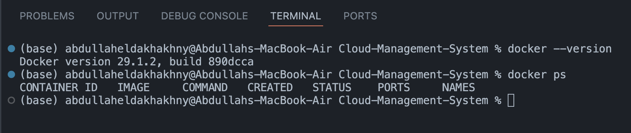
---
#### Test 2 — Create Dockerfile
Steps:
1) Run program
2) Docker menu → `1) Create Dockerfile`
3) Enter path: `./Dockerfile`
4) Type lines and finish with `EOF`
Expected:
- Dockerfile is saved at the path
Output:
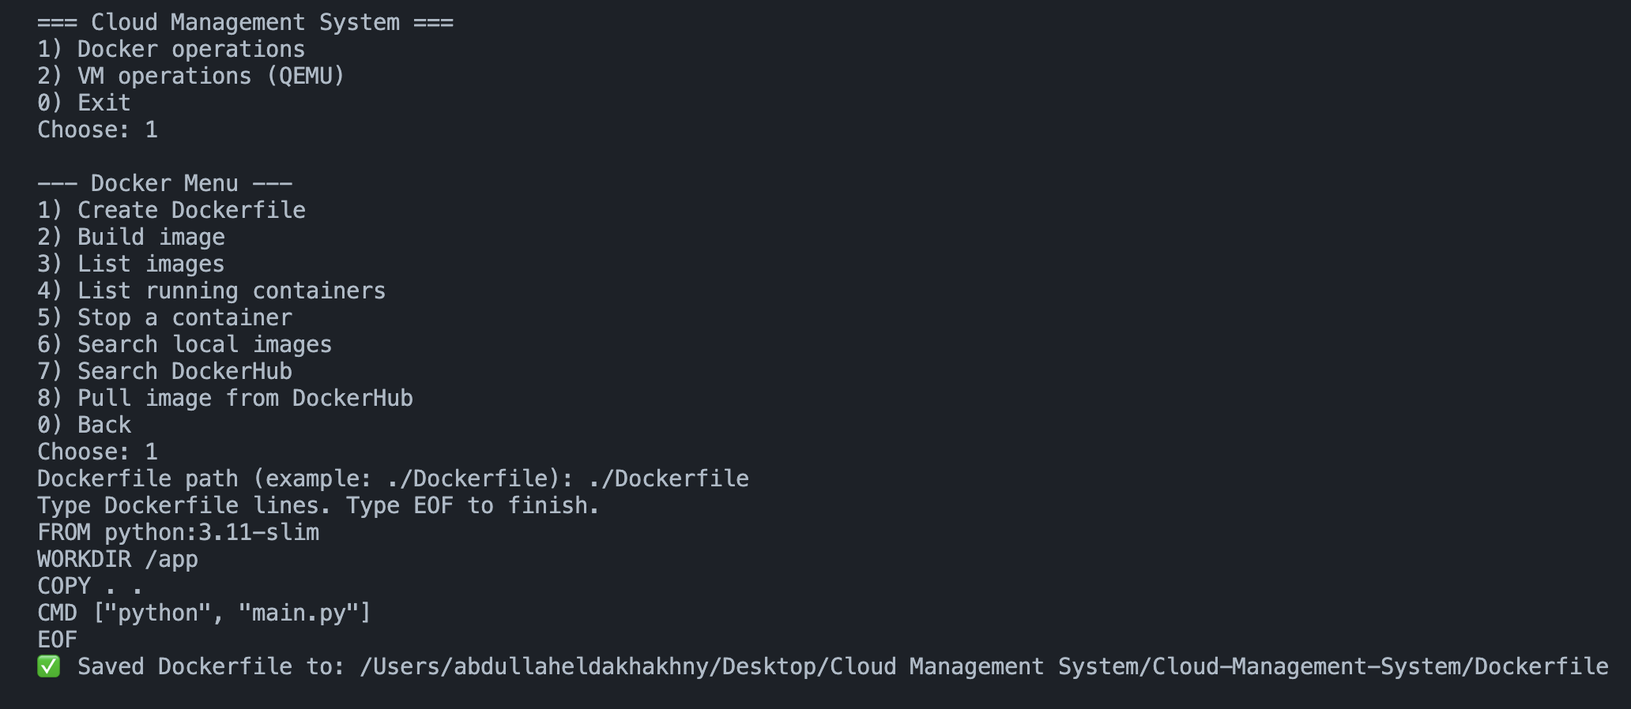
---
#### Test 3 — Build image
Steps:
1) Docker menu → `2) Build image`
2) Dockerfile path: `./Dockerfile`
3) Tag: `cms-test:1.0`
Expected:
- Build succeeds
Output:
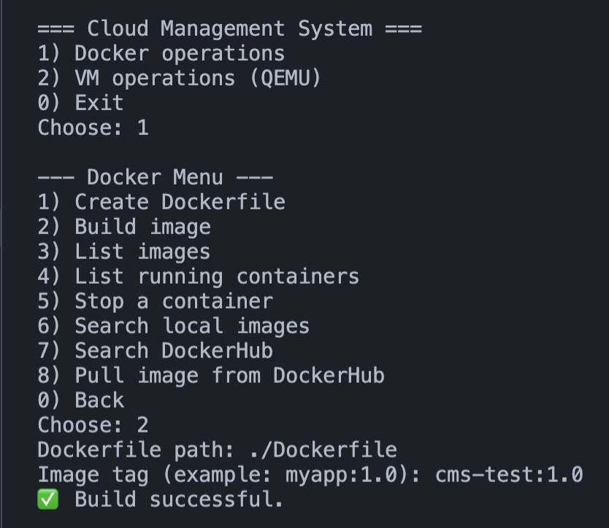

#### Test 4 — List images
Steps:
1) Docker menu → `3) List images`
Expected:
- Local images table prints
Output:
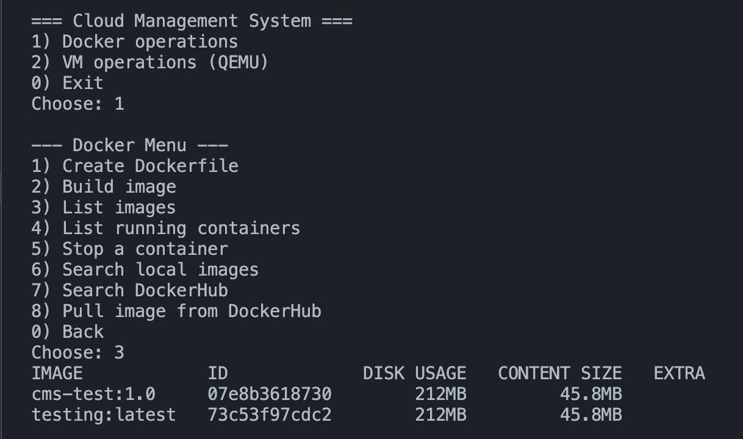
---
#### Test 5 — List running containers
Steps:
1) Docker menu → `4) List running containers`
Expected:
- Prints running containers table (may be empty)
Output:
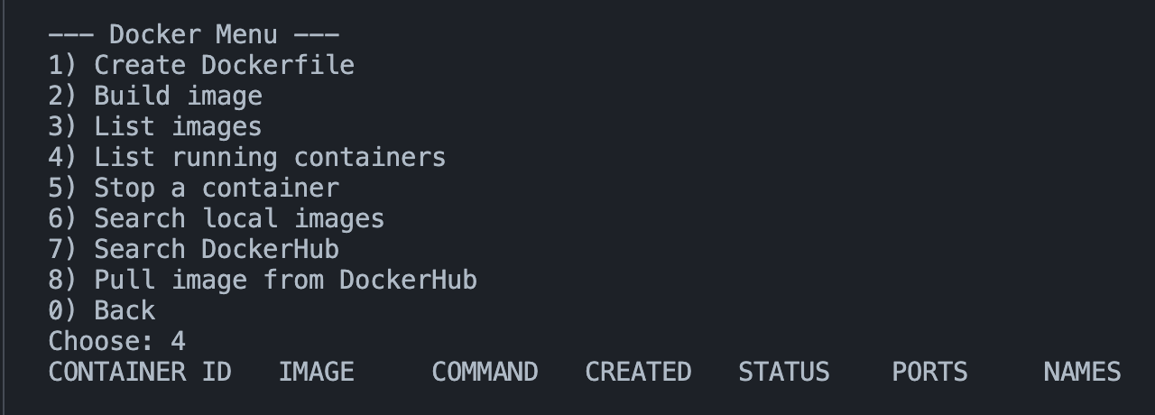
---
#### Test 6 — Search local images
Steps:
1) Docker menu → `6) Search local images`
2) Enter term: `nginx` (or any image name you have)
Expected:
- Shows matching local images or “no matches”
Output:
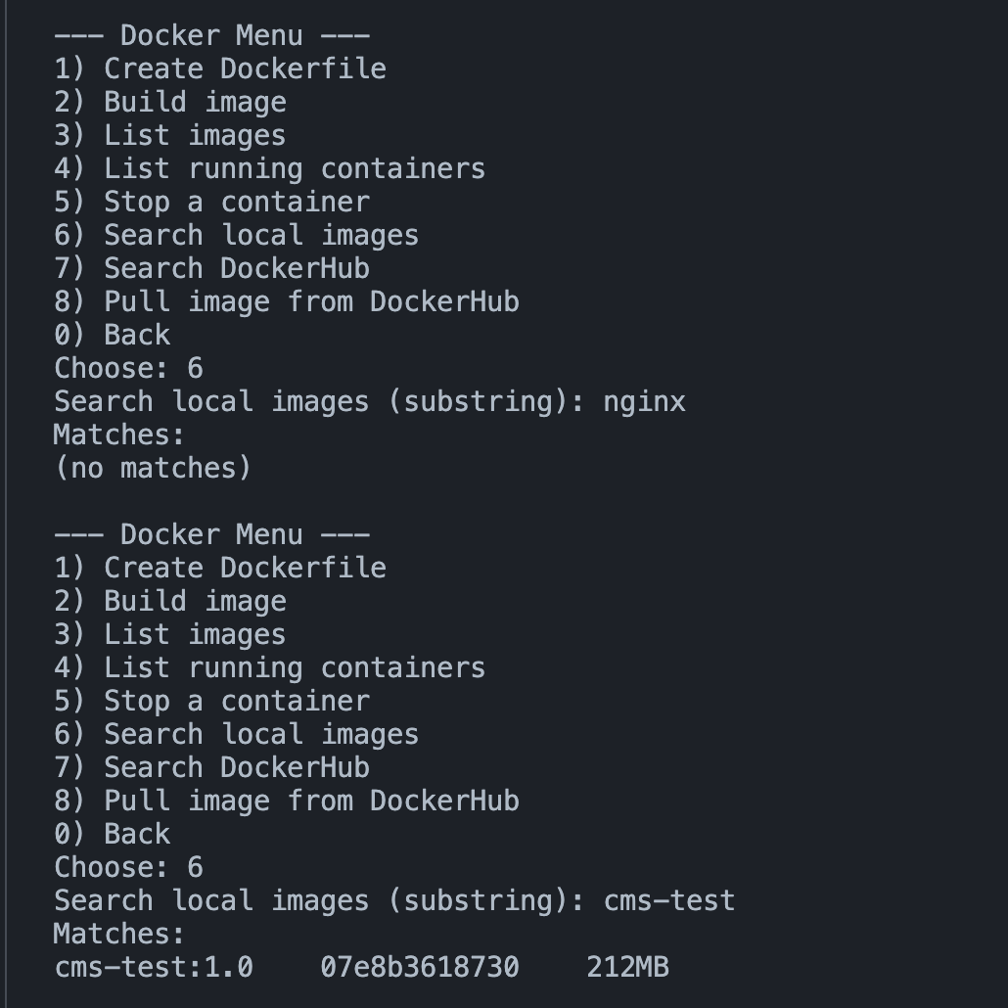
---
#### Test 7 — Search DockerHub
Steps:
1) Docker menu → `7) Search DockerHub`
2) Enter term: `nginx`
Expected:
- Shows DockerHub search results
Output:
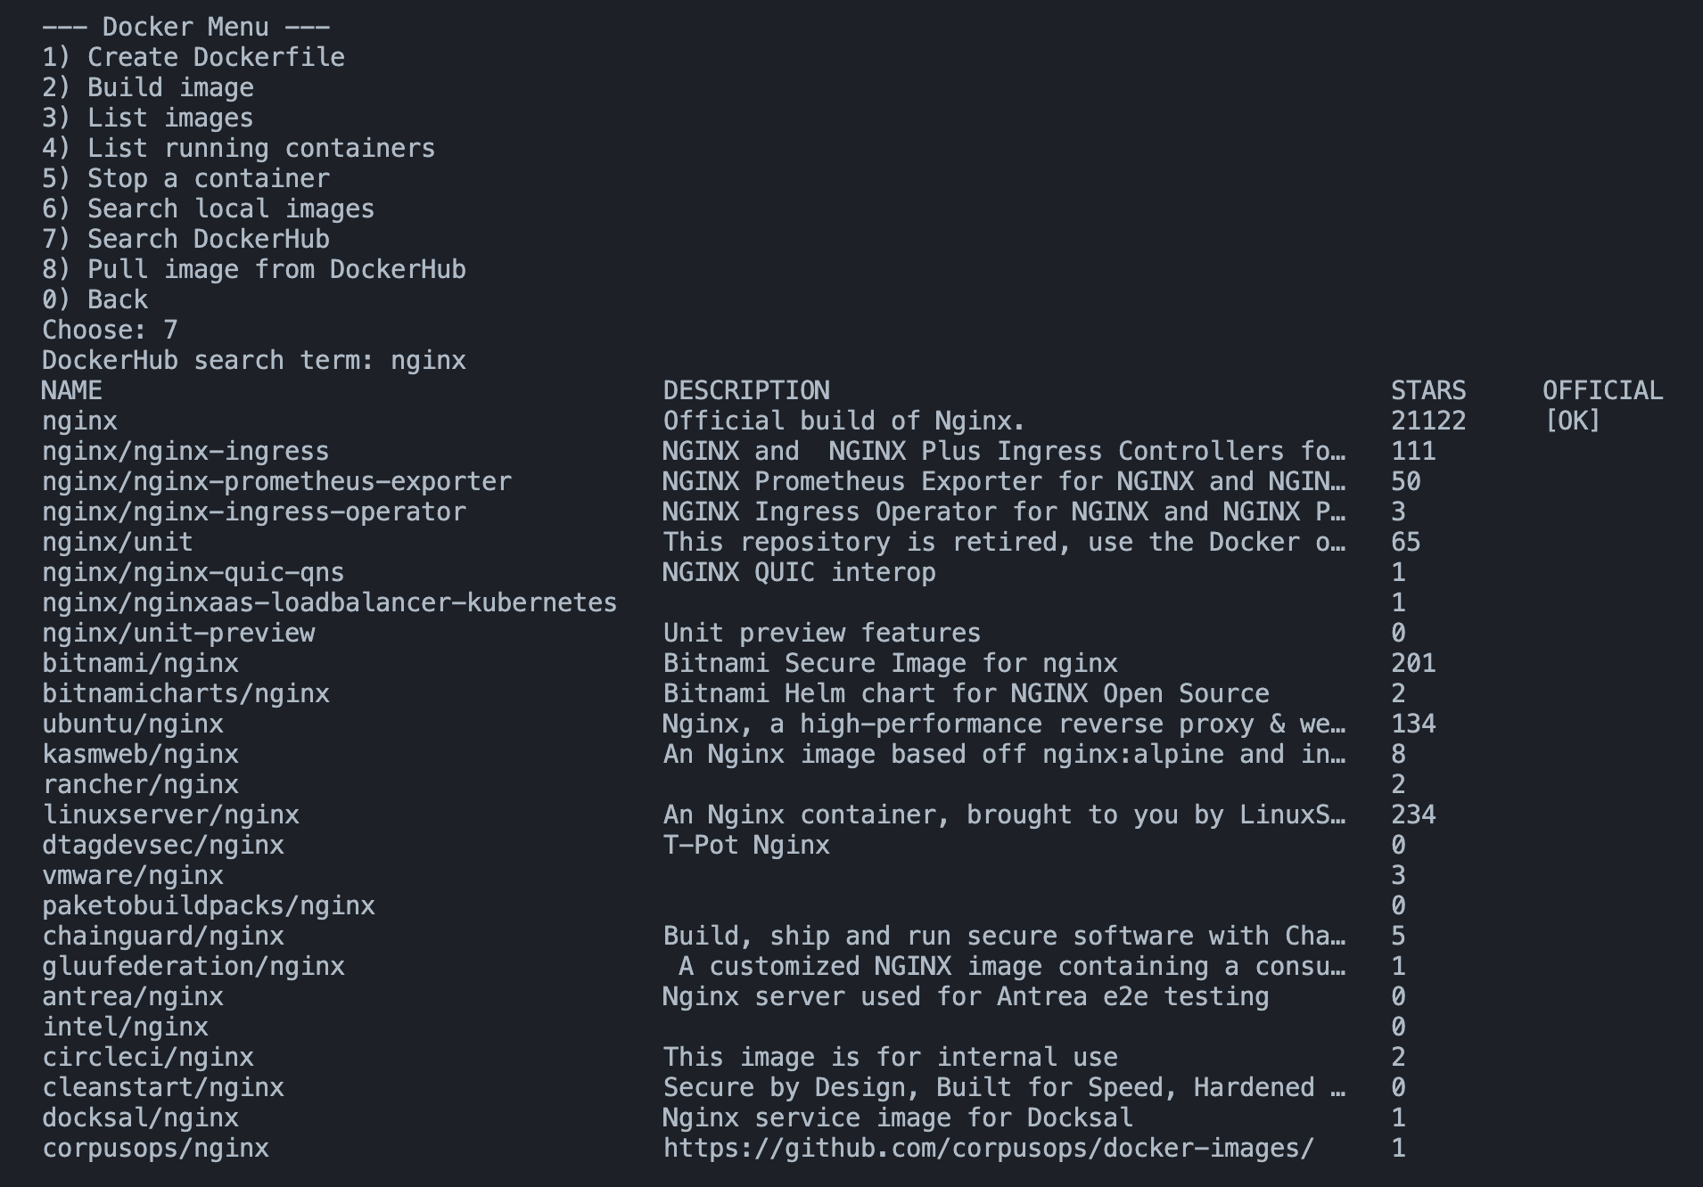
---
#### Test 8 — Pull image from DockerHub
Steps:
1) Docker menu → `8) Pull image from DockerHub`
2) Enter: `nginx:latest`
Expected:
- Pull successful
Output:
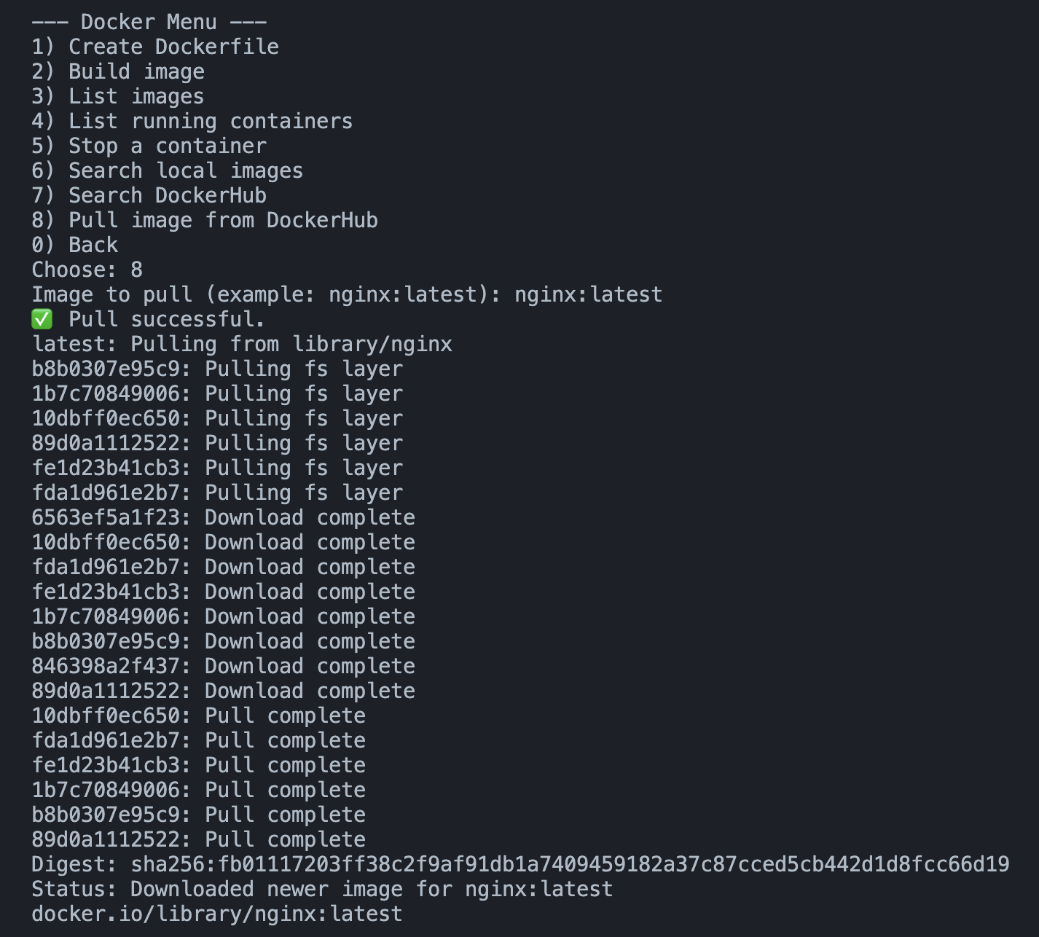
---
### VM / QEMU Tests
#### Test 9 — QEMU installed
Steps:
1) Run: `qemu-img --version`
2) Run: `qemu-system-x86_64 --version`
Expected:
- Both show version output
Output:
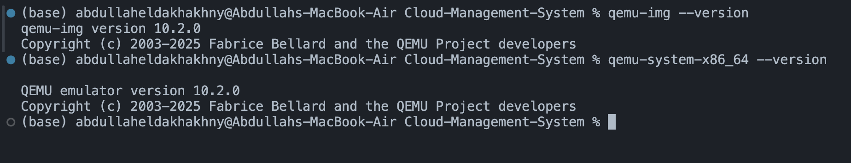

#### Test 10 — Create VM (interactive)
Steps:
1) Run program
2) VM menu → `1) Create VM (interactive)`
3) Enter:
- VM name: `ubuntu_test1`
- CPU: `2`
- Memory: `2048`
- Disk GB: `10`
- Disk path: `ubuntu_test1.qcow2`
- iso path: "C:\Users\HP\Downloads\ubuntu-20.04.6-desktop-amd64.iso"
Expected:
- Program creates disk file
- Program launches QEMU window
Output:
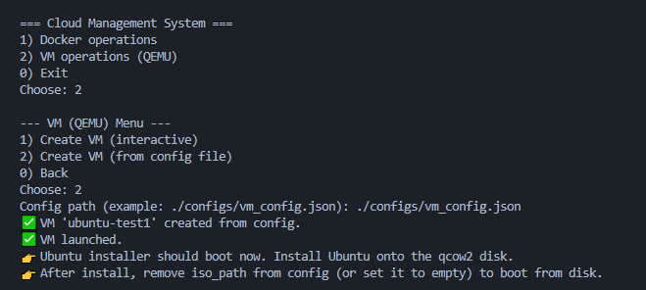
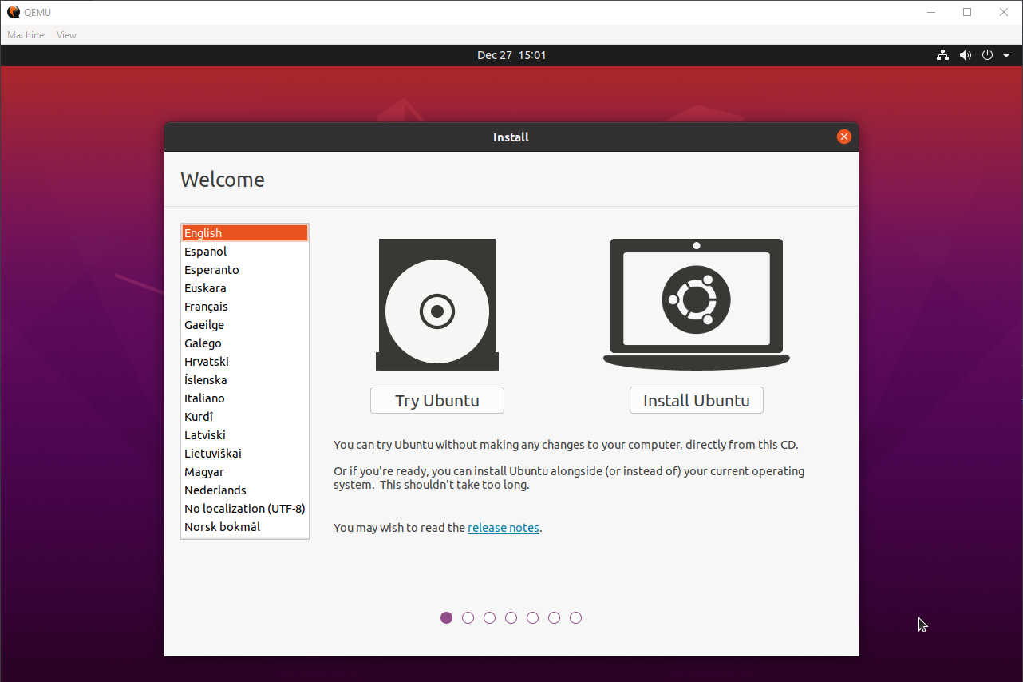

#### Test V2 — Create VM (from config)
Config used (example):
Use the json config file path:
./configs/vm_config.json
{
"name": "ubuntu-test1",
"cpu": 2,
"memory_mb": 2048,
"disk_gb": 10,
"disk_path": "./ubuntu-test1.qcow2"
"iso_path": "C:\\Users\\HP\\Downloads\\ubuntu-20.04.6-desktop-amd64.iso"
}
Output:

