**Preliminary Modelling of IFNa2**

Model 1:

Differential internalization and recycling of IFNa vs IFNb. Active receptor complex can be internalized by does not signal from the endosome.

* This model can produce a stronger response from IFNa than IFNb, but IFNb does not saturate to the same level as IFNa.
* See Figure 1

Model 2:

Differential internalization, recycling, *and signaling* of IFNa vs IFNb. Active receptor complex can be internalized and can phosphorylate STAT from the endosome. All rates of internalization, recycling, and endosomal phosphorylation are different.

* This model can produce the same qualitative relationships seen in the data. However, the number of degrees of freedom makes it over-parameterized.
* See Figure 2

Minimal Model 2:

* Same dynamics available as in Model 2, but now I try to constrain as many parameters as possible to be the same between IFNa and IFNb. I found that internalization rates and endosomal phosphorylation rates must differ in order to maintain the same qualitative relationships between dose-response curves. Recycling rates can be identical.
* See Figure 3

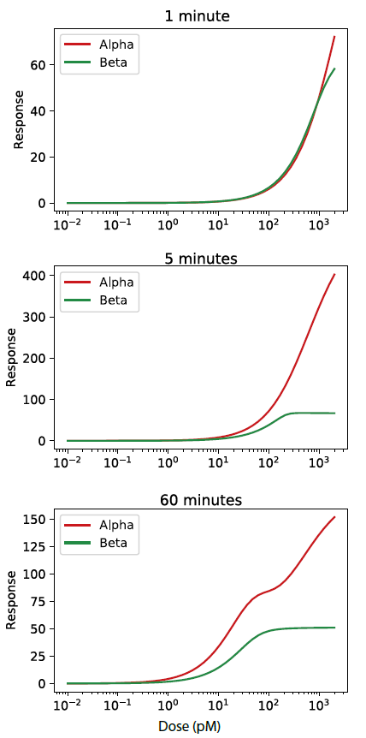

**Figure 1**: Model 1 dose response curves.

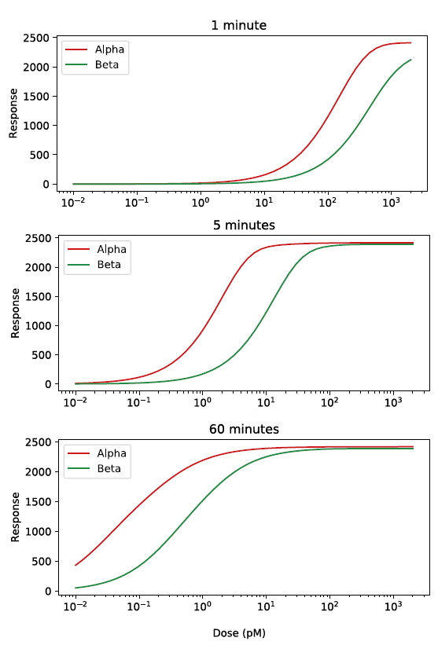

**Figure 2**: Model 2 dose-response curves

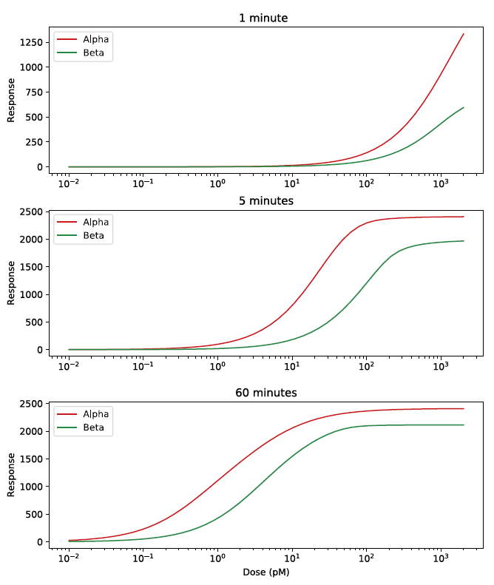

**Figure 3**: A minimal Model 2.