**Preliminary Modelling of IFNa2**

We tried to explain the data presented in Figure 1, focusing on the qualitative relationships between IFNa2 and IFNb. The parameters we considered were the rates of receptor internalization (both free surface receptors and in complexes), receptor subunit recycling back to the surface, and STAT phosphorylation by internalized receptor complexes in some models. Here are results for three different scenarios (models).

Model 1:

Differential internalization and recycling of IFNa vs IFNb bound to receptor subunits. Active receptor complex can be internalized but does not signal from the endosome.

* This model can produce a stronger response from IFNa than IFNb, but IFNb does not saturate to the same level as IFNa.
* See Figure 2

Model 2:

Differential internalization, recycling, *and signaling* of IFNa vs IFNb. Active receptor complex can be internalized and can phosphorylate STAT from the endosome. All rates of internalization, recycling, and endosomal phosphorylation are different.

* This model can produce the same qualitative relationships seen in the data. However, the number of degrees of freedom makes it over-parameterized.
* See Figure 3

Minimal Model 2:

* Same dynamics available as in Model 2, but now we try to constrain as many parameters as possible to be the same between IFNa and IFNb. We found that internalization rates and endosomal phosphorylation rates must differ in order to maintain the same qualitative relationships between dose-response curves. Recycling rates can be identical.
* See Figure 4

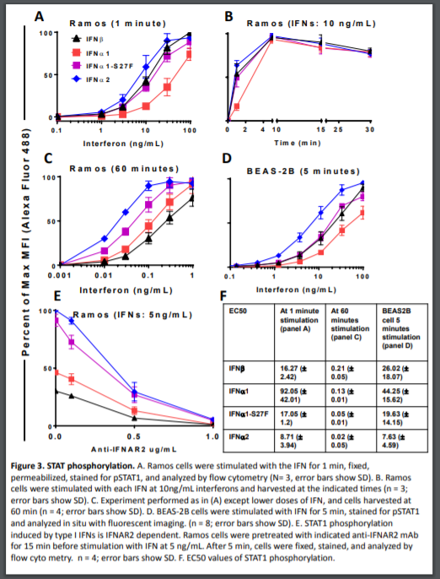

**Figure 1**. The data which was qualitatively modelled.

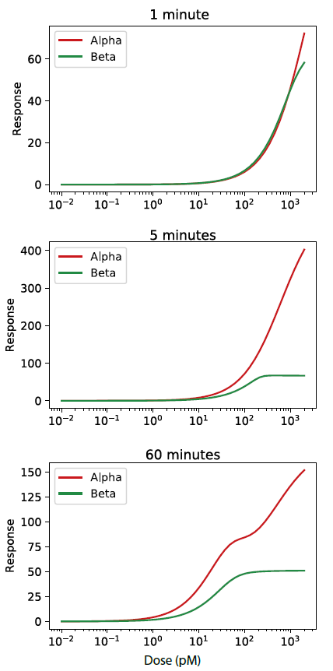

**Figure 2**: Model 1 dose response curves.

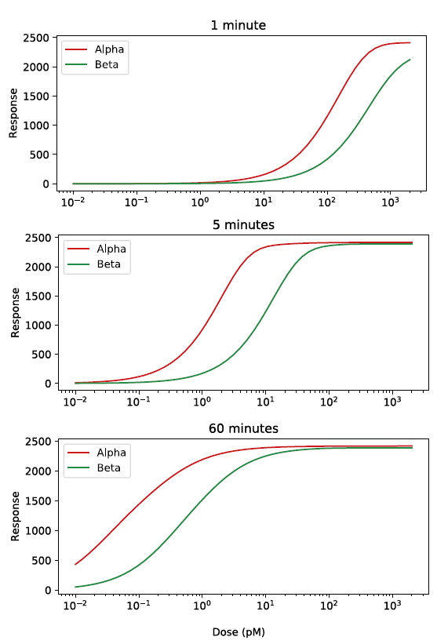

**Figure 3**: Model 2 dose-response curves

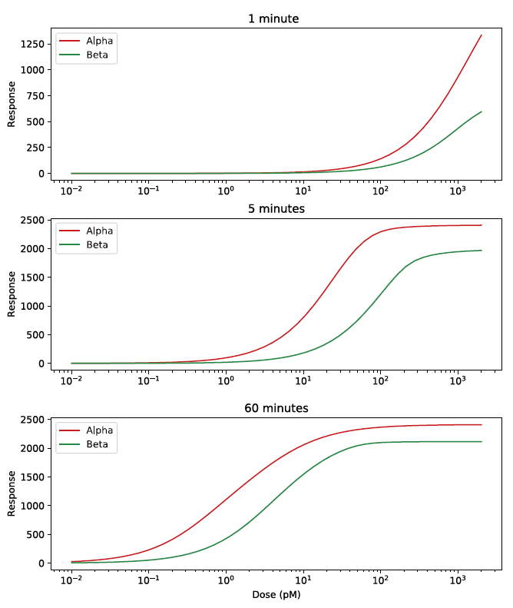

**Figure 4**: A minimal Model 2.