 | INTERNATIONAL TELECOMMUNICATION UNION  TELECOMMUNICATION  STANDARDIZATION SECTOR  STUDY PERIOD 2025-2028 |  | FG-AI4SSC-I-#
 |  |  | Focus Group on AI for Smart Sustainable Cities and Communities
 |  |  | Original: English
WG(s): |  | N/A | Tampere, 10-11 September 2026
INPUT DOCUMENT
Source: |  | Tegrity.AI - an initiative of The Integral Management Society, Switzerland
Title: |  | Minimum Sufficient Control as an Architectural Property of AI-enabled Urban Systems
Contact: |  | Iván Abril Palma  Tegrity.AI  Switzerland |  | Email: ivan.abril@tegrity.ai

Abstract: | This contribution asks a practical question for AI-enabled urban systems: what minimum level of coordination, architecture and technology is needed to achieve a city’s legitimately defined objectives—such as mobility performance, accessibility, safety, emissions, service availability and capacity use—within agreed effectiveness ranges?  Rather than assuming maximum data collection, connectivity or control, the approach first declares the outcomes and mandatory constraints. These priorities and acceptable ranges may legitimately differ between cities. It then organizes the indispensable means into three practical groups: (1) actors or flows, including their type and the proportion subject to direct control or legitimate influence; (2) intervention mechanisms; and (3) technologies for observation, communication, interoperability and actuation.  Existing approaches in related domains—including MIMs, reference-point architectures and bounded urban control systems—demonstrate the value of selective and sufficient architectural commitments. This contribution proposes that FG-AI4SSC examine what combination of observation, coordination and intervention is sufficient for a declared urban objective. This question falls within the Focus Group’s mandate on architectural frameworks, coordination mechanisms and the assessment of AI-enabled urban systems.  Making such context-dependent sufficiency explicit could help cities compare alternative configurations, reuse existing capabilities, direct investment toward what is demonstrably necessary and avoid unnecessary complexity.
1 Purpose and architectural question
FG-AI4SSC addresses architectural frameworks, coordination, interoperability, supervision, control and assessment for cities as interconnected socio-technical systems [1]. This contribution adds one narrow question: not how much an AI-enabled urban system could observe or control, but what minimum coordinated control is sufficient to maintain its declared objectives.
How much coordinated control is sufficient to keep an urban system within its declared objective envelope?
1.1 Why this question fits FG-AI4SSC
Terms of Reference establish a system-level, pre-standardization study of AI-enabled urban systems rather than a study of isolated AI tools. The scope expressly joins four elements that MSC needs: (i) architectural frameworks and reference models for interoperable and scalable deployment; (ii) interoperability and coordination mechanisms across city operational systems, including MIMs; (iii) requirements for supervisory and control mechanisms, taking account of service criticality and operations; and (iv) lifecycle, evaluation and assessment frameworks, including benchmarking, monitoring and international comparability [1].
The same mandate asks the Focus Group to identify gaps, develop system-level technical frameworks and operational considerations, and prepare future standardization of architectural frameworks, interoperability approaches and assessment methodologies [1]. MSC sits at the intersection of those tasks. It asks what evidence would allow architecture to demonstrate that its combination of coordination, intervention and enabling means is sufficient for a declared objective envelope.
This positioning also respects the ToR boundary. MSC is not a proposal for detailed AI-model design, general urban policy or sector-specific regulation. It is a question about architecture, system integration, supervision, control and assessment in AI-enabled urban operations - the technical pre-standardization territory assigned to FG-AI4SSC [1].
1.2 Precedents for minimum-sufficiency as an architectural strategy
Several precedents show that an important system property need not require a maximal architecture. MIMs make this logic explicit for interoperability; NIST Pivotal Points of Interoperability focus standardization on high-leverage interfaces; SynchroniCity used a common minimal technical ground across multiple cities; and ITU-T Y.4200 and Y.4201 frame interoperability requirements and reference points [5]-[7]. These are not models of Minimum Sufficient Control. They demonstrate the broader design strategy: identify the selective architectural commitments that are sufficient to make a system-level property achievable.
Dimension | MIMs | Minimum Sufficient Control
Property sought | Interoperability | Sufficiency of coordination and control
Primary question | What must systems share to interoperate? | How much coordination and intervention is sufficient for the objective?
Minimum of | Common interfaces and capabilities | Coordination scope (C), operational mechanisms (P) and enabling means (M)
Primary input | Heterogeneous systems and services | Objective envelope, mandatory constraints and operating state
Output | Sufficient interoperability | Evidence-supported sufficient control
Sensitivity to change | An interface may remain valid | The sufficient control level may change with demand, infrastructure or priorities
Within that broader precedent set, MIMs remain especially useful because their sufficiency logic is explicit. They can be used within MSC rather than treated as a competing approach: they may supply part of M, the interoperability means that enable selected actors and mechanisms to work together. They do not by themselves determine C, the actors, flows or proportion that must be coordinated, or P, the operational interventions required. A city could have excellent interoperability and still not know whether it must coordinate 2%, 20% or the whole relevant system; another city might meet the same objective by coordinating a small strategic subset and reusing legacy capabilities.
The proposed contribution is therefore not another MIM. Its pre-standardization gap can be stated as follows: MIMs establish minimum sufficient interoperability; the FG mandate adds coordination, supervision/control and assessment; MSC asks what constitutes a minimum sufficient combination of those elements for a declared urban objective. This changes the emphasis from a reference architecture as a catalogue of possible components to a reference architecture that can express a context-dependent sufficiency condition.
That distinction is particularly relevant across heterogeneous cities. Different cities can achieve comparable objective envelopes through different combinations of technology, existing infrastructure and human-mediated operations. A lower-bound description based on C, P and M can support international comparability without imposing identical infrastructures or maximum architectures - directly serving the FG's scalability, assessment and comparability aims [1].
2 Objective-led minimum sufficient control
Urban systems normally pursue several outcomes at once — for mobility, punctuality, travel time, congestion, accessibility, emissions, capacity use and compliance with access or safety constraints; the same logic extends to human movement, access and presence, appointment or service allocation, and occupancy of public facilities. These outcomes need not be mutually supportive, and some constraints may be non-negotiable.
It is not necessary to reduce every objective to one universal scalar. A city can instead define a legitimate local objective envelope S(t): the outcomes it must maintain, their acceptable effectiveness ranges under the relevant operating conditions, and the constraints that must always hold. The selected objectives and ranges may differ from one city to another and may change legitimately over time. The architectural question is then modest and concrete:
Find the least intervention-intensive architecture that combines (1) a locally defined objective envelope and mandatory constraints, (2) coordinated actors or flows and the proportion subject to control or legitimate influence (C), (3) intervention mechanisms (P), and (4) enabling technologies (M), while keeping outcomes inside S(t) and meeting the required control and effectiveness ranges.
No universal minimum, metric, equivalence range or optimization procedure is proposed here. The suggestion is that sufficiency—and practical equivalence between different combinations of objectives, actors, interventions and technologies—may be worth representing when future AI-enabled urban architectures are described or assessed.
3 A possible organization of the indispensable means
Once objectives, acceptable ranges and mandatory constraints are declared, the indispensable means can be organized into three practical groups, offered as a discussion aid rather than a proposed standard.
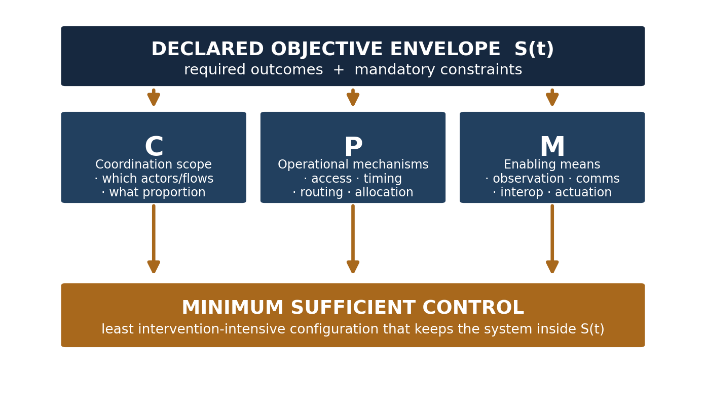
Figure 1 — Objective-led description of minimum sufficient control. The objective envelope and the three groups of indispensable means are illustrative, not proposed as an adopted FG framework.
Dimension | Question | Examples
C · Actors and coordination scope | Which actors or flows must be coordinated, of what type, and what proportion must be controlled or legitimately influenced? | Public or private fleets; selected corridors or zones; passenger, pedestrian or service-demand flows; a strategic subset rather than the whole system.
P · Intervention mechanisms | Which types of intervention must be available? | Access rules; timing and scheduling; routing; capacity, occupancy, appointment, service or spatial-allocation decisions.
M · Enabling technologies | Which technologies are required to observe, communicate, interoperate and act? | Existing operational data; telemetry; messaging; APIs and event interfaces; automated or human-mediated actuation.
4 Why limited control is a legitimate architectural variable
Direct controllability and system-level effect are not one-to-one. Stern et al. [2] showed on a circular track that one controlled vehicle among more than twenty could damp stop-and-go waves; the CIRCLES MegaVanderTest later reproduced wave dissipation in open-road rush-hour traffic with about one hundred connected and automated vehicles [3]. These results establish a principle, not a city-scale method: system-level influence need not require direct control of every actor.
Those studies use automated vehicles as mobile actuators and do not establish the minimum for a governed, non-automated urban population or for service-level interventions such as assignment, timing, routing and access. Their value here is narrower: they make the controlled fraction a legitimate architectural variable, to be assessed rather than maximized or transferred without validation.
Zurich provides a particularly relevant urban precedent. Its adaptive perimeter system observes selected inner-city roads and changes access-road signals when service levels deteriorate [9]. This is a bounded architecture—selected observation, an operational threshold, intervention and feedback—rather than direct control of the whole mobility system.
Other evidence supports the same pattern without requiring equal treatment here. SCOOT demonstrates responsive coordination through frequent small signal adjustments; Lisbon's WONE combines selected monitoring zones, telemetry, alerts and targeted intervention; and target-control theory formalizes control of selected targets rather than an entire network [8], [10], [11]. Together, these cases support the feasibility of objective-led, bounded sensing and intervention, not a universal minimum.
5 Illustrative bounded case: Riviera Maya mobility orchestration
From 2016, a tourism operator used a passenger-mobility orchestration system in the Riviera Maya to collect passengers from approximately 400 hotels and serve seven destination parks. Instead of fixed itineraries, the system generated constrained route sheets for each bus and dynamically replanned assignments, routes, timing, access and occupancy across hundreds of vehicles, coordinating between 7,000–15,000 passenger movements per day [4]. Because those buses used shared corridors and access points, urban traffic forecasts were an operating input to the plan.
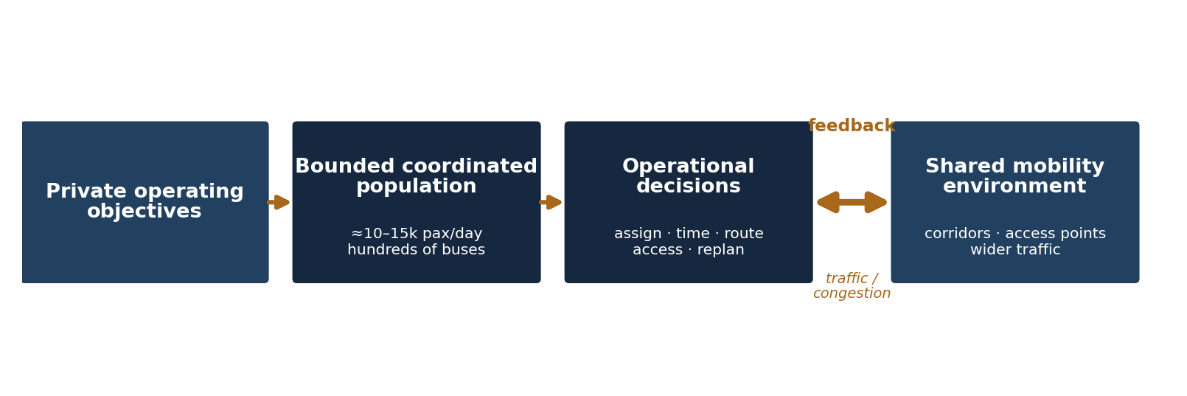
Figure 2 — Documented reciprocal interaction pathway in the bounded case. No quantified causal estimate of regional traffic impact is claimed.
The case illustrates how intervention in a limited controlled fleet can matter in a highly interconnected system. When the Google traffic reports received by the planner indicated likely congestion affecting a group of buses, the system considered alternative routes; those choices in turn redistributed vehicle flows on the shared network. The retained reports support possible reciprocal interaction between fleet routing and wider congestion conditions, but they do not isolate or quantify a causal reduction across the entire regional network [4].
6 Suggested consideration for FG-AI4SSC
FG-AI4SSC might wish to consider minimum sufficient control as an explicit architectural property alongside, but distinct from, interoperability, coordination and supervision. An architecture would state its local objective envelope, coordination scope (C), intervention mechanisms (P) and enabling means (M), including any MIM-based capabilities it reuses, and provide evidence that their combination is sufficient. No universal control level is prescribed.
This matters because cities differ in technology, institutions, regulation and resources. A minimum-sufficient description offers a common architectural floor for comparable objective achievement without requiring maximum sensing or control. It supports scalable harmonization and resource proportionality, not merely a smaller architecture.
Two implications follow. First, rationalize and reuse existing sensing, data, communications, planning, interoperability and actuation before adding new elements. Second, sufficiency is conditional: material changes in demand, infrastructure, actors, constraints or priorities should trigger re-evaluation.
Can minimum sufficient control be made an explicit, describable property of an AI-enabled urban architecture?
This initial contribution does not request a new work item or Working Group and does not propose a complete methodology. It is intended only to place this architectural question, and one possible description of it, on the table for consideration.
Define objectives → rationalize / reuse → minimum sufficient control → re-evaluate after material change
References
[1] ITU-T Focus Group on AI for Smart Sustainable Cities and Communities (FG-AI4SSC), Terms of Reference, 2026.
[2] R. E. Stern et al., “Dissipation of stop-and-go waves via control of autonomous vehicles: field experiments,” Transportation Research Part C, 89 (2018), 205–221.
[3] D. B. Lee et al., “Traffic Control via Connected and Automated Vehicles (CAVs): An Open-Road Field Experiment with 100 CAVs,” IEEE Control Systems, 45 (1) (2025), 28–60. DOI: 10.1109/MCS.2024.3498552.
[4] Riviera Maya case: contributor-retained project documentation and operational Google traffic reports.
[5] OASC, “Minimal Interoperability Mechanisms (MIMs)”; European Commission, CORDIS, SynchroniCity final reporting, grant 732240.
[6] NIST, “Pivotal Points of Interoperability Enable Smart City Standardization,” 2021.
[7] ITU-T Recommendations Y.4200, “Requirements for the interoperability of smart city platforms,” and Y.4201, “High-level requirements and reference framework of smart city platforms,” 2018.
[8] J. Gao, Y.-Y. Liu, R. M. D'Souza and A.-L. Barabási, “Target control of complex networks,” Nature Communications, 5, 5415 (2014). DOI: 10.1038/ncomms6415.
[9] M. Menendez and L. Ambühl, “Implementing Design and Operational Measures for Sustainable Mobility: Lessons from Zurich,” Sustainability, 14 (2), 625 (2022). DOI: 10.3390/su14020625.
[10] P. B. Hunt et al., “SCOOT — a traffic responsive method of coordinating signals,” TRRL LR1014, 1981.
[11] EPAL, “WONE — Water Optimization for Network Efficiency,” accessed 27 August 2026.

