10HZ 9600 Baud rate

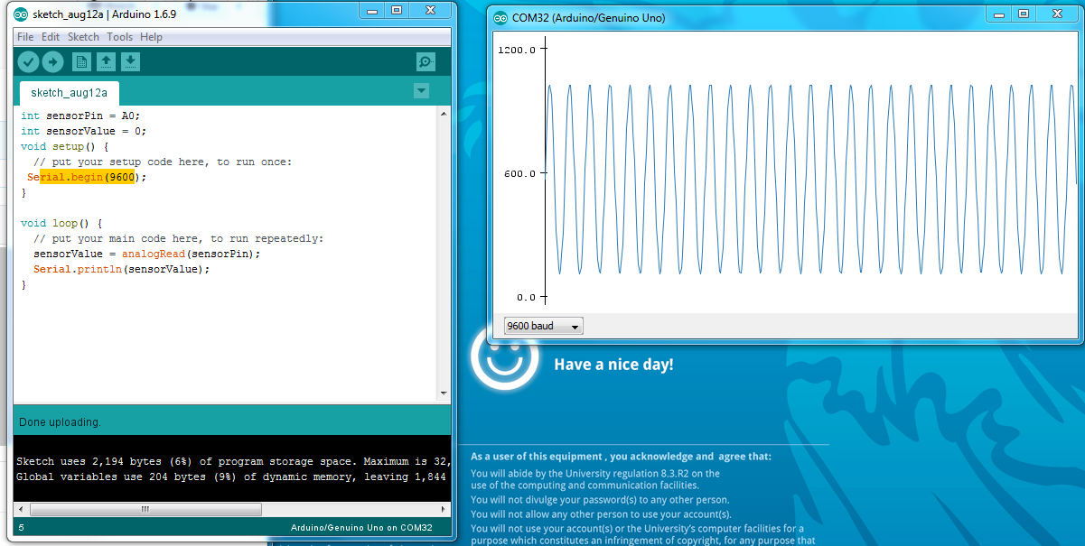

Function generator increase to 100HZ

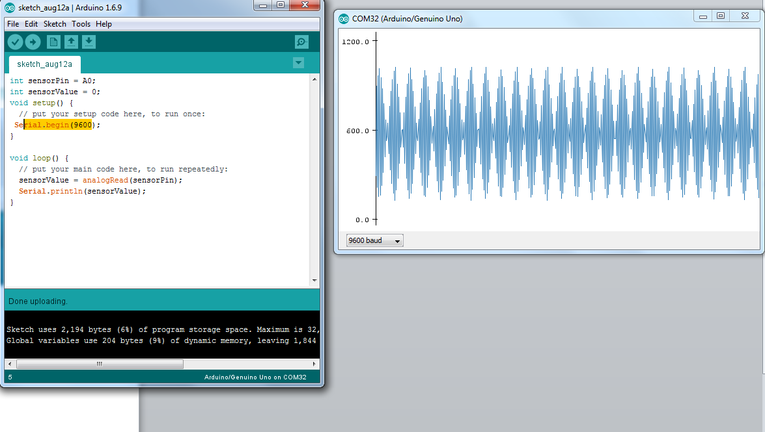

The plot is becoming inaccurate because the signal has a higher frequency than the resolution

100HZ+115200+4.5_0.5

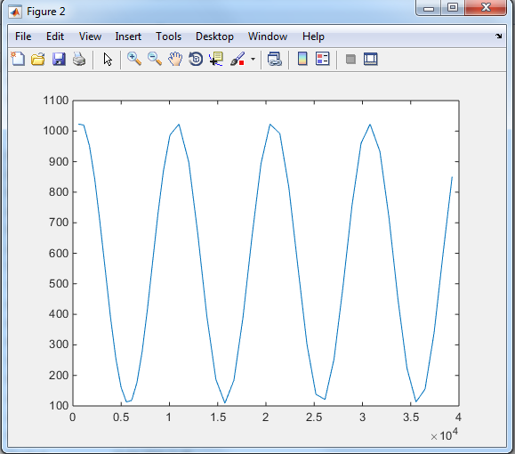

115200+10HZ+2.05-2.00

