Abstract—The Badhwar-O’Neill Galactic Cosmic Ray (GCR) model has been revised to model all balloon and satellite GCR measurements since 1955. This includes the newer 1997-2010 (ACE) measurements and spans six solar cycles.
Badhwar-O’Neill 2010 Galactic Cosmic Ray Flux Model - Revised
Patrick M. O'Neill

Index Terms—Galactic Cosmic Rays, solar modulation, Advanced Composition Explorer, sunspot number, heliosphere, Single Event Effect, radiation environment.

INTRODUCTION
THE purpose of this work is to provide an accurate GCR energy spectrum that can be used by Single Event Effect (SEE) rate prediction codes such as CREMEMC [https://crème-mc.isde.vanderbilt. edu] and CREME96 [1]. The GCR spectrum is also needed by radiation health physicist’s for astronaut exposures on deep space missions[2]. GCR's are known to be the major cause of "quiet time" SEE's in spacecraft in the solar system and even beyond. Accurate knowledge of the GCR spectrum is needed, especially during solar minimum when the GCR flux is at its maximum.

All GCR energy spectra (measurements and model) reported in this paper apply in free space - beyond the earth's magnetosphere. To get the GCR flux within the earth's magnetic field, you should use an appropriate magnetic cutoff code such as that used by CREMEMC or CREME96.

New results presented in this paper model the "quiet time" GCR flux over the period from 1955 to 2010 and provide the most comprehensive comparison between model and GCR in-flight measurements made above the magnetic cutoff - from balloons (high latitude) and satellites (high altitude) ever compiled. This data set spans Solar Cycle 19 to 24 and confirms the maximum flux attained during the past six (6) solar minima. This includes the most recent solar minimum, which is by far the deepest minimum since the measurements began. The Badhwar-O’Neill model parameters are uniquely influenced by measurements from the NASA Advanced Composition Explorer (ACE) Cosmic Ray Isotope Spectrometer (CRIS) that is currently measuring the low energy (~50 - 300 MeV/n) spectrum for all ions from Lithium (z=3) to Nickel (z=28) - see the ACE Web site - http://www.srl.caltech.edu/ACE/.

We based the original Badhwar-O’Neill model (BO’96) [3] on balloon and satellite measurements made between 1955 and 1996 and BO’96 provided excellent agreement with these measurements. The BO'96 model was updated in 2004 [4] and that update was based entirely on the newly available measurements such as that provided by ACE, BESS [5], and HEAO [6].

However, a recent study [7] showed that the BO'04 model does not fit the older ('55-'97) GCR data as well as the Nymmik GCR model (NY'97). In response to this conclusion, the older GCR data ('55-'97) was re-examined we found that it could be effectively combined with the new data ('97 - '10).

The result is the new BO'10 model that now agrees excellently with both the old and the new GCR data measurements. The new coefficients did not change significantly and the least square errors are within that expected for both the older and the newer instruments.

This is a significant improvement to the overall accuracy of modeling the true GCR spectrum - now based on 55 years of cosmic ray measurements - because spacecraft designers need the actual history of GCR fluxes since it is the best knowledge of actual worst-case conditions. BO'10 is the only GCR model that utilizes all of the GCR measurements made from 1955 to 2010.

We have also improved our method of determining the solar modulation parameter. The BO'10 model now uses the International Sun Spot number to determine level of solar modulation.

We have also added the ability of the BO'10 model to calculate GCR flux for the elements from copper (z=29) to plutonium (z=94). In this range GCR flux measurements are essentially non-existent so we used the relative abundance data of [8] multiplied by our silicon spectrum (z=14).

To get the BO'10 model, send a request to patrick.m.oneill @nasa.gov.

GCR SPECTRUM

Models
The steady GCR flux is the dominant cause of Single Event Effects (SEE) for hard components (those not susceptible to protons) in Low Earth Orbit (LEO) and for all components in orbits above LEO (such as Molniya, Geosynchronous, Lunar, and Mars). Of all the elements, carbon, oxygen, silicon and iron cause most of these SEE’s because they are the most abundant of the more ionizing elements. It is especially critical that we model these elements precisely.

The Badhwar-O’Neill model uses the spherically symmetric Fokker-Planck equation that accounts for cosmic ray propagation in the heliosphere due to diffusion, convection, and adiabatic deceleration. The boundary condition is the constant energy spectrum (called the Local Interstellar Spectrum (LIS)) for each GCR element at the outer edge of the heliosphere (~100 AU). The Fokker-Planck equation modulates the LIS to a given radius from the sun - assuming steady state heliosphere conditions.

Local Interstellar Spectrum (LIS)
The BO'10 model uses a physically significant, simple, analytical form for the LIS of each element. The model uses the same power law that GCR physicists have used since Fermi [9] first demonstrated shock acceleration for GCR's in the Milky Way.

The LIS for each element is

j_{lis}(E) = j₀ β^{δ} (E + E₀) ^{- γ} (1)

Where E is the elemental particle’s kinetic energy/nucleon and E₀ is the particle’s rest energy/nucleon (938 MeV/n for every particle), β is particle speed relative to the speed of light.
The model has three free parameters: γ, δ and j₀ for each element.

Solar Modulation
The Fokker-Planck equation uses a single parameter – the solar modulation parameter (Ф) - to account for attenuation of the LIS due to the state of the heliosphere. Larger values of Ф cause lower GCR flux. In units of rigidity (volts), Ф is proportional to the momentum / charge required for a particle to penetrate the heliosphere.

The solar modulation parameter (Ф) is directly associated with solar activity and can be determined (in principle) by a number of methods. The various solar indices: such as sunspot number, radio and X-ray flux, neutron monitor rates, spacecraft GCR measurements, even tree rings [10] indicate the temporal variation of the sun's intensity.

One value of Ф describes the state of the heliosphere and applies at a specific time for all of the elements from hydrogen (z=1) through plutonium (z=94).

Methods that determine Ф from the current measurement of solar activity at the sun - such as sunspot number - tend to precede the GCR modulation. The heliosphere's response has a lag of 8 to14 months to account for changes in solar activity. On the other hand, direct measurement of the GCR flux by a spacecraft instrument samples the current state of the heliosphere. The sunspot method has the advantage of predicting future GCR fluxes however; the spacecraft method more precisely emulates the actual GCR flux.

Analysis shows that the correlation of the spectra of all the significant GCR elements (z=1 to 28) is better using direct sampling of the heliosphere by spacecraft to determine Ф. This is important to the SEE analyst who needs to know the actual history of GCR fluxes. The SEE analyst needs knowledge of actual worst-case conditions for spacecraft designs.

The BO'10 model now uses the International Sun Spot (ISS) number rather than actual GCR flux to determine the value of Ф from a flight instrument. However, actual spacecraft data was used calibrate the sun spot number for periods where they overlap - IMP-8from '74 to '97 and ACE from '97 to present.

GCR FLUX MEASUREMENTS

Hydrogen and Helium (z=1, 2)

The GCR flux measurements for abundant elements - such as hydrogen, helium, carbon, oxygen, silicon and iron - appear in the literature from 1955 to 1997. Spectra measurements are especially numerous for the '60's, '70's, and '80's. Some measurements of the other elements are also available in the older data - but sparsely. Flight instruments have measured hydrogen and helium spectra extensively for years. A short balloon flight (~16 hours) such as the IMAX with a large superconducting magnet spectrometer can accurately determine the "quiet time" GCR spectrum for these highly abundant species - see Figure 1.

High Energy Heavy Ions (z=3 to 28)
The high-energy (> 1000 MeV/n) measurements provide the foundation for the BO'10 parameter fit. The high energy data is used to determine 2 of the 3 fit parameters - the slope (γ) and the absolute magnitude (j₀) of the LIS.

Figure 2 shows the major high energy flux measurements for O, Fe, and P (EFS [6], JUL [11], and ORTH [12]). These measurements are available for practically every element from Li (z=3) to Ni(z=28).

At these and higher energies, the flux becomes less subject to solar modulation so the measurements can be used to determine the LIS. This allows precise data fitting even though the flux is low in this energy region.
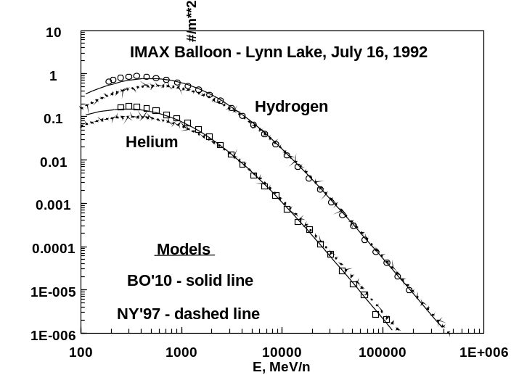
Fig. 1. Hydrogen and Helium spectra measured by IMAX balloon flown in 1992 from Lynn Lake, Manitoba. The BO'10 model used a solar modulation parameter of 728 MV as derived for the time of the balloon flight from the International Sun Spot (ISS) number.

Large instruments are used and instruments can collect data for long periods - EFS (HEAO) continuously collected data for 8 months. The balloon flights (JUL, ORTH) were only one day and their collection factors were about the same as the EFS (~700 cm² sr). Therefore, we weighted the EFS data heavier in the fit calculations.
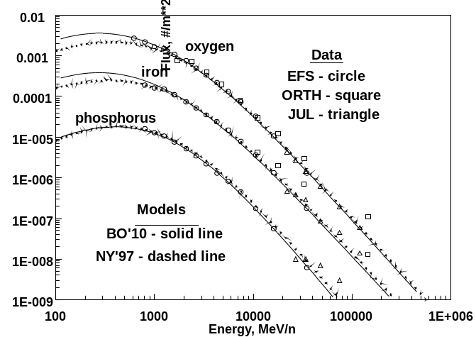
Fig. 2. Measured (EFS, JUL and ORTH) and modeled high energy spectra for phosphorus, iron, and oxygen This data is typical of that used for all the elements from Li(z=3) to Ni(z=28).

Low Energy Heavy Ions (z=3 to 28)
The low energy (50 - 1000 MeV/n) measurements
determine the BO'10 model free parameter (δ) of the LIS.

For the abundant elements (B, C, N, O, Si, Fe), low energy (50 - 1000 MeV/n) measurements are available from several sources - GARCIA-MUNOZ [13] and ACE are typical as in Figure 3.

For some of the less abundant elements (Be, Li, Ne, Mg, Ca and Ni), only 1 source (at most) of data is available in addition to ACE data.

However, for the vast majority of the elements - the least abundant species (F, Na, Al, P, S, Cl, Ar, K, Sc, Ti, V, Cr, Mn, and Co) - ACE is the only source of low energy measurements! Figure 4 shows the ACE data for low energy phosphorus at 2 modulation levels. For this rare element, even the ACE measurements have a wide spread. The NY'97 model did not use these low energy ACE measurements and that model differs significantly for all these rare elements.
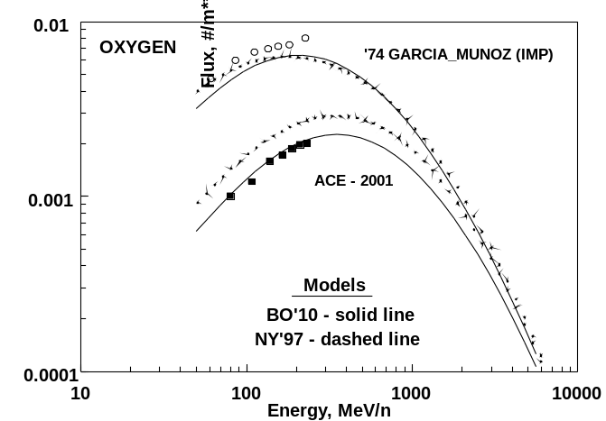
Fig. 3 Low energy oxygen spectra measured by IMP and ACE. This data is typical of that for the abundant elements (B, C, N, O, Si, and Fe).

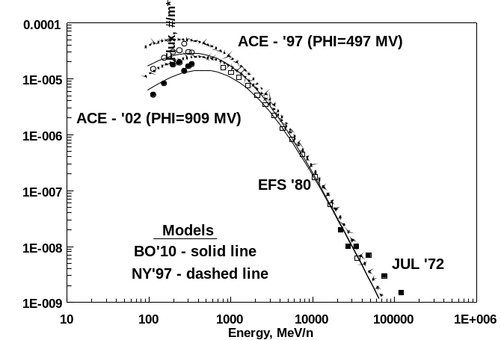
Fig. 4. Low and high energy spectrum for phosphorus measured by ACE (low energy) and EFS and JUL (high energy). This data is typical of that used for the least abundant elements (F, Na, Al, P, S, Cl, Ar, K, Sc, Ti, V, Cr, Mn, and Co).

Chi Square

Overall Measure of Fit
We used Equation 2 to calculate chi square errors for both the BO’10 and the NY’97 models.
N
χ² = (1/N-1)∑ [f_{meas}(E_{i}) - f_{model}(E_{i}) ]² / σ_{i}² (2)
i=1
Where N is the number of energy points measured in the spectrum, f(E_{i}) is the measured or model flux at the measured energy.

B. High Energy Spectrum (>1000 MeV/n)
Table I shows the average χ² errors for all high energy (>1000 MeV/n) measurements from 1955 to present for both the BO'10 and the NY'97 models. In addition to the EFS (HEAO), JUL, and ORTH measurements previously discussed, the balloon flight data of references [14 -19] were used to fit the high energy parameters (γ and j₀) of the BO'10 model and for the Table I χ² errors

For the abundant elements (Li to Si, and Fe) σ_{i} was taken to be 20% of f_{meas}(E_{i}) for all the high energy instruments except EFS (HEAO) and 100% for all the rare elements (P to Mn, and Co and Ni). σ_{i} was taken to be 10% of f_{meas}(E_{i}) for all of the EFS (HEAO) measurements.

In Table I and II, the smaller chi squared errors are shown in bold and the more abundant, critical heavy ions are shaded.

Table I Average χ² errors for high energy spectrum (>1000 MeV/n) measurements
z | BO'10 | NY'97 | z | BO'10 | NY'97
H ₁ | 0.8 | 4.3 | P₁₅ | 0.4 | 2.2
He ₂ | 1.5 | 3.4 | S₁₆ | 0.2 | 0.6
Li ₃ | 5.2 | 36.0 | Cl ₁₇ | 0.5 | 0.5
Be ₄ | 7.4 | 21.7 | Ar ₁₈ | 0.3 | 0.5
B ₅ | 4.6 | 19.8 | K₁₉ | 0.5 | 0.5
C ₆ | 1.4 | 2.9 | Ca ₂₀ | 1.0 | 1.7
N ₇ | 2.5 | 6.1 | Sc ₂₁ | 0.8 | 1.1
O ₈ | 1.8 | 3.5 | Ti ₂₂ | 0.3 | 0.2
F ₉ | 0.5 | 7.9 | V₂₃ | 1.0 | 0.8
Ne₁₀ | 2.6 | 5.8 | Cr ₂₄ | 1.2 | 1.2
Na₁₁ | 0.4 | 1.5 | Mn₂₅ | 1.6 | 1.3
Mg₁₂ | 1.3 | 4.1 | Fe ₂₆ | 2.2 | 2.4
Al ₁₃ | 0.5 | 1.0 | Co₂₇ | 5.0 | 177.0
Si ₁₄ | 1.9 | 3.3 | Ni₂₈ | 1.0 | 0.6

In this energy range, the measurements are much less dependent on solar modulation. The BO'10 model is a little better for these high energy measurements, but there really isn't too much difference between the models in this energy range for most of the elements.

C. Low Energy Spectrum (50-1000 MeV/n)
Table II shows the average χ² errors for all low energy measurements since 1955 for two periods - early and modern - for both the BO'10 and the NY'97 model.

In the early period (1955 to 1997), the measurements are from various balloon flights and satellite missions. Here BO'10 and NY'97 are reasonably close but BO'10 is a little better for most elements. Note that for the rare elements from F to Ni (excluding Ne, Mg, Si, and Fe) there is practically no measurement data. All that is available is the low energy tail of the high-energy measurements - that is only about 1 or 2 energy points below 1000 MeV/n. This is what makes the modern ACE data so important.

All of the modern low energy measurements for H and He are from BESS. For the heavier ions (Li to Ni) all of the measurements for the modern period are from NASA's Advanced Composition Explorer (ACE) Cosmic Ray Isotope Spectrometer (CRIS). In this period there are ~150 ACE measurements for every element from z=3 to 29 with each measurement being the average of one Bartel's Rotation (~27 days). The cosmic ray community [20] knows the ACE CRIS to be the authority for the heavy ion spectra in the energy range of interest. This data is readily available from the ACE Web site.

Clearly, BO'10 is the more accurate - for the Modern period - especially for the more critical ion species.

Table II Average χ² errors for low energy spectrum (50-1000 MeV/n) measurements
 | Early '55-'97 |  | Modern '97-'10
z | BO'10 | NY'10 | BO'10 | NY'10
H ₁ | 5.5 | 9.8 | 3.5 | 21.4
He ₂ | 3.4 | 4.6 | 3.9 | 5.4
Li ₃ | 1.1 | 3.0 | 0.1 | 8.3
Be ₄ | 4.1 | 9.1 | 1.1 | 1.6
B ₅ | 4.5 | 4.4 | 5.7 | 20.6
C ₆ | 1.5 | 5.5 | 5.3 | 23.7
N ₇ | 1.9 | 4.7 | 4.9 | 11.4
O ₈ | 1.5 | 2.6 | 5.0 | 15.4
F ₉ | 1.7 | 3.4 | 12.2 | 36.5
Ne₁₀ | 3.4 | 4.5 | 4.5 | 36.1
Na₁₁ | 0.5 | 5.2 | 7.7 | 32.1
Mg ₁₂ | 1.8 | 4.2 | 4.6 | 18.6
Al₁₃ | 0.3 | 0.8 | 6.4 | 33.2
Si ₁₄ | 2.0 | 2.6 | 5.0 | 22.3
P₁₅ | 0.7 | 0.4 | 14.1 | 111.7
S₁₆ | 2.0 | 13.1 | 6.2 | 31.4
Cl ₁₇ | 1.0 | 4.8 | 14.8 | 68.9
Ar₁₈ | 3.7 | 16.3 | 9.0 | 29.1
K₁₉ | 1.2 | 2.8 | 9.4 | 23.2
Ca₂₀ | 2.1 | 4.1 | 5.3 | 28.1
Sc₂₁ | 1.1 | 8.7 | 13.5 | 38.0
Ti ₂₂ | 2.7 | 3.8 | 7.1 | 18.9
V₂₃ | 4.7 | 2.7 | 9.9 | 44.5
Cr ₂₄ | 4.4 | 6.1 | 6.9 | 37.3
Mn₂₅ | 23.5 | 8.9 | 10.2 | 32.1
Fe ₂₆ | 3.8 | 3.7 | 4.0 | 13.3
Co₂₇ | 34.9 | 147.3 | 25.2 | 33.8
Ni₂₈ | 18.6 | 8.1 | 14.5 | 22.3
Early - low energy measurements are extremely sparse for the rare elements shown hashed (F, Na, Al, P, Cl - Mn, Co, and Ni).

For all the elements σ_{i} was taken to be 20% of f_{meas}(E_{i}) for all the low energy instruments.

D. Helium Chi Squared Errors
Figure 5 shows the chi square error for helium for both models from 1955 to present. This is the chi square error for the entire helium spectrum, including both low and high-energy measurements. Figure 5 compares to Figure 3 of [7]. However, here the chi square errors are for BO'10 rather than the old Badhwar-O'Neill model. In the case of helium, there is no significant difference in the BO'10 and NY'97 models.

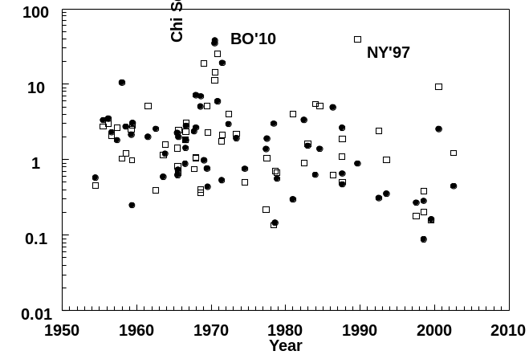
Fig. 5. Chi square error for helium

Solar Modulation Parameter (Ф)

The solar modulation parameter (Ф) is directly associated with solar activity and determines the modulated GCR flux for any given time. Prior versions of the BO'10 model used neutron monitor (Climax) count to determine Ф(t) for periods when actual spacecraft instrument data were not available - such as prior to 1974. However, in this revision, we use the International Sun Spot (ISS) number for all times.
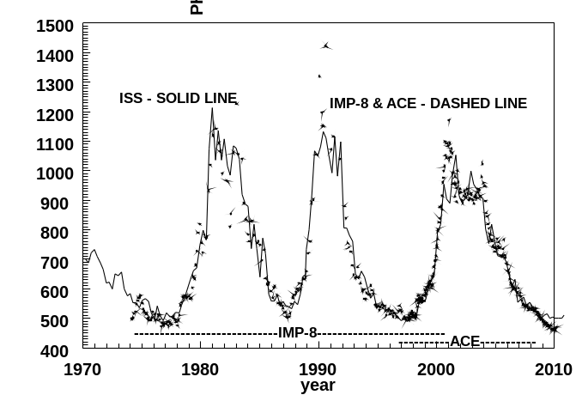

Fig. 6. Solar Modulation Parameter (Ф) as derived from Sunspot Number (ISS) and from actual spacecraft instruments - IMP and ACE.

However, we do not use the ISS# directly. First, we properly account for the time lag using Nymmik' s formulas described below. Then, we calibrated the "time delayed" ISS# by multiplying it by a constant. This calibration produces the excellent agreement with the Ф values derived from IMP-8 & ACE shown in Figure 6.

We downloaded the ISS# from the National Geographic Data Center (NGDC) - NOAA (www.ngdc.noaa.gov/stp/SOLAR/getdata.html).

A. Solar Modulation Parameter (Ф) from ISS# Time Lag
The secret to deriving Ф(t) from the ISS# is Nymmik's [21] formula for accounting for the time delay between the time of the solar activity (the sun spots) and the time this effect (the magnetic field disturbance) reaches into the heliosphere enough to significantly modulate the GCR flux. Nymmik's time delay formula shown in Figure 7 is typical of GCR ion spectra. Nymmik describes the time lag dependence on the rigidity of the ion species and the solar magnetic field polarity. The lag is constant when the magnetic field is steady and undergoes a major change at the onset of solar activity (* in Figure 7). The lag is about 6 months larger for odd solar cycles.
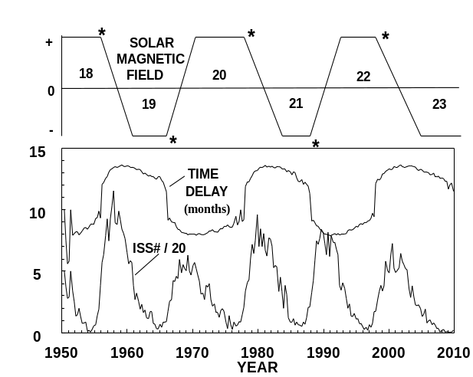
Fig. 7 Time delay (in months) from Nymmik [21] between solar events (sun spots) and their impact on the heliosphere regarding modulation of GCR ions.

A. Steady-state Fokker-Planck Equation
According to Nymmik, the time lag for GCR'S in the heliosphere depends on rigidity – the lag being larger for the lower rigidity ions. On the other hand, the Fokker-Planck equation (used by BO'10) assumes steady-state heliosphere magnetic conditions.

When the Fokker-Planck equation modulates the LIS it transports the entire spectrum - accounting for energy loss. It systematically shifts higher energy ions to lower energies. This partially explains why we are able to use Nymmik’s excellent time lag formulation to determine the solar modulation level. Keep in mind, the Fokker-Planck method actually provides a better fit of the experimental GCR spectra - for all energies.

B. Deepest Solar Minimum
The current solar minimum (Cycle 23) is the quietest time, according to average monthly sun spot numbers since 1912. This is a good opportunity to observe a worst-case GCR spectrum since that should be a maximum about 10 - 15 months after the sunspot minimum.

The monthly average sunspot number from NOAA reached a minimum for Cycle 23 around October 2009. The minimum value of Ф as derived from ACE oxygen data occurred around January 2010 and was ~430 MV. This compares to a value of ~ 500 MV for the Cycle 22 minimum as observed by ACE in 1997. Of interest is the fact that the ACE oxygen flux is ~ 20% higher for the Cycle 23 minimum than that for the Cycle 22 minimum.

Conclusion
The BO’10 and NY'97 models now agree reasonably well for the "early" measurements. This shows that each model is fundamentally sound - since both models use nearly the same measurements.

However, the BO’10 GCR model has the advantage in the "recent" period because Nymmik has not updated the NY'97 model coefficients with the new ACE measurements. NY'97 derived all of its coefficients from the older measurements – NY'97 needs to update its coefficients. The modern data from ACE is the most complete GCR spectra measurement set – all elements from Lithium (z=3) to Nickel (z=28) are given for the 10’s – 100’s MeV/n energy range continuously from 1997 to 2010 which covers a complete solar cycle. The NY'97 model is over an order of magnitude off for the ACE data period. My version of NY'97 does not run past the beginning of 2009.

The BO'10 model now provides a predictive capability (using sunspot number per Nymmik's formula) - this feature is important to some analysts. However, due to calibration with actual flight instrument measurements (IMP-8 and ACE) to determine the solar modulation level, the model produces a more accurate GCR flux data fit.

The radiation health community uses the BO'10 GCR model for astronaut protection. The BO’10 model is integral to the NASA transport code HZETRAN [2 & 22] and we should consider adopting it by the electronic parts community as well.
Appendix
Appendixes, if needed, appear before the acknowledgment.
Acknowledgment
Special thanks to Dr. James H. Adams, Jr. for pointing out the shortcomings of the old BO'04 model and for being my GCR mentor since 1986.

References
- Tylka, A. J. et al., IEEE Trans. on Nucl. Sci., 44, 2150 (1997)
- Cucinotta, F. A. et al., Managing Lunar and Mars Mission Radiation Risks Part I: Cancer Risks, Uncertainties, and Shielding Effectiveness NASA/TP-2005-213164 (July 2005)
- Badhwar, G. D. and P.M. O'Neill, "Galactic Cosmic Radiation Model and Its Applications," Advances in Space Research, 17 No. 2, (1996)
- P. M. O’Neill, “Badhwar – O’Neill Galactic Cosmic Ray Model Update Based on Advanced Composition Explorer (ACE) Energy Spectra from 1997 to Present,” Advances in Space Research, 37, 1727 (2006)
- Sanuki, T. et al., "Precise Measurement of Cosmic-Ray Proton and Helium Spectra with the BESS Spectrometer," Astrophys. J., 545, 1135-1142 (December 2000)
- Engelmann, J.J. et al, "Charge Composition and Energy Spectra of Cosmic-Ray Nuclei for Elements from Be to Ni. Results from HEAO-3-C2, " Astron. Astrophys., 233, 96-111 (1990)
- Adams, James H. Jr., Samuel Heiblim, and Christopher Malott, “Evaluation of Galactic Cosmic Ray Models,” IEEE Nuclear and Space Radiation Effects Conference, Quebec City, Quebec (July 2009)
- Mewaldt, R.A. et al., "Elemental Composition and Energy Spectra of Galactic Cosmic Rays," Proc. From Conference on Interplanetary Particle Environment, JPL Publication 88-28, pp 121-132, JPL, Pasadena, CA, April 15, 1988
- Fermi, E., "On the Origin of the Cosmic Radiation," Phys. Rev., 75, 1169-1174 (1949)
- Sigrid Dengel, Dominik Aeby, and John Grace, "A relationship between galactic cosmic radiation and tree rings," New Phytologist, 184 (3), 545–551, November 2009
- Juliusson, Einar "Charge Composition and Energy Spectra of Cosmic-ray Nuclei at Energies above 20 GeV per Nucleon," Astrophys. J., 191, 331-348 (July 1974)
- Orth, Charles D., et al, "Abundances and Spectra for Cosmic-ray Nuclei from Lithium to Iron for 2 to 150 GeV Per Nucleon," Astrophys. J., 226, 1147-1161 (December 1978)
- Garcia-Munoz, M., et al., "The Anomalous 4He Component in the Cosmic-ray Spectrum at <50 MeV per Nucleon During 1972-1974," Astrophys. J., 202, 265-275 (November 1975)
- Lezniak, J.A. and W.R. Webber, "The Charge Composition and Energy Spectra of Cosmic-ray Nuclei from 3000 MeV per Nucleon to 50 GeV per Nucleon," Astrophys. J., 223, 676-696 (July 1978)
- Chappell, J.H. and W.R. Webber, “High Energy Cosmic ray Charge and Energy Spectra Measurements,” International Cosmic Ray Conference, Paris, France, 2, 59-61 (1981)
- Simon, M., H. Spiegelhauer, and W.K.H. Schmidt, et al., "Energy Spectra of Cosmic-ray Nuclei to Above 100 GeV per Nucleon," Astrophys. J., 239, 712-724 (July 1980)
- Scarlett, W.R., et al., " The Charge and Energy Spectra of Heavy Cosmic-ray Nuclei," Astrophys. and Space Sci., 59, 301-311 (1978)
- Minagawa, Gary, " The abundances and energy Spectra of Cosmic Ray Iron and Nickel at energies from 1 to 10 GeV per amu," Astrophys. J., 248, 847-855 (September 1981)
- Fowler, P.H., et al., "Iron Fluxes from Ariel-6 Workshop ICRC, Dublin, August 1991," Nucl. Tracks Radiat. Meas., 20 No. 3, 423-425 (1992)
- Mewaldt, R.A. et al., "The Cosmic Ray Radiation Dose in Interplanetary Space – Present Day and Worst-Case Evaluations", 29th International Cosmic Ray Conference Pune (2005) 00, 101-104
- Nymmik, R.A., "Time Lag of galactic Cosmic Ray Modulation: Conformity to General Regularities and Influence on Particle Energy Spectra," Adv Space Res, 26, No. 11, 1875-2000 (2000)
- W. Schimmerling , W. and F. A. Cucinotta, "Dose and dose rate effectiveness of space radiation," Radiat Prot Dosimetry, 122 (1-4): 349-353 (December 2006)

 Manuscript received July 15, 2010. P. M. O'Neill is with the National Aeronautics and Space Administration, Johnson Space Center, Avionic Systems Division, Houston, TX 77058 USA ( phone: 281-483-5180; fax: 281-483-8426; e-mail: patrick.m.oneill@.nasa. gov).

