Dakota Benjamin

Biology 315

Week 10 Journal: Project Update #1

**Introduction:**

My project is a spatial analysis of deer browse given distances from defined edges within the Metroparks reservation. For the first week, I explored the deer browse and disturbance data and the basics of spatial data in R. The disturbance data was from the PCAP data, and the deer browse and distance data came from the Metroparks. The distance data is a GIS shape file of the PCAP plots with calculated distances from different edges: distance to nearest edge, distance to developed edge, and distance to nearest trail (sanctioned or bootleg). Edges are comprised of roads, and railroad tracks, APT’s, streams, and use areas.

**Methods:**

First, the deer browse data was ranked on a numerical scale from 0 to 7: 0 where no data was recorded, 1 where deer browse was marked “VL=Very Low”, and 7 where deer browse was marked “VH=Very high.” A histogram (Figure 1) showed that the distribution of deer browse across all plots was skewed to the right. In order to figure out which distance data to use for the analysis, I performed a manual simplification of a MANOVA model. Table 1 displays the results of that analysis, and Figure 2 shows the plots that prove the model assumptions.

The spatial tools used were the packages sp and rgdal. Three simple maps were plotted: the PCAP plots (Figure 3), an outline of the whole Metroparks reservations (Figure 4), and an outline of the Rocky River Reservation (Figure 5).

**Results/Discussion:**

The model used for the two-way ANOVA was “deerbrowse ~ EDGE_DIST + DEV_DIST.” Table 1 shows that the DEV_DIST data has a significant effect on the deer browse (p=0.0494). DEV_DIST is the nearest distance to developed edges such as roads, trails, and use areas. There is still some data being processed by the Metroparks’ staff, but after further analysis, it is likely that these distances will be used for the spatial analysis of the deer browse data. It should be noted, however, that the data is not very normally distributed, as shown in the Normal Q-Q plot in Figure 2. With some manipulation, a more accurate analysis may provide better answers.

From the spatial tools, area of plots can be calculated. However, the distance-to-edge data given is more complex than originally intended. The hypothesis of my project proposal will have to be adjusted now that I have a better idea of the data I am working with. I will have to examine the data more closely in the next lab to tune my hypothesis more.

In the next lab I will try to use the spatial tools in R on the GIS data to see if I can plot the PCAP plots with the edge distances. Additionally, I will do a PCA analysis on effect of the different distances on the deer browse.

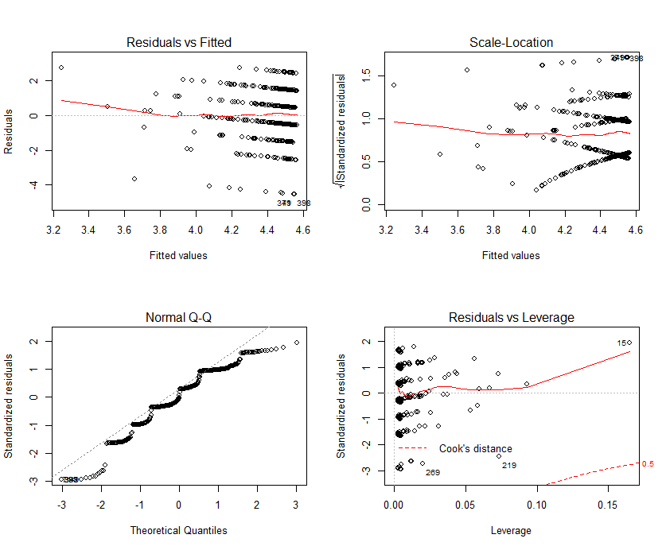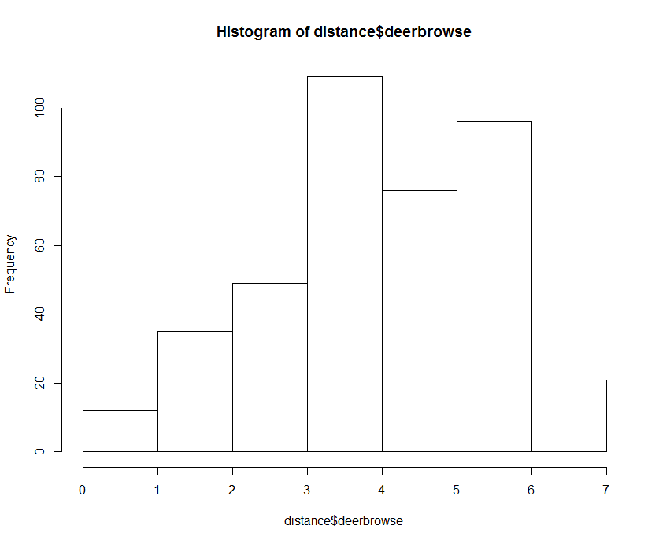

Figure . Histogram of distribution of deer browse Figure . Model Assumptions

|  |  |  |  |  |  |
| --- | --- | --- | --- | --- | --- |
|  | Df | Sum Sq | Mean Sq | F Value | P-value |
| EDGE_DIST | 1 | 3.3 | 3.316 | 1.379 | 0.2410 |
| DEV_DIST | 1 | 9.3 | 9.345 | 3.887 | 0.0494 |
| Residuals | 395 | 949.8 | 2.404 |  |  |

Table . Two-way ANOVA summary results

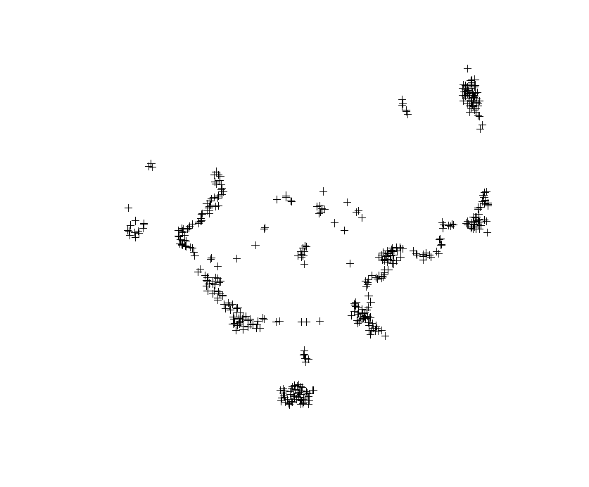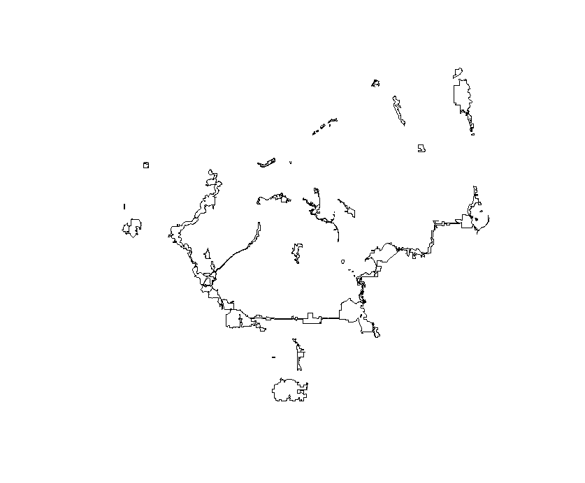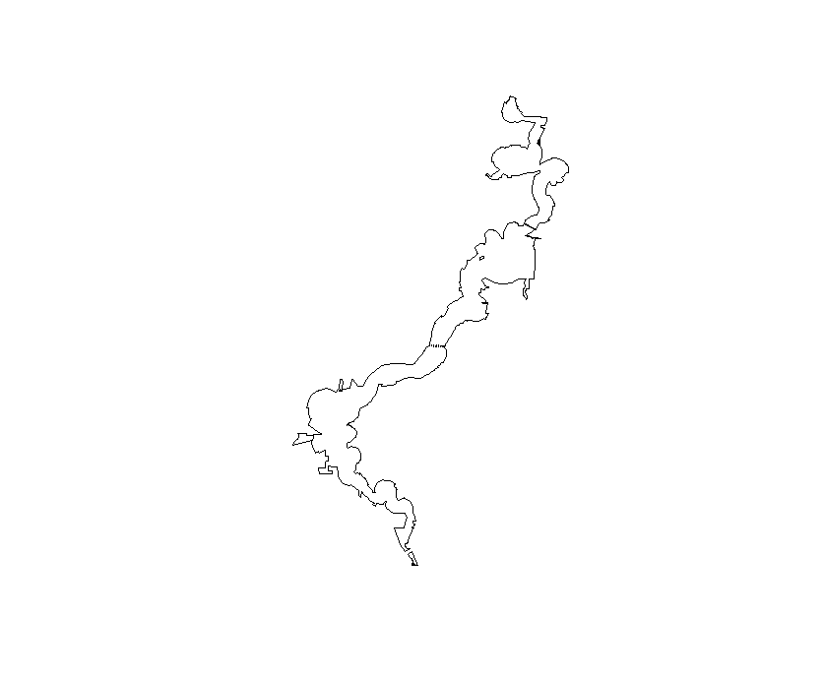

Figure . PCAP Plots in all reservations

Figure . Outline of all reservations

Figure . Outline of Rocky River Reservation