Dakota Benjamin

Biology 315

Week 11 Journal: Project Update #2

**Introduction:**

Controlling the negative effects of deer browse on the vegetative health of the deer in the Cleveland Metroparks reservations is a priority for the organization. Now that the first round of the Plant Community Assessment Program is finished, some preliminary analysis of the deer browse data can shed light on specific areas across the park system and within each park. This project analyzed the effects of deer browse given distances from defined edges within the Metroparks reservation. It is known that deer tend towards edges of forests, so an exploration of the relationship between deer browse and edges should be fruitful.

The disturbance data was from the PCAP data, and the deer browse and distance data came from the Metroparks. The deer browse was ranked from 0 to 7, 0 being “none recorded” and 6 being “very high.” The distance data is a GIS shape file of the PCAP plots with calculated distances from different edges: distance to nearest edge, distance to developed edge, and distance to nearest trail (sanctioned or bootleg). Edges are comprised of roads, and railroad tracks, APT’s, streams, use areas, etc.

**Methods:**

The first analysis was with a linear regression model of deer browse level by distance to the nearest developed edge. Similar analyses will be done with the other distance types. The model used the formula “deerbrowse ~ dev_dist.” The assumptions of the model were that there is equal variance among residuals and that the data was normally distributed.

Results from the first model showed that a more in depth analysis on the deer browse needed to be done. The deer browse and distance data was grouped by reservation to examine the average deer browse in each reservation by the average distance to edge for that particular reservation. It is assumed that reservations with a greater average distance to edge have less edges overall.

An additional spatial analysis was briefly covered. Moran’s I was calculated to see how related all the plots were based on their relative locations to each other in a type of analysis called spatial autocorrelation. (Note: I am unsure if this is useful information for the full analysis. I have no results yet.)

**Results/Conclusion:**

Figure 1 shows the scatter plot from the first linear regression analysis. The linear regression line falls between a deer browse rating of 3 and 4, decreasing slightly. It has has a p-value of 0.14 and an adjusted R2 of 0.003057. Figure 2 shows that the model assumptions are true. Given the small effect and significance, there is not enough evidence to reject the null hypothesis. It is important to note that most of the plots are between 0 and about 500 meters to the nearest developed edge. This would indicate that there is a high number of edges across all the Metroparks reservations.

The second analysis groups the plots by reservation and takes the mean distance to edge and deer browse ratings. The scatter plot of this relationship is shown in Figure 3. In this figure, the average deer browse increases with increasing distance to edge. In figure 4 we see that the assumptions of the model are more or less held up. However, there is not enough evidence to reject the null hypothesis given a p-value of 0.2046 on the linear regression and an R-squared of 0.04885. In this plot we see that the relationship may be more complex than a simple linear regression. The error in the deer browse decreases as the distance to edge increases. This would indicate that there are other factors affecting the response.

Further analyses is needed to discover the reason for the difference in error. A PCA analysis might provide more information. Additionally, it might help to look at each rating and run analyses on those. I don’t know if Moran’s I will give any usefull information, but it will be interesting to see the results of that.

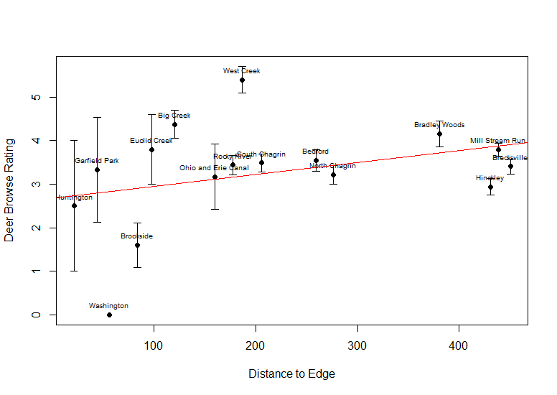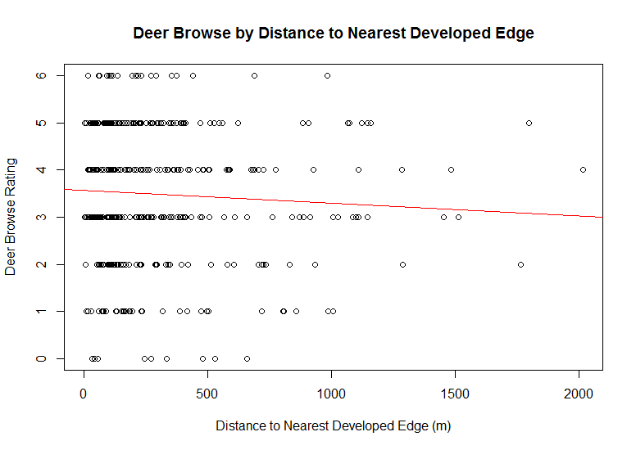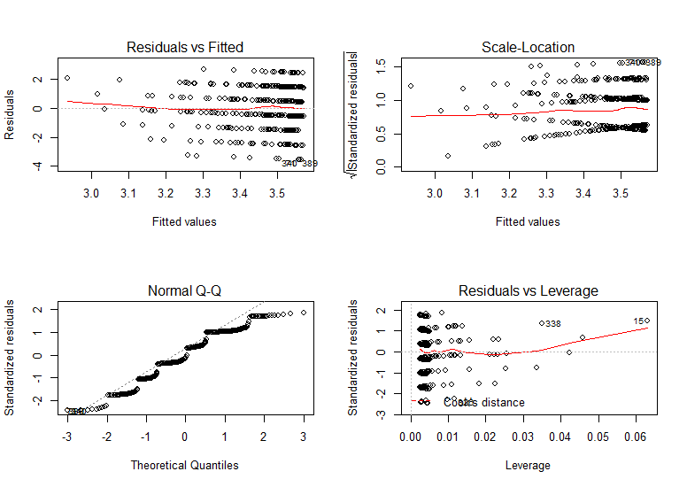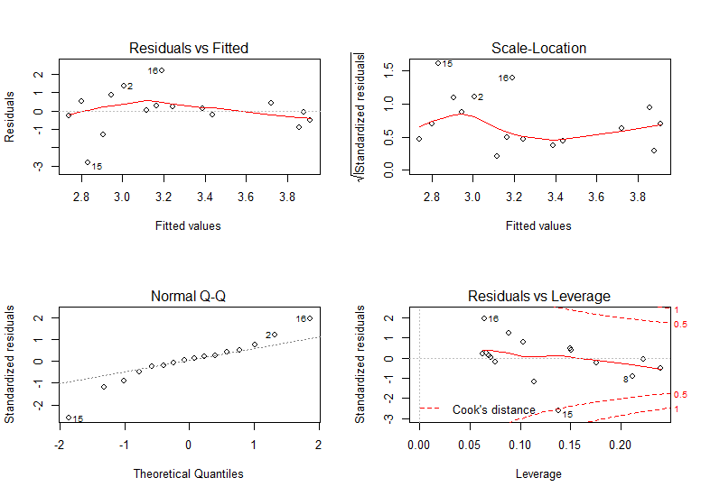

Figure 3. Linear regression of average deer browse by average distance to edge for each reservation

Figure 1. Linear regression of all plots

Figure 2. Model Assumptions

Figure 4. Model Assumptions for Figure 3