Dakota Benjamin

Biology 315

Week 12 Journal: Project Update #2

**Introduction:**

Controlling the negative effects of deer browse on the vegetative health of the deer in the Cleveland Metroparks reservations is a priority for the organization. Now that the first round of the Plant Community Assessment Program is finished, some preliminary analysis of the deer browse data can shed light on specific areas across the park system and within each park. This project analyzed the effects of deer browse given distances from defined edges within the Metroparks reservation. It is known that deer tend towards edges of forests, so an exploration of the relationship between deer browse and edges should be fruitful.

The disturbance data was from the PCAP data, and the deer browse and distance data came from the Metroparks. The deer browse was ranked from 0 to 7, 0 being “none recorded” and 6 being “very high.” The distance data is a GIS shape file of the PCAP plots with calculated distances from different edges: distance to nearest edge, distance to developed edge, and distance to nearest trail (sanctioned or bootleg). Edges are comprised of roads, and railroad tracks, APT’s, streams, use areas, etc.

I hypothesized that there would be a significant negative effect of the distance from edge on the deer browse rankings. That is, the further from an edge that a plot was located, the lower the ranking would be. In addition, reservations with large areas of forest would

**Methods:**

The first analysis was with a linear regression model of deer browse level by distance to the nearest developed edge. Similar analyses will be done with the other distance types. The model used the formula “deerbrowse ~ dev_dist.” The assumptions of the model were that there is equal variance among residuals and that the data was normally distributed.

Results from the first model showed that a more in depth analysis on the deer browse needed to be done. The deer browse and distance data was grouped by reservation to examine the average deer browse in each reservation by the average distance to edge for that particular reservation. It is assumed that reservations with a greater average distance to edge have less edges overall. Only the 7 “major reservations” (as noted in the PCAP summary) were used for the rest of the analysis, as there was insufficient data in the minor reservations.

Each reservation was then analyzed individually using the same approach as the first linear regression. Seven plots and their corresponding linear regression lines were produced.

**Results/Discussion:**

Figure 1 shows the scatter plot from the first linear regression analysis. The linear regression line falls between a deer browse rating of 3 and 4, decreasing slightly. It has has a p-value of 0.14 and an adjusted R2 of 0.003057. Figure 2 shows that the model assumptions are true. Given the small effect and significance, there is not enough evidence to reject the null hypothesis. It is important to note that most of the plots are between 0 and about 500 meters to the nearest developed edge. This would indicate that there is a high number of edges across all the Metroparks reservations.

The second analysis groups the plots by reservation and takes the mean distance to edge and deer browse ratings. The scatter plot of this relationship is shown in Figure 3. In this figure, the average deer browse increases with increasing distance to edge. In figure 4 we see that the assumptions of the model are more or less held up. However, there is not enough evidence to reject the null hypothesis given a p-value of 0.2046 on the linear regression and an R-squared of 0.04885. In this plot we see that the relationship may be more complex than a simple linear regression. The error in the deer browse decreases as the distance to edge increases. This would indicate that there are other factors affecting the response.

In the third analysis, while the overall trend was negative for all plots in the sample, each reservation had varying effect sizes. (Figures 5 and 6) None of the linear regressions showed a significant effect between deer browse and distance to edge. (Table 1) Given the analyses done, there is not enough evidence to show a significant relationship between deer browse and edge distance. There are a few possible explanations for this. There may be confounding factors regarding deer migration and habitation. Also, perhaps the parks are too small to see any considerable effect.

A cursory analysis of the effect of distance to edge on VIBI scores shows a strong correlation between the two variables (Figure 7). Since deer browse data is included in the VIBI scoring, it is possible that the lack of correlation between deer browse and distance to edge is due to confounding factors.

Further questions arise from these results. In order to find priority areas for reducing deer browse, I want to examine the community types within each reservation. I still want to try spatial autocorrelation, but have yet to get it working in R.

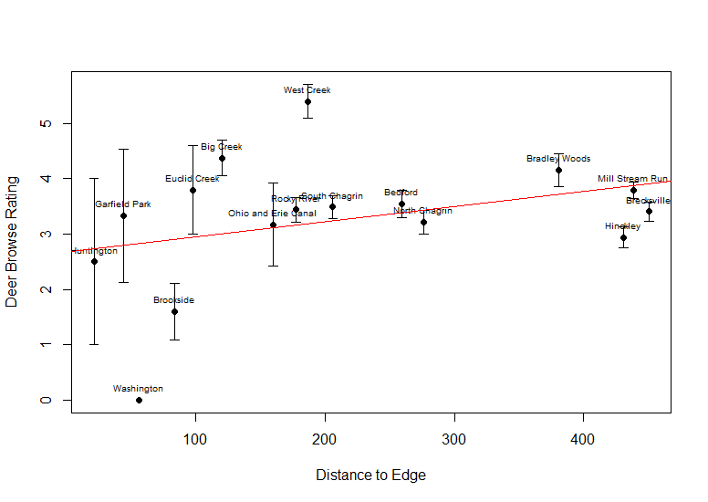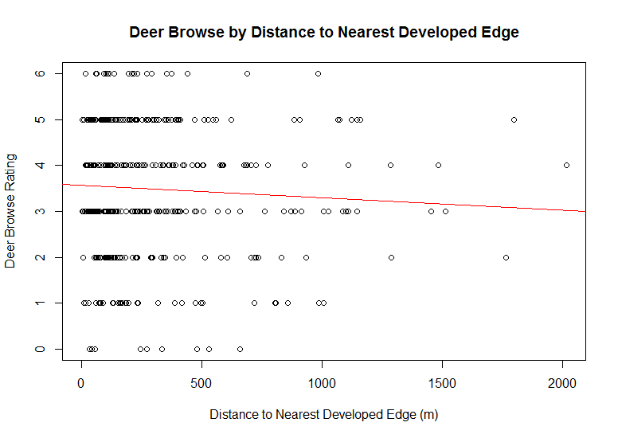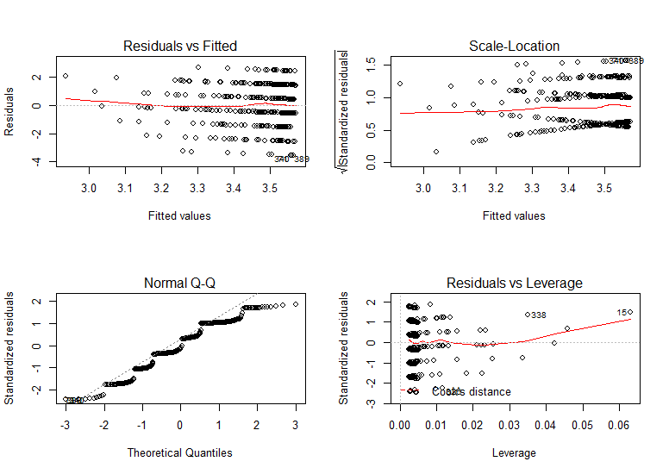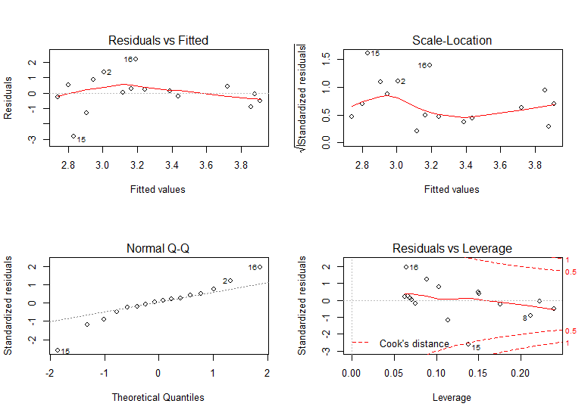

Figure 3. Linear regression of average deer browse by average distance to edge for each reservation

Figure . Linear regression of all plots

Figure . Model Assumptions

Figure 4. Model Assumptions for Figure 3

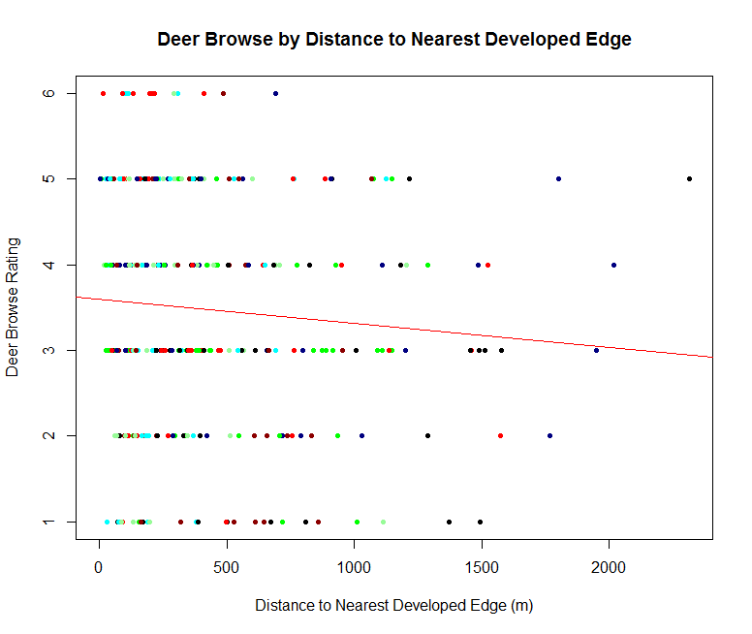Figure

(Other figures are attach because I need to resize them properly. )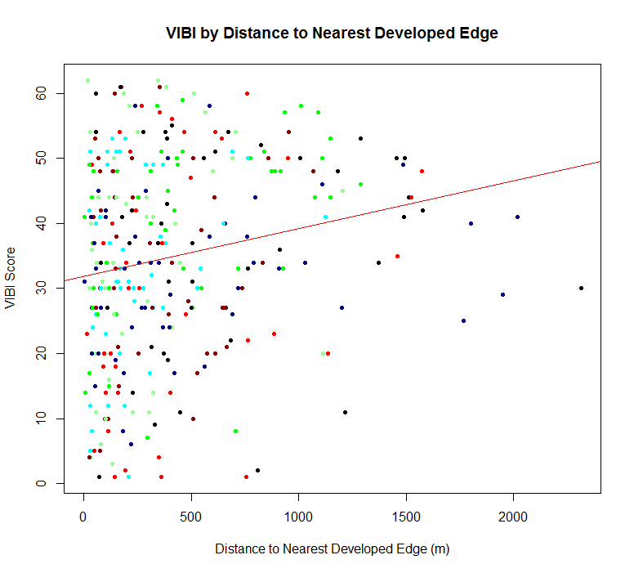

Figure