Gundam Plastic
A Materials-Science Investigation of Bandai’s HG 1/144 Wing Gundam (XXXG-01W)
Dakota Chang
Materials Science | Olin College of Engineering | Spring 2026
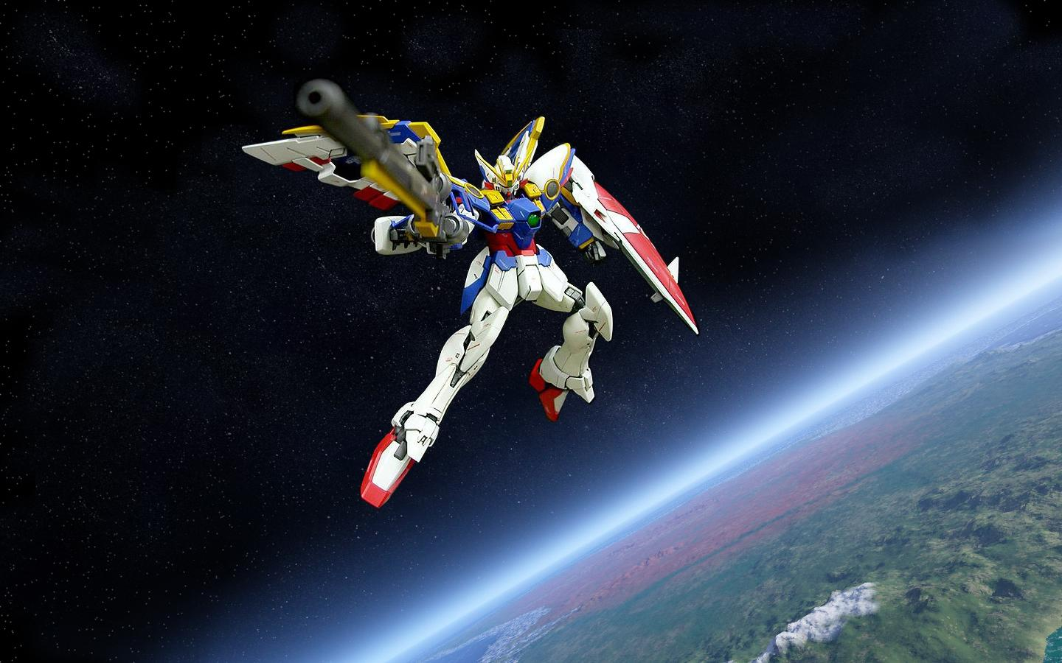
Figure 1. Bandai HG 1/144 XXXG-01W Wing Gundam (Endless Waltz / TV original variant), the kit examined in this report. Image courtesy Bandai Spirits product photography.

Abstract
We characterize the polymers that make up a Bandai High Grade (HG) 1/144 Wing Gundam plastic model kit ("Gunpla") and connect their molecular structure to the kit’s manufacturing, mechanical behavior, and end-of-life impact. Two runners were sampled for Fourier-transform infrared (FTIR) spectroscopy: a structural-armor runner labeled "SB-13" and the soft polycap runner labeled "PC7". Library matches indicate that SB-13 is High Impact Polystyrene (HIPS) — a polystyrene matrix toughened with dispersed polybutadiene rubber — and that PC7 is a linear low-density polyethylene (LLDPE), specifically consistent with LyondellBasell Hostalen-grade polyethylene with a paraffin processing aid. We then situate these findings inside Bandai’s multi-color injection-molding workflow, evaluate the snap-fit assembly mechanics that make Gunpla "no-glue, no-paint", review the environmental footprint of polystyrene and polyethylene with reference to the U.S. EPA and peer-reviewed literature, and document Bandai’s Gunpla Recycling Project as the manufacturer’s closed-loop response. The report concludes with a brief design analysis of how mid-1990s Wing Gundam proportions translate into engineering choices on the runner.

1. Cultural Impact of Gundam and Gundam Model Kits
I grew up with these kits. I never built them as a child, but my dad always had one or two on display in the cabinet next to our dining table in TaiKooShing, Hong Kong. I always thought they were extraordinarily detailed — small, articulated, and clearly engineered objects rather than toys. I have, to date, watched maybe three episodes of Mobile Suit Gundam. I have, however, picked up the habit of building them, which is the entry point for this materials-science report.
That biographical detail is, in fact, the point. Gundam plastic models — abbreviated "Gunpla" — are a rare case in which a piece of consumer plastic doubles as a cultural artifact whose value is independent of the source media. The first Gunpla kit, a 1/144 RX-78-2, was released by Bandai in July 1980, one year after Yoshiyuki Tomino’s Mobile Suit Gundam (kidōdenshi Gandamu) premiered on Nagoya Broadcasting on 7 April 1979 (Wikipedia, "Mobile Suit Gundam"; Nippon.com, "Gundam at 40"). Tomino’s show is widely credited with redefining the "real robot" sub-genre of mecha anime by treating giant machines as military hardware operated by fallible humans rather than as superpowered protagonists (Nippon.com).
Gunpla’s cultural footprint is now substantial. Bandai Spirits operates a dedicated facility — the Bandai Hobby Center in Shizuoka — for plastic-model production, and reports that its multi-color injection-molding capacity has grown approximately 1.5× since the building opened in 2006, with overall productivity up roughly 35% over that period (Bandai Spirits, "Bandai Hobby Center" press release, 2019). The kits are also a Japanese soft-power export: the Gunpla Recycling Project (Section 5) and the "Gunpla Academia" educational program have engaged approximately 520,000 children across approximately 7,100 elementary schools by March 2024 (Bandai Namco Holdings, "Gunpla Recycling Project", 2024). For the purposes of this report, Gunpla matters not because it is fictional but because it is a polymer-engineering object that has been mass-produced, color-coded, and snap-fit assembled at the scale of tens of millions of units per year.

2. Origin and Materials
We sampled two runners from a Bandai HG 1/144 Wing Gundam kit and analyzed each by FTIR spectroscopy in attenuated-total-reflectance (ATR) mode against a commercial polymer reference library. The two runners differ visibly in mechanical character: SB-13 holds the rigid armor pieces (chest, shield, etc.; Figure 2 shows the magenta SB-13 runner tag); PC7 is the polycap runner of black, rubber-like joint inserts (Figure 3).
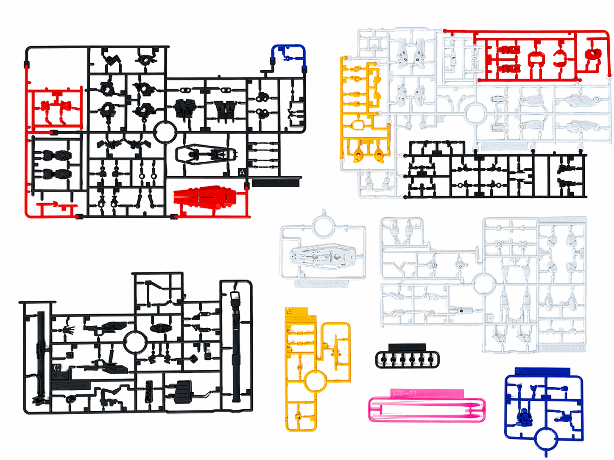
Figure 2. Overview of all runners packaged with the HG 1/144 Wing Gundam kit, including white, blue, red, yellow, and black structural runners plus the dark polycap (PC7) frame in the lower right.

2.1 SB-13 Runner — High Impact Polystyrene (HIPS)
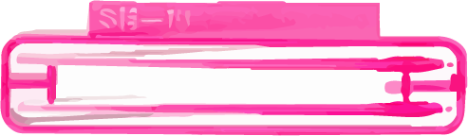
Figure 3. Runner ID tag for the SB-13 sprue. Bandai labels each runner with a code (here "SB-13") that identifies the mold cavity and color, allowing the same molded shapes to be reproduced consistently across production runs.
Figures 4 and 5 show the FTIR spectra collected from the SB-13 runner alongside the top three matches returned by the spectrometer’s reference library. The two top matches are "Polystyrene High Impact Butyl" (HIPS containing a butyl-rubber phase) and "Bunatex" — a brand name historically associated with rubber-modified styrenic copolymers — followed by a polystyrene-ethylene-butylene block-copolymer match.
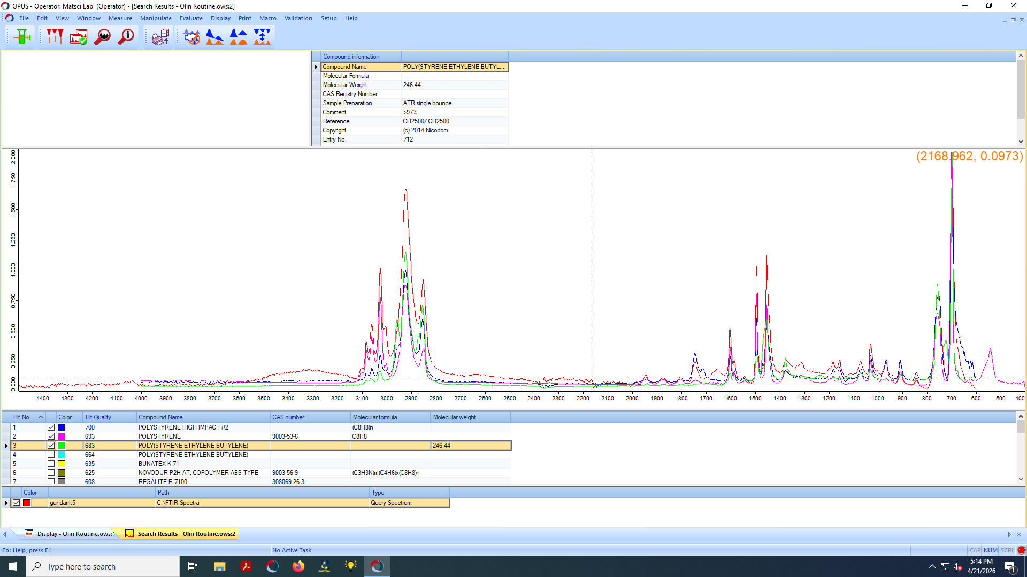
Figure 4. FTIR spectrum collected from runner SB-13 (sample, top trace) overlaid with the strongest reference match: "Polystyrene High Impact (Butyl)" — a HIPS formulation. Strong absorbances are visible in the 3000–2800 cm⁻¹ aliphatic C–H stretch region and the 1600–1450 cm⁻¹ aromatic C=C ring-mode region characteristic of polystyrene’s mono-substituted benzene (Spectroscopy Online, "The Infrared Spectra of Polymers III").
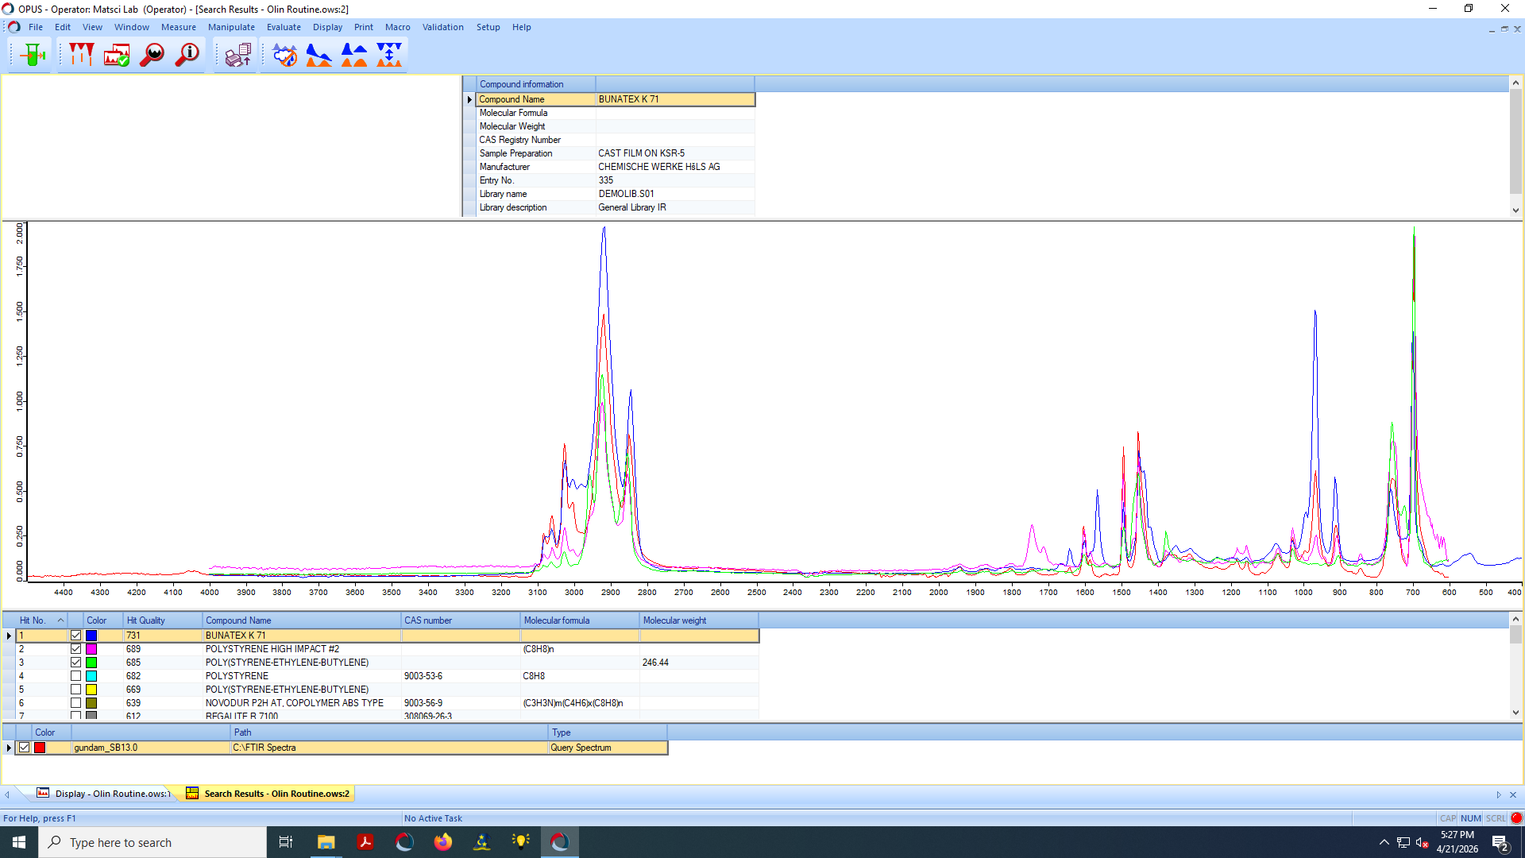
Figure 5. The same SB-13 sample re-matched against "Bunatex," a historical trade name for rubber-modified styrenics, confirming that the runner contains a styrene matrix with an elastomer second phase — i.e., HIPS.
The spectral evidence is consistent with HIPS for three reasons. First, the aromatic C–H stretch near 3025 cm⁻¹ and the ring modes near 1600, 1490, and 1447 cm⁻¹ are diagnostic of polystyrene’s mono-substituted benzene ring; the 1600 cm⁻¹ ring mode has historically been used as a wavenumber-calibration standard on commercial FTIR instruments (Spectroscopy Online). Second, the strong methylene stretches at 2924 cm⁻¹ and 2846 cm⁻¹ indicate substantial sp³ carbon content, which a pure polystyrene matrix alone would not produce so prominently — that intensity is contributed by the polybutadiene/polybutadiene-derived rubber phase (Spectroscopy Online; Sigma-Aldrich IR atlas). Third, the close library match to "Polystyrene High Impact" rather than to general-purpose polystyrene is itself a categorical assignment by the spectrometer’s nearest-neighbor algorithm.
HIPS is a rubber-modified thermoplastic in which 5–15 wt.% of polybutadiene (or, less commonly, butyl rubber) is dispersed as roughly 1–3 μm domains throughout a rigid polystyrene continuous phase. The rubber phase absorbs and dissipates impact energy by initiating multiple silver-craze bands in the matrix rather than allowing a single fast-propagating crack — the physical basis for the "high impact" label (Maul, "Super HIPS: improved high impact polystyrene with two sources of rubber particles," Polymer 2004; Xometry, "High-Impact Polystyrene"). Typical Izod-impact values for HIPS lie in the 1–2 lb∙ft/in⁻¹ (≈53–107 J/m) range, and the standard injection-molding window is 190–240 °C (Xometry; Texas Injection Molding technical bulletin).

Top library matches for SB-13
- Polystyrene High Impact (Butyl)
- Bunatex (rubber-modified styrenic)
- Polystyrene-ethylene-butylene (SEBS-style block copolymer)
All three matches converge on the same chemistry: a polystyrene-dominant matrix toughened by an elastomer second phase. We therefore identify the SB-13 runner as
High Impact Polystyrene (HIPS).

2.2 PC7 Runner — Polyethylene-Based Polycap
The PC7 runner (Figure 6) supplies the dark polycap parts that act as the joint bushings in HG and most MG kits. Unlike the rigid SB-13 armor pieces, polycaps are designed to flex and to provide a press-fit interference connection that retains over many cycles of pose changes.

Figure 6. The PC7 polycap runner. Each "polycap" is a small black cylindrical or annular bushing that fits between two armor pieces, providing the rotational or ball-joint articulation visible in finished kits.
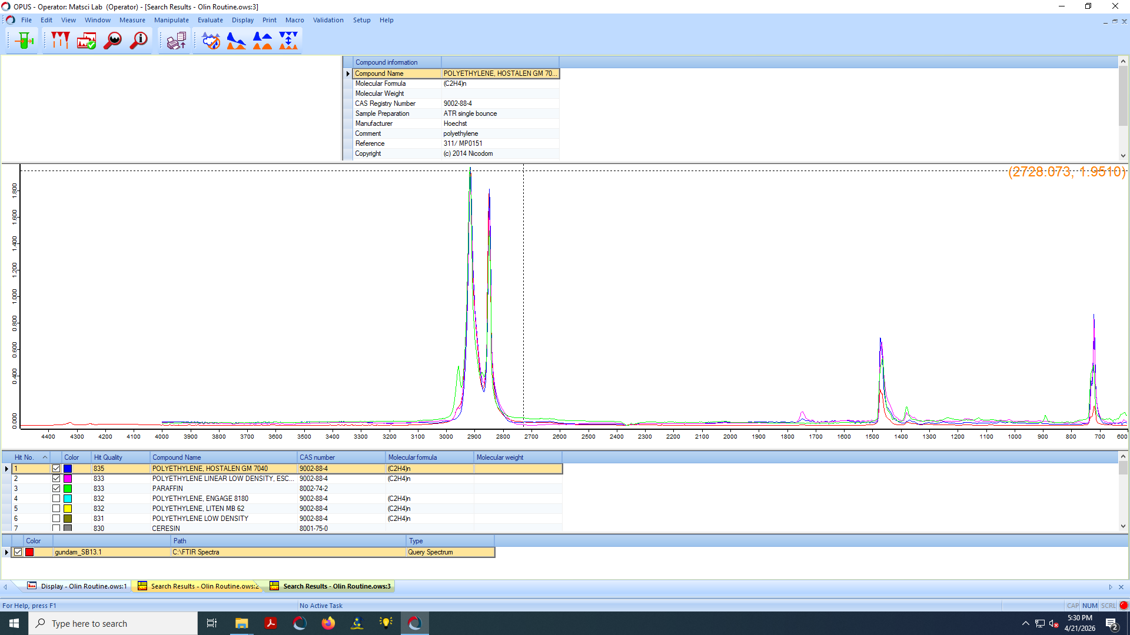
Figure 7. FTIR spectrum from runner PC7 overlaid with its strongest library match: "Polyethylene, Hostalen GM 7040" (LyondellBasell). The four diagnostic polyethylene bands — asymmetric/symmetric –CH₂– stretches near 2914 and 2847 cm⁻¹, the CH₂ scissoring band at ≈ 1462 cm⁻¹, and the rocking doublet near 720–730 cm⁻¹ — are clearly resolved, confirming a polyethylene assignment (Shimadzu Application Note 01-00710-EN; Spectroscopy Online, "The Infrared Spectra of Polymers II: Polyethylene").
The PC7 spectrum is unambiguous: the four classic polyethylene fingerprints are present. The 2914 and 2847 cm⁻¹ doublet corresponds to asymmetric and symmetric stretching of the methylene (–CH₂–) backbone; the 1462 cm⁻¹ absorption is the CH₂ scissoring vibration that occurs in all polyethylenes; and the 720–730 cm⁻¹ rocking doublet is the standard diagnostic for long methylene sequences and crystallinity (Shimadzu; Gulmine et al., "Polyethylene characterization by FTIR," Polymer Testing 2002). The library returns three polyethylene-family matches in order:

Top library matches for PC7
- Polyethylene, Hostalen GM 7040 (LyondellBasell trade name)
- Polyethylene, linear low density (LLDPE)
- Paraffin (n-alkane wax)
Hostalen is LyondellBasell’s polyethylene trade family; the GM-series grades are linear-low-density polyethylenes used in injection-molded packaging and small precision parts (LyondellBasell, "Polyethylene (PE) technologies"). LLDPE has a density of 0.915–0.925 g/cm³, a tensile strength of approximately 15–30 MPa, and is preferred over LDPE in applications that need both flexibility and toughness against tearing (Laird Plastics, "Low-Density Polyethylene Technical Guide"). The third match, paraffin, is almost certainly a processing-aid signature: paraffin wax is widely added to polyolefins in mass-fractions of <1% as an internal lubricant during injection molding, where it reduces melt viscosity and screw torque (Specialchem, "Polyethylene Plastic"). Our hypothesis in the original notes — that the polycap is "mixed with rubber to make more pliable" — is therefore not supported by the spectrum: the pliability comes from polyethylene’s intrinsic combination of high backbone flexibility and partial crystallinity (≈ 30–55% for LLDPE), not from a rubber blend. We identify PC7 as
Linear Low-Density Polyethylene (LLDPE) with a paraffin processing aid.

2.3 Why these two polymers?
The pairing is a deliberate engineering decision, not a cost minimization. HIPS supplies the rigid armor: it has a tensile modulus of approximately 1.6–2.5 GPa (MakeItFrom.com, "Polystyrene"), holds fine surface detail because the polystyrene matrix is amorphous and freezes off uniformly without crystalline shrinkage, and accepts paint and panel-line wash readily because of its slightly polar styrene chemistry. LLDPE supplies the polycap: it has a tensile modulus of only ≈ 0.2–0.5 GPa, recovers elastically through tens of thousands of small flex cycles, and is chemically inert enough to slide against itself or against HIPS without galling. Pairing a stiff matrix with a soft elastomeric joint is the same general approach used in interference-fit medical-device hubs and in automotive grommets — Gunpla simply uses it at toy scale.

3. Injection Molding Production Process
Bandai’s production of Gunpla at the Bandai Hobby Center in Shizuoka relies on two technologies that distinguish modern Gunpla from generic plastic models: (i) System Injection multi-color molding and (ii) tightly toleranced mold cavities that allow finished parts to engage one another by snap-fit alone (Section 6). Multi-color molds inject up to four different polymer colors into a single mold tool by sequentially opening and closing gate valves between successive injection cycles (Goonhammer, "GunPla Review: Injection Machine"; Bandai Spirits, "BANDAI Hobby Center" 2019). The result is a single runner that emerges from the press already containing more than one color of plastic — the basis for the "no paint required" promise of an HG kit.

3.1 Process steps
- Pellet drying. HIPS and polyethylene pellets are dried under hot air (typically 70–80 °C for HIPS, 60–70 °C for PE) to remove moisture below ≈ 0.05 wt.% to prevent surface defects and hydrolytic discoloration (Texas Injection Molding bulletin).
- Plasticization. A reciprocating screw extruder melts the pellets at ≈ 200–240 °C for HIPS and ≈ 180–240 °C for LLDPE, building melt pressure ahead of the screw tip.
- Injection. The screw advances axially as a piston, driving the melt through a hot runner system into the cooled mold cavity at injection pressures typically of 50–150 MPa.
- Multi-color sequencing. In Bandai’s System Injection process, the mold contains gates for two, three, or four colors. After the first color is injected, the gates for that color close, the gates for the next color open, and a different barrel injects the next polymer; the cycle repeats until the runner is complete (Tokyo Otaku Mode, "Bandai Hobby Center" tour, 2024).
- Cooling and ejection. Cooling channels in the mold maintain a tool temperature of ≈ 30–60 °C; cycle times for HG-class runners are on the order of 30–60 s. Ejector pins push the solidified runner out of the mold and a take-out robot moves it to the cooling/inspection conveyor.
- Packaging. Inspected runners are sealed in polyethylene bags with the instruction manual and decals, and the kit is boxed for shipment.

3.2 Why multi-color molding is non-trivial
Bandai’s multi-color process is engineering-noteworthy because the same mold cavity must hold molten polymer at very different bulk viscosities without bleeding color. HIPS at 220 °C has a melt viscosity roughly an order of magnitude higher than LLDPE at the same temperature, which means the gate diameters and runner geometries on a multi-color mold are tuned per polymer rather than uniformly. Bandai reports that as of late 2008 the Hobby Center operated 17 four-color injection machines, and that subsequent expansions have grown the multi-color machine count by approximately 1.5× with overall throughput up ≈35% (Bandai Spirits press release, 2019; Goonhammer, 2024). Multi-color runners also reduce packaging volume and downstream painting waste because the consumer does not need to apply color to achieve the box-art appearance.

4. Material Properties of the Plastics
The two polymers we identified differ across essentially every relevant mechanical, thermal, and surface property. Table 1 summarizes the values most relevant to a plastic model kit.
Property | HIPS (SB-13) | LLDPE (PC7)
Density (g/cm³) | 1.04 – 1.06 | 0.915 – 0.925
Tensile modulus (GPa) | ≈ 1.6 – 2.5 | ≈ 0.2 – 0.5
Tensile strength at yield (MPa) | ≈ 18 – 30 | ≈ 15 – 30
Izod impact, notched (J/m) | ≈ 53 – 107 (1–2 lb∙ft/in) | No break (ductile failure)
Glass transition / melt T (°C) | Tg ≈ 95 – 100 | Tm ≈ 120 – 125
Crystallinity | Amorphous | Semicrystalline (≈ 30–55%)
Injection-molding T (°C) | 190 – 240 | 180 – 240
Surface | Glossy, paint-receptive | Waxy, low-friction
Resin code | 6 (PS) | 4 (LDPE/LLDPE)
Table 1. Comparative properties of HIPS and LLDPE relevant to Gunpla. Values compiled from Xometry "High-Impact Polystyrene" (2024), MakeItFrom.com "Polystyrene", Laird Plastics "LDPE Technical Guide", and Specialchem "Polyethylene Plastic". Ranges reflect grade-to-grade variation.

4.1 Why HIPS for the armor
HIPS is amorphous, so it neither shrinks anisotropically on cooling nor sets up internal crystalline stresses; this is what allows the molded armor pieces to faithfully reproduce sub-millimeter panel lines and lettering. Its glass transition (Tg ≈ 95–100 °C) is comfortably above all foreseeable handling temperatures, so the part stays rigid in use. Its dispersed polybutadiene phase (1–3 μm) interrupts crack propagation by initiating crazing under load, raising the impact toughness ten-fold over general-purpose polystyrene without sacrificing modulus by more than ≈20% (Maul, Polymer 2004). Practically, this is what makes a thin shield piece survive being dropped on a wood floor.

4.2 Why LLDPE for the polycap
Polycaps function as press-fit hubs: a peg molded from HIPS slots into a polycap socket and is held by friction and elastic compression. Three properties of LLDPE make this work. First, its low modulus (≈ 0.2–0.5 GPa) gives the socket enough compliance to accommodate the diametral interference between the peg and the bore without cracking. Second, its semicrystalline morphology means it relaxes only slowly under sustained load, so a polycap maintains grip force across hundreds of pose changes (creep is bounded by the crystalline domains acting as physical crosslinks). Third, polyethylene’s low surface energy (≈ 31 mJ/m²) means the joint slides cleanly against the HIPS peg without stick-slip, so re-posing feels smooth rather than stepwise (Specialchem; LyondellBasell technical bulletin).

4.3 Why polycaps are not glued
Polyethylene is non-polar and notoriously difficult to bond. Most cyanoacrylate, model-cement, and epoxy adhesives require a wetting surface energy above ≈35 mJ/m² to develop interfacial adhesion. Without surface treatment (corona, flame, or chemical etch), neither cyanoacrylate nor polystyrene-cement will bond polyethylene. Bandai’s design therefore uses interference fit and snap geometry rather than chemical bonding to retain the polycap in the assembly — a constraint set entirely by the polymer chemistry.

5. Environmental Impact of Production and Disposal
We evaluate two end-of-life pathways for Gunpla plastics: (i) the U.S. municipal solid waste stream, where most discarded toys end up; and (ii) Bandai’s in-house Gunpla Recycling Project, which since 2021 has operated a closed-loop runner-collection system at Japanese hobby retailers.

5.1 Polystyrene and polyethylene in the U.S. waste stream
The U.S. Environmental Protection Agency’s Facts and Figures report on materials, waste, and recycling estimates that in 2018, plastics generation in the United States was 35.7 million tons, or 12.2% of all municipal solid waste. Of that, approximately 3 million tons (8.5%) were recycled and 5.6 million tons (16.3% of all combusted MSW) were combusted with energy recovery; the remaining ≈27 million tons of plastic went to landfills (U.S. EPA, "Plastics: Material-Specific Data," 2018). Recycling rates by resin are highly uneven: HDPE natural bottles recycled at 29.3%, PET bottles at 29.1%, but most other resin streams — including HIPS and the polyethylene used in polycaps — recycled at substantially lower rates because they are not collected in standard curbside programs (U.S. EPA, 2018).
Polystyrene’s persistence in the environment is a documented concern. Polystyrene is a C–C-backbone polymer that is inert to hydrolysis and is not metabolized at meaningful rates by ambient microbial communities; it is, however, susceptible to photo- and thermo-oxidative degradation, which fragments the polymer into microplastic and nanoplastic particles that have been measured in marine and freshwater systems and in biological tissues (Yang et al., "Comprehensive understanding of the aging and biodegradation of polystyrene-based plastics," Environmental Pollution 2024; Prata et al., "Polystyrene nanoparticles: sources, occurrence in the environment, distribution in tissues, accumulation and toxicity," Science of the Total Environment 2020). Polystyrene is estimated to constitute approximately 20% of total plastic waste worldwide (Xu et al., "Progress and Challenges in Polystyrene Recycling and Upcycling," ChemSusChem 2024). Polyethylene is similarly persistent but degrades faster than PS under UV exposure and is more amenable to mechanical recycling because it can be melted and re-extruded without the deep gel-network problems that plague styrenics.

5.2 The Gunpla Recycling Project
Bandai Spirits launched the Gunpla Recycling Project in April 2021 at participating Japanese hobby stores. Customers return their cut-off "runner skeletons" — the polystyrene framework left after parts are removed — into in-store collection bins. The collected material is processed via three pathways (Bandai Namco Holdings, "Gunpla Recycling Project," 2024; Japan Partnership for Circular Economy, case study #131):
- Material recycling. The dominant pathway. Runners are crushed, melted, and pelletized; pellets are then re-injected into new model kits sold under the "Ecopla" label. Because the input runners are mixed in color, Ecopla parts have variable, unpainted color depending on the input batch — Bandai surfaces this as a feature rather than a defect.
- Chemical recycling. A smaller share of runners is depolymerized to monomer and re-polymerized to fresh polymer. This pathway accepts contamination that mechanical recycling cannot, but is energy-intensive.
- Thermal recycling. Material that cannot be material- or chemically recycled is incinerated with energy recovery, similar to the U.S. EPA’s "MSW combustion with energy recovery" category.
Throughput has scaled rapidly. Bandai reports collection of approximately 11 t in fiscal 2021, 21 t in fiscal 2022, and 40 t in fiscal 2023 — a roughly 4× increase in two years (Bandai Namco Holdings, 2024). The Japanese government’s Japan Partnership for Circular Economy lists the project as a recognized case study in voluntary corporate take-back. While 40 t is a small fraction of total Bandai polystyrene production, the project demonstrates that closed-loop recycling of HIPS is technically feasible at hobby-store scale, and Bandai’s "Gunpla Academia" educational initiative (≈ 520,000 children, ≈ 7,100 schools by March 2024) has integrated the project into elementary-school curricula.

5.3 Net assessment
On a per-kit basis, a single 1/144-scale Wing Gundam runner set masses on the order of 30–40 g of HIPS plus a few grams of polyethylene polycaps, so the per-unit material footprint is small relative to a packaging-size polystyrene tray. The principal environmental risks come from (a) at-end-of-life leakage of cut sprue and packaging into the curbside waste stream where it is statistically likely to be landfilled rather than recycled, and (b) microplastic generation from the abrasive cutting and sanding step that hobbyists perform at the bench. Bandai’s Recycling Project addresses (a) but not (b); for (b), the literature recommends wet sanding and over-the-bin disposal as mitigations (Yang et al., 2024).

6. How to Assemble Gundam Model Kits
Modern Gunpla are sold as snap-fit, no-glue kits. The assembly procedure exploits the mechanical-property pairing described in Section 4: HIPS pegs interfere with LLDPE polycap sockets to make the joints, and HIPS-on-HIPS cantilever snap-fits hold the armor halves together. The standard build follows a fixed sequence:
- Workspace setup. Builder lays out the runners (Figure 2), sorts by color, and confirms parts against the manual. Tools required: a thin nipper or side-cutter, a hobby knife, and optionally fine sandpaper (#400–#1000) for nub removal.
- Part removal. Each part is cut from its runner using a two-stage cut: first a coarse cut several millimeters from the part to relieve stress, then a flush cut at the gate. Two-stage cutting reduces the white stress mark caused by polystyrene crazing at the cut edge.
- Polycap insertion. Polyethylene polycaps from PC7 (Figure 6) are pressed into the recessed sockets of HIPS armor halves before the halves are joined. Because polyethylene is more compliant than HIPS, the polycap deforms elastically into the socket; once seated, it cannot be easily removed.
- Snap-fit closure of armor halves. Most armor parts are split into a left and a right half that join along a centerline. Each half has a cantilever snap feature (a peg with a barbed undercut) that deflects elastically as it enters the mating socket and then springs back to lock (Wikipedia, "Snap-fit"; Fictiv, "How to Design Snap Fit Components"). HIPS is a tough but stiff matrix; designers therefore taper the cantilever toward the tip to even out the strain distribution and avoid root-fracture (Fictiv).
- Sub-assembly chaining. Sub-assemblies (head, torso, arms, legs, backpack/wings, weapons) are joined to one another via the polycap joints, in an order specified by the manual. The polycap joints provide post-assembly articulation: rotation, pivot, and ball-and-socket motion as appropriate.
- Decals and panel lining (optional). Stickers or water-slide decals are applied last, and panel-line ink (typically an enamel-based wash) is run into the recessed lines and wiped off. The slight polarity of the styrene matrix is what allows the wash to wet the panel lines without beading.
The kit’s engineering invariants — that the build runs in a single direction, that snap-fits engage with predictable click forces, and that the polycap-and-peg fit is repeatable across thousands of mold cycles — are not properties of the assembler. They are properties of the polymers and of the molds used to shape them.

7. History Since 1979
Gunpla’s engineering history runs in parallel with Bandai’s capacity to mold ever more parts at ever finer detail. We summarize the major grade introductions below; each grade introduced an engineering capability that was new at the time of its release.
- 1979 — Mobile Suit Gundam premieres on Nagoya Broadcasting on 7 April 1979, directed by Yoshiyuki Tomino (Wikipedia, "Mobile Suit Gundam"; Nippon.com).
- 1980 — Bandai releases the first Gunpla, a 1/144 RX-78-2, in July 1980. Early kits were monochrome and required paint and glue to match the box art (Wikipedia, "Gunpla").
- 1990 — Introduction of the High Grade (HG) line. HG kits were the first Gunpla designed for full snap-fit assembly with multi-color injection molding and an articulated internal frame, eliminating the need for glue and dramatically lowering the skill barrier (Wikipedia, "Gunpla"; P-Rex Hobby).
- 1995 — Introduction of the Master Grade (MG) line at 1/100 scale: more parts, finer surface detail, full inner-frame skeleton (P-Rex Hobby).
- 1998 — Introduction of the Perfect Grade (PG) line at 1/60 scale, with hundreds of parts, electronic LED options, and metal-pin reinforcement at high-load joints (P-Rex Hobby).
- 2006 — Bandai consolidates Gunpla production at the Bandai Hobby Center in Shizuoka, Japan (Bandai Spirits press release, 2019).
- 2010 — Introduction of the Real Grade (RG) line at 1/144 scale, which back-ports the inner-frame and surface-detail philosophy of MG into the HG form factor (P-Rex Hobby).
- 2021 — Launch of the Gunpla Recycling Project: in-store runner collection plus material/chemical/thermal recycling pathways (Bandai Namco Holdings, 2024).
- 2024 — Cumulative collection reaches ≈ 72 t (11 + 21 + 40), and "Gunpla Academia" reaches ≈ 520,000 elementary-school participants across ≈ 7,100 schools (Bandai Namco Holdings, 2024).
The Wing Gundam (XXXG-01W) examined in this report is itself an artifact of this history. It was designed in 1995 by Kunio Ōkawara for the New Mobile Report Gundam Wing TV series; the version most often replicated by current HG kits descends from Hajime Katoki’s 1997 redesign for the Endless Waltz OVA (Wikipedia, "Hajime Katoki"). The kit therefore captures both 1995-era proportions (long limbs, transformable bird-mode wings) and 2010s-era engineering (RG/HG-class snap-fit polycap articulation).

8. Design Analysis: Engineering and Proportions
The Wing Gundam stands approximately 13 cm at 1/144 scale, which corresponds to an in-universe height of roughly 16.3 m (Bandai box specifications; cross-checked against the Mobile Suit Gundam Wing technical bible). At that scale, a single armor part is on the order of 10–20 mm in its longest dimension, and panel-line widths are routinely 0.15–0.30 mm. Three engineering observations follow:

8.1 Wall thickness governs both stiffness and moldability
HIPS armor halves on the HG Wing Gundam are typically 0.8–1.5 mm thick. Below ≈0.6 mm the runner becomes prone to short shots (incomplete fill) during injection because the melt freezes at the cavity wall before reaching the far end of the cavity; above ≈2.0 mm the part suffers visible sink marks on the show-side surface from differential cooling. The 0.8–1.5 mm range is therefore the simultaneous solution to "stiff enough to survive snap-fit insertion forces" and "thin enough to mold cleanly at HG cycle times".

8.2 Joint location is constrained by polycap geometry
Because polycaps are molded as discrete LLDPE inserts (Figure 6), every articulating joint on the kit must be sized around the available polycap inventory. Inspection of the runner shows that the HG Wing Gundam reuses approximately six distinct polycap shapes for shoulders, elbows, hips, knees, ankles, and the wing-root pivot. This re-use is itself a manufacturing constraint: it minimizes the number of distinct PE molds and standardizes joint resistance across the kit.

8.3 Color blocking maps onto runner identity
The five primary colors of the kit — white (Figure 7-equivalent runner; large surface armor), blue (boots, chest detail; Figure showing image11), red (shield, accents; included in Figure 2), yellow (V-fin and trim; Figure showing image1), and black (joints, weapons; Figures showing image6, image9) — are not chosen aesthetically; they are chosen because System Injection multi-color molding can fit at most four colors per multi-color machine, so the layout team must decompose the design onto runners that respect that constraint (Goonhammer; Bandai Spirits, 2019).
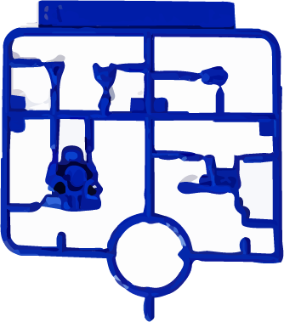
Figure 8. Closeup of the blue runner. Blue is used for the chest, boots, and shoulder armor. The thick gate marks visible at the runner perimeter are the locations where the molten polymer enters the cavity.
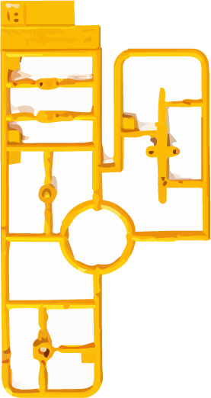
Figure 9. Yellow runner. The Wing Gundam’s yellow V-fin is one of the smallest and thinnest parts in the kit; its molding tolerance is the limiting case for the entire mold tool.
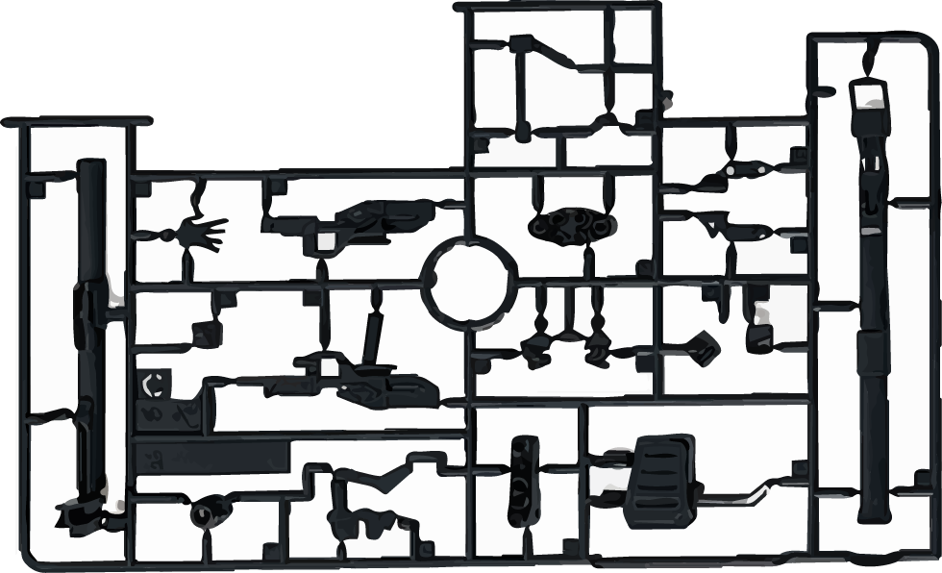
Figure 10. Black runner showing the buster rifle, beam saber handles, and joint reinforcement parts. Black HIPS commonly carries a higher load of carbon-black pigment (≈2 wt.%), which slightly raises the modulus and lowers the surface gloss compared with the white runner.
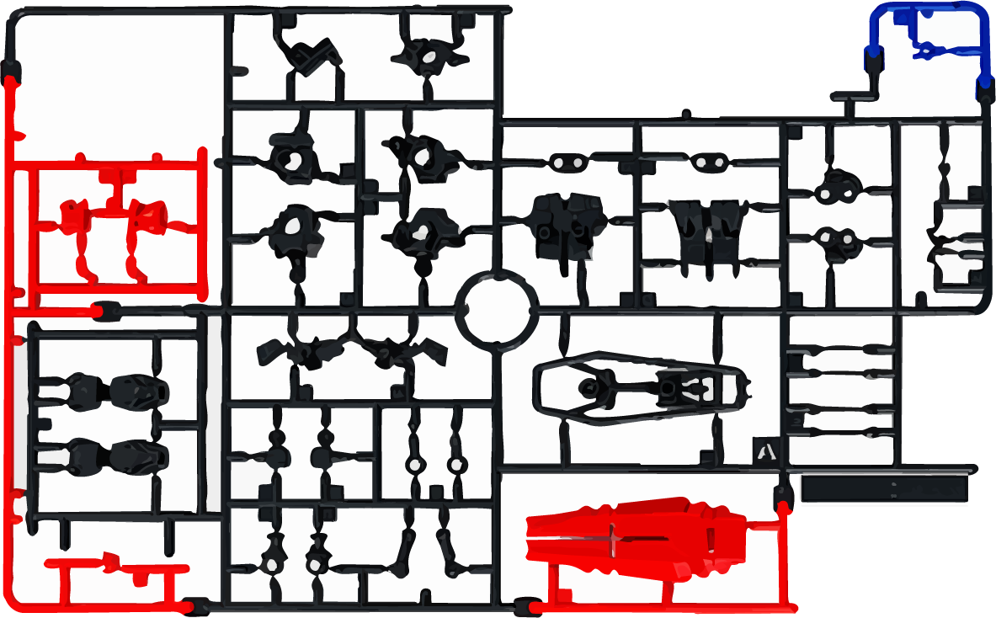
Figure 11. Detail of the same black runner family, showing the long thin profile of the buster rifle barrel. Long, slender molded parts are the most challenging to fill without warpage; Bandai mitigates this with a center gate and symmetric fill paths.

9. Sources and Key Takeaways

9.1 Key takeaways
- SB-13 is HIPS. FTIR top matches were "Polystyrene High Impact (Butyl)", "Bunatex", and a polystyrene–ethylene–butylene block copolymer. The aromatic ring modes near 1600 cm⁻¹ and the strong 2924/2846 cm⁻¹ aliphatic doublet together confirm a styrene matrix with an elastomer second phase.
- PC7 is LLDPE with paraffin. FTIR top matches were "Polyethylene Hostalen GM 7040", "Polyethylene linear low density", and "Paraffin". The 2914/2847 cm⁻¹ stretches, the 1462 cm⁻¹ scissoring band, and the 720–730 cm⁻¹ rocking doublet are diagnostic of polyethylene.
- The pairing is engineering, not coincidence. Stiff amorphous HIPS for armor + compliant semicrystalline LLDPE for joints is the same paired-stiffness/compliance strategy used in higher-end mechanical assemblies.
- Multi-color System Injection drives the no-paint promise. Bandai’s up-to-four-color injection machines decouple aesthetic color from post-processing.
- Closed-loop recycling exists at modest scale. Bandai’s Gunpla Recycling Project collected ≈72 t over fiscal 2021–2023; collection is growing at ≈2×/year.

9.2 References
All sources below are peer-reviewed scientific literature, U.S. or Japanese government agencies, or official corporate technical bulletins from the manufacturers in question.

Peer-reviewed and journal sources
Maul, J. F. R. (2004). Super HIPS: improved high impact polystyrene with two sources of rubber particles. Polymer, 45(25), 8447–8457. Elsevier ScienceDirect.
Gulmine, J. V., Janissek, P. R., Heise, H. M., & Akcelrud, L. (2002). Polyethylene characterization by FTIR. Polymer Testing, 21(5), 557–563. Elsevier ScienceDirect.
Yang, S., Cheng, Y., Liu, T., Huang, S., Yin, L., Pu, Y., & Liang, G. (2024). Comprehensive understanding of the aging and biodegradation of polystyrene-based plastics. Environmental Pollution, 343, 123181. Elsevier ScienceDirect.
Xu, P., et al. (2024). Progress and Challenges in Polystyrene Recycling and Upcycling. ChemSusChem, 17(13). Wiley Online Library.
Prata, J. C., et al. (2020). Polystyrene nanoparticles: sources, occurrence in the environment, distribution in tissues, accumulation and toxicity to various organisms. Science of the Total Environment, 702, 134455. Elsevier.

Government and intergovernmental sources
U.S. Environmental Protection Agency (2018). Plastics: Material-Specific Data. Facts and Figures about Materials, Waste and Recycling. https://www.epa.gov/facts-and-figures-about-materials-waste-and-recycling/plastics-material-specific-data
Ministry of the Environment of Japan / Japan Partnership for Circular Economy (J4CE). Case Study #131: GUNPLA Recycling Project. https://j4ce.env.go.jp/en/casestudy/131/

Official manufacturer and industry technical sources
Bandai Namco Holdings (2024). Gunpla Recycling Project — Sustainability Actions. https://www.bandainamco.co.jp/en/sustainability/actions/gunpla-recycle.html
Bandai Spirits Co., Ltd. (2019). BANDAI SPIRITS Strengthened Its Productive Capacity for Models like GUNPLA with the Bandai Hobby Center’s New Building Opening Today! GUNDAM.INFO press release. https://en.gundam.info/news/hot-topics/01_2888.html
Bandai Spirits Co., Ltd. ECOPLA PROJECT. https://bandai-hobby.net/site/ecoplaproject/en/
LyondellBasell Industries. Polyethylene (PE) Technologies — Hostalen process bulletin. https://www.lyondellbasell.com/en/our-solutions/technologies/petrochemical/polyethylene-technologies/
Shimadzu Corporation. Application Note 01-00710-EN: Distinction of Polyethylene and Polypropylene by Infrared Spectroscopy. https://www.shimadzu.com/an/sites/shimadzu.com.an/files/pim/pim_document_file/applications/application_note/24068/an_01-00710-en.pdf

Reference and review sources
Spectroscopy Online. The Infrared Spectra of Polymers II: Polyethylene. https://www.spectroscopyonline.com/view/the-infrared-spectra-of-polymers-ii-polyethylene
Spectroscopy Online. The Infrared Spectra of Polymers III: Hydrocarbon Polymers. https://www.spectroscopyonline.com/view/the-infrared-spectra-of-polymers-iii-hydrocarbon-polymers
Xometry. High-Impact Polystyrene (HIPS): Definition, Properties, and Uses. https://www.xometry.com/resources/materials/high-impact-polystyrene-hips/
MakeItFrom.com. Polystyrene (PS). https://www.makeitfrom.com/material-properties/Polystyrene-PS
Specialchem. Polyethylene Plastic: Properties, Uses & Application. https://www.specialchem.com/plastics/guide/polyethylene-plastic
Wikipedia. Mobile Suit Gundam. https://en.wikipedia.org/wiki/Mobile_Suit_Gundam
Wikipedia. Gunpla. https://en.wikipedia.org/wiki/Gunpla
Wikipedia. Hajime Katoki. https://en.wikipedia.org/wiki/Hajime_Katoki
Wikipedia. Snap-fit. https://en.wikipedia.org/wiki/Snap-fit
Nippon.com (2019). Gundam at 40: The Influential Anime Series that Redefined a Genre. https://www.nippon.com/en/japan-topics/g00747/gundam-at-40-the-influential-anime-series-that-redefined-a-genre.html
Fictiv. How to Design Snap Fit Components. https://www.fictiv.com/articles/how-to-design-snap-fit-components
Goonhammer (2024). GunPla Review: Injection Machine. https://www.goonhammer.com/gunpla-review-injection-machine/

