ECE: 579 Artificial Intelligence
HW Assignment #3
David Akre

- Specify a heuristic function h(n) in formula:
The heuristic function h(n) used in this programming assignment is as follows: h(n) = the number of misplaced tiles. Thus when selecting which node to visit from all expanded nodes in the A* algorithm the following formula applies: Cost = G(n) + h(n), where G(n) is the cost to get to the next node summed with the heuristic measure of the misplaced nodes to the next node.
- Show that your heuristic function never overestimates:
The heuristic function never overestimates because every action that results in a smaller amount of misplaced tiles will be taken (e.g. there is an if/else control strategy condition in the code that will not allow future actions to take place if h(n) results in a larger value than the previous or current h(n)). Additionally, A* will choose the total cost summed with the h(n) which is lowest as the next path to be explored. Hence, the cost of the path chosen will be the minima of all other states expanded. Thus, the h(n) function will never overestimate the cost of getting to the solution state.

The following is an output example of the code proving this (e.g. build and execution on the ece3 server at the University of Arizona):

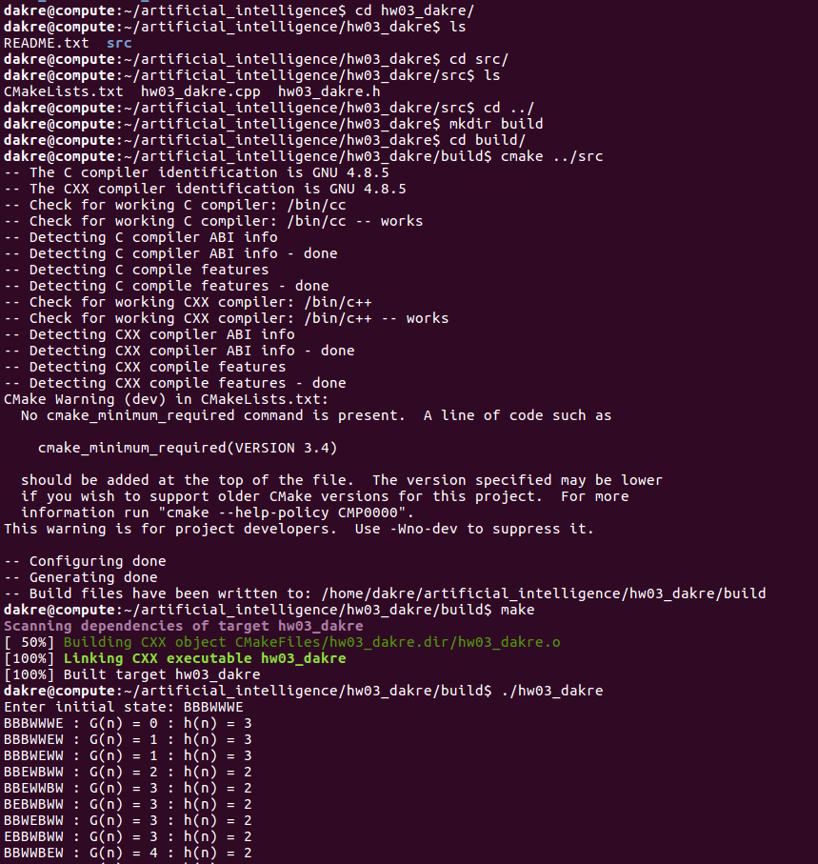

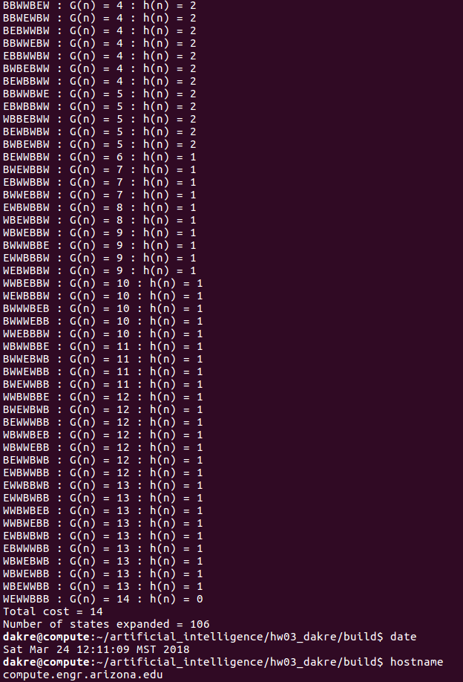
As one can see h(n) never overestimates the total cost to get to the solution state.

